**A4: Conceptual Data Model – Project Management**

The diagram presented below seeks to present the main entities and relationships required by the project management assignment. Besides that, it represents all the constraints and business rules applied to those entities and their attributes.

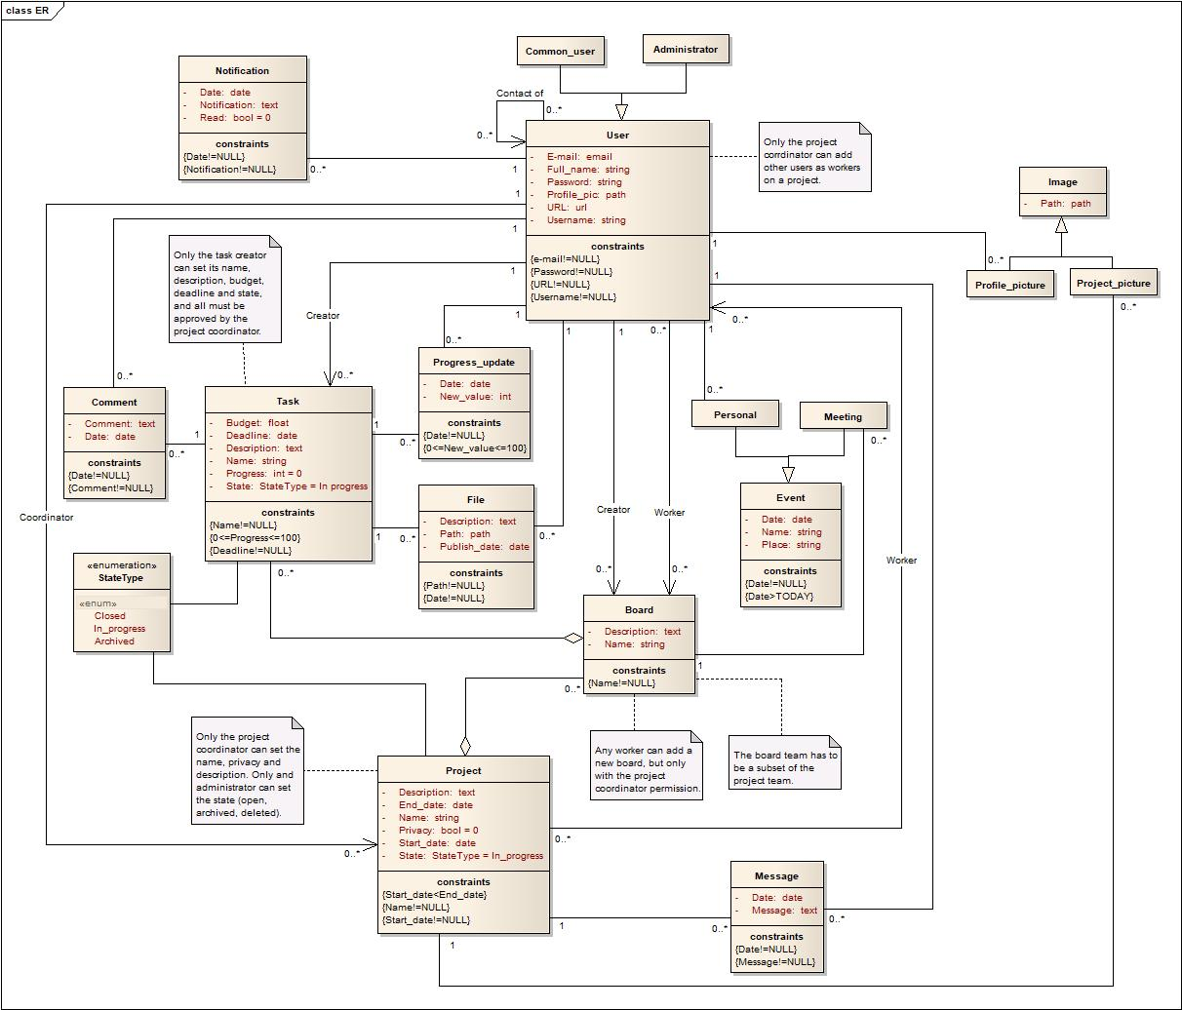

GROUP1734, 17/02/2018

- Ilona Generalova, up201400035@fe.up.pt

- Maria Inês Gonçalves, up201402784@fe.up.pt

- Maria Teresa Valério, up201405655@fe.up.pt

- Sara Gomes, up201405085@fe.up.pt

Figure 1: UML conceptual data model.

Figure 2: UML conceptual data model.