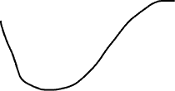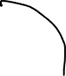

Start: no mushroom, no shortcut;1 mushroom, shortcut2; mushroom shortcut3. Extra mushroom at the end

Relies on getting one mushroom per shortcut until almost after one lap there is a mushroom right before the 1 lap mark



Total time: 68 seconds

**Never use the 4 second shortcut**

Optimal:

Time using the 15 second shortcut and the 5 second shortcut = 52 seconds