PAN — SENSOR ARRAY & HARDWARE SPECIFICATION
Personal Ambient Network · Complete Build Document · Sensors + Case Layout + Radio + eSIM + Mounting + Roadmap
PAN Project · April 2026

1. Device Envelope
Width | Height | Depth from chest | Total weight V1 | Attachment | Weather rating
100mm (4in) | 80mm (3.15in) | 63mm (2.5in) | ~132g | N52 magnet + steel plate | ~IPX4 splash resist

2. Sensor Master List
13 sensors plus built-in microphone. Tier = daily life value. Face = which side of the case the sensor window must face.

# | Sensor | Chip | Tier | Size mm | Face | Source | Notes
1 | Gas / Air Quality | BME688 | Critical | 20x20x3 | Front (Gore-Tex) | Mouser EU | 5-in-1: VOC CO methane temp humidity pressure
2 | Accelerometer/Gyro | BMI270 | Critical | 17x17x3 | Internal | Mouser EU | Motion steps fall detection sleep tracking
3 | GPS | L76K GNSS | Critical | 16x16x6 | Internal top | AliExpress | Position speed altitude — works without phone
4 | Thermal Camera | MLX90640 | Critical | 25x25x5 | Front | Mouser EU | 32x24 thermal image — heat signatures at distance
5 | Spectrometer | AS7341 | Critical | 20x20x3 | Left side | Mouser EU | 11-channel — food freshness bacteria material ID
6 | EMF Sensor | AD8317 | Critical | 20x15x3 | Internal | AliExpress | WiFi towers power lines appliance exposure
7 | Ambient Light | BH1750 | High | 18x10x3 | Front | AliExpress | Lux measurement — AI context sensor
8 | UV Sensor | VEML6075 | High | 14x10x2 | Front | AliExpress | UVA + UVB separately — sun exposure tracking
9 | Air Quality VOC | SGP40 | High | 15x15x3 | Front (Gore-Tex) | AliExpress | VOC index — complements BME688
10 | Laser Distance | VL53L0X | High | 15x12x3 | Front | AliExpress | Time-of-flight proximity and ranging
11 | Sound Level | MAX4466 | High | 18x14x3 | Right side hole | AliExpress | Decibel measurement — noise environment logging
12 | Magnetometer | QMC5883L | Situational | 12x12x2 | Internal | AliExpress | Compass direction when standing still
13 | Battery Monitor | INA219 | Critical | 26x13x3 | Internal | AliExpress | Voltage + current — mandatory power management

3. All Components — Hardware, Radio & eSIM
Component | Size | Weight | Purpose | Face | Source
XIAO ESP32S3 Sense | 21x17.5x3.5mm | 5g | MCU — mic + OV2640 · 8MB flash · WiFi + BLE5 | Internal | Already owned
OV5640 5MP camera | 40x40x8mm | 4g | Upgrades built-in OV2640 — CSI compatible | Front center | AliExpress ~8EUR
Waveshare 1.69in LCD | 40x35x4mm | 8g | Full top face · SPI · 240x280 · 262K colors | Top face | Already owned
MAX98357A amplifier | 18x18x2mm | 2g | I2S Class D · 3W · powers speaker | Internal | Already owned
28mm Mylar speaker | O28x4.7mm | 4g | 0.5W · 8 ohm · 81dB · grille cutout bottom | Bottom face | Already owned
KY-008 laser module | 18x15x8mm | 3g | Visible red laser — shows where camera points | Front below cam | AliExpress ~1EUR
LED ring | O30x4mm | 2g | White illumination around camera lens | Front around cam | AliExpress ~2EUR
MCP23017 GPIO expander | 28x10x3mm | 2g | I2C · 16 extra GPIO · manages all sensor pins | Internal | AliExpress ~2EUR
SA818 voice radio | 26x26x4mm | 4g | VHF/UHF PTT radio · 5-10km voice range | Internal + stub | AliExpress ~8EUR
VHF stub antenna | 80mm | 2g | Quarter-wave VHF — required for voice range | Top edge | AliExpress ~2EUR
SX1262 LoRa module | 16x16x3mm | 1g | LoRa 868MHz · Meshtastic · GPS beacon · 50km | Internal | AliExpress ~4EUR
SIM7080G eSIM module | 24x24x3mm | 2g | NB-IoT + LTE Cat-M · global eSIM · internal ant | Internal | AliExpress ~8EUR
Gore-Tex vent plugs x3 | O8mm each | 1g | IP67 gas-permeable waterproof membrane | 2x front · 1x left | AliExpress ~3EUR
18650 battery | O18x65mm | 47g | 3000-3500mAh · stands vertically | Internal center | AliExpress ~5EUR
USB-C + rubber cover | — | 1g | Charging · bottom face · splash protection | Bottom face | AliExpress ~1EUR
Power button | 8x8mm | 1g | Tactile · left side | Left side | AliExpress ~1EUR
PTT / Volume button | 8x8mm | 1g | Push-to-talk SA818 · right side | Right side | AliExpress ~1EUR
3D printed case PLA | 100x80x63mm | 20g | Two-half snap fit · silicone bead seal · V1 | — | Print yourself
TOTAL | ~100x80x63mm | ~132g | V2 target 90g · V3 target 60g | — | —

4. Three-Layer Communication System
Three independent communication layers. eSIM configured once via PAN app — pendant operates autonomously without phone after setup.

Layer | Module | Range | Voice | Data | Antenna | Cost/mo | Best for
Layer 1 — Cellular | SIM7080G eSIM | Global | VoIP possible | Yes LTE | Internal flex | 5-15 EUR | Daily use · calls 112 · uploads PAN data · works anywhere with cell coverage
Layer 2 — Voice Radio | SA818 VHF/UHF | 5-10km | Yes PTT | No | 80mm stub top edge | Free | Grid-down · wilderness · no cell · instant PTT voice to anyone with a radio
Layer 3 — LoRa Mesh | SX1262 Meshtastic | 50km | No | Low bandwidth | Internal flex | Free | GPS beacon · SOS relay · mesh data · works when everything else fails

eSIM and LoRa use internal flex PCB antennas — zero external protrusion. SA818 requires 80mm VHF stub on top edge — non-negotiable physics at 150MHz.

5. Face Assignment
Back face now includes embedded steel plate for magnetic mounting system.

Face | Dimensions | Components | Notes
Top face | 100x63mm | Waveshare 1.69in LCD screen | Screen fills entire top — user glances down to read
Front face | 100x80mm | OV5640 · MLX90640 · KY-008 laser · LED ring · VL53L0X · BH1750 · VEML6075 · Gore-Tex x2 | Primary sensor face — outward from chest. Gore-Tex for BME688 + SGP40 air intake
Left side | 80x63mm | AS7341 spectrometer · Gore-Tex vent · Power button | Spectrometer for targeted scanning without blocking camera
Right side | 80x63mm | MAX4466 sound hole · PTT button | PTT activates SA818 voice. Sound hole for decibel sensor
Bottom face | 100x63mm | 28mm speaker grille · USB-C charging · rubber port cover | Speaker grille cutout. Rubber cover protects USB-C from splash
Top edge | 100mm edge | SA818 stub antenna 80mm rubber duck | Required for voice radio — physics non-negotiable
Back face | 100x80mm | Steel plate (60x80x2mm) embedded flush · N52 magnet attachment point | Steel plate for magnetic mounting. Pendant snaps to front magnet through shirt.
Internal | All remaining | XIAO · 18650 vertical · all sensors · SA818 · SX1262 · SIM7080G · MCP23017 · amp · GPS | Battery stands vertically. GPS + eSIM antennas need top edge clearance

6. Battery Strategy
Cell | Capacity | Weight | Size | Est. Runtime | Verdict
18650 x1 | 3000-3500mAh | 47g | O18x65mm | 18-20hrs real use | PRIMARY — full day charge
18350 x2 | 1800mAh | 34g | O18x35mm x2 | 10-12hrs | Fallback if height issue
18350 x1 | 900mAh | 17g | O18x35mm | 5-6hrs | V3 only custom cell

Power: BMI270 + BME688 + BH1750 always-on every 5s. GPS + LoRa beacon every 30s. eSIM idle low power always-on. Camera + thermal + spectrometer on AI demand. SA818 on PTT only. Daily draw ~1950mAh = full day on 18650.

7. Gore-Tex Membrane Vents
Gore-Tex vent plugs: waterproof but gas/vapor permeable. Bosch recommends for BME688 enclosures. Search 'IP67 Gore-Tex vent plug membrane' AliExpress. Press-fit 6-8mm. 3 plugs needed. ~3-6 EUR.
Placement: x2 front face below camera (BME688 + SGP40) · x1 left side (circulation). Weather rating: ~IPX4. Add rubber cover to USB-C port outdoors.

8. Sourcing by Supplier
Supplier | Items | Notes
Mouser Europe | BME688 · BMI270 · MLX90640 · AS7341 | Quality-critical sensors. One cart one EU shipment
AliExpress | L76K GPS · BH1750 · VEML6075 · SGP40 · VL53L0X · MAX4466 · QMC5883L · AD8317 · INA219 · KY-008 · LED ring · 18650 · MCP23017 · SA818 · SX1262 · SIM7080G · Gore-Tex x3 · stub antenna · OV5640 · buttons · USB-C cover · N52 magnets x2 · steel washer · silicone sleeve | Combine into one order. 2-3 week delivery to Greece
Already owned | XIAO ESP32S3 Sense · Waveshare 1.69in LCD · MAX98357A amp · 28mm speaker | Already in hand
Hardware store | Steel plate 60x80x2mm | Cut to size — any local hardware store
3D print yourself | Case two halves · snap fit · silicone bead seal | PLA · print yourself

9. Version Roadmap
Version | Builder | Electronics | Weight | Size | Enclosure | Goal
V1 — Proof of concept | You | Breakout boards | ~132g | 100x80x63mm | 3D printed PLA · silicone seal · steel plate back | Prove all sensors + radio + eSIM work. Full feature set.
V2 — Manufactured | Chinese partner | Bare chips custom PCB | ~90g | ~80x60x40mm | Overmolded TPU · proper windows · IPX4 · steel plate integrated | Commercial feel. All features. Proper antenna. Gore-Tex factory.
V3 — Refined | Same partner | Custom battery cell | ~60g | ~70x50x30mm | Full industrial design · IPX6 | Mass production ready. Sub-60g target.

10. Sensors Deliberately Cut
Sensor | Reason cut
TCS34725 Color Sensor | Redundant — AS7341 covers all color channels plus 7 extra
GSR Skin Conductance | Requires direct skin electrode contact — invalid over clothing
pH Sensor PH-4502C | Requires liquid immersion with probes — no wearable use case
RadSens Radiation Detector | Too large too niche — gamma/beta irrelevant for daily life
MLX90614 Point IR Thermometer | Redundant — MLX90640 thermal camera already measures temp at distance
SCD40 CO2 Sensor | BME688 + SGP40 together sufficient — precise CO2 adds minimal value

PAN Sensor Array & Hardware Specification · Personal Ambient Network · April 2026

PAN — Six-View Case Layout
Top · Front · Left · Right · Bottom · Internal | eSIM + SA818 Voice + LoRa
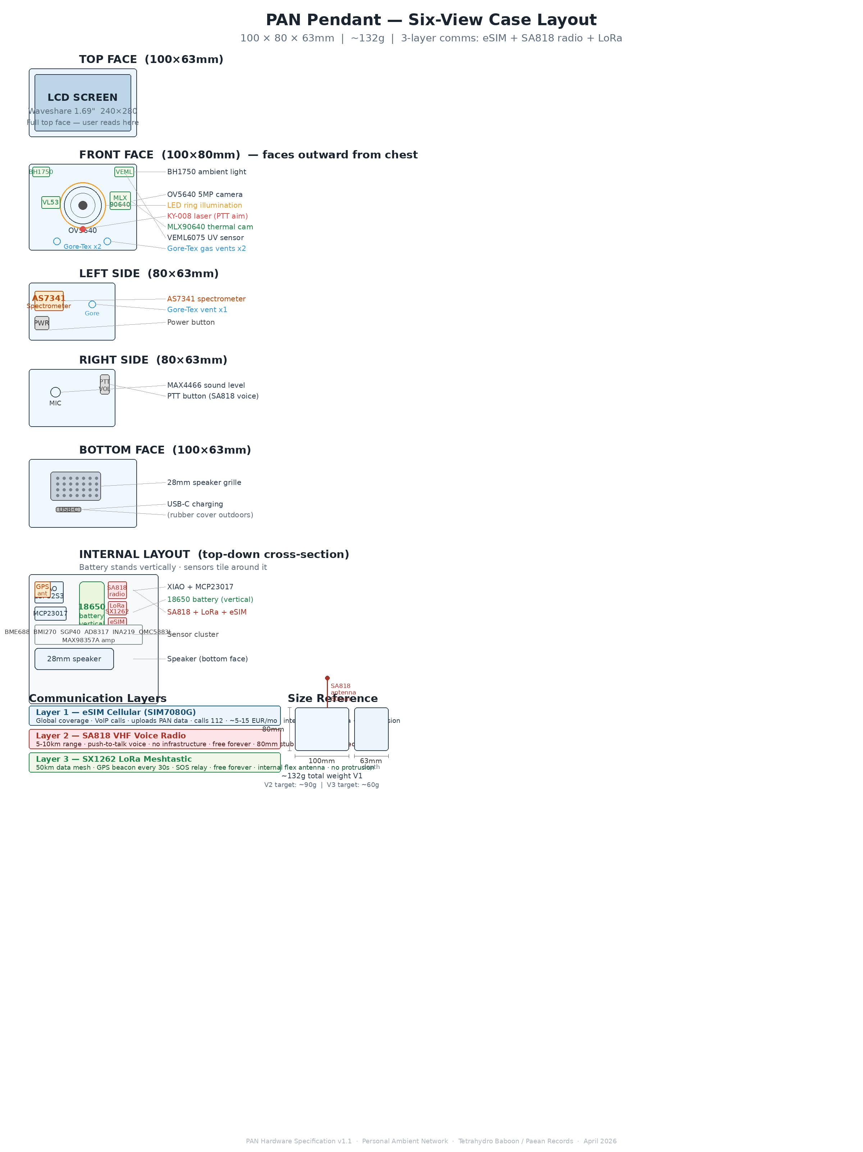

PAN — Magnetic Mounting System
Option A (recommended) · Option B · In-box accessory kit · Warnings
