**Software Requirements**

**Specification**

**for**

**Real-Time Language Translation Earpiece**

**Prepared by**

Swayam Chhaba PES2UG21CS566

Tarun Sairaj Vepamaninti PES2UG21CS572

Vismay Rallabandi PES2UG21CS612

Y Teresha PES2UG21CS618

# 1. Introduction

## 1.1 Purpose

The purpose of this Software Requirements Specification (SRS) document is to outline the detailed requirements, features, and specifications for the development of the Real-Time Language Translation Earpiece mobile application. This document serves as a comprehensive reference for the project team, stakeholders, and developers, ensuring a shared understanding of the project's scope and requirements.

## 1.2 Intended Audience

This Software Requirements Specification (SRS) document is designed to cater to a diverse audience, each with specific roles and responsibilities within the project. The document is intended for the following types of readers:

**Developers:** Developers will find detailed technical specifications and requirements for building the Real-Time Language Translation Earpiece mobile application.

**Project Managers:** Project managers can gain insights into project scope, objectives, and technical requirements to effectively plan resources, timelines, and milestones.

**Marketing Staff:** Marketing staff can leverage the SRS to understand the product's features and capabilities, aiding in the creation of marketing materials and strategies.

**Users:** End-users, potential or current, can acquire a high-level understanding of the mobile application's features and functionality.

**Testers:** Testers will benefit from detailed functional and non-functional requirements and quality assurance criteria to plan and execute testing efforts effectively.

## 1.3 Product Scope

This software aims to facilitate seamless language translation during conversations. Its purpose is to break down language barriers by offering real-time translation services via compatible wireless earbuds. The key objectives and benefits include:

**Effortless Communication:** Enabling users to converse naturally with others, regardless of their language, fostering global connections.

**Versatility for Diverse Users:** Catering to travellers, business professionals, language learners, and those interested in cultural exchange.

**Enhancing Global Reach**: Aligning with corporate goals of expanding communication capabilities and fostering international collaborations.

# 2. Overall Description

## 2.1 Product Perspective

**Context:** This application is not a component of a larger system but serves as a complete and user-centric solution. It connects with external services for speech recognition and translation through APIs but functions independently for the end-users.

**Interfaces:** While the mobile application itself is self-contained, it interfaces with external components for specific functions:

* **Speech Recognition Service:** The application communicates with an external speech recognition service to convert spoken language into text.
* **Machine Translation Service:** It integrates with an external machine translation service to provide real-time translation.
* **Cloud Services:** The application connects to cloud-based services for language models, updates, and synchronization.

## 2.2 Product Functions

The Real-Time Language Translation Earpiece mobile application must enable users to:

* Pair compatible earbuds with the app.
* Select source and target languages.
* Provide real-time speech recognition and translation.
* Support two-way translation between users.
* Offer offline mode for basic translations.
* Implement noise reduction and echo reduction.
* Facilitate user profiles and settings.
* Enable user feedback and issue reporting.
* Ensure robust privacy and security controls.
* Provide tutorials and user assistance.

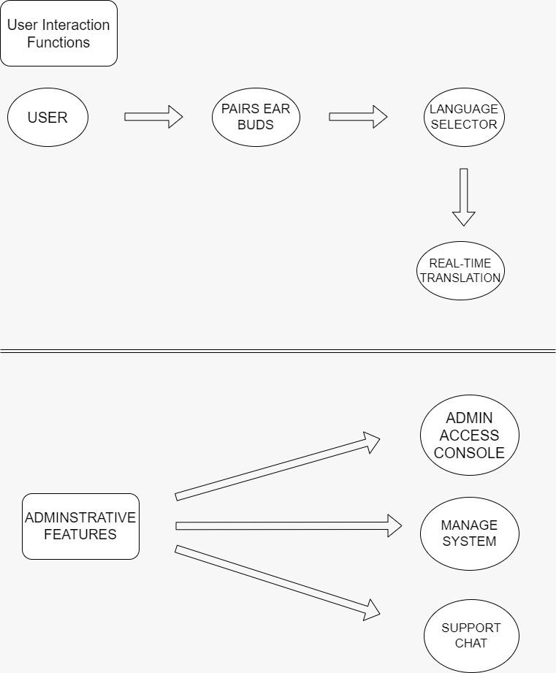

Image 2.0

## 2.3 User Classes and Characteristics

The Real-Time Language Translation Earpiece mobile application is designed to cater to a diverse range of user classes, each with unique characteristics and expectations. Here are the primary user classes:

**1. Travelers:**

Varied language backgrounds, frequent travellers, often use translation for social interaction and navigation.

**2. Business Professionals:**

Multilingual, international travel for business, communication with colleagues and clients from diverse backgrounds.

**3. Language Learners:**

Focused on learning new languages, need real-world practice and translation assistance during conversations.

**4. Cultural Enthusiasts:**

Interest in cultural exchange, frequent interaction with people from different linguistic backgrounds.

**5. General Users:**

Casual users who may occasionally require translation services for communication with non-native speakers.

**6. Accessibility Users:**

Individuals with disabilities, requiring specialized accessibility features like real-time captions or voice customization.

The most important user classes for this product are Travelers, Business Professionals, and Language Learners, as they represent the primary target audience for the Real-Time Language Translation Earpiece mobile application. Their needs and expectations will be a significant focus in meeting the product requirements.

## 2.4 Operating Environment

The Real-Time Language Translation Earpiece mobile application will operate in the following environment:

**Hardware Platform:** It is expected to be compatible with both iOS and Android devices.

**Software Components:** The application will interact with external services and APIs for speech recognition and machine translation, which may include third-party services like Google's Speech-to-Text and Google Translate. It must also smoothly integrate with cloud-based services for language models and updates.

**Internet Connectivity:** The application will require an active internet connection for real-time speech recognition and translation services, as well as for accessing cloud-based language models and updates.

**Hardware Compatibility:** While the mobile application itself will run on a wide range of smartphones and tablets, it is expected to be compatible with a variety of wireless earbuds or similar audio devices that support Bluetooth connectivity.

## 2.5 Design and Implementation Constraints

**1. Hardware Limitations**

Lists any hardware constraints that could affect development, such as memory limitations or timing requirements. For example, the software must run smoothly on mobile devices with limited processing power and RAM.

**2. Parallel Operations**

Explains any constraints related to concurrent processing or multi-threading, especially relevant for real-time translation.

**3. Language Requirements**

Details any language-specific constraints, such as the need to support multiple languages, including right-to-left languages if necessary.

**4. Communications Protocols**

Specifies the communications protocols that must be used, especially for Bluetooth connectivity, data transmission, and cloud integration.

**5. Security Considerations**

Outlines security constraints, like the need for end-to-end encryption or compliance with data protection laws, that could limit implementation options.

**6. Design Conventions or Programming Standards**

Lists the coding standards, naming conventions, or architectural patterns that must be followed. This is particularly important if the customer's organization will be responsible for maintaining the software post-delivery.

## 2.6 Assumptions and Dependencies

**Assumptions**

**Third-Party APIs Reliability:** We assume that the third-party APIs, such as speech recognition and translation services, will be available and reliable for integration throughout the project's development and operational phases.

**Hardware Compatibility:** We assume that the wireless earbuds and mobile devices used by our target users will have Bluetooth capability and meet the necessary hardware requirements for seamless connectivity and real-time translation.

**Regulatory Compliance:** It is assumed that the development and deployment of the software will adhere to all relevant regulatory and legal requirements related to data privacy and user consent, including obtaining necessary permissions for microphone access.

**Internet Connectivity:** Users are assumed to have access to a stable internet connection for the initial setup and optimal use of the app. However, the app should also support limited functionality in offline mode for basic translations.

**Dependencies**

**Third-Party APIs:** The project is dependent on third-party APIs for speech recognition and translation. Any changes, discontinuations, or limitations in these APIs could impact the project's functionality.

**Operating System Updates:** The software's compatibility with mobile operating systems (e.g., iOS, Android) depends on the continued support of Bluetooth and other necessary features. Updates or changes to these operating systems may require adjustments to the software.

**External Hardware Manufacturers:** The project relies on the availability and quality of compatible wireless earbuds on the market. Changes in the design or specifications of these earbuds could affect the app's performance.

**Cloud Services:** If the project utilizes cloud-based services for language models and updates, the availability and reliability of these services are critical dependencies.

**Localization Services:** If the app includes support for multiple languages and regions, it will depend on localization services for translations and cultural adaptations.

**Customer Input:** The project may depend on timely and accurate feedback from the customer or end-users for improvements and updates to the software.

# 3. External Interface Requirements

## 3.1 User Interfaces

**Mobile Application User Interface**

Purpose: The mobile application serves as the primary interface between users and the real-time language translation earpiece system. It allows users to control the earpiece, select languages, and monitor translations.

**Characteristics:**

GUI Standards: The user interface design will follow industry-standard mobile app design guidelines for the target platforms.

Standard Buttons and Functions: Common functions like "Settings," "Help," and "Feedback" will appear consistently across screens.

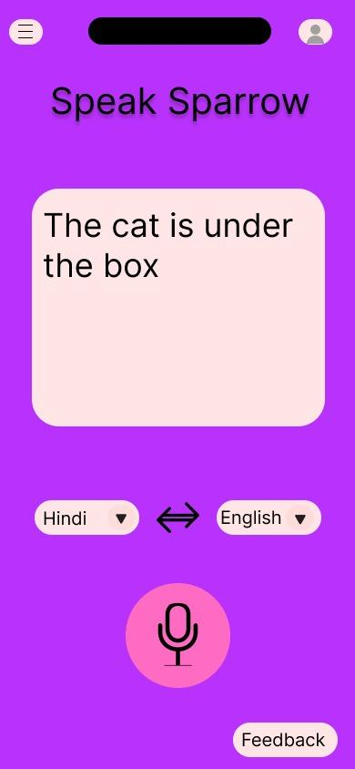

**Cloud-Based Management Console (Admin Interface)**

Purpose: This interface is intended for administrators or support staff responsible for managing and monitoring the real-time language translation system.

Characteristics:

Authentication: Requires secure login credentials for authorized access.

Dashboard: Provides a dashboard for monitoring system performance, user activity, and error logs.

Management Tools: Offers tools for managing user profiles, language support, and access permissions.

Reporting: Allows generation and export of reports on system usage and performance.

**Offline Mode (Limited Interface)**

Purpose: In cases where the user does not have internet connectivity, a limited offline mode allows basic translations.

Characteristics:

Minimal Interface: A simplified interface for offline use, focusing on essential translation functions.

Commonly Used Phrases: Access to a predefined set of common phrases for basic communication.

No Cloud Integration: In this mode, features dependent on cloud services (such as advanced translations) will be disabled.

## Communications Interfaces

**Bluetooth Communication**

Purpose: Bluetooth communication is essential for establishing a connection between the mobile application and the wireless earbuds for real-time audio transmission.

Requirements:

Data Transfer: High-quality audio data (e.g., voice) must be transmitted with low latency.

Security: Data transmitted over Bluetooth must be encrypted to ensure user privacy and prevent eavesdropping.

Synchronization: Real-time synchronization of audio data to maintain a seamless conversation experience.

Error Handling: Mechanisms for handling dropped or out-of-sequence audio packets to prevent communication disruptions.

**Internet Communication**

Purpose: Internet communication is required for various aspects of the system, including cloud-based services, software updates.

Requirements:

Protocols: HTTPS for secure communication with cloud services, HTTP for web-based components.

Data Transfer Rates: Adequate bandwidth to support real-time audio streaming, data downloads.

Security and Encryption: All data transmitted over the internet, including user data and translations, must be encrypted to ensure privacy and data security.

Synchronization: Real-time or near-real-time synchronization for chat messages and system updates.

**API Communication**

Purpose: Interaction with third-party APIs for speech recognition, translation, and noise cancellation.

Requirements:

Protocols: RESTful APIs over HTTPS for secure data exchange.

Message Formatting: Data sent to APIs must follow the required format (e.g., audio data for ASR APIs and text for translation APIs).

Data Transfer Rates: Fast data transfer to minimize latency in real-time translation.

Security: API keys or authentication tokens must be used to access third-party services securely.

Error Handling: Mechanisms for handling API errors and retries in case of communication failures.

**Local Storage Communication**

Purpose: Communication with local storage for caching and offline mode functionality.

Requirements:

Storage Format: Data stored locally, such as commonly used phrases for offline mode, must be stored efficiently and in a format that is easily retrievable.

Data Transfer Rates: Reading and writing data from local storage must be fast and responsive.

Synchronization: Mechanisms for synchronizing data between local storage and cloud services when an internet connection is available.

**Admin Console Communication**

Purpose: Communication with the web-based admin console for system management.

Requirements:

Protocol: HTTPS for secure communication.

Authentication: Secure login for authorized access to the admin console.

Data Transfer Rates: Adequate bandwidth for administrators to access system data and generate reports.

Security and Encryption: Data transmitted to and from the admin console must be encrypted to maintain system security and privacy.

Communication interfaces must adhere to industry standards and security best practices to ensure the confidentiality, integrity, and availability of data during transmission. Additionally, mechanisms for error handling and synchronization are crucial for providing a seamless user experience.

Analysis Models

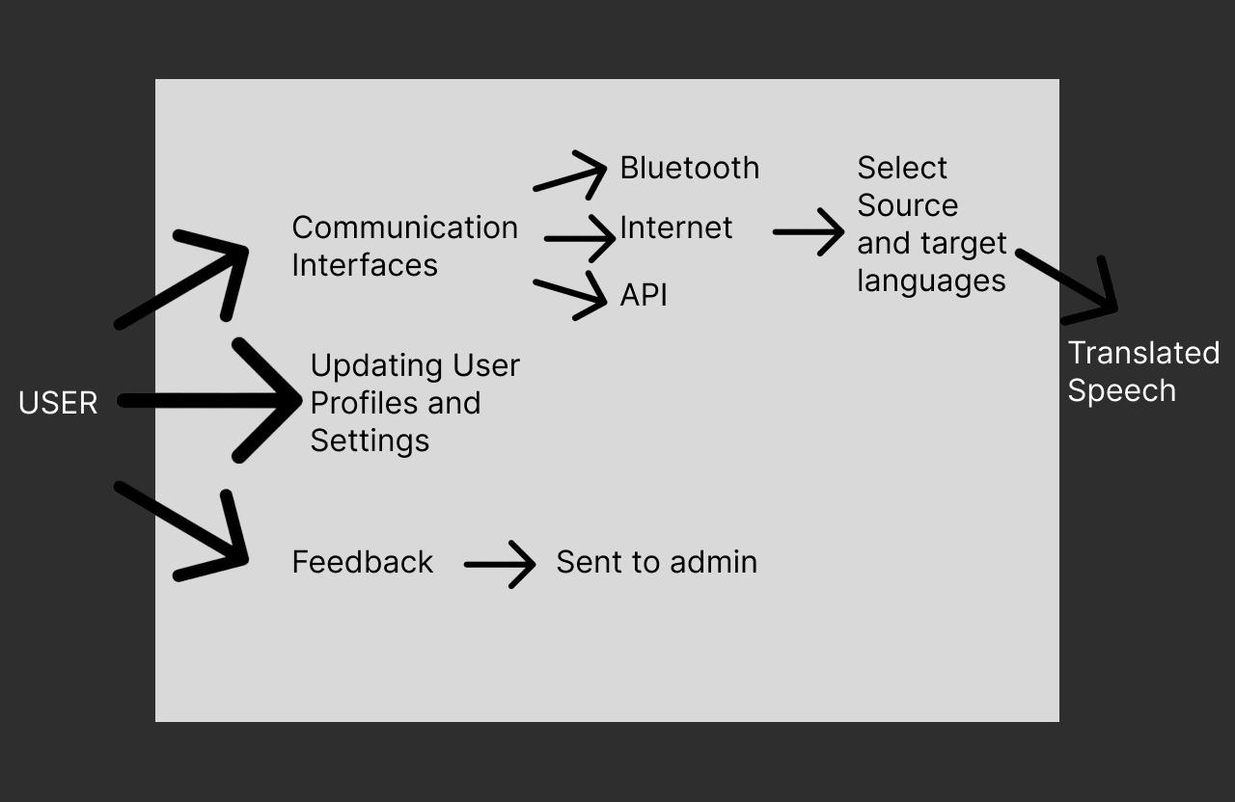

System Features

#### **User Interaction Features**

##### 1.1 Pairing Earbuds

* Description: Users can easily pair their wireless earbuds (e.g., AirPods) with the mobile application for seamless translation.
* Use Case: Users initiate the pairing process, and the app guides them through the setup.
* User Interface: Mobile application interface for pairing and setup.
* Dependencies: Bluetooth connectivity to the earbuds.

##### 1.2 Language Selection

* Description: Users can choose the source and target languages for translation.
* Use Case: Users select their preferred languages from a list of supported languages.
* User Interface: Language selection interface within the mobile app.
* Dependencies: Access to a database of supported languages.

##### 1.3 Real-Time Translation

* Description: Users can engage in natural conversations with others while the app provides real-time speech recognition and translation.
* Use Case: Users speak into the earbuds, and translations are delivered in real-time through the earpiece.
* User Interface: Audio feedback via the earpiece.
* Dependencies: Integration with speech recognition and translation APIs.

##### 1.4 Offline Mode

* Description: Users can access basic translation functionality without an internet connection for commonly used phrases.
* Use Case: Users can enable offline mode and access preloaded translations when there is no internet access.
* User Interface: Option to enable offline mode within the mobile app.
* Dependencies: Local storage of common phrases and translations.

##### 1.5 Feedback and Reporting

* Description: Users can provide feedback on translation quality and report issues to help improve the system.
* Use Case: Users can submit feedback and report problems through the mobile app.
* User Interface: Feedback and reporting forms within the app.
* Dependencies: Internet connectivity for submitting feedback.

#### **Administrative Features**

##### 2.1 Access Admin Console

* Description: Administrators can access admin console for system management.
* Use Case: Administrators log in to the admin console with their credentials.
* User Interface: Admin console login page.
* Dependencies: Secure login system.

##### 2.2 Manage System

* Description: Administrators can manage user profiles, language support, and access permissions through the admin console.
* Use Case: Administrators use the admin console to configure and manage system settings.
* User Interface: Admin console interface for user and system management.
* Dependencies: Integration with user database and language support.

# Other Non Functional Requirements

## Performance Requirements

**1. Translation Accuracy:**

Requirement: Achieve at least 95% accuracy in translating spoken language.

Rationale: High accuracy ensures that the translated output is reliable and meaningful, preventing misunderstandings between users speaking different languages.

**2. Response Time:**

Requirement: Translate spoken words within 1 to 2 seconds.

Rationale: Quick response time is vital for real-time conversations, enabling natural and uninterrupted communication between users.

**3. Multilingual Support:**

Requirement: Support translation between a minimum of 10 major languages.

Rationale: Catering to a diverse user base and ensuring the earpiece is useful in various international contexts.

**4. Offline Mode:**

Requirement: Offer basic translation functionality for at least few languages in offline mode.

Rationale: Offline mode ensures the earpiece remains functional even without an internet connection, which can be crucial in certain situations, like traveling in remote areas.

## Safety Requirements

**1. Language Accuracy:**

Requirement: Ensure translations are accurate and culturally sensitive to prevent misunderstandings that could lead to harm or offense.

Safeguard: Implement advanced translation algorithms and regularly update language databases to improve accuracy and relevance.

**2. Privacy and Data Security:**

Requirement: Protect user data and conversations from unauthorized access or misuse.

Safeguard: Encrypt data transmission, provide clear user privacy settings, and comply with data protection regulations such as GDPR (General Data Protection Regulation) or local equivalents.

## Security Requirements

**1. Secure Connection Protocols:**

Requirement: Use secure connection protocols (such as HTTPS) to establish a connection between the translation application and the earpiece.

Rationale: Secure protocols prevent man-in-the-middle attacks and data interception, enhancing the overall security of the communication channel.

**2. Compliance with Data Protection Regulations:**

Requirement: Ensure compliance with relevant data protection regulations, such as GDPR or local privacy laws, governing the handling of user data.

Rationale: Compliance with regulations demonstrates the software's commitment to user privacy and legal standards.

**3 . Privacy Settings and User Consent:**

Requirement: Provide clear privacy settings within the software, allowing users to control their data and obtain explicit consent for data collection and usage.

Rationale: Transparent privacy settings empower users to make informed decisions about their data, enhancing trust in the software.

## Software Quality Attributes

**1. Usability:**

Attribute: The software should have an intuitive user interface, allowing users to translate languages with minimal effort and confusion.

Quantifiable Measure: Achieve a minimum of 90% positive user feedback in usability surveys.

Rationale: Usability is critical for user satisfaction, ensuring that the software is user-friendly and easy to navigate.

**2. Accuracy:**

Attribute: The translated text must be accurate, capturing the nuances and context of the original language.

Quantifiable Measure: Maintain a translation accuracy rate of at least 95% based on benchmark tests.

Rationale: Accuracy is paramount for effective communication, preventing misunderstandings and misinterpretations.

**3. Reliability:**

Attribute: The software should provide reliable translation services consistently, without unexpected crashes or errors.

Quantifiable Measure: Aim for a system uptime of 99.9% in real-world usage scenarios.

Rationale: Reliability ensures that users can rely on the software for important translations without disruptions.

**4. Flexibility:**

Attribute: The software should support a wide range of languages and dialects, accommodating diverse user needs.

Quantifiable Measure: Support translation for at least 50 languages and dialects.

Rationale: Flexibility enhances the software's applicability, making it useful for a global audience with varying language requirements.

**5. Interoperability:**

Attribute: The software should seamlessly integrate with various devices and platforms, enabling smooth communication between different systems.

Quantifiable Measure: Successfully integrate and function with at least three different platforms (e.g., iOS, Android, Windows).

Rationale: Interoperability ensures that the software can collaborate with other technologies, enhancing its usefulness and reach.

**6. Maintainability:**

Attribute: The software codebase should be well-organized and documented, allowing for easy maintenance and updates.

Quantifiable Measure: Maintain a code complexity score below a specific threshold (e.g., maintain a Cyclomatic Complexity below 15).

Rationale: Maintainability facilitates future enhancements and bug fixes, ensuring the software remains robust and up-to-date.

## Business Rules

**User Authentication:**

Rule: Only registered users can access advanced translation features, such as storing translation history and setting preferences.

Implication: Implement a user registration and authentication system within the software.

**Usage Limits:**

Rule: Free users are limited to a specific number of daily translations, while premium users have unlimited access.

Implication: Implement usage tracking and restrict access for free users after reaching the daily limit.

**Data Privacy:**

Rule: User conversations and translation history are strictly confidential and will not be stored or shared with third parties without explicit user consent.

Implication: Implement robust encryption methods for data transmission and storage, and clearly outline the privacy policy in the user agreement.

**Language Support:**

Rule: Users can only translate languages supported by the software.

Implication: Regularly update language databases to include a wide variety of languages and dialects, and clearly communicate the available languages to users.

**Real-Time Processing:**

Requirement: The software must support real-time processing of spoken language, providing translations with minimal latency.

Rationale: Real-time processing is crucial for enabling seamless and natural conversations between users speaking different languages.

**Continuous Learning:**

Requirement: Implement machine learning algorithms that continuously learn from user interactions to improve translation accuracy and user experience over time.

Rationale: Continuous learning ensures that the software adapts to user preferences and language usage patterns, enhancing its effectiveness.

**Appendix A: Glossary**

|  |  |
| --- | --- |
| **User** | Individual who provides spoken input to receive the corresponding translated version. |
| **Admin** | Privileged user responsible for system management , user oversight, security and ensuring the system’s effective operation. |