HOME/Biography/Teacher/”The Caldwell Collection of Viols”/”Oberlin Baroque Performance Institute”/ Music from Oberlin

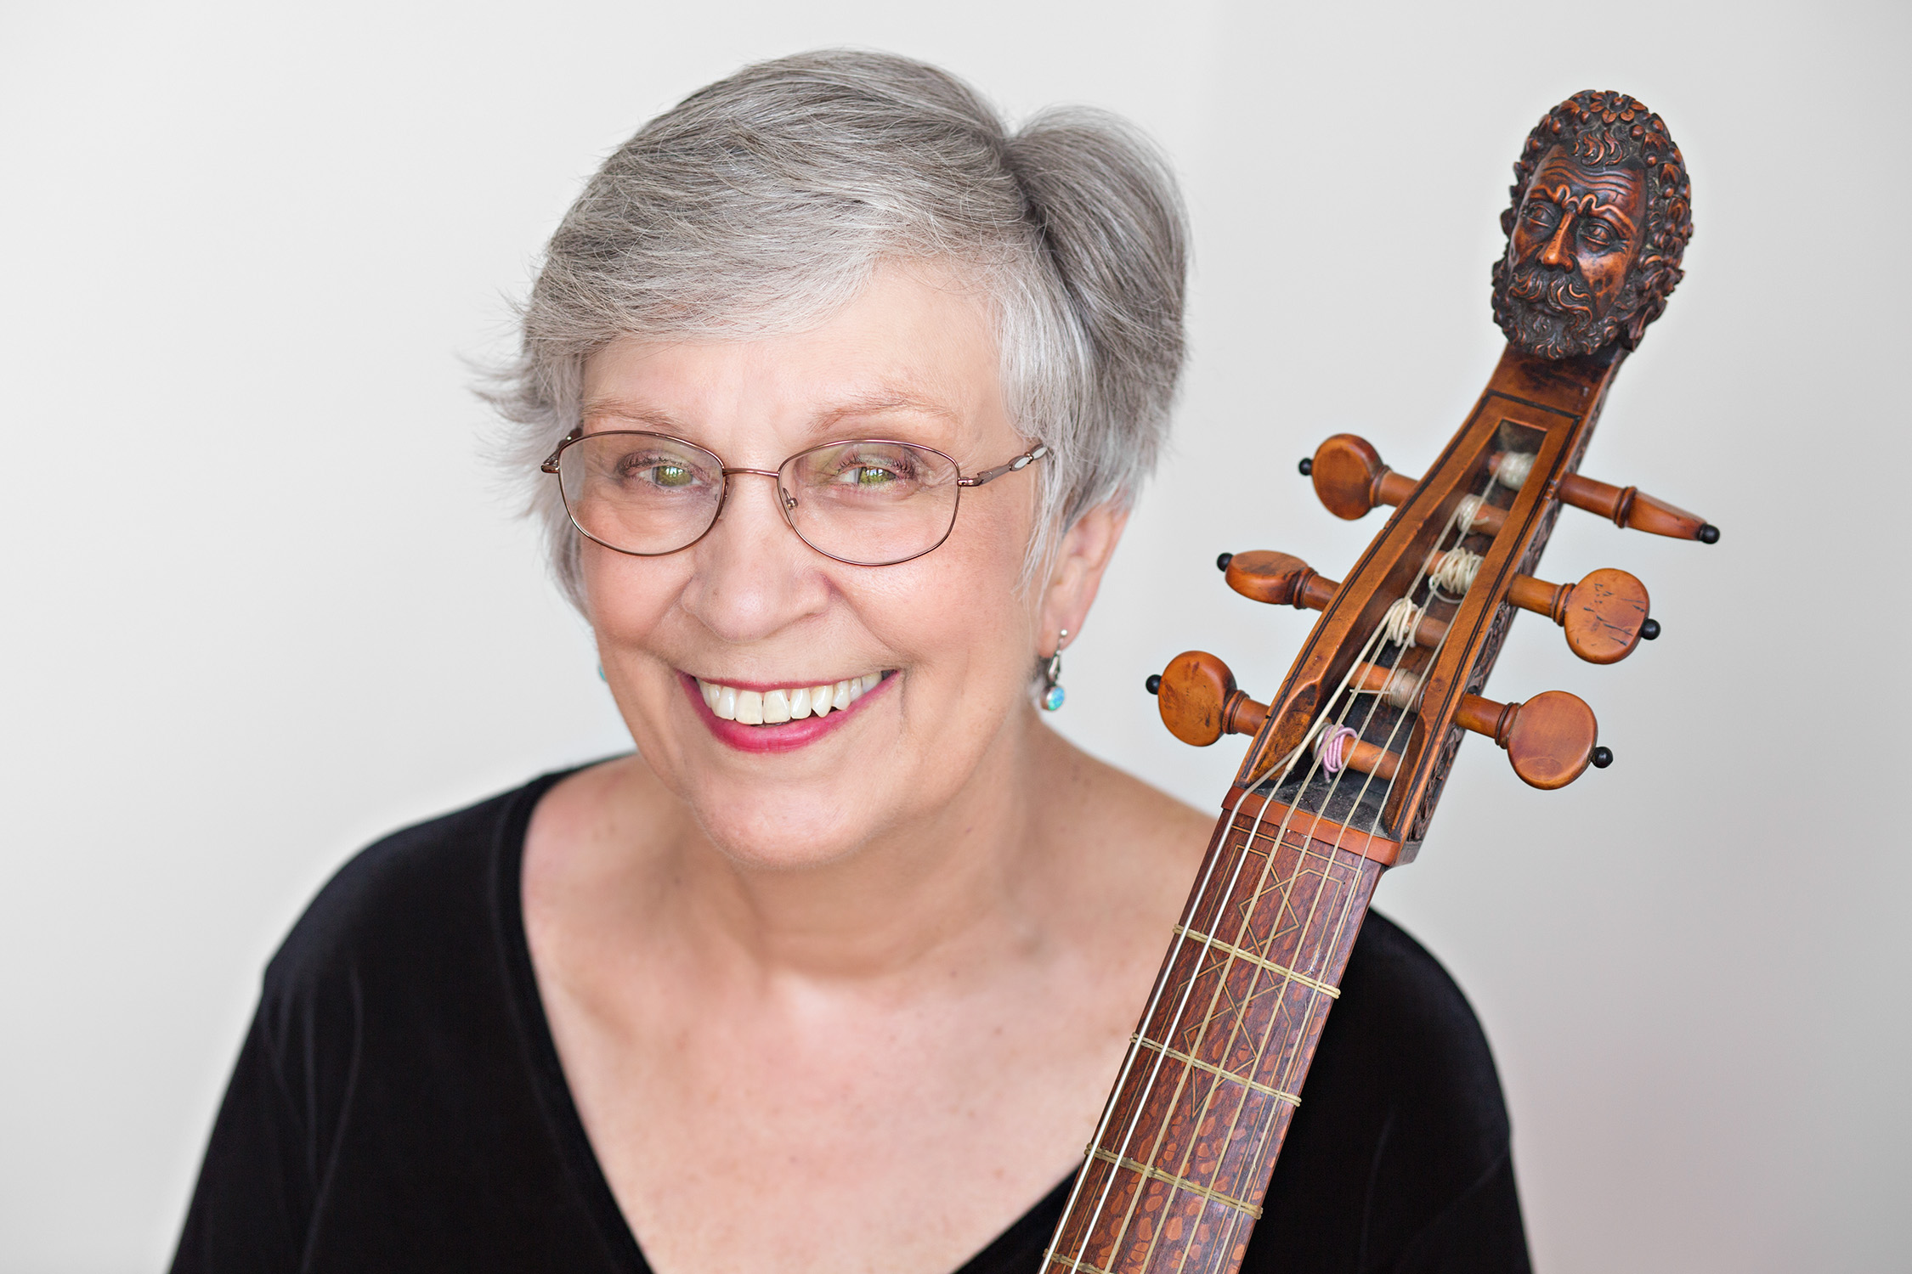

Catharina Meints -----Musician

Performer-Teacher-Author-Collector