***Král moří is a hardcore survival game set in a world consisting of various randomly generated islands in a vast ocean. Survive as long as you can! Collect various goods (yummy oranges and juicy coconuts)! Harness the power of wind! Join spectacular naval battles and become the king of the sea!***

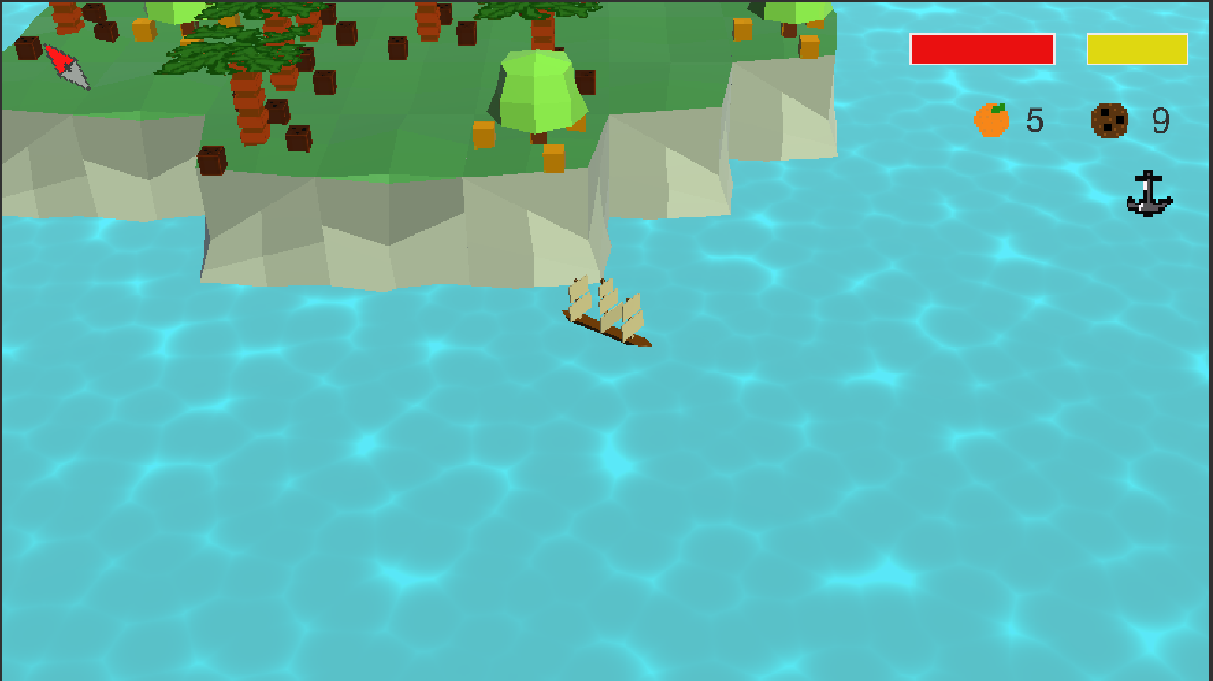

**Controls**

* **Mouse:** Use the scroll wheel to zoom in or out and harvest fruit by clicking the orange or coconut trees.
* **Keyboard: Space** – fire (costs you 3 coconuts)

**A** – anchor

**H** – healing (costs you 5 oranges)

**L** – call more enemies (if you dare)

**Left and right arrow** – navigate your ship

**Escape** – pause

**wind arrow**

**trees**

**oranges in possession**

**coconuts in possession**

**healthbar**

**shootbar**

**your ship**

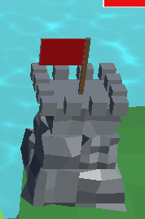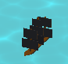

**anchor**

**enemy fortress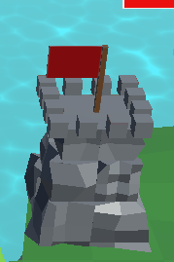fortress**

**enemy**