НАЦІОНАЛЬНИЙ ТЕХНІЧНИЙ УНІВЕРСИТЕТ УКРАЇНИ

“КИЇВСЬКИЙ ПОЛІТЕХНІЧНИЙ ІНСТИТУТ ІМЕНІ ІГОРЯ СІКОРСЬКОГО”

Факультет інформатики та обчислювальної техніки

Кафедра обчислювальної техніки

Лабораторна робота №3

з дисципліни

“Програмування мобільних систем”

Виконав:

студент групи ІВ-82

ЗК ІВ-8226

Теряткін Назарій

Київ 2021

Скріншоти роботи додатка (**Варіант 8226 % 2 + 1 = 1**)

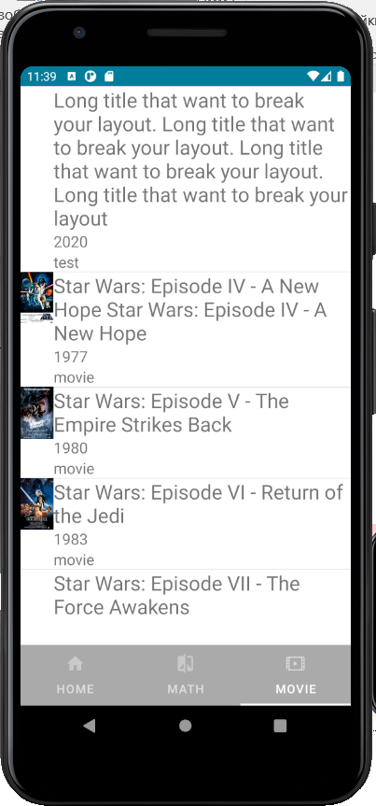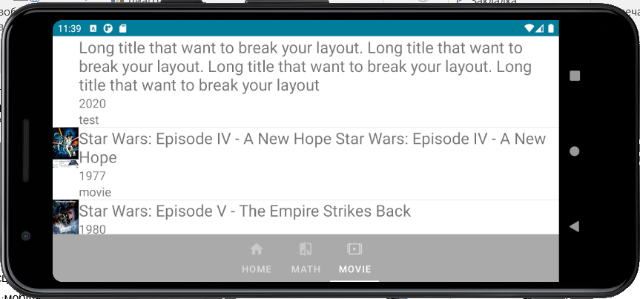

Лістинг коду

**MainActivity.java**

package ua.kpi.comsys.iv8226;

import android.os.Bundle;

import androidx.annotation.NonNull;

import androidx.appcompat.app.AppCompatActivity;

import androidx.fragment.app.Fragment;

import androidx.fragment.app.FragmentActivity;

import androidx.viewpager2.adapter.FragmentStateAdapter;

import androidx.viewpager2.widget.ViewPager2;

import com.google.android.material.tabs.TabLayout;

import com.google.android.material.tabs.TabLayoutMediator;

public class MainActivity extends AppCompatActivity {

private static final int NUMBER_OF__PAGES = 3;

private static final String[] PAGE_TITLES = new String[]{"Home", "Math", "Movie"};

private static final int[] TAB_ICONS = {R.drawable.ic_home, R.drawable.ic_drawing, R.drawable.ic_action_name};

@Override

protected void onCreate(Bundle savedInstanceState) {

super.onCreate(savedInstanceState);

setContentView(R.layout.activity_main);

ViewPager2 viewPager = findViewById(R.id.pager);

FragmentStateAdapter pagerAdapter = new MyPagerAdapter(this);

viewPager.setAdapter(pagerAdapter);

TabLayout tabLayout = findViewById(R.id.tab_layout);

new TabLayoutMediator(tabLayout, viewPager,(tab, position) -> {

tab.setText(PAGE_TITLES[position]);

tab.setIcon(TAB_ICONS[position]);

}).attach();

}

private static class MyPagerAdapter extends FragmentStateAdapter {

public MyPagerAdapter(FragmentActivity fa) {

super(fa);

}

@NonNull

@Override

public Fragment createFragment(int position) {

switch (position) {

case 2: {

return new MoviesFragment();

}

case 1: {

return new DrawingFragment();

}

case 0:

default:

return new GeneralFragment();

}

}

@Override

public int getItemCount() {

return NUMBER_OF__PAGES;

}

}

**Movie.java**

package ua.kpi.comsys.iv8226;

import java.util.ArrayList;

import java.util.HashMap;

import java.util.Map;

public class Movie {

String title;

String year;

String imdbID;

String type;

String poster;

public Movie(String title, String year, String imdbID, String type, String poster) {

this.title = title;

this.year = year;

this.imdbID = imdbID;

this.type = type;

this.poster = poster;

}

public Movie() {

}

public Map<String, String> CreateMovie(Movie movie) {

Map<String, String> movie_array = new HashMap<>();

movie_array.put("Title", movie.title);

movie_array.put("Year", movie.year);

movie_array.put("imdbID", movie.imdbID);

movie_array.put("Type", movie.type);

movie_array.put("Poster", movie.poster);

return movie_array;

}

public Movie getMovie(Map<String, String> movie) {

Movie some_movie = new Movie(movie.get("Title"), movie.get("Year"), movie.get("imdbID"), movie.get("Type"), movie.get("Poster"));

return some_movie;

}

public ArrayList<Map<String, String>> splitMovies(ArrayList<String> movies) {

ArrayList<Map<String, String>> some_movie = new ArrayList<>();

for (int i = 0; i < movies.size(); i++) {

Map<String, String> movie = new HashMap<>();

int index_left = movies.get(i).indexOf("\"Title\":") + 9;

int index_right = movies.get(i).indexOf("\"", index_left);

movie.put("Title", movies.get(i).substring(index_left, index_right));

index_left = movies.get(i).indexOf("\"Year\":") + 8;

index_right = movies.get(i).indexOf("\"", index_left);

movie.put("Year", movies.get(i).substring(index_left, index_right));

index_left = movies.get(i).indexOf("\"imdbID\":") + 10;

index_right = movies.get(i).indexOf("\"", index_left);

movie.put("imdbID", movies.get(i).substring(index_left, index_right));

index_left = movies.get(i).indexOf("\"Type\":") + 8;

index_right = movies.get(i).indexOf("\"", index_left);

movie.put("Type", movies.get(i).substring(index_left, index_right));

index_left = movies.get(i).indexOf("\"Poster\":") + 10;

index_right = movies.get(i).indexOf("\"", index_left);

movie.put("Poster", movies.get(i).substring(index_left, index_right));

some_movie.add(movie);

}

return some_movie;

}

}

**MoviesFragment.java**

package ua.kpi.comsys.iv8226;

import android.graphics.drawable.Drawable;

import android.os.Bundle;

import androidx.annotation.NonNull;

import androidx.annotation.Nullable;

import androidx.fragment.app.Fragment;

import android.view.LayoutInflater;

import android.view.View;

import android.view.ViewGroup;

import android.widget.ImageView;

import android.widget.LinearLayout;

import android.widget.ScrollView;

import android.widget.TableLayout;

import android.widget.TableRow;

import android.widget.TextView;

import java.io.BufferedReader;

import java.io.DataInputStream;

import java.io.IOException;

import java.io.InputStream;

import java.io.InputStreamReader;

import java.util.ArrayList;

import java.util.Map;

public class MoviesFragment extends Fragment {

@Override

public void onViewCreated(@NonNull View view, @Nullable Bundle savedInstanceState) {

super.onViewCreated(view, savedInstanceState);

ScrollView scrollView = (ScrollView) getView().findViewById(R.id.scrollView);

String list = "";

InputStream is = null;

try {

is = getView().getContext().getAssets().open("MoviesList.txt");

DataInputStream data = new DataInputStream(is);

BufferedReader bufferedReader = new BufferedReader(new InputStreamReader(data));

String string;

while ((string = bufferedReader.readLine()) != null){

list += list + string;

}

bufferedReader.close();

data.close();

is.close();

}catch (IOException e){

e.printStackTrace();

}

list = list.substring(list.indexOf("[") + 1, list.indexOf("]"));

String leftbr = "{";

String rightbr = "}";

int lastIndex_l = 0;

int lastIndex_r = 0;

ArrayList<String> movies = new ArrayList<>();

while ((lastIndex_l != -1)&&(lastIndex_r != -1)){

lastIndex_l = list.indexOf(leftbr, lastIndex_l);

lastIndex_r = list.indexOf(rightbr, lastIndex_r);

if((lastIndex_l != -1)&&(lastIndex_r != -1)){

movies.add(list.substring(lastIndex_l+1, lastIndex_r));

lastIndex_l += 1;

lastIndex_r += 1;

}

}

Movie movie = new Movie();

ArrayList<Map<String, String>> MoviesArray = movie.splitMovies(movies);

int rows = MoviesArray.size();

TableLayout tableLayout = getView().findViewById(R.id.tableLayout);

for(int i = 0; i < rows; i++){

TableRow tableRow = new TableRow(getView().getContext());

tableRow.setLayoutParams(new TableRow.LayoutParams(ViewGroup.LayoutParams.MATCH_PARENT, ViewGroup.LayoutParams.WRAP_CONTENT));

ImageView imageView = new ImageView(getView().getContext());

String postername = MoviesArray.get(i).get("Poster");

InputStream inputStream = null;

try {

inputStream = getView().getContext().getApplicationContext().getAssets().open("Posters/" + postername);

Drawable drawable = Drawable.createFromStream(inputStream, null);

imageView.setImageDrawable(drawable);

imageView.setScaleType(ImageView.ScaleType.FIT_CENTER);

}

catch (IOException e){

e.printStackTrace();

}

tableRow.addView(imageView, 0);

LinearLayout linearLayout_title = new LinearLayout(getView().getContext());

linearLayout_title.setOrientation(LinearLayout.HORIZONTAL);

LinearLayout linearLayout_year = new LinearLayout(getView().getContext());

linearLayout_year.setOrientation(LinearLayout.HORIZONTAL);

LinearLayout linearLayout_type = new LinearLayout(getView().getContext());

linearLayout_type.setOrientation(LinearLayout.HORIZONTAL);

TextView title = new TextView(getView().getContext());

TextView year = new TextView(getView().getContext());

TextView type = new TextView(getView().getContext());

title.setText(MoviesArray.get(i).get("Title"));

year.setText(MoviesArray.get(i).get("Year"));

type.setText(MoviesArray.get(i).get("Type"));

title.setTextSize(24);

year.setTextSize(18);

type.setTextSize(18);

linearLayout_title.addView(title);

linearLayout_year.addView(year);

linearLayout_type.addView(type);

TableLayout tl = new TableLayout(getView().getContext());

tl.addView(linearLayout_title, 0);

tl.addView(linearLayout_year, 1);

tl.addView(linearLayout_type, 2);

tableRow.addView(tl, 1);

tableLayout.addView(tableRow, i);

}

tableLayout.setColumnShrinkable(1, true);

}

@Override

public View onCreateView(LayoutInflater inflater, ViewGroup container,

Bundle savedInstanceState) {

return inflater.inflate(R.layout.fragment_movies, container, false);

}

}

}**GeneralFragment.java**

package ua.kpi.comsys.iv8226;

import android.os.Bundle;

import android.view.LayoutInflater;

import android.view.View;

import android.view.ViewGroup;

import androidx.fragment.app.Fragment;

public class GeneralFragment extends Fragment {

@Override

public View onCreateView(LayoutInflater inflater, ViewGroup container,

Bundle savedInstanceState) {

return inflater.inflate(R.layout.general_fragment, container, false);

}

}

**DrawingGraphFragment.java**

package ua.kpi.comsys.iv8226;

import android.graphics.Color;

import android.os.Bundle;

import android.view.LayoutInflater;

import android.view.View;

import android.view.ViewGroup;

import androidx.fragment.app.Fragment;

import com.jjoe64.graphview.GraphView;

import com.jjoe64.graphview.GridLabelRenderer;

import com.jjoe64.graphview.series.DataPoint;

import com.jjoe64.graphview.series.LineGraphSeries;

import java.util.stream.DoubleStream;

public class DrawingGraphFragment extends Fragment {

private static final int X_MIN = -6;

private static final int X_MAX = 6;

private static final double X_STEP = .5;

private static final int NUMBER = (int) ((X_MAX - X_MIN) /X_STEP + 1);

@Override

public View onCreateView(LayoutInflater inflater, ViewGroup container,

Bundle savedInstanceState) {

View view = inflater.inflate(R.layout.drawing_graph_fragment, container, false);

GraphView graph = view.findViewById(R.id.graph);

LineGraphSeries<DataPoint> series = new LineGraphSeries<>();

DoubleStream.iterate(X_MIN, d -> d + X_STEP)

.limit(NUMBER)

.forEach(value -> series.appendData(new DataPoint(value, Math.exp(value)),true,NUMBER));

series.setColor(Color.rgb(0,80,100));

series.setDrawDataPoints(true);

series.setDataPointsRadius(5);

series.setThickness(2);

graph.getViewport().setXAxisBoundsManual(true);

graph.getViewport().setMinX(-8);

graph.getViewport().setMaxX(8);

graph.getViewport().setYAxisBoundsManual(true);

graph.getViewport().setMinY(0);

graph.getViewport().setMaxY(450);

graph.addSeries(series);

graph.setTitle("y = e^x");

graph.setTitleTextSize(100);

graph.setTitleColor(Color.BLACK);

GridLabelRenderer gridLabel = graph.getGridLabelRenderer();

gridLabel.setHorizontalAxisTitle("X");

gridLabel.setVerticalAxisTitle("Y");

return view;

}

}

**DrawingDiagramFragment.java**

package ua.kpi.comsys.iv8226;

import android.graphics.Color;

import android.os.Bundle;

import android.view.LayoutInflater;

import android.view.View;

import android.view.ViewGroup;

import androidx.fragment.app.Fragment;

import com.github.mikephil.charting.charts.PieChart;

import com.github.mikephil.charting.data.PieData;

import com.github.mikephil.charting.data.PieDataSet;

import com.github.mikephil.charting.data.PieEntry;

import java.util.ArrayList;

public class DrawingDiagramFragment extends Fragment {

private static final String ORANGE = "#FF8000";

private static final String GREEN = "#00FF00";

private static final String BLACK = "#000000";

private static final int ORANGE_VALUE = 30;

private static final int GREEN_VALUE = 30;

private static final int BLACK_VALUE = 40;

@Override

public View onCreateView(LayoutInflater inflater, ViewGroup container,

Bundle savedInstanceState) {

View view = inflater.inflate(R.layout.drawing_diagram_fragment, container, false);

PieChart pieChart= view.findViewById(R.id.chart1);

ArrayList<PieEntry> pieEntries = new ArrayList<>();

ArrayList<Integer> colors = new ArrayList<>();

colors.add(Color.parseColor(ORANGE));

colors.add(Color.parseColor(GREEN));

colors.add(Color.parseColor(BLACK));

pieEntries.add(new PieEntry(ORANGE_VALUE, ""));

pieEntries.add(new PieEntry(GREEN_VALUE, ""));

pieEntries.add(new PieEntry(BLACK_VALUE, ""));

PieDataSet pieDataSet = new PieDataSet(pieEntries, "");

pieDataSet.setColors(colors);

PieData pieData = new PieData(pieDataSet);

pieData.setDrawValues(true);

pieChart.setData(pieData);

pieDataSet.setDrawValues(false);

pieChart.getLegend().setEnabled(false);

pieChart.getDescription().setEnabled(false);

pieChart.invalidate();

return view;

}

}

**DrawingFragment.java**

package ua.kpi.comsys.iv8226;

import android.os.Bundle;

import android.view.LayoutInflater;

import android.view.View;

import android.view.ViewGroup;

import androidx.annotation.NonNull;

import androidx.fragment.app.Fragment;

import androidx.viewpager2.adapter.FragmentStateAdapter;

import androidx.viewpager2.widget.ViewPager2;

import com.google.android.material.tabs.TabLayout;

import com.google.android.material.tabs.TabLayoutMediator;

public class DrawingFragment extends Fragment {

private static final int NUMBER_OF__PAGES = 2;

private static final String[] PAGE_TITLES = new String[]{"Graph", "Diagram"};

private static final int[] TAB_ICONS = {R.drawable.ic_graph, R.drawable.ic_diagram};

@Override

public View onCreateView(LayoutInflater inflater, ViewGroup container,

Bundle savedInstanceState) {

View view = inflater.inflate(R.layout.drawing_fragment, container, false);

ViewPager2 viewPager = view.findViewById(R.id.pager2);

FragmentStateAdapter pagerAdapter = new DrawingFragment.MyPagerAdapter(this);

viewPager.setAdapter(pagerAdapter);

TabLayout tabLayout = view.findViewById(R.id.tab_layout2);

new TabLayoutMediator(tabLayout, viewPager,(tab, position) -> {

tab.setText(PAGE_TITLES[position]);

tab.setIcon(TAB_ICONS[position]);

}).attach();

return view;

}

private static class MyPagerAdapter extends FragmentStateAdapter {

public MyPagerAdapter(@NonNull Fragment fragment) {

super(fragment);

}

@NonNull

@Override

public Fragment createFragment(int position) {

switch (position) {

case 1: {

return new DrawingDiagramFragment();

}

case 0:

default:

return new DrawingGraphFragment();

}

}

@Override

public int getItemCount() {

return NUMBER_OF__PAGES;

}

}

}

**Висновок**

В даній лабораторній роботі було розроблено мобільний додаток, який показує малює графік функції на проміжку та сворює кільцеву діаграму за варіантом.

Обидві вкладки працюють коректно. Кінцева мета досягнута.