НАЦІОНАЛЬНИЙ ТЕХНІЧНИЙ УНІВЕРСИТЕТ УКРАЇНИ

“КИЇВСЬКИЙ ПОЛІТЕХНІЧНИЙ ІНСТИТУТ ІМЕНІ ІГОРЯ СІКОРСЬКОГО”

Факультет інформатики та обчислювальної техніки

Кафедра обчислювальної техніки

Лабораторна робота №5

з дисципліни

“Програмування мобільних систем”

Виконав:

студент групи ІВ-82

ЗК ІВ-8226

Теряткін Назарій

Київ 2021

Скріншоти роботи додатка

(**Варіант 8226 % 6 + 1 = 1**)

(**Варіант 8226 % 2 + 1 = 1**)

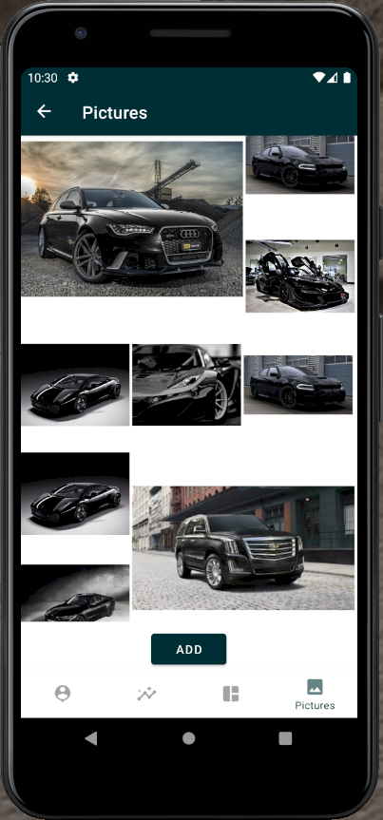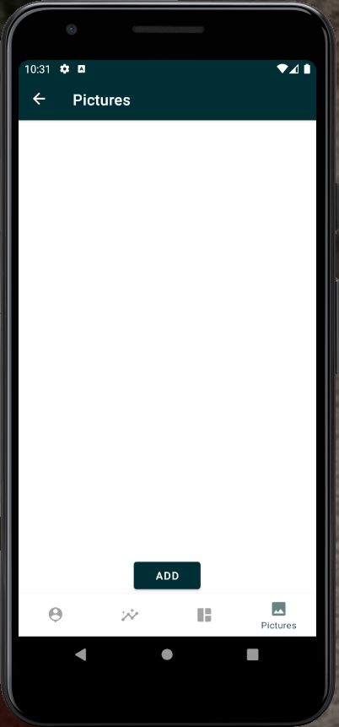

Лістинг коду

**MainActivity.java**

package ua.kpi.comsys.IV8226;

import android.os.Bundle;

import com.example.lab4.R;

import com.google.android.material.bottomnavigation.BottomNavigationView;

import androidx.appcompat.app.AppCompatActivity;

import androidx.navigation.NavController;

import androidx.navigation.Navigation;

import androidx.navigation.ui.AppBarConfiguration;

import androidx.navigation.ui.NavigationUI;

public class MainActivity extends AppCompatActivity {

@Override

protected void onCreate(Bundle savedInstanceState) {

super.onCreate(savedInstanceState);

setContentView(R.layout.activity_main);

BottomNavigationView navView = findViewById(R.id.nav_view);

AppBarConfiguration appBarConfiguration = new AppBarConfiguration.Builder(

R.id.navigation_home, R.id.navigation_dashboard)

.build();

NavController navController = Navigation.findNavController(this, R.id.nav_host_fragment);

NavigationUI.setupActionBarWithNavController(this, navController, appBarConfiguration);

NavigationUI.setupWithNavController(navView, navController);

}

}

**PicsFragment.java**

package ua.kpi.comsys.IV8226.ui_fragments.pics;

import android.content.Intent;

import android.graphics.Bitmap;

import android.graphics.BitmapFactory;

import android.net.Uri;

import android.os.Bundle;

import android.view.LayoutInflater;

import android.view.View;

import android.view.ViewGroup;

import android.widget.Button;

import android.widget.ListAdapter;

import androidx.annotation.NonNull;

import androidx.fragment.app.Fragment;

import com.example.lab1.R;

import ua.kpi.comsys.IV8226.adapters.PicsAdapter;

import ua.kpi.comsys.IV8226.model.PicItem;

import com.felipecsl.asymmetricgridview.library.Utils;

import com.felipecsl.asymmetricgridview.library.widget.AsymmetricGridView;

import com.felipecsl.asymmetricgridview.library.widget.AsymmetricGridViewAdapter;

import java.io.FileNotFoundException;

import java.io.InputStream;

import java.util.ArrayList;

import java.util.List;

public class PicsFragment extends Fragment {

private static final int RESULT_LOAD_IMG = 1;

private ListAdapter adapter;

private AsymmetricGridView listView;

final List<PicItem> items = new ArrayList<>();

private int index = 0;

public View onCreateView(@NonNull LayoutInflater inflater,

ViewGroup container, Bundle savedInstanceState) {

View root = inflater.inflate(R.layout.fragment_pics, container, false);

listView = root.findViewById(R.id.picsList);

Button addButton = root.findViewById(R.id.addPicButton);

addButton.setOnClickListener(new View.OnClickListener() {

public void onClick(View v) {

Intent photoPickerIntent = new Intent(Intent.ACTION_PICK);

photoPickerIntent.setType("image/*");

startActivityForResult(photoPickerIntent, RESULT_LOAD_IMG);

}

});

listView.setRequestedColumnWidth(Utils.dpToPx(this.getContext(), 120));

adapter = new PicsAdapter(getContext(), items);

listView.setAdapter(new AsymmetricGridViewAdapter(getContext(), listView, adapter));

return root;

}

@Override

public void onActivityResult(int reqCode, int resultCode, Intent data) {

super.onActivityResult(reqCode, resultCode, data);

System.out.println("Result Code: " + reqCode);

if (reqCode == RESULT_LOAD_IMG) {

try {

final Uri imageUri = data.getData();

final InputStream imageStream = getContext().getContentResolver().openInputStream(imageUri);

final Bitmap selectedImage = BitmapFactory.decodeStream(imageStream);

ArrayList<Integer> Span = new ArrayList<>();

fillSpan(Span);

items.add(new PicItem(Span.get(index % 9), Span.get(index % 9), 0, selectedImage, imageUri));

index++;

refresh();

} catch (FileNotFoundException e) {

e.printStackTrace();

}

}

}

private void fillSpan(ArrayList<Integer> columnSpan) {

/*columnSpan.add(2);

for (int i = 0; i < 7; i++) {

columnSpan.add(1);

}

columnSpan.add(2);*/

columnSpan.add(2);

columnSpan.add(1);

columnSpan.add(1);

columnSpan.add(1);

columnSpan.add(1);

columnSpan.add(1);

columnSpan.add(1);

columnSpan.add(2);

columnSpan.add(1);

}

private void refresh() {

listView.setRequestedColumnWidth(Utils.dpToPx(this.getContext(), 116));

adapter = new PicsAdapter(getContext(), items);

listView.setAdapter(new AsymmetricGridViewAdapter(getContext(), listView, adapter));

listView.setAllowReordering(true);

}

}

**DashboardFragment.java**

package ua.kpi.comsys.IV8226.ui_fragments.dashboard;

import android.os.Bundle;

import android.view.LayoutInflater;

import android.view.View;

import android.view.ViewGroup;

import android.widget.CompoundButton;

import android.widget.Switch;

import androidx.annotation.NonNull;

import androidx.fragment.app.Fragment;

import com.example.lab4.R;

public class DashboardFragment extends Fragment {

public View onCreateView(@NonNull LayoutInflater inflater,

ViewGroup container, Bundle savedInstanceState) {

View root = inflater.inflate(R.layout.fragment_dashboard, container, false);

Switch switch1 = (Switch) root.findViewById(R.id.switch1);

View f1 = root.findViewById(R.id.line);

View f2 = root.findViewById(R.id.pie);

switch1.setText("Show Line Graph");

showPie(f1, f2);

switch1.setOnCheckedChangeListener(new CompoundButton.OnCheckedChangeListener()

{

public void onCheckedChanged(CompoundButton buttonView, boolean isChecked) //Line A

{

if(isChecked) {

showLine(f1, f2);

switch1.setText("Show Line Graph");

} else {

showPie(f1, f2);

switch1.setText("Show Pie Chart");

}

}

});

return root;

}

public void showPie(View f1, View f2) {

f2.setVisibility(View.INVISIBLE);

f1.setVisibility(View.VISIBLE);

}

public void showLine(View f1, View f2) {

f1.setVisibility(View.INVISIBLE);

f2.setVisibility(View.VISIBLE);

}

}

**MoviesListAdapter.java**

package ua.kpi.comsys.IV8226.adapters;

import android.annotation.SuppressLint;

import android.os.Bundle;

import android.util.Log;

import android.view.LayoutInflater;

import android.view.View;

import android.view.ViewGroup;

import android.widget.AdapterView;

import android.widget.ArrayAdapter;

import android.widget.ImageView;

import android.widget.TextView;

import androidx.fragment.app.Fragment;

import com.example.lab4.R;

import ua.kpi.comsys.IV8226.model.MovieItem;

import java.util.ArrayList;

import java.util.List;

public class MoviesListAdapter extends ArrayAdapter<String> {

private final String TAG = "Adapter";

private final Fragment context;

private final ArrayList<MovieItem> movies;

List<String> textViewResourceId;

public MoviesListAdapter(Fragment context, ArrayList<MovieItem> movies, List<String> textViewResourceId) {

super(context.getContext(), R.layout.display_movie_item, textViewResourceId);

this.textViewResourceId=textViewResourceId;

this.context=context;

this.movies=movies;

Log.i(TAG, "Size: " + String.valueOf(textViewResourceId.size()));

}

public View getView(int position, View view, ViewGroup parent) {

LayoutInflater inflater=context.getLayoutInflater();

@SuppressLint({"ViewHolder", "InflateParams"}) View rowView=inflater.inflate(

R.layout.display_movie_item, null,true);

ImageView image = (ImageView) rowView.findViewById(R.id.poster);

ImageView deleteButton = (ImageView) rowView.findViewById(R.id.deleteButton);

TextView titleText = (TextView) rowView.findViewById(R.id.title);

TextView yearText = (TextView) rowView.findViewById(R.id.year);

TextView typeText = (TextView) rowView.findViewById(R.id.type);

int drawableResourceId = this.getContext().getResources().getIdentifier(

movies.get(position).getPoster().toLowerCase().replace(".jpg", ""),

"drawable", this.getContext().getPackageName());

if (drawableResourceId == 0)

image.setImageResource(R.drawable.no_poster);

else

image.setImageResource(drawableResourceId);

titleText.setText(movies.get(position).getTitle());

yearText.setText(movies.get(position).getYear());

typeText.setText(movies.get(position).getType());

Log.i(TAG, String.valueOf(position));

Bundle bundle = new Bundle();

bundle.putString("delete", movies.get(position).getTitle());

deleteButton.setOnClickListener(new AdapterView.OnClickListener() {

@Override

public void onClick(View v) {

deleteItem(position);

}

});

return rowView;

};

private void deleteItem(int position) {

textViewResourceId.remove(position);

movies.remove(position);

notifyDataSetChanged();

}

}

}

**LineGraphFragment.java**

package ua.kpi.comsys.IV8226.ui_fragments.linegraph;

import android.os.Bundle;

import android.view.LayoutInflater;

import android.view.View;

import android.view.ViewGroup;

import androidx.annotation.NonNull;

import androidx.fragment.app.Fragment;

import com.example.lab4.R;

import com.github.mikephil.charting.charts.LineChart;

import com.github.mikephil.charting.data.Entry;

import com.github.mikephil.charting.data.LineData;

import com.github.mikephil.charting.data.LineDataSet;

import java.util.ArrayList;

public class LineGraphFragment extends Fragment {

public View onCreateView(@NonNull LayoutInflater inflater,

ViewGroup container, Bundle savedInstanceState) {

View root = inflater.inflate(R.layout.fragment_linegraph, container, false);

LineChart lineChart = (LineChart) root.findViewById(R.id.idLineChart);

showLineChart(lineChart);

return root;

}

private void showLineChart(LineChart lineChart){

ArrayList<Entry> lineEntries= new ArrayList<Entry>();

for (float x = -6; x < 6; x += 0.0001) {

lineEntries.add( new Entry(x, (float)Math.exp(x)));

}

LineDataSet lineDataSet = new LineDataSet(lineEntries, "");

LineData lineData = new LineData(lineDataSet);

lineChart.setDrawMarkers(false);

lineChart.getXAxis().setGranularityEnabled(false);

lineChart.getDescription().setEnabled(false); //remove description

lineChart.getLegend().setEnabled(false); //remove legend

lineChart.setData(lineData);

lineChart.invalidate();

}

}

**DrawingDiagramFragment.java**

package ua.kpi.comsys.iv8226;

import android.graphics.Color;

import android.os.Bundle;

import android.view.LayoutInflater;

import android.view.View;

import android.view.ViewGroup;

import androidx.fragment.app.Fragment;

import com.github.mikephil.charting.charts.PieChart;

import com.github.mikephil.charting.data.PieData;

import com.github.mikephil.charting.data.PieDataSet;

import com.github.mikephil.charting.data.PieEntry;

import java.util.ArrayList;

public class DrawingDiagramFragment extends Fragment {

private static final String ORANGE = "#FF8000";

private static final String GREEN = "#00FF00";

private static final String BLACK = "#000000";

private static final int ORANGE_VALUE = 30;

private static final int GREEN_VALUE = 30;

private static final int BLACK_VALUE = 40;

@Override

public View onCreateView(LayoutInflater inflater, ViewGroup container,

Bundle savedInstanceState) {

View view = inflater.inflate(R.layout.drawing_diagram_fragment, container, false);

PieChart pieChart= view.findViewById(R.id.chart1);

ArrayList<PieEntry> pieEntries = new ArrayList<>();

ArrayList<Integer> colors = new ArrayList<>();

colors.add(Color.parseColor(ORANGE));

colors.add(Color.parseColor(GREEN));

colors.add(Color.parseColor(BLACK));

pieEntries.add(new PieEntry(ORANGE_VALUE, ""));

pieEntries.add(new PieEntry(GREEN_VALUE, ""));

pieEntries.add(new PieEntry(BLACK_VALUE, ""));

PieDataSet pieDataSet = new PieDataSet(pieEntries, "");

pieDataSet.setColors(colors);

PieData pieData = new PieData(pieDataSet);

pieData.setDrawValues(true);

pieChart.setData(pieData);

pieDataSet.setDrawValues(false);

pieChart.getLegend().setEnabled(false);

pieChart.getDescription().setEnabled(false);

pieChart.invalidate();

return view;

}

}

**DrawingFragment.java**

package ua.kpi.comsys.iv8226;

import android.os.Bundle;

import android.view.LayoutInflater;

import android.view.View;

import android.view.ViewGroup;

import androidx.annotation.NonNull;

import androidx.fragment.app.Fragment;

import androidx.viewpager2.adapter.FragmentStateAdapter;

import androidx.viewpager2.widget.ViewPager2;

import com.google.android.material.tabs.TabLayout;

import com.google.android.material.tabs.TabLayoutMediator;

public class DrawingFragment extends Fragment {

private static final int NUMBER_OF__PAGES = 2;

private static final String[] PAGE_TITLES = new String[]{"Graph", "Diagram"};

private static final int[] TAB_ICONS = {R.drawable.ic_graph, R.drawable.ic_diagram};

@Override

public View onCreateView(LayoutInflater inflater, ViewGroup container,

Bundle savedInstanceState) {

View view = inflater.inflate(R.layout.drawing_fragment, container, false);

ViewPager2 viewPager = view.findViewById(R.id.pager2);

FragmentStateAdapter pagerAdapter = new DrawingFragment.MyPagerAdapter(this);

viewPager.setAdapter(pagerAdapter);

TabLayout tabLayout = view.findViewById(R.id.tab_layout2);

new TabLayoutMediator(tabLayout, viewPager,(tab, position) -> {

tab.setText(PAGE_TITLES[position]);

tab.setIcon(TAB_ICONS[position]);

}).attach();

return view;

}

private static class MyPagerAdapter extends FragmentStateAdapter {

public MyPagerAdapter(@NonNull Fragment fragment) {

super(fragment);

}

@NonNull

@Override

public Fragment createFragment(int position) {

switch (position) {

case 1: {

return new DrawingDiagramFragment();

}

case 0:

default:

return new DrawingGraphFragment();

}

}

@Override

public int getItemCount() {

return NUMBER_OF__PAGES;

}

}

}

**Висновок**

В даній лабораторній роботі було удосконалено мобільний додаток, а саме:

* +1 нова вкладка, що слугує фото-галереєю
* можливість додавання фото з телефону

Програма працює коректно. Кінцева мета досягнута.