REGAINX:ADAPTIVE REINFORCEMENT LEARNING
EXOSKELETONS
FORREAL-TIME MITIGATIONOF PARKINSON’S MOTOR
IMPAIRMENTS
A PREPRINT
Rohan Bankapur
Independent Researcher
Code:
June 21, 2026
ABSTRACT
Parkinson’s disease (PD) limits daily elbow movement in over 10 million people, causing progressive muscular degeneration and idiosyncratic bradykinesia.Existing exoskeletons fail to generalise to Parkinson’s patients due to a lack of representative data, hardware limitations, and calibration difficulty. ReGainX introduces a three-stage multi-agent reinforcement learning framework that creates diverse Parkinson’sdigitaltwinsusingProximalPolicyOptimisation(PPO).AcustomRecurrentPPO algorithm with an LSTM policy fuses EMG and IMU data for real-time,adaptive torque control. Thetrainedpolicyachievesameantrajectorymatchofr=0.494andagoalachievementrateof 88.8% across 4 000 stratified evaluation episodes spanning the full PD severity spectrum, without per-session recalibration.An ablation study demonstrates that the combined-trained policy achieves a 35.7% higher trajectory match than exoskeletons trained on muscle weakness alone, sustaining ameanrewardof382.30atthemostsevereimpairmentlevelversus9.26forthedegeneration-only policy—validating combined impairment modelling as a necessary condition for cross-patient generalisability.
KeywordsParkinson’s disease · exoskeleton · reinforcement learning · musculoskeletal simulation · bradykinesia ·multi-agent systems
1 Introduction
Parkinson’s disease (PD) affects over 10 million people globally, costing $82.2 billion annually in the U.S. [Chaud-huri et al., 2025, Parkinson’s Foundation, 2026].Two compounding motor impairments progressively restrict daily elbow movement:muscular degeneration, the progressive weakening of muscle force by sarcopenia and fatigue, and bradykinesia, the fluctuating slowing and delay of voluntary movement.Critically, PD motor severity does not remain fixed—patients cycle between ON and OFF states within a single day as medication efficacy fluctuates, producing unpredictable swings in impairment magnitude [Ramesh and Bilal, 2022].Despite this, even mildly affected patients show a 22% force production deficit at the elbow [Ingram et al., 2021].Existing wearable technology fails PD patients in three ways:per-session manual calibration, unreliable noisy sensing, and a lack of multimodal PD-specific datasets needed to train generalisable devices [ResearchGate, 2023, arXiv, 2025].Despite a 90% interest in medical wearables, only 8% of PD patients adopt them [Hirczy et al., 2024].
Elbow exoskeletons have evolved significantly since early devices relied on rigid trajectory control, where the controller moved the joint through a fixed path regardless of user effort—a system that becomes inflexible when patient states constantlychange[DallaGasperinaetal.,2021,Myoelectric,2022].AsreviewedbySupriyonoetal.[2025],the elbow joint is the most targeted joint in upper-limb exoskeleton design, yet control strategies have historically required

ReGainX: Adaptive Reinforcement Learning Exoskeletons
for Real-Time Mitigation of Parkinson’s Motor Impairments | A PREPRINT
patient-specific and session-specific parameter tuning that cannot account for short- and long-term severity fluctuations. The field has progressively shifted toward intent-detection using myoelectric signals; EMG captures continuous, multi-channel neural drive data reflecting both movement intention and muscle activation state, but surface EMG remains highly susceptible to noise and session-to-session variability—barriers compounded in PD patients whose neural drive signals carry abnormal bursting patterns from basal ganglia dysfunction [Supriyono et al., 2025, MDPI Sensors, 2025].
Deep reinforcement learning (DRL) addresses this directly:rather than calibrating to a fixed patient profile, a DRL policy trained across a diverse distribution of patient conditions learns to generalise without manual re-tuning between sessions.Luo et al. [2024] validated this principle when training a hip exoskeleton entirely in simulation and deploying it to real hardware without a single human experiment, achieving a 24.3% reduction in metabolic walking cost.Endrei etal.[2025]appliedDRLspecificallytoPD,demonstratingtremorsuppressionattheelbowandshoulderacross dynamic movements.Despite this, no prior work has trained an autonomous elbow exoskeleton controller for muscular degeneration and bradykinesia—the defined characteristics of PD motor impairments.The absence of real multimodal PD patient datasets makes simulation-based training the only viable path, and no existing framework has constructed a proper environment to do this for exoskeletons.
ReGainX addresses this with a three-phase multi-agent DRL framework. Using MyoSuite’s high-fidelity musculoskeletal simulator [Caggiano et al., 2022], we first train a healthy digital twin of the human elbow with DRL, then simultaneously apply randomised severities of muscular degeneration and bradykinesia to generate a distribution of PD digital twins, and finally train a DRL exoskeleton agent against the frozen PD controller across approximately 20 000 distinct PD patient profiles.The objective of this paper is to assess whether deep reinforcement learning can produce an autonomous elbow exoskeleton controller that provides real-time, adaptive mitigation of motor impairments at the elbow across diverse PD patients.
2 Related Work
2.1 Control Strategies for Upper-Limb Exoskeletons
Elbow exoskeletons have evolved across three distinct control generations.First-generation devices applied forces inde-pendently of voluntary human activity—an approach fundamentally unsuited to patients with non-constant impairment levels [Dalla Gasperina et al., 2021].The logical successor, intent-detection through surface EMG, allows devices to respond to neural drive signals.Supriyono et al. [2025] confirm that EMG and IMU sensing now dominate the field precisely because of their low cost and high information density.However, the same review identifies sEMG noise, elec-trode placement shifts, and IMU drift as the primary barriers preventing reliable cross-patient generalisation [Supriyono et al., 2025].
2.2 Exoskeleton Research in Parkinson’s Disease
Despite the scale of PD as a motor disorder, published exoskeleton work targeting PD patients remains strikingly sparse. Fortunati et al. [2024] conducted a systematic review of powered lower-limb exoskeletons in PD gait training and found only five original studies involving 46 patients total—all stable on medication, all at Hoehn and Yahr stages below 3. None used adaptive or learning-based control.Furthermore, all five studies addressed gait, with zero coverage of upper limb function.The elbow—a major site of PD motor decline—has not been the target of any published PD-specific exoskeleton study to date, and there is currently no standardised assessment or targeted intervention for upper limb function in PD rehabilitation [Capato et al., 2023].
2.3 Deep Reinforcement Learning for Exoskeleton Control
The recognised limitation of static, patient-specific controllers has motivated a shift toward DRL. Luo et al. [2023] presented the first DRL controller for a lower-limb rehabilitation exoskeleton trained on a coupled musculoskeletal model, using domain randomisation of muscle strength across quadriplegic, muscle-weakness, and hemiplegic condi-tions.Luo et al. [2024] extended this to experiment-free deployment.Endrei et al. [2025] applied DRL specifically to PD tremor suppression.However, none of these works model the simultaneous interaction of muscular degeneration and bradykinesia, nor construct a multi-agent environment where a simulated patient and an exoskeleton agent co-exist during training.
2.4 Musculoskeletal Simulation as a Training Foundation
The absence of PD datasets makes high-fidelity simulation the most viable training framework.Caggiano et al. [2022] introduced MyoSuite, a contact-rich musculoskeletal simulation suite built on MuJoCo that supports the modelling
2

ReGainX: Adaptive Reinforcement Learning Exoskeletons
for Real-Time Mitigation of Parkinson’s Motor Impairments | A PREPRINT
ofphysiologicalimpairments—includingfatigueandsarcopenia—asnativenon-stationarities.Wangetal.[2022] extendedthiswithMyoSim,operatingovertwoordersofmagnitudefasterthanpriortools,makinglargeepisode counts computationally feasible.No prior work has applied these capabilities to train a PD-specific elbow exoskeleton controller under combined muscular degeneration and bradykinesia.
3 Parkinson’s Disease Simulation
3.1 Musculoskeletal Model and Joint Scope
ReGainX’sdigitaltwinsarebuiltwithinMyoSuite’smyoElbowenvironment,a6-muscleelbowmodelembedded in MuJoCo’s physics engine, comprising three primary flexors—BIClong, BICshort, and BRA—and three primary extensors—TRIlong, TRIlat, and TRImed [Caggiano et al., 2022].Muscle force generation follows Hill-type muscle-tendon dynamics, in which each muscle’s contractile force depends on its activation level, fiber operating length, and contraction velocity [Zajac, 1989].The resulting joint torque is expressed through the rigid-body equation of motion:
τ= M(q)¨q + C(q,˙q) ˙q + G(q), (1)
whereM(q)istheinertiamatrix,C(q,˙q)capturesCoriolisandcentrifugalforces,andG(q)isthegravitational torque vector.The simulated joint operates over 0 to 2.4 rad (≈138◦), consistent with the clinically established active range of motion [Cools et al., 2017, Morrey et al., 1981].The exoskeleton provides a normalised torque τexo∈[0, 1], representing a fraction of the biological joint torque capacity following Durandau et al. [2019].
The elbow is targeted for two clinical reasons:elbow extensors show the largest force production deficit (22%) even in mildly affected, medicated PD patients [Ingram et al., 2021], and the hand-to-mouth movement—essential for eating and drinking—is significantly altered in PD through reduced elbow flexion velocity and range of motion, correlating with UPDRS-III scores [Caligiuri et al., 2018].
3.2 Muscular Degeneration Model
Muscular degeneration in PD arises from sarcopenia (OR 3.98 vs. controls, prevalence 10.9–31.4%) and chronic muscle fatigue (pooled prevalence ≈50%) [Hart et al., 2023, Ponsoni et al., 2023, Siciliano et al., 2024].ReGainX adopts the combined degeneration equation from the MyoSuite framework [Caggiano et al., 2022]:
Fdeg= α1 · Fmax · e−(α2+βt)= mloss · mfati, (2)
where α1∈[0, 1] is the sarcopenic mass-loss factor, α2∈[0, 1] is the fatigue onset parameter (weighted toward higher values reflecting patients who require assistance), and βis held at MyoSuite’s default value from the Cheema et al. (2020) three-compartment fatigue model.All parameters are independently randomised per episode.
3.3 Bradykinesia Model
Bradykinesia produces two quantifiable deficits:a delay in movement initiation and a reduction in movement speed and amplitude.Off-medication PD patients move 41% slower than controls with 29% shorter displacement [Agostino et al., 2015].ReGainX models bradykinesia as:
Nbrady= x(i −∆i) · α, (3)
where ∆i ∈[1.1, 1.4] is a temporal scaling factor (an action taking 1.0 s healthy takes 1.1–1.4 s in the PD patient) andα ∈[0.3, 1.0] scales the movement amplitude, reproducing the 29–41% reduction documented clinically [Agostino et al., 2015, Raethjen et al., 2018].
3.4 Combined PD Severity and Episode Diversity
Both impairments are applied simultaneously across all training episodes:the patient model has degraded peak force capacity and delayed, attenuated movement.The composite PD severity of each episode is parameterised across both impairment scales, with start angle and target goal angle randomised uniformly over [0, 2.4] rad.The policy encounters no two identical patient profiles during training and must generalise across the full clinical spectrum.
Figure 1 illustrates the effect of each impairment on muscle activation and joint trajectory.
3

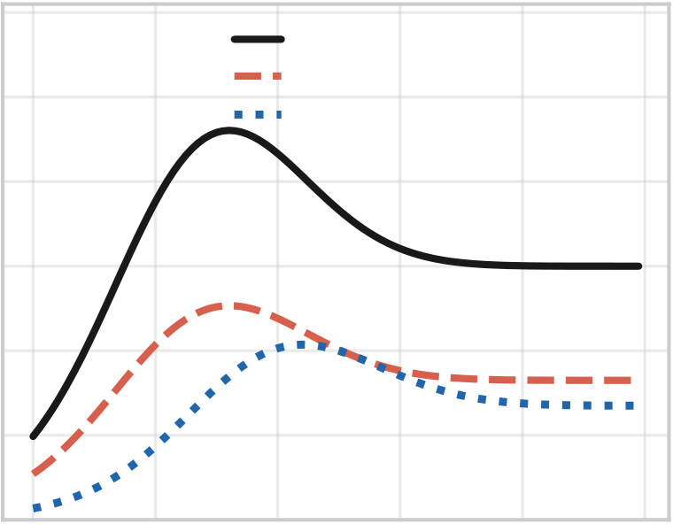
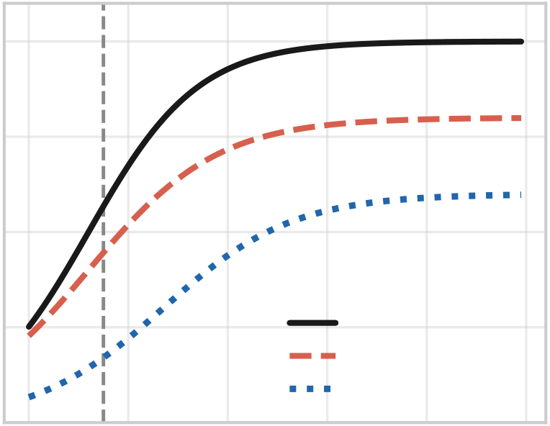
ReGainX: Adaptive Reinforcement Learning Exoskeletons
for Real-Time Mitigation of Parkinson’s Motor Impairments | A PREPRINT
Parkinsonian Motor Deficit Modeling
Muscle Activation (normalized) | 1.2 | 0 | 20 | Muscle Activation |  |  |  | Joint Angle (rad) | 2.0 | 0 | Joint Angle Trajectory
 |  |  |  | Healthy
 | 1.0 |  |  | Degeneration (α1 = 0.5,β= 0.3)
 |  |  |  | Combined PD
 | 0.8 |  |  | 40 | 60 | 80 | 100 |  | 1.5 |  | Healthy
 | 0.6 |  |  |  |  |  |  |  | 1.0
 | 0.4
 |  |  |  |  |  |  |  |  | 0.5
 | 0.2
 |  |  |  |  |  |  |  |  |  |  | Δi delay | Degeneration-only  Combined PD
 |  |  |  |  |  |  |  |  | 0.0
 | 0.0
 |  |  |  |  |  |  |  |  |  |  | 20 | 40 | 60 | 80 | 100
 |  |  |  | Timestep |  |  |  |  |  |  | Timestep
Figure 1:Parkinsonian motor-deficit model.Left:muscle activation is reduced by degeneration and further delayed under combined PD impairment.Right:joint-angle trajectories show reduced reach and delayed onset; the vertical dashed line marks the akinetic delay ∆i.
4 Methodology
4.1 Safety Design
The MyoSuite exoskeleton model incorporates an upper-arm attachment (0.101 kg) and a forearm attachment (0.111 kg), foracombinedsimulatedweightof0.212 kg—withinthe0.2–0.5 kgrangeidentifiedasfeasibleforpatientswith reducedarmstrength[PMC,2025a,b].Ahealthyelbowcontrollerevaluatedwiththeexoskeletonmassattached achieved perfect trajectory match, confirming the modelled weight does not interfere with voluntary movement.
Twoexplicitsafetyconstraintsareenforcedbytheenvironment.First,thejointangleishard-cappedat2.4 rad, the anatomically established upper limit of active elbow flexion [Cools et al., 2017].Second, exoskeleton torque is normalised to [0, 1] as a fraction of biological joint torque; the exoskeleton cannot deliver more torque than the joint’s own biological capacity.
4.2 Multi-Agent Training Framework
ReGainX implements a three-phase pipeline (Figure 2), sequentially developing a healthy musculoskeletal controller, a simulated PD patient, and an exoskeleton agent.The patient controller is frozen before exoskeleton training begins to prevent co-adaptation:if both agents trained simultaneously, the patient model could learn to move in unnatural patterns that inflate the reward—a failure that would not transfer to real patients whose movement patterns are not shaped by the device.ReGainX is designed so the exoskeleton adapts to the patient, not vice versa.
Phase | 1 | — | Healthy | Controller | Training. | A | musculoskeletal | elbow | controller | is | trained | on
myoElbowPose1D6MRandom-v0—ahealthy6-muscleelbowmodel—viaPPO[Raffinetal.,2021]for250 000 timesteps, with policy updates every 2 048 steps.The action space is the 6-dimensional neural drive signal.The reward is given each timestep, scaled to how much closer the joint moved toward the target angle.Both starting and target angles are drawn uniformly from [0, 2.4] rad per episode.
Phase2—Parkinson’sPatientControllerSetup. ThehealthycontrolleristransferredunchangedtothePD-impaired environment (Section 3).Joint position errors increase, targets are missed, and reduced peak force combined with slowed activation dynamics creates a realistic impaired profile.Randomising impairment parameters alongside startingandtargetanglesperepisodegenerates≈20 000distinctpatientprofiles—servingasasimulation-based
4

ReGainX: Adaptive Reinforcement Learning Exoskeletons
for Real-Time Mitigation of Parkinson’s Motor Impairments | A PREPRINT
ReGainX Three-Phase Training Pipeline
target = 2.0 rad
Phase 1: Healthy Controller | Phase 2: PD Patient (Frozen) | Phase 3: Exoskeleton Agent
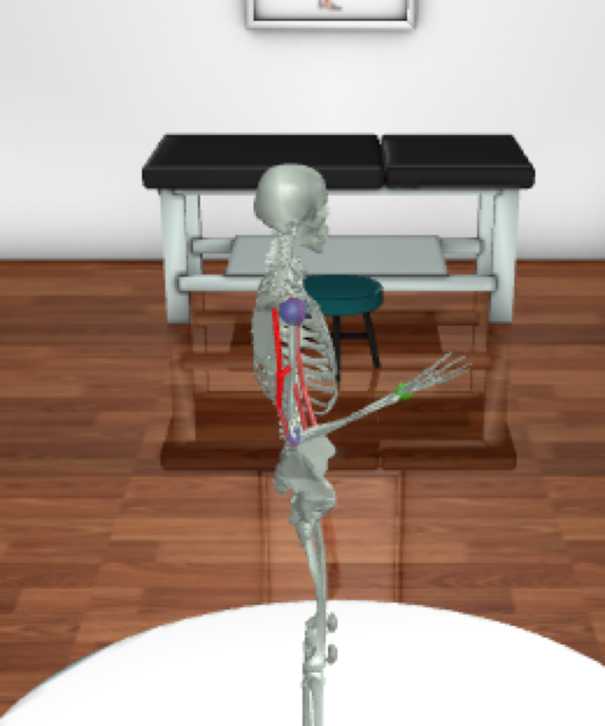 | 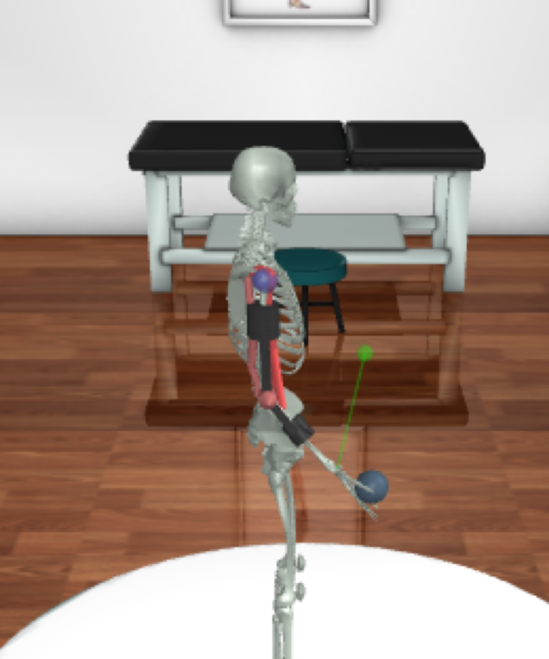 | 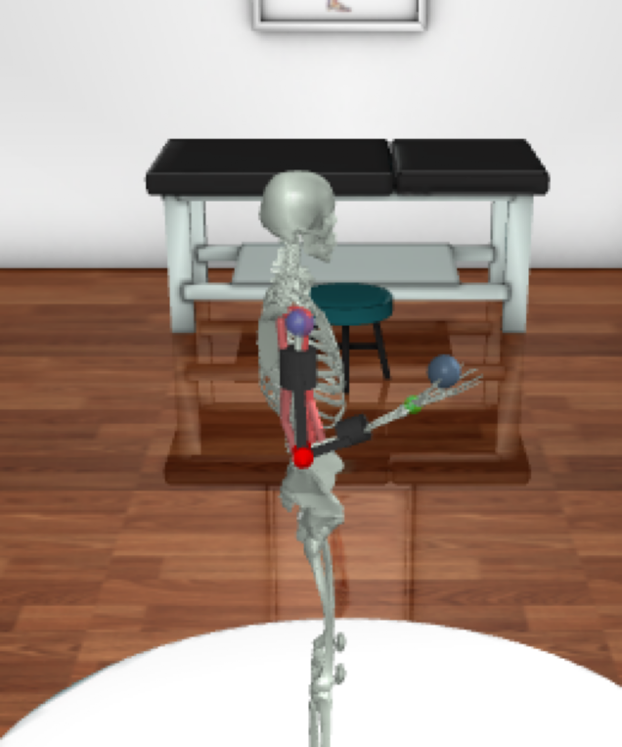
PPO trains the 6-muscle elbow | Healthy policy is frozen and run under | RecurrentPPO (LSTM) adds torque to the
(myoElbow, 250k steps). The healthy | bradykinesia and muscular degeneration. | frozen patient (2M steps, POMDP).
arm reaches the 2.0 rad target. | It stalls at 0.7 rad; the target is missed. | Assisted arm reaches the 2.0 rad target.
Figure 2:Three-phase ReGainX training pipeline, shown with MuJoCo/MyoSuite renders at a fixed 2.0 rad target. Phase 1:a PPO healthy controller (trained) drives the six elbow muscles and reaches the target.Phase 2:the same controller is frozen and run under combined bradykinesia and muscular degeneration, stalling well short of the target. Phase 3:a RecurrentPPO exoskeleton agent (trained) supplies assistive torque to the frozen patient, restoring movement to the target.The exoskeleton is trained under domain randomisation over ≈20 000 PD profiles.
alternative to real PD datasets,which are scarce [ResearchGate, 2023, arXiv, 2025].The controller is then frozen, representing a PD patient still attempting voluntary movement but unable to complete it.
Phase 3 — Exoskeleton Agent Training. With the PD controller frozen, the exoskeleton agent is initialised and trained for 2 000 000 timesteps using RecurrentPPO. Both agents act within the same environment each timestep.The exoskeleton agent receives an 8-dimensional observation and outputs a single normalised torque τexo∈[0, 1].
The observation space satisfies the Markov property:it consists of the 6 current muscle activations from the patient controller, the current joint angle q, and the current joint velocity˙q. Velocity encodes the rate of joint state change without requiring access to prior states.The target angle and starting angle are excluded:it is not feasible to input precise joint angles every millisecond in deployment, and it is impossible to extract the patient’s intended target from neural signals. Patient diversity is achieved through continuous domain randomisation of force_scale, activation_slowdown, and muscle fatigue fraction at each episode.
4.3 Policy Architecture
The exoskeleton policy is a RecurrentPPO [Raffin and Kanervisto, 2023], which augments the standard PPO actor-critic frameworkwithanLSTMlayerbetweentheobservationinputandthepolicyhead.Ateachtimestep,theLSTM maintains a cell state and hidden state carried forward across timesteps within an episode.At episode boundaries both states are reset, ensuring the policy re-initialises its temporal context for each new patient profile.
This formulates the control problem as a Partially Observable Markov Decision Process (POMDP): the observation deliberately excludes the user’s goal angle.The LSTM builds up evidence about the patient’s activation pattern over a movement, allowing the policy to infer the direction of intended movement and the degree to which impairment will prevent its completion.A feedforward policy acting only on the current observation cannot distinguish a progressively fatiguing patient from one at a stable impairment level.
A shorter rollout of nsteps=256 was used (vs. 2 048 in Phase 1) to produce more frequent LSTM state resets during training,amplifyingtheepisodeboundarysignalandboundingtruncatedbackpropagationthroughtimetoavoid vanishing gradients.
5

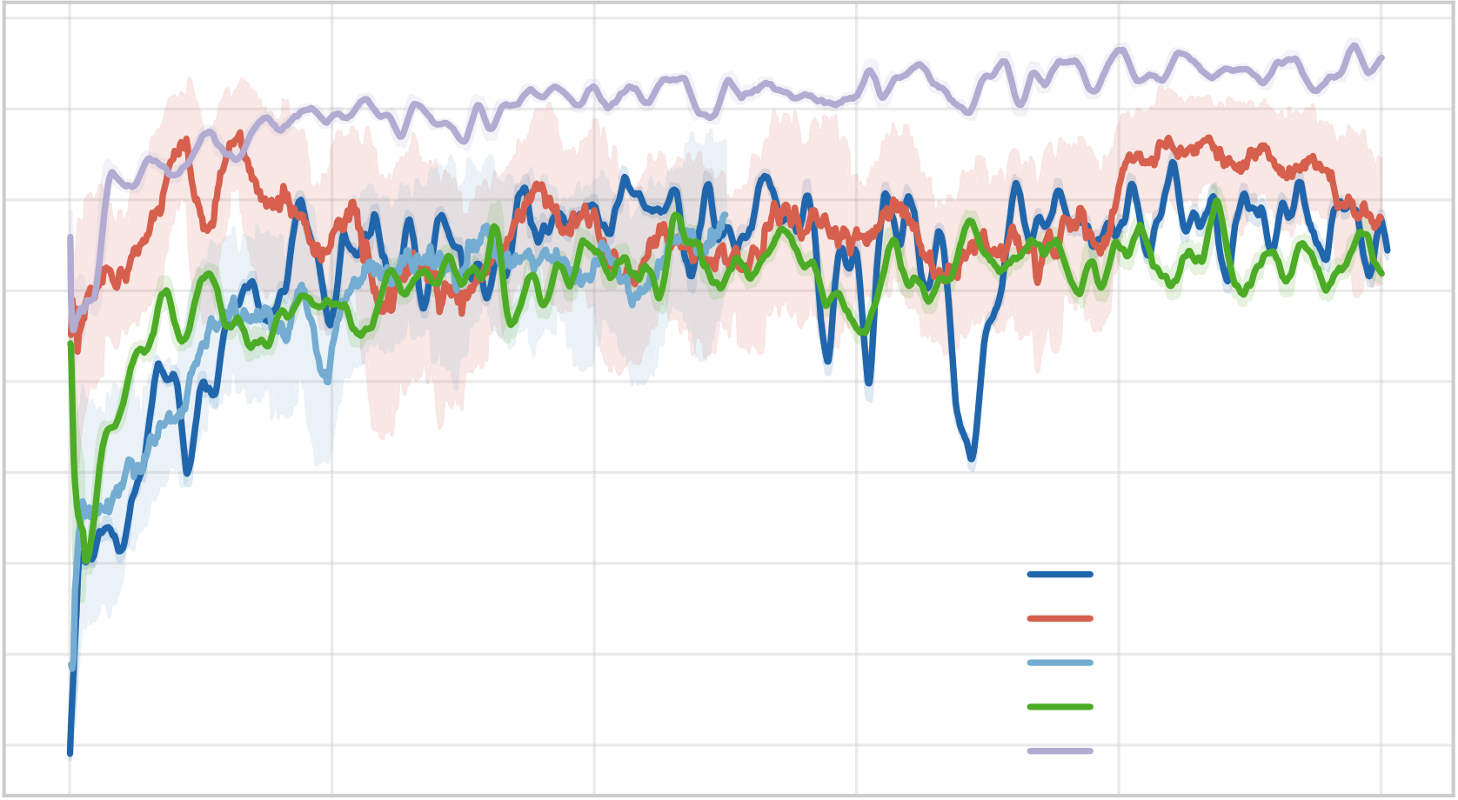
ReGainX: Adaptive Reinforcement Learning Exoskeletons
for Real-Time Mitigation of Parkinson’s Motor Impairments | A PREPRINT
Training Reward Curves
700
600
Mean Episodic Reward | 500 | RecurrentPPO brady+deg
 | 400
 | 300
 | 200
 | 100
RecurrentPPO deg-only 0 Noisy RecurrentPPO
MLP brady+deg
−100 | 0.0 | 0.2 | 0.4 | 0.6 | MLP deg-only | 1.0 | 1e6
 |  |  |  |  | 0.8
 |  |  | Training Timesteps
Figure 3:Training reward curves (rolling mean, window = 20, with ±1σ band).The RecurrentPPO brady+deg policy converges substantially more slowly than MLP policies, consistent with the higher sample complexity of learning a useful LSTM hidden state.
Table 1:Bayesian optimisation results.
Metric | MLP | RecurrentPPO
Completed / pruned trials | 13 / 7 | 11 / 9
Reward range | −62.88–546.37 | 27.67–377.07
Mean reward | 367.14 ± 190.40 | 143.91 ± 89.87
Best learning rate | 9.31 × 10−4 | 7.90 × 10−5
Best nsteps | 512 | 4096
Best batch size | 256 | 64
Best entropy coef | 0.01641 | 1.96 × 10−4
Best γ | 0.9986 | 0.9835
Best clip range | 0.2320 | 0.2320
Training reward curves for all policies are shown in Figure 3.
4.4 Hyperparameter Optimisation
Hyperparameters were selected through Bayesian optimisation using Optuna [Akiba et al., 2019] with a Tree-structured Parzen Estimator (TPE) sampler and a MedianPruner (5 startup trials, 2 warmup steps).Two studies were run—one for the MLP baseline and one for RecurrentPPO—each comprising 20 trials of 75 000 timesteps with a deterministic 10-episode evaluation to score each trial.The best configurations and study statistics are summarised in Table 1.
All training was conducted on a Lenovo PC with 16 GB RAM and GPU acceleration.
6

ReGainX: Adaptive Reinforcement Learning Exoskeletons
for Real-Time Mitigation of Parkinson’s Motor Impairments | A PREPRINT
Per-Step Inference Latency vs. Real-Time Budget
Brady+Deg MLP  Healthy MLP  Deg-only MLP  Brady+Deg Recurrent (Noisy)  Brady+Deg RecurrentPPO  Deg-only RecurrentPPO | (10 ms) (20 ms)  ntrol period ntrol period  Min exo co Max exo co  MLP Noisy RecurrentP PO
0.0 |  | 2.5 | 5.0 | 7.5 | 10.0 | 12.5 | 15.0 | 17.5 | 20.0
Mean Inference Latency (ms)
Figure4:Per-stepinferencelatency(mean±std)foreachpolicy.Verticallinesmarkthe10–20 msexoskeleton real-time control budget; all policies run well within budget.
Table 2:Inference latency across architectures (ms).
 | Model | Mean | Std | Min | p5 | p50 | p99 | Max
 | Healthy MLP | 1.267 | 0.405 | 0.840 | 0.896 | 1.090 | 2.414 | 2.799
 | Brady+Deg MLP | 1.017 | 0.302 | 0.807 | 0.827 | 0.902 | 2.412 | 2.704
 | Deg-only MLP | 1.056 | 0.335 | 0.808 | 0.832 | 0.913 | 2.252 | 3.275
 | Brady+Deg RecPPO | 1.930 | 0.560 | 1.448 | 1.488 | 1.686 | 3.714 | 5.310
 | Noisy RecPPO | 1.851 | 0.458 | 1.447 | 1.479 | 1.666 | 3.387 | 4.110
 | Deg-only RecPPO | 1.974 | 0.555 | 1.454 | 1.495 | 1.752 | 3.960 | 4.887
4.5 | Inference Latency
Inferencelatencywasmeasuredacrossalltrainedpolicyarchitecturesover1 000timedforwardpasses.Results areshowninFigure4andTable2.TheRecurrentPPOpolicyproducedameaninferencelatencyof1.930 ms (p99 = 3.714 ms, worst-case 5.310 ms)—well below the 10–20 ms control period of typical upper-limb exoskeleton platforms [Supriyono et al., 2025].
5 Experiments and Results
5.1 Evaluation Methodology
Each policy was evaluated on the same shared set of 4 000 episode configurations.Episodes were stratified across four severity quartiles (Q1 mild–Q4 severe) and four radian-travelled bins reflecting the actual distance the elbow moved during the episode:0.0–0.5 (39.2%), 0.5–1.0 (29.2%), 1.0–1.5 (20.6%), and 1.5+ rad (11.0%), with 250 episodes per pairing.For every episode, three tracks ran on identical configurations:a healthy elbow baseline, an impaired patient with no exoskeleton assistance, and the impaired patient with exoskeleton assistance.
7



ReGainX: Adaptive Reinforcement Learning Exoskeletons
for Real-Time Mitigation of Parkinson’s Motor Impairments | A PREPRINT
Trajectory Tracking (Pearson r): Angle × Severity
Target Angle Bin (rad) | 0.0–0.5 | Ours: RecurrentPPO |  |  |  | 0.0–0.5 | Baseline: RecurrentPPO (deg-only) |  |  |  |  | 1.0 | Mean Pearson r
 |  | (combined brady+deg) |  |  |  |  | current state-of-the-art
 |  | 0.49 0.38 0.31 0.31  0.73 0.58 0.42 0.38  0.79 0.63 0.53 0.43  0.83 0.68 0.59 0.57 |  |  |  |  | 0.39 0.22 0.14 0.11  0.63 0.40 0.22 0.06  0.74 0.59 0.45 0.43  0.80 0.67 0.59 0.56
 | 0.5–1.0 |  |  |  |  | 0.5–1.0 |  |  |  |  |  | 0.8
 |  |  |  |  |  |  |  |  |  |  |  | 0.6
 | 1.0–1.5 |  |  |  |  | 1.0–1.5 |  |  |  |  |  | 0.4
 | 1.5+ |  |  |  |  | 1.5+ |  |  |  |  |  | 0.2
 |  |  |  |  |  |  |  |  |  |  |  | 0.0
 |  | Q1 (Mild) | Q2 | Q3 | Q4 (Severe) |  | Q1 (Mild) | Q2 | Q3 | Q4 (Severe)
 |  | Severity Quartile |  |  |  |  | Severity Quartile
Figure 5:Mean Pearson r across target-angle bins (rows) and severity quartiles (columns) for our combined-trained RecurrentPPO (left) versus the degeneration-only policy that represents the current state of the art (right).Both degrade toward Q4 severe and toward small movements (short LSTM context window), but the combined-trained policy retains substantially higher correlation across the grid.
The primary metric is the Pearson correlation coefficient r between the exoskeleton-assisted trajectory and the healthy baseline trajectory over the episode.The healthy trajectory represents what the patient intended to do; PD breaks the link between intention and execution.r=1.0 means the assisted movement is indistinguishable from healthy movement; r=0 means no relationship; negative values indicate the assisted movement opposes the intended trajectory.
Goal achievement rate—the fraction of episodes in which the target angle was reached—is reported as a secondary metric.Mean episodic reward is reported for all policy comparisons.All policies were trained to maximise the same MyoSuite pose-error reward.
5.2 Movement Restoration Performance
The primary policy—RecurrentPPO trained on combined PD impairments—achieved r=0.494 (std = 0.317) and a goal rate of 88.8% across 4 000 stratified episodes.Relative to the no-exoskeleton baseline (r=0.223, goal rate = 65.1%), the exoskeleton improved trajectory match by 0.271 and goal achievement by 23.7 percentage points.Mean reward improved from 97.37 to 499.73.
Performance degraded predictably across severity quartiles:r=0.654 at Q1, 0.522 at Q2, 0.417 at Q3, and 0.384 at Q4, with goal rates of 99.8%, 95.4%, 83.7%, and 76.4% respectively—consistent with the exoskeleton’s normalised torque ceiling being insufficient to fully compensate at extreme impairment levels.
Performance also varied by radian travelled.Trajectory match was lowest for smallest movements (r=0.373, 0.0–0.5 rad bin, 39.2% of episodes) and highest for largest movements (r=0.667, 1.5+ rad, 11.0%).Larger movements give the LSTM more timesteps to accumulate temporal context, improving inference of intent and impairment severity.The 0.0–0.5 rad bin—the most common and hardest—therefore disproportionately shapes the mean metric.Figure 5 shows the full 4×4 performance heatmap.
5.3 Ablation 1:RecurrentPPO vs. MLP
RecurrentPPO achieved r=0.494 versus the MLP’s r=0.439 on the same 4 000 configurations, a gap of 0.055.Goal rates were close (88.8% vs. 89.0%), but RecurrentPPO produced higher mean reward (499.73 vs. 460.29, gap = 39.4)—indicating a smoother, more proportionate trajectory toward the goal rather than merely reaching the endpoint.The MLP stabilised at 512 timesteps; RecurrentPPO continued varying through the full run, reflecting higher sample complexity of learning a useful hidden state.Figure 6 compares the two architectures across severity quartiles:RecurrentPPO
8

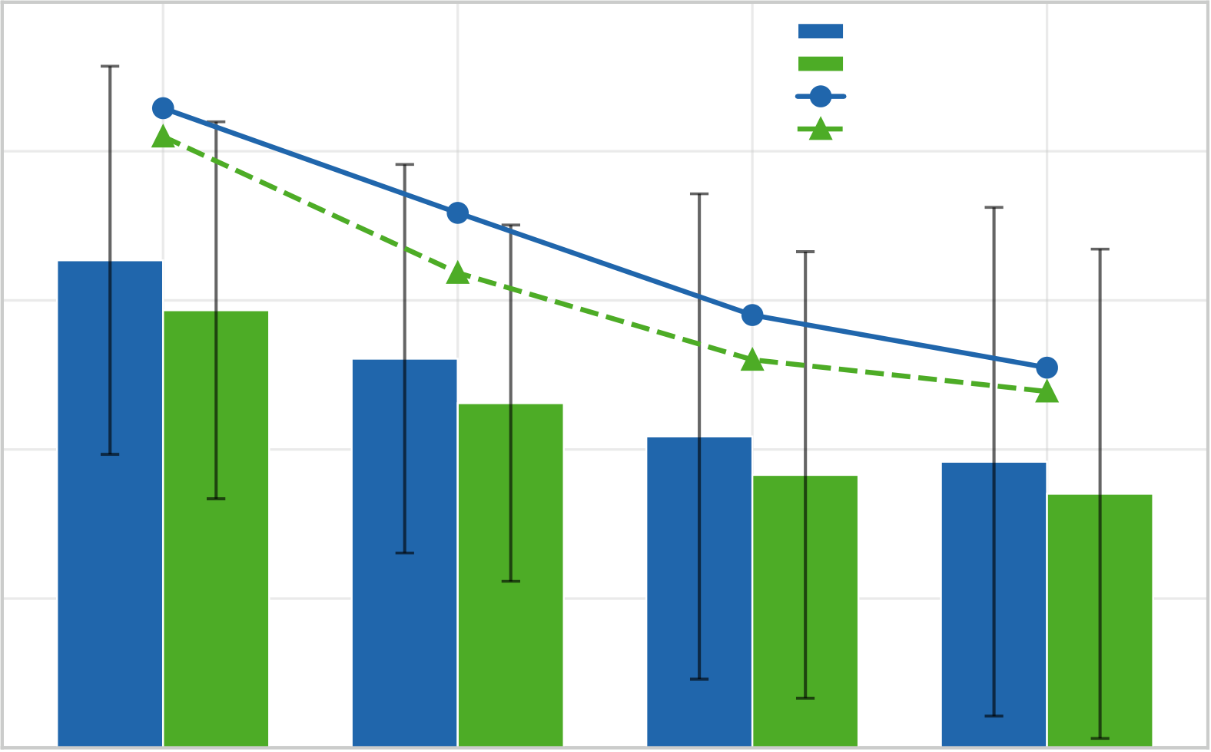
ReGainX: Adaptive Reinforcement Learning Exoskeletons
 | for Real-Time Mitigation of Parkinson’s Motor Impairments | A PREPRINT
1.0 | Ablation 1: RecurrentPPO vs. MLP across PD Severity | 700
 | RecurrentPPO brady+deg (r)
 | MLP brady+deg (r)
RecurrentPPO brady+deg (reward)
Mean Pearson r | 0.8 | MLP brady+deg (reward) | 600 | Mean Episodic Reward
 | 0.6 |  | 500
 | 0.4 |  | 400
 |  |  | 300
 |  |  | 200
0.2
100
0.0 | Q1 (Mild) | Q2 | Q3 | Q4 (Severe) | 0
Severity Quartile
Figure 6:Ablation 1:per-severity Pearson r (bars) and mean episodic reward (lines) for the RecurrentPPO brady+deg policy versus the MLP brady+deg baseline, evaluated on the full brady+deg environment.RecurrentPPO retains higher trajectory match and reward across all severity quartiles.
Table 3:Ablation 2:RecurrentPPO brady+deg vs. deg-only, evaluated on the full brady+deg environment.
Quartile | Pearson r |  | Mean Reward
 | brady+deg | deg-only | brady+deg | deg-only
Q1 mild | 0.654 | 0.570 | 643.35 | 493.78
Q2 | 0.522 | 0.399 | 538.03 | 185.56
Q3 | 0.417 | 0.276 | 435.25 | 39.86
Q4 severe | 0.384 | 0.211 | 382.30 | 9.26
Overall | 0.494 | 0.364 | 499.73 | 182.12
matches or exceeds the MLP in both trajectory match and reward at every quartile, with the gap widening at higher severity.
5.4 Ablation 2:Combined Impairment vs. Degeneration-Only Training
We claim that training on muscular degeneration alone produces a policy that fails under the full complexity of PD. Table 3 and Figure 7 test this directly.
Thedegeneration-onlyRecurrentPPOachievedr=0.364(std=0.404),agapof0.130fromthecombined-trained policy.Goalachievementfellfrom88.8%to78.9%.Mostcritically,atQ4severethedegeneration-onlypolicy collapsed tor=0.211 and a mean reward of9.26,compared tor=0.384 and382.30 for the combined policy.The degeneration-only policy’s standard deviation grows from 0.281 at Q1 to 0.446 at Q4, while the combined policy stays bounded (0.260–0.341).This pattern is consistent with the degeneration-only agent having never learned the temporal delay pattern of akinesia:when bradykinesia is mild the missing model matters little, but as intensity increases the agent’s inability to time torque corrections compounds, producing both lower mean performance and higher variance.
9

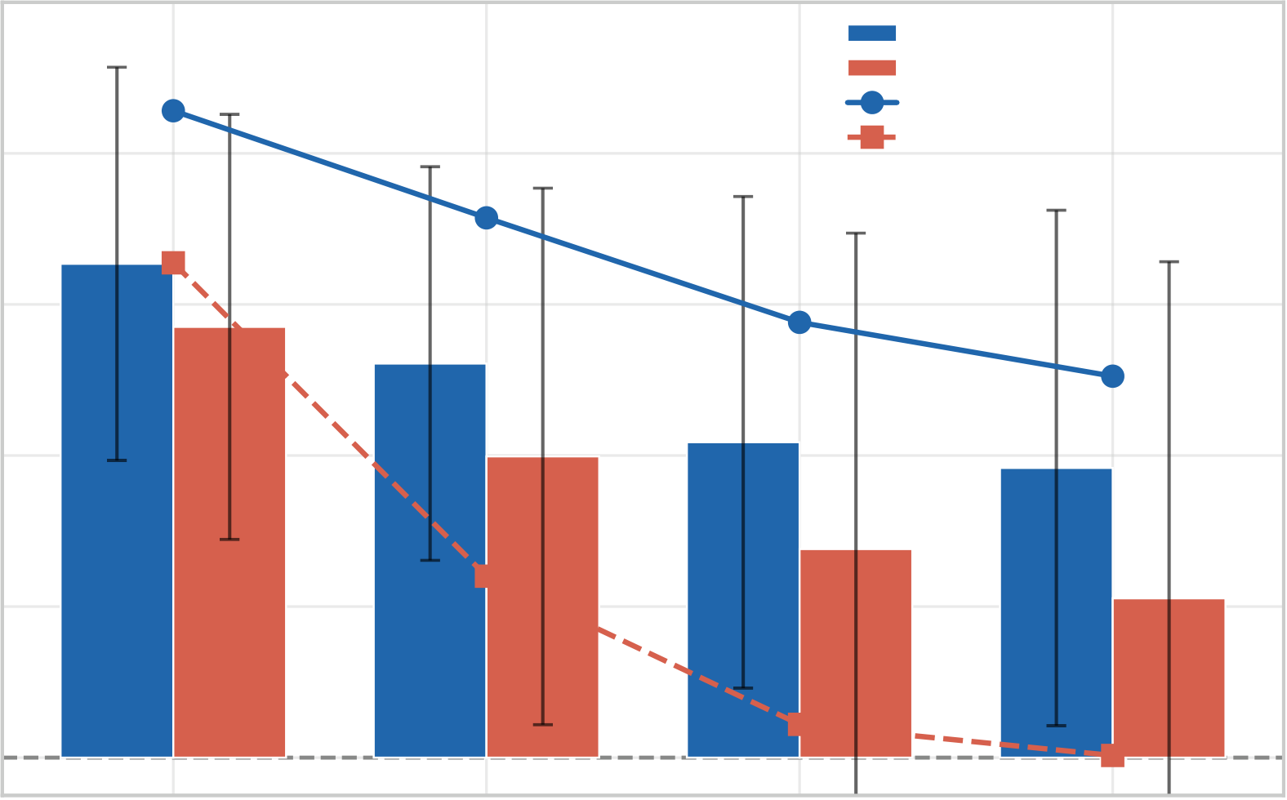
ReGainX: Adaptive Reinforcement Learning Exoskeletons
 | for Real-Time Mitigation of Parkinson’s Motor Impairments | A PREPRINT
1.0 | Ablation 2: Trajectory Tracking vs. PD Severity | 700
 | RecurrentPPO brady+deg (r)
 | RecurrentPPO deg-only (r)
RecurrentPPO brady+deg (reward)
Mean Pearson r | 0.8 | RecurrentPPO deg-only (reward) | 600 | Mean Episodic Reward
 | 0.6 |  | 500
 | 0.4 |  | 400
 |  |  | 300
 |  |  | 200
0.2
100
0.0 | No trajectory correlation | Q2 | Q3 | Q4 (Severe) | 0
 | Q1 (Mild)
Severity Quartile
Figure 7:Ablation 2:per-severity Pearson r (bars) and mean episodic reward (lines) for RecurrentPPO brady+deg vs. deg-only.At Q4 the degeneration-only policy’s mean reward collapses to 9.26 (vs. 382.30 for the combined policy), highlighting how it fails at severe bradykinesia.
For MLP architectures, the same comparison showed a negligible and reversed gap (r=0.439 brady+deg vs. r=0.443 deg-only).Thisnullresult,contrastedwiththe0.130RecurrentPPOgap,confirmsthatthebenefitofcombined-impairmenttrainingisconditionalonthepolicy’scapacitytoexploitit.TheLSTM’shiddenstateiswhatallows combined-impairment training to translate into combined-impairment competence.
Figure 8 shows performance broken down by radian travelled across all policies.
5.5 Ablation 3:Noise Robustness
RecurrentPPO was compared against a noise-trained variant across four noise levels (σ= 0.00, 0.01, 0.05, 0.10) injected into muscle activation observations only.The noise-trained policy was initially trained for 1 500 000 timesteps in a clean environment, then fine-tuned for a further 1 500 000 timesteps in a noisy environment with σ∼Uniform(0.01, 0.10) per episode.
Bothpoliciesmaintainedstrongtrajectorymatchacrossthefullnoiserange(Figure9).ThecleanRecurrentPPO declined by only ∆r=0.011 from σ=0.00 to σ=0.10.The noise-trained variant maintained slightly higher performance, thoughthegapissmall.TheseresultsdemonstratethattheLSTM’stemporalintegrationprovidesinherentnoise robustness—the recurrent hidden state effectively filters transient signal corruption.The tested range reflects realistic sEMG sensing conditions:literature establishes adequate sEMG SNR at ≥18 dB [PMC, 2025c].
5.6 Summary
Table 5 presents the full evaluation summary across all policies.
TheRecurrentPPOpolicytrainedoncombinedsymptomsachievesthehighesttrajectorymatchandreward.The degeneration-only RecurrentPPO performs worst of all exoskeleton policies on the full PD environment, confirming that temporal reasoning amplifies the consequences of training environment mismatch.
10

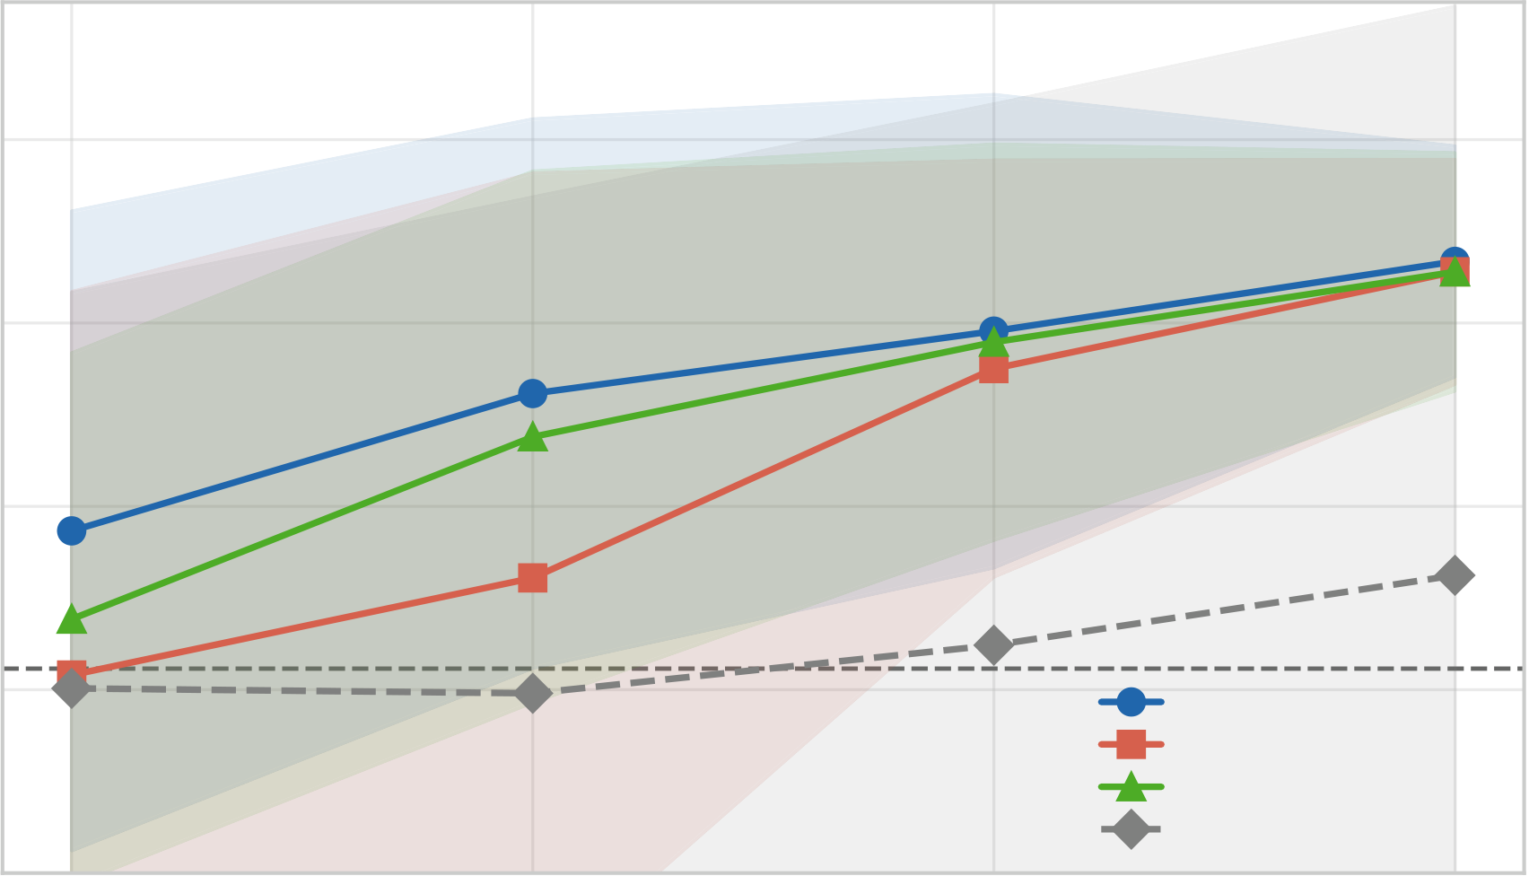
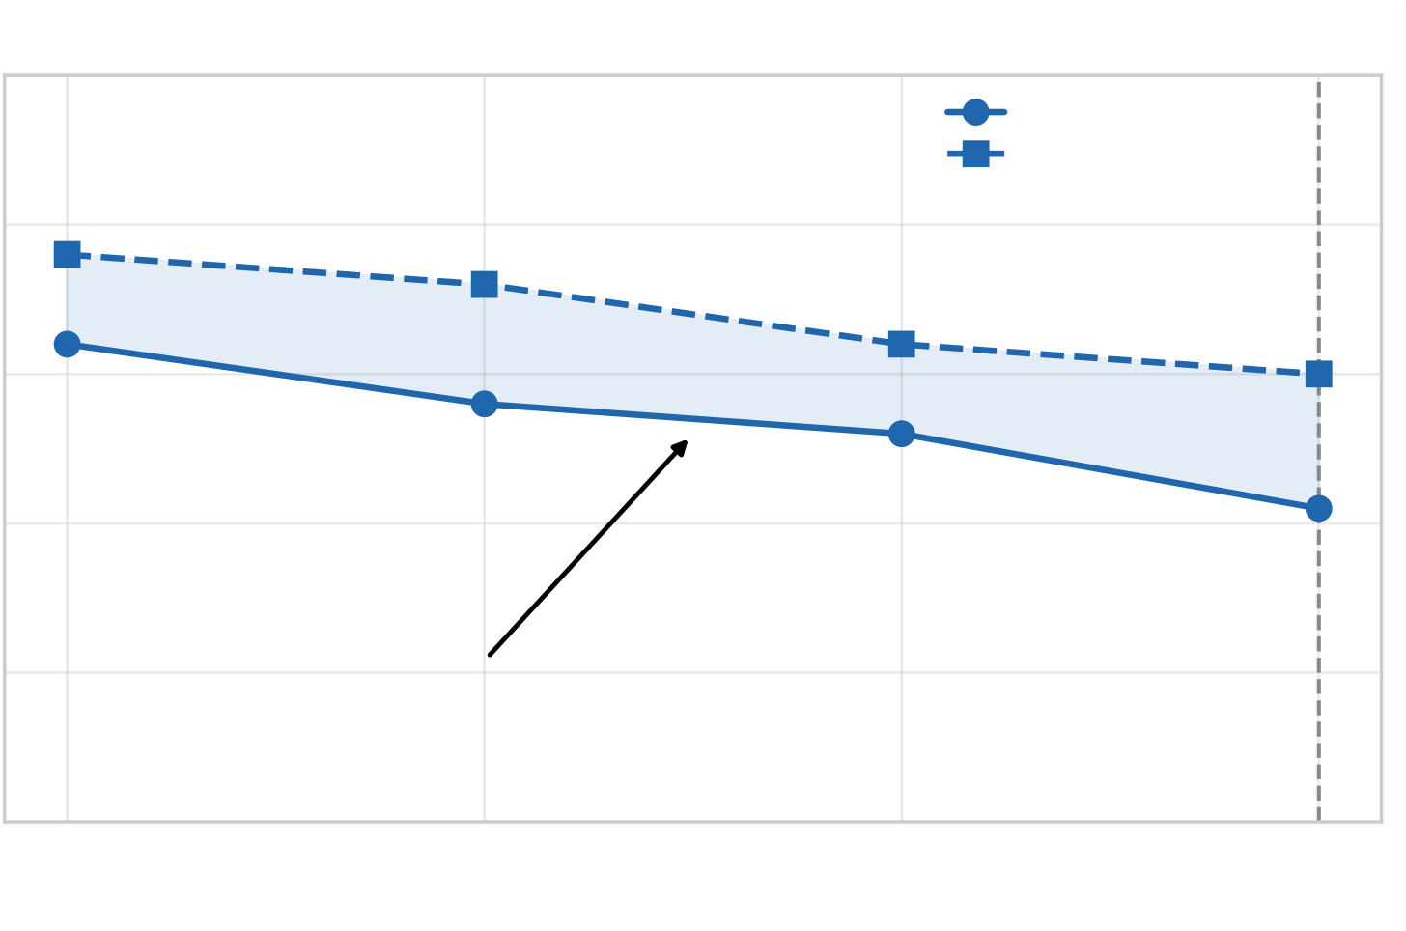
ReGainX: Adaptive Reinforcement Learning Exoskeletons
for Real-Time Mitigation of Parkinson’s Motor Impairments | A PREPRINT
Trajectory Tracking vs. Target Angle
0.8
Mean Pearson r | 0.6  0.4
No-exo overall (r = 0.223)
0.2 RecurrentPPO brady+deg RecurrentPPO deg-only MLP brady+deg No exoskeleton
0.0 | 0.0–0.5 | 0.5–1.0 | 1.0–1.5 | 1.5+
Target Angle Bin (rad)
Figure8:Trajectory-trackingPearsonrbyradian-travelledbinforfourpolicieswith±1σbands.TheLSTM accumulates temporal context over longer movements, improving performance at larger angles.Dashed line marks the no-exoskeleton overall baseline (r=0.223).
0.65 | Noise Robustness of the Exoskeleton Policy
Clean RecurrentPPO
Noisy-trained RecurrentPPO
0.64
Pearson r | 0.63 | 0.00 | Δr = 0.011 | Observation Noise σ | 0.05 | Max tested
 | 0.62
 | 0.61
 | 0.60 |  | 0.01 |  |  | 0.10
Figure 9:Noise robustness:clean vs. noisy-trained RecurrentPPO across observation noise σ.Performance degrades by only ∆r=0.011.
11

ReGainX: Adaptive Reinforcement Learning Exoskeletons
for Real-Time Mitigation of Parkinson’s Motor Impairments | A PREPRINT
Table 4:Noise robustness—Pearson r and goal rate.
 | Clean RecPPO |  | Noisy-trained RecPPO
σ | r | Goal | r | Goal
0.00 | 0.632 | 0.906 | 0.638 | 0.923
0.01 | 0.628 | 0.897 | 0.636 | 0.895
0.05 | 0.626 | 0.903 | 0.632 | 0.897
0.10 | 0.621 | 0.899 | 0.630 | 0.897
Table 5:Full evaluation summary (4 000 shared episodes, brady+deg environment).
Policy |  | Architecture |  | Pearson r | Goal Rate | Mean Reward
No exoskeleton |  | — |  | 0.223 | 0.651 | 97.37
policy_deg |  | MLP |  | 0.443 | 0.805 | 319.07
policy_brady_deg |  | MLP |  | 0.439 | 0.890 | 460.29
policy_deg_recurrent |  | RecPPO |  | 0.364 | 0.789 | 182.12
policy_brady_deg_recurrent |  |  | RecPPO | 0.494 | 0.888 | 499.73
policy_noisy_recurrent |  | RecPPO |  | 0.475 | 0.892 | 488.67
6 | Discussion
Interpretingresultsacrossseverity. |  | TheRecurrentPPOpolicyachievedr=0.494and88.8%goalrateacross
stratified episodes covering mild (Q1, r=0.654) to severe (Q4, r=0.384) presentations.The monotonic degradation with severity confirms the policy is being tested across the full clinical range.For a progressive disease, cross-severity generalisation without recalibration is more clinically meaningful than peak accuracy on a single calibrated patient. This matters because accessibility and adaptability—not sensor precision—are the documented barriers to adoption: over 90% of PD patients express interest in wearable technology, yet only 8% have used a medical device [Hirczy et al., 2024, PMC, 2024].
Environment design as the mechanismof generalisability. The central resultis what the ablation reveals:the degeneration-only and combined-trained RecurrentPPO are architecturally identical, differing only in their training environment.AtQ4severe,thedegeneration-onlypolicyachievesr=0.211andreward9.26,whilethecombined policy achieves r=0.384 and reward 382.30.This isolates the training environment as the critical variable.The same three-phase framework is disease-agnostic:replacing the bradykinesia and degeneration equations with pathological models for ALS, muscular dystrophy, or post-stroke spasticity would apply it to an entirely different clinical population.
6.1 Limitations
Thisevaluationisentirelysimulation-based—norealPDpatientswereinvolvedandnophysicalexoskeletonwas constructed.Sim-to-realtransferformusculoskeletalcontrollersremainsanopenchallenge[Luoetal.,2025]; potential gaps in muscle dynamics, sensor noise profiles, and body variability cannot be fully characterised without clinical validation.However, MyoSuite was developed with validated Hill-model dynamics and in collaboration with musculoskeletal researchers, reducing but not eliminating this gap [Caggiano et al., 2022].The system addresses only the elbow joint, while PD can affect gait, posture, handwriting, and full-body coordination; the elbow remains the most underrepresented joint in PD-specific research [Capato et al., 2023].Finally, while the torque ceiling proved sufficient acrossthetestedseverityrange,late-stagepatientsatQ4maybenefitfromadditionaltorquecapacityorextended training.
6.2 Future Work
The immediate next step is physical exoskeleton construction and clinical validation with real PD patients, using the cloud pipeline confirmed viable at 1.930 ms mean inference latency.The three-phase framework can be extended to hip, knee, and ankle joints for PD gait impairment, or adapted to other neurological conditions.RLHF-based fine-tuning using patient preference feedback on the timing and feel of assistance would allow post-deployment personalisation without recalibration [Endrei et al., 2025].Finally, the monotonic relationship between severity and the policy’s reward output—from 643.35 at Q1 to 382.30 at Q4—suggests that exoskeleton torque demand could serve as a continuous
12

ReGainX: Adaptive Reinforcement Learning Exoskeletons
for Real-Time Mitigation of Parkinson’s Motor Impairments | A PREPRINT
proxy for PD severity, enabling passive longitudinal monitoring of disease progression through daily device use without formal UPDRS examination.
7 Conclusion
Thispaperaskedwhetherdeepreinforcementlearningcanproduceanautonomouselbowexoskeletoncontroller thatprovidesreal-time,adaptivemitigationofParkinson’smotorimpairmentsacrossdiversepatients.Threecore outcomes characterise our answer.The RecurrentPPO policy trained on combined PD symptoms achieved r=0.494 and 88.8% goal achievement across 4 000 stratified episodes spanning the full PD severity spectrum, without recalibration between patients.Inference latency was 1.930 ms mean across 1 000 timed forward passes—well below the control period of typical upper-limb exoskeleton platforms—confirming viability for real-time deployment on lightweight hardware.Most critically, the ablation study isolates the training environment as the mechanism of generalisability:a degeneration-only RecurrentPPO—representative of the current state-of-the-art approach of training exoskeletons on muscle weakness alone—collapsed to r=0.211 and reward 9.26 at the most severe patients, compared to r=0.384 and 382.30 for the combined PD-trained policy at the same severity.This collapse, produced by architecturally identical policies, shows that what the controller is trained on matters more than how it is built.
ReGainX demonstrates that multi-agent RL training environments tailored to the full complexity of disease pathology can produce exoskeleton policies that generalise across patients without per-session calibration.The novel three-phase framework—healthy controller training, combined PD impairment simulation, and frozen-patient exoskeleton training—is disease-agnostic and computationally tractable on consumer hardware, establishing a feasible and scalable blueprint for future ML-based assistive devices in progressive, complex neurological disease.
References
Agostino, R. et al. (2015). Integrated robotics platform:41% slower speed, 29% shorter displacement off-medication. PMC, 6815040.
Akiba,T.,Sano,S.,Yanase,T.,Ohta,T.,andKoyama,M.(2019).Optuna:Anext-generationhyperparameter optimization framework. In Proceedings of the 25th ACM SIGKDD.
Caggiano, V., Wang, H., Durandau, G., Sartori, M., and Kumar, V. (2022). MyoSuite:A contact-rich simulation suite for musculoskeletal motor control. In Proceedings of Machine Learning Research.

Caligiuri, M.P. et al. (2018). Quantitative assessment of upper limb functional impairments in PD. Gait & Posture, 60, 80–85.
Capato, T.T.C. et al. (2023). Clinical assessment of upper limb impairments and functional capacity in Parkinson’s disease:a systematic review. Arquivos de Neuro-Psiquiatria.
Chaudhuri,K.R.etal.(2025).UnderstandingParkinson’sdisease: currenttrends.FrontiersinAgingNeu- roscience.

Cools,A.M. et al. (2017). Normative values and affecting factors for the elbow range of motion. Sports Medicine.
DallaGasperina,S.etal.(2021).Reviewonpatient-cooperativecontrolstrategiesforupper-limbrehabilitation exoskeletons. Frontiers in Robotics and AI.
Durandau,G. et al. (2019). Neuromusculoskeletal controller for exoskeleton assistance. Referenced via MyoSuite documentation [Caggiano et al., 2022].
Endrei,T.etal.(2025).Learningtosuppresstremors:aDRL-enabledsoftexoskeletonforParkinson’spatients. Frontiers in Robotics and AI.

Fortunati, M. et al. (2024). Lower-limb exoskeletons for gait training in Parkinson’s disease:state of the art. Healthcare.
Hart,N.etal.(2023).PrevalenceofsarcopeniainParkinson’sdisease:systematicreview.NeurologicalSciences.
Hirczy, S. et al. (2024). The current state of wearable device use in Parkinson’s disease:a survey.
13

ReGainX: Adaptive Reinforcement Learning Exoskeletons
for Real-Time Mitigation of Parkinson’s Motor Impairments | A PREPRINT
Ingram,L.A.etal.(2021).QuantifyingupperlimbmotorimpairmentinpeoplewithParkinson’sdisease.PeerJ.
Luo, S. et al. (2023). Robust walking control of a lower limb rehabilitation exoskeleton via DRL. Journal of NeuroEngi- neering and Rehabilitation. Luo, S. et al. (2024). Experiment-free exoskeleton assistance via learning in simulation. Nature.
Luo, S. et al. (2025). Robust neural network controller for a lower limb exoskeleton with minimal sensors. Journal of Neu- roEngineering and Rehabilitation. Supriyono,Dragusanu,andMalvezzi(2025).Acomprehensivereviewofelbowexoskeletons.Sensors.
Morrey,B.F.etal.(1981).Functionalrangeofmotionoftheelbow.JournalofBoneandJointSurgery.
PMC (2022). Myoelectric control systems for upper limb wearable robotic exoskeletons. Sensors.
Parkinson’s Foundation (2026). $82.2 billion economic burden.
Reicherzer,L.etal.(2024).Barriersandfacilitatorstotheuseofwearablerobotsasassistivedevices.
PMC(2025).LSTM-enabledEMG-controlledupperarmexoskeleton.
Carnevale, A. et al. (2025). Portable exoskeletons for upper limb rehabilitation:a systematic review.
PMC (2021). An ultra-low power surface EMG sensor for wearable applications.
Ponsoni, A. et al. (2023). Prevalence of sarcopenia in PD: meta-analysis.
Raethjen, J. et al. (2018). Quantitative analysis of bradykinesia and rigidity in PD.
Raffin, A. et al. (2021). Stable-Baselines3:Reliable reinforcement learning implementations. JMLR.
Raffin, A. and Kanervisto, A. (2023). SB3-Contrib:Experimental RL code for Stable Baselines3.
Ramesh,V.andBilal,E.(2022).DetectingmotorsymptomfluctuationsinParkinson’sdiseasewithgenerative adversarial networks. npj Digital Medicine. ResearchGate discussion (2023). How can I find a dataset of pathological EMG signals?
arXiv (2025). AI-enabled detection and assessment of PD using multimodal data:a survey.
Siciliano, M. et al. (2024). Fatigue in Parkinson’s disease:pooled prevalence ≈50%.
Supriyono,Dragusanu,M.,andMalvezzi,M.(2025).Acomprehensivereviewofelbowexoskeletons:classifica- tion by structure, actuation, and sensing technologies. Sensors.
Wang, H., Caggiano, V. et al. (2022). MyoSim:Fast and physiologically realistic MuJoCo models for musculoskeletal and exoskeletal studies. In IEEE ICRA. Zajac, F.E. (1989). Muscle and tendon:properties, models, scaling, and application to biomechanics and motor control.
Critical Reviews in Biomedical Engineering, 17(4), 359–411.
14

