Aidan Chin Problem Set 2 ECE522 Spring25

these are the queries that I used, it also shows that Condition 1 is satisfiable while Condition 2 is not

because condition 2 was not satisfied we can just ignore it and do condition 1

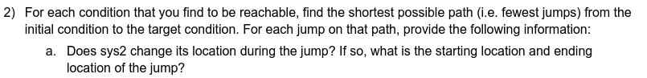
in our simulation we find that there are 3 jumps,
jump 1 sys2 goes from f to g and sys1 stays at same node,
jump 2 has sys1 going from A to B and sys2 stays,
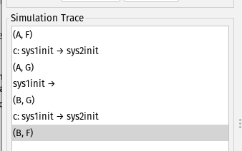
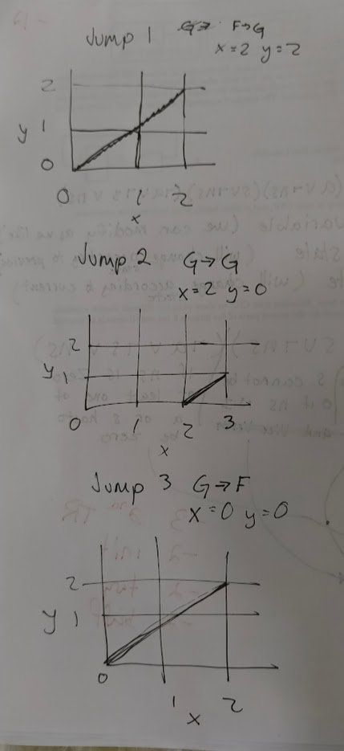
jump 3 we have sys2 going from G to F and sys1 stays

