**Bugzilla**

Bugzilla is an open-source issue/bug tracking system that allows developers effectively to keep track of outstanding problems with their product.

This open bug-tracker enables users to stay connected with their clients or employees, to communicate about problems effectively throughout the data-management chain.

Key features of Bugzilla includes:

* Advanced search capabilities
* E-mail Notifications
* Modify/file Bugs by e-mail
* Time tracking
* Strong security
* Customization
* Localization

**How to log-in to Bugzilla**

Step 1)

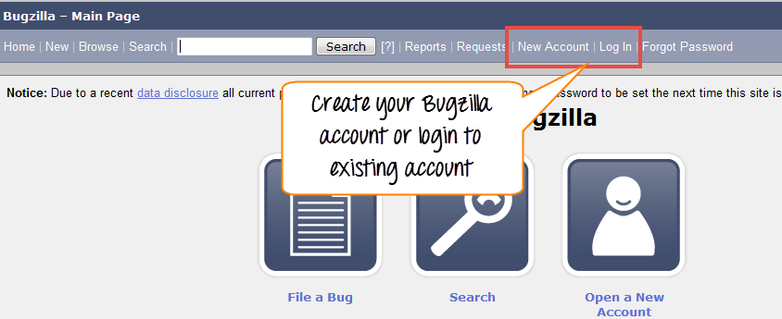Use the following link for your handons. To create an account in Bugzilla or to login into the existing account go to New Account or Log in option in the main menu.

Step 2)

Now, enter your personal details to log into Bugzilla

* User ID
* Password
* 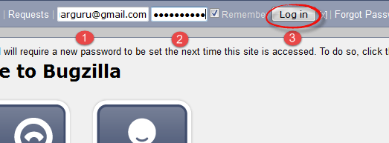And then click on "Log in"

Step 3)

You are successfully logged into Bugzilla system.

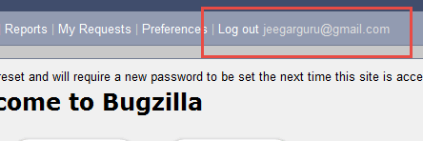

**Creating a Bug-report in Bugzilla**

Step 1)

To create a new bug in Bugzilla, visit the home-page of Bugzilla and click on NEW tab from the main menu.

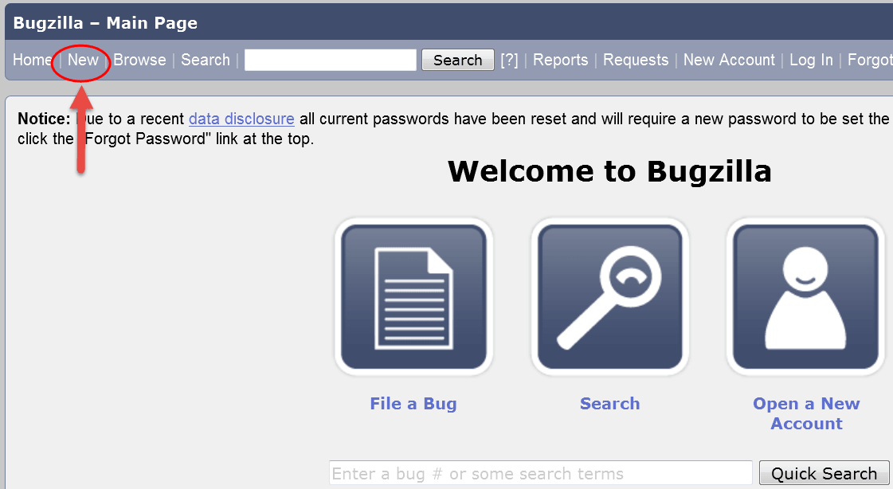

Step 2)

In the next window,

* Enter Product
* Enter Component
* Give Component description
* Select version,
* Select severity
* Select Hardware
* Select OS
* Enter Summary
* Enter Description
* Attach Attachment
* Submit

NOTE: The above fields will vary as per your customization of Bugzilla.

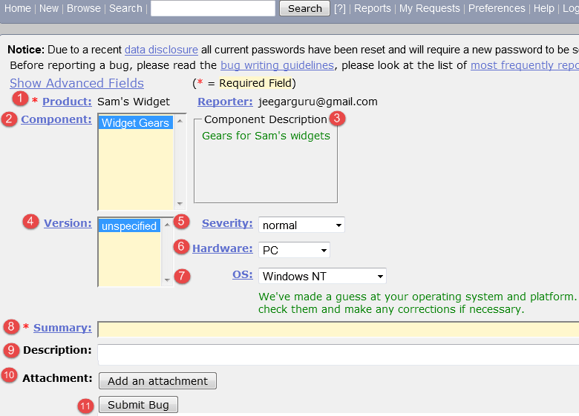

NOTE: The mandatory fields are marked with *.

In our case following fields are mandatory

* Summary
* Description

If you do not fill them you will get a screen like below,

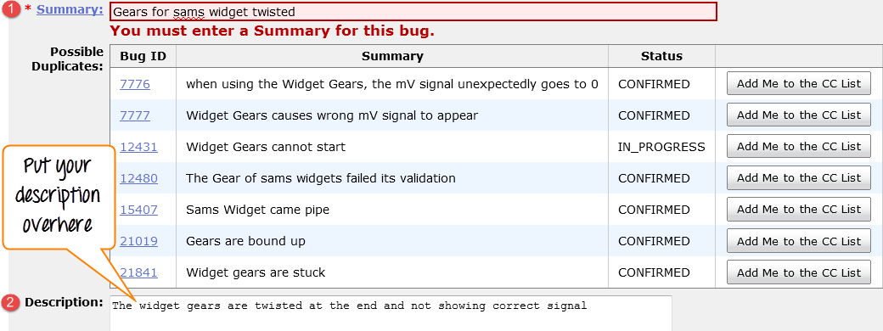

Step 4)

Bug is created ID# 26320 is assigned to our Bug. You can also add additional information to the assigned bug like URL, keywords, whiteboard, tags, etc. This extra-information is helpful to give more detail about the Bug you have created.

* Large text box
* URL
* Whiteboard
* Keywords
* Tags
* Depends on
* Blocks
* Attachments

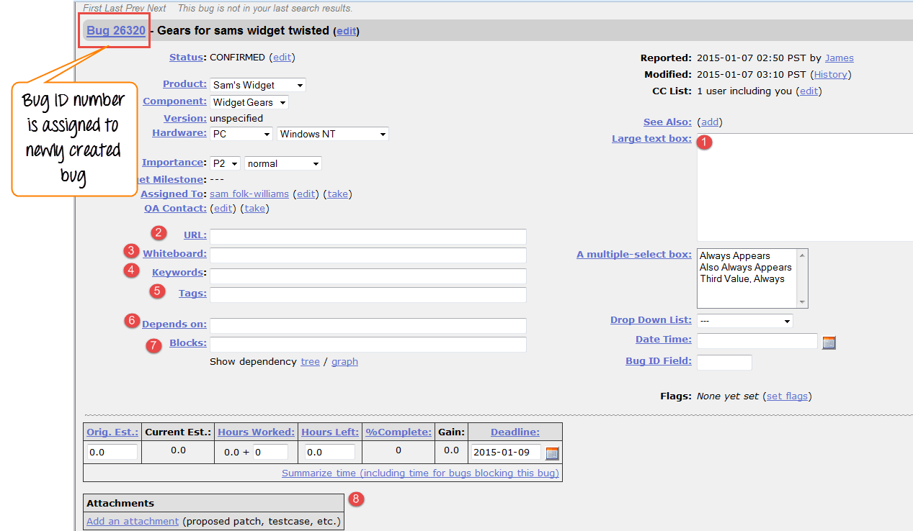

Step 5)

In the same window if you scroll down further. You can select deadline date and also status of the bug. Deadline in Bugzilla usually gives the time-limit to resolve the bug in given time frame.

