**Batch: T2**

**Asssignment No: 1**

**Title of Assignment: Installation, Configuration and Testing of MySQL**

**Student Name: Shreeyash Shripad Dongarkar**

**Student PRN: 22510025**

**Installation Steps**

1. Download MySQL Installer and Run the Installer
2. Choose setup type ( We can select Custom to manually select components )

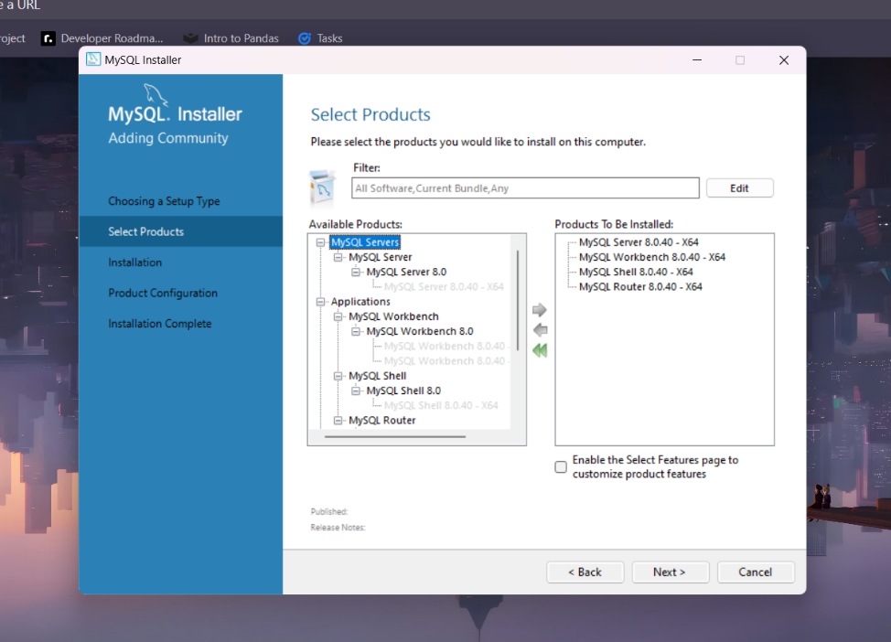

1. Install the selected components

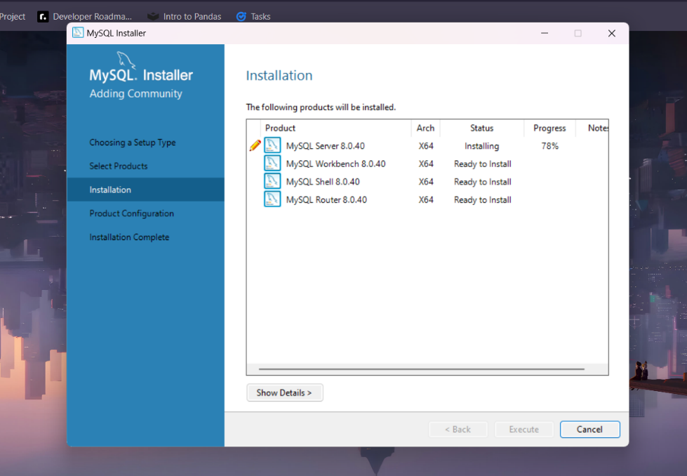

1. Configure types and networking

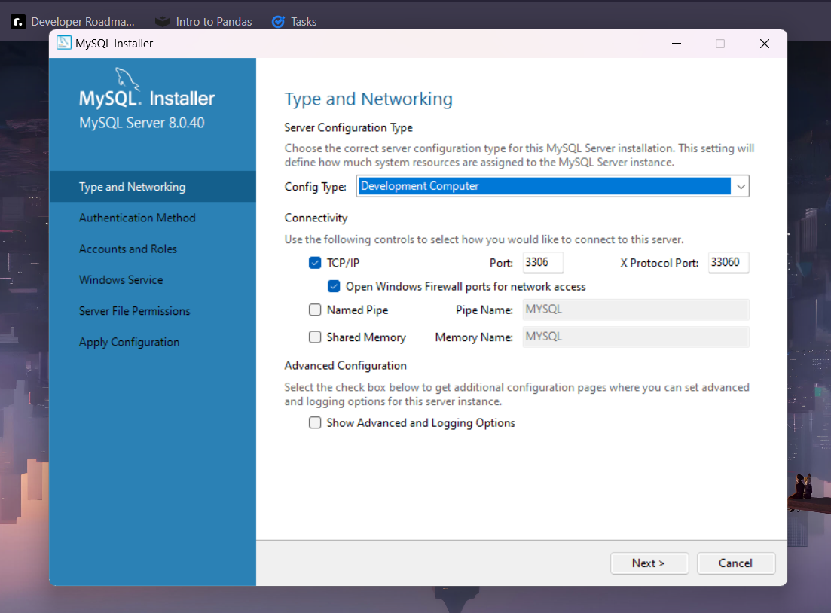

1. Apply configuration and finish installation.

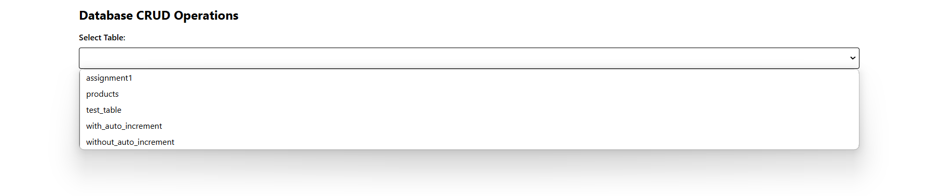

Creating record directly as ID is set auto_increment

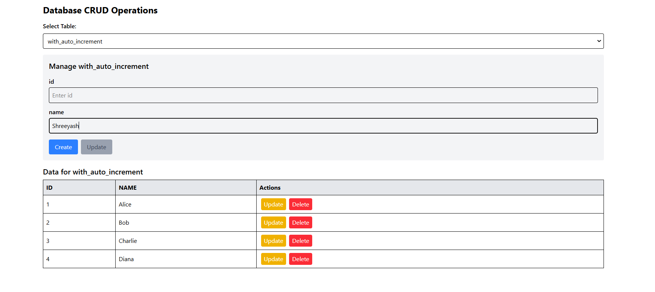

Clicking on update populates values in form

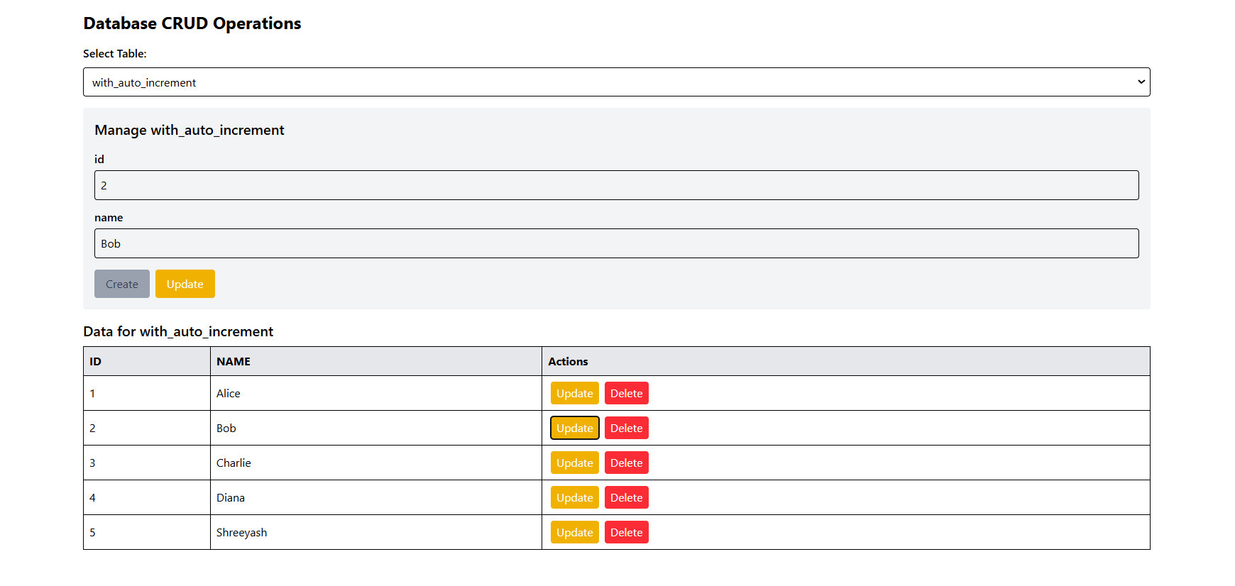

After Update

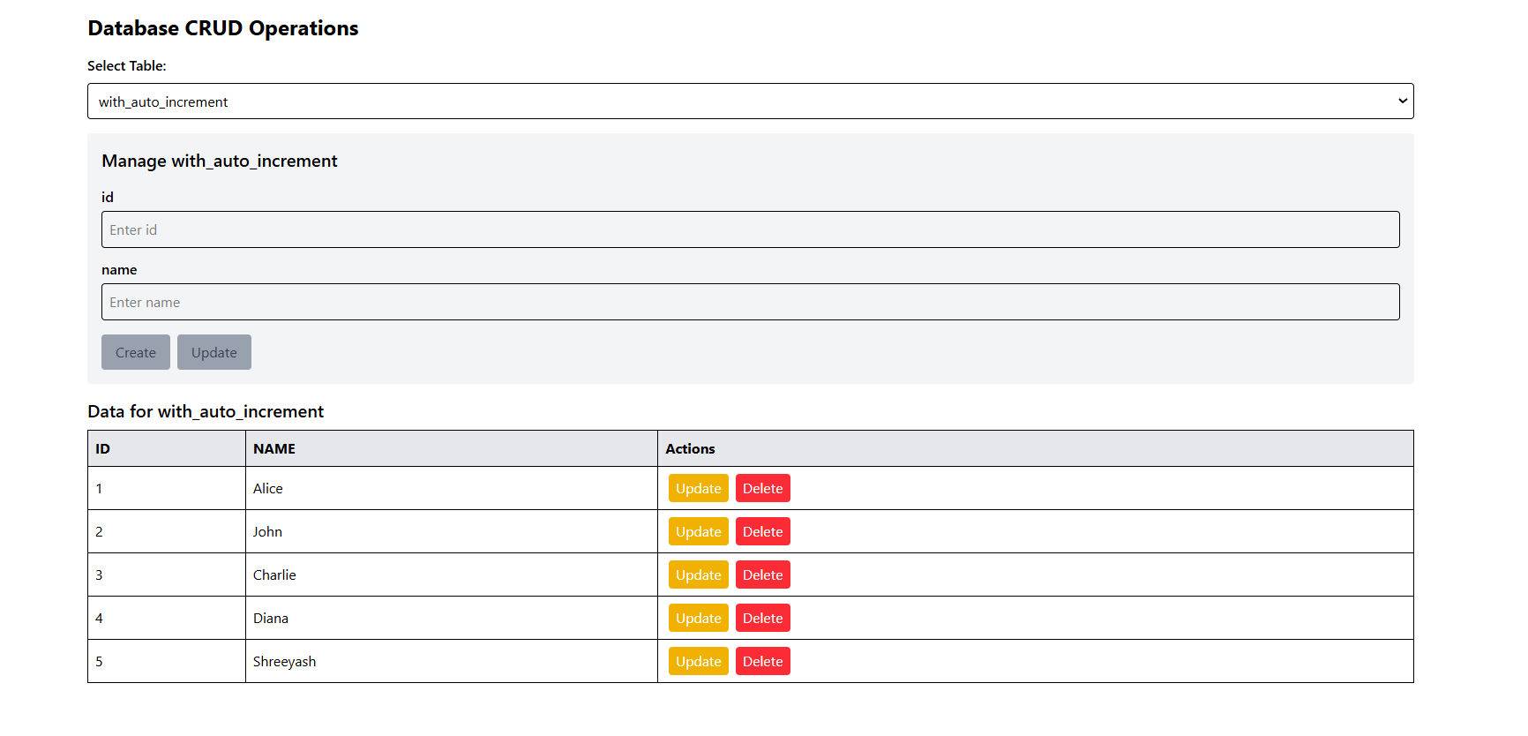

Need to provide ID as constraint is not set to auto_increment

