**Batch: T2**

**Asssignment No: 2**

**Title of Assignment: PSM and Object Relation Databases**

**Student Name: Shreeyash Shripad Dongarkar**

**Student PRN: 22510025**

**PSM Review**

1. After inserting 50 records into table

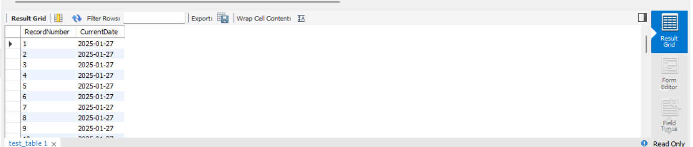

1. Before using procedure

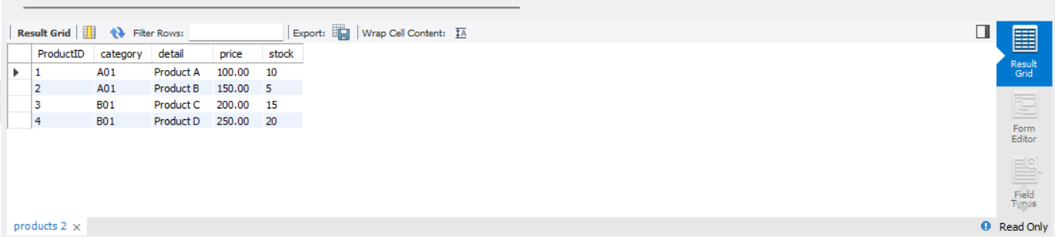

After using procedure

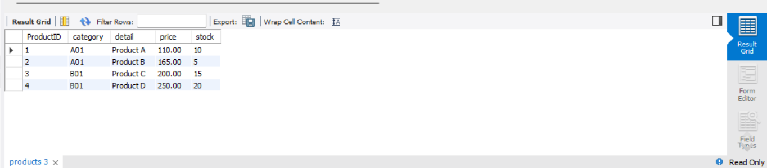

**Object Relational Database**

1. Working of member function countOfWords for different words

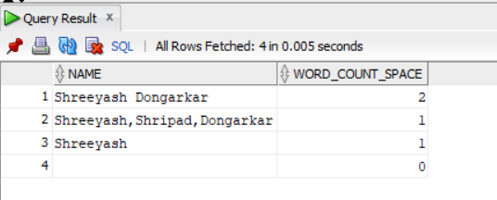

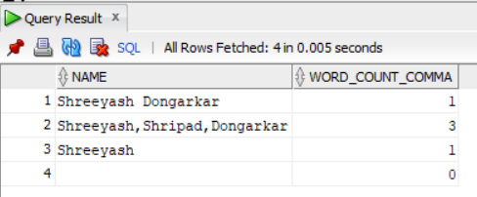

1. Returning address based on keyword

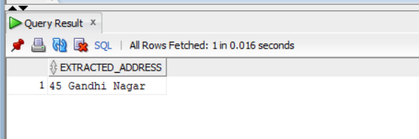

Returning no. of words for each record for each field

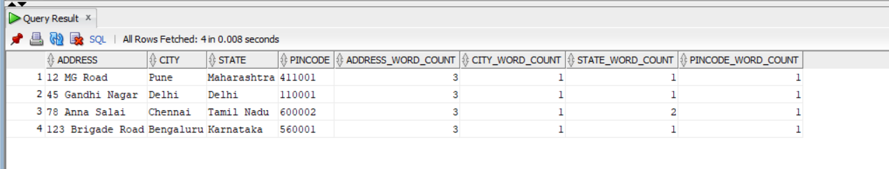

1. Inserting into table with type courseType

