**Batch: T2**

**Assignment No: 4**

**Title of Assignment: Online MCQ Exam Platform**

**Student Name: Shreeyash Shripad Dongarkar**

**Student PRN: 22510025**

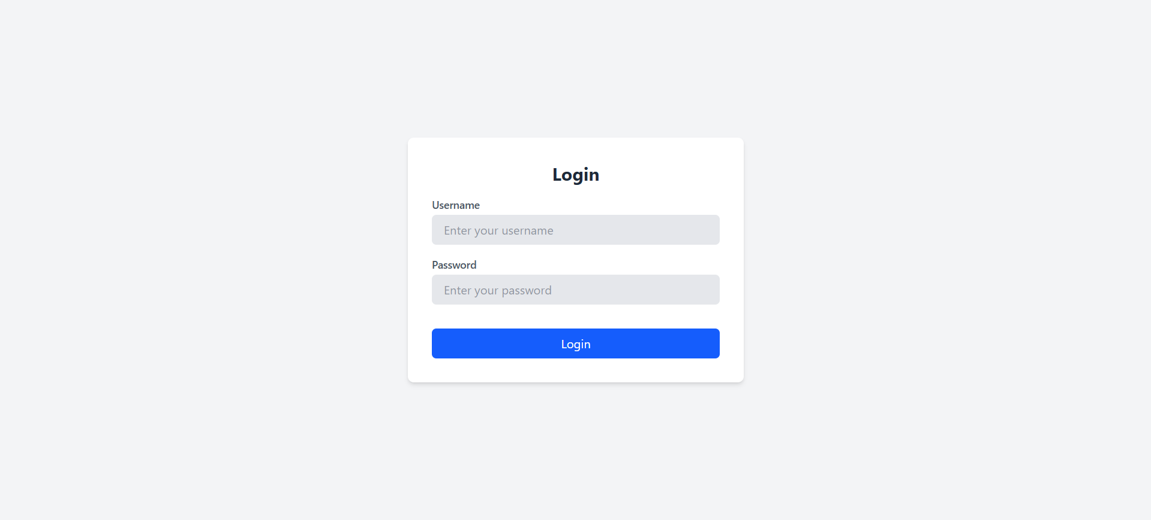

**Role: Teacher**

Exams Dashboard

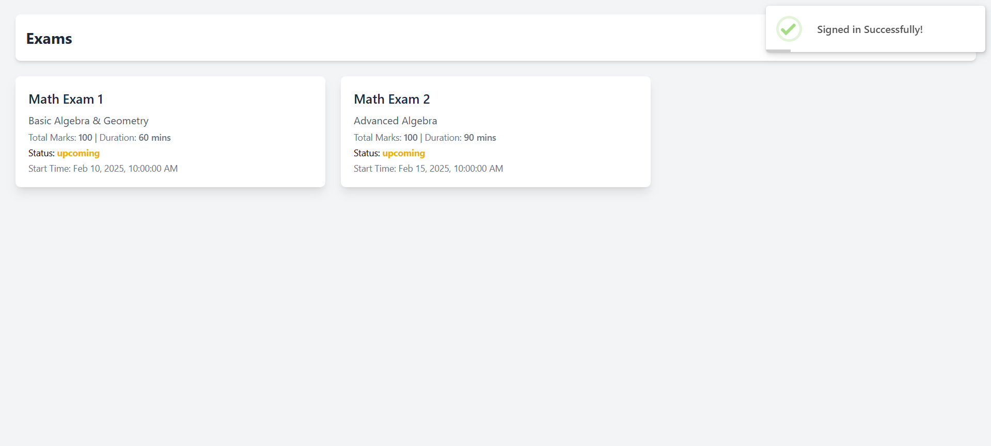

Exam Information Edit

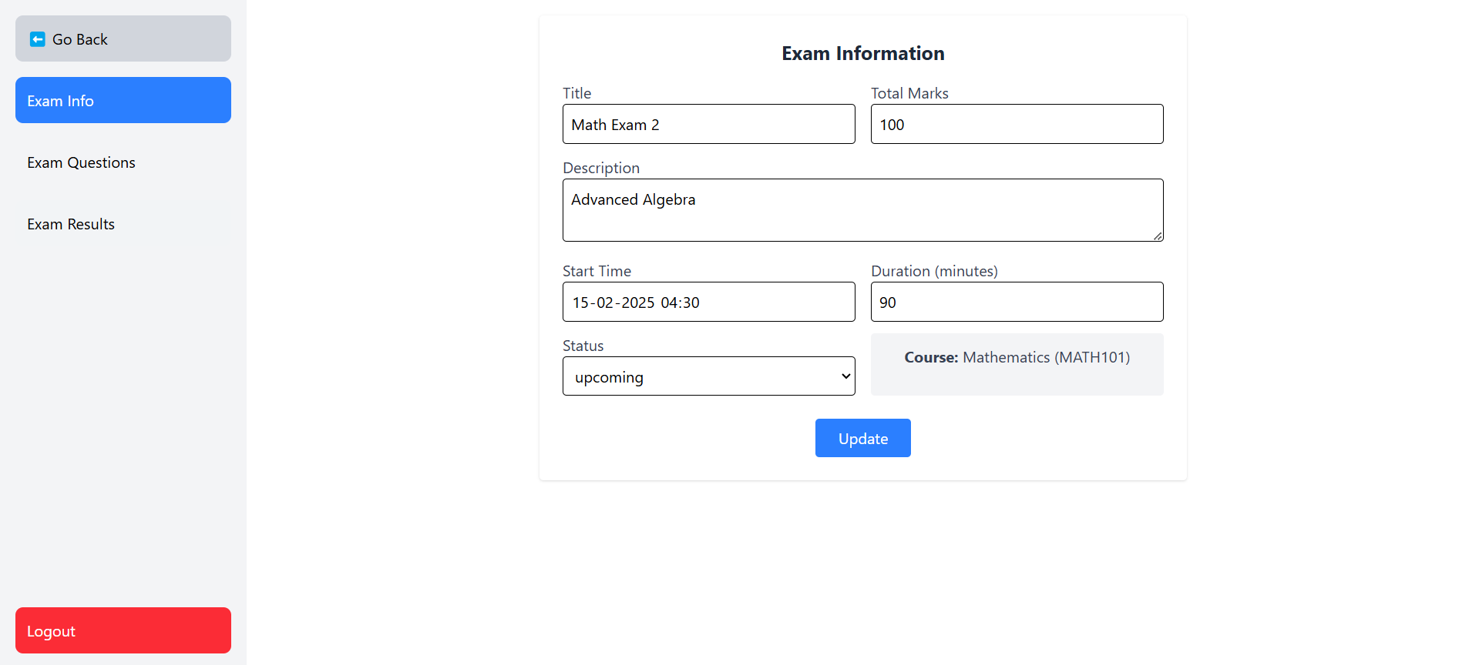

Exam Questions Edit

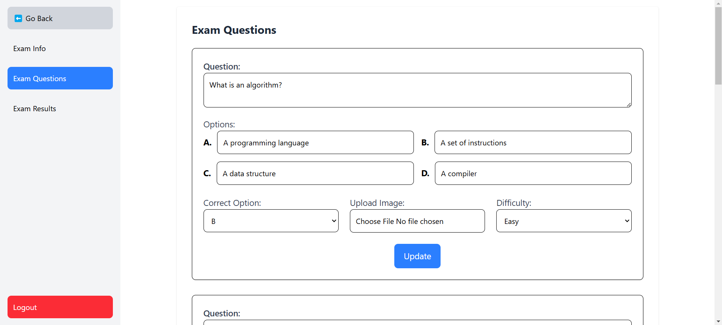

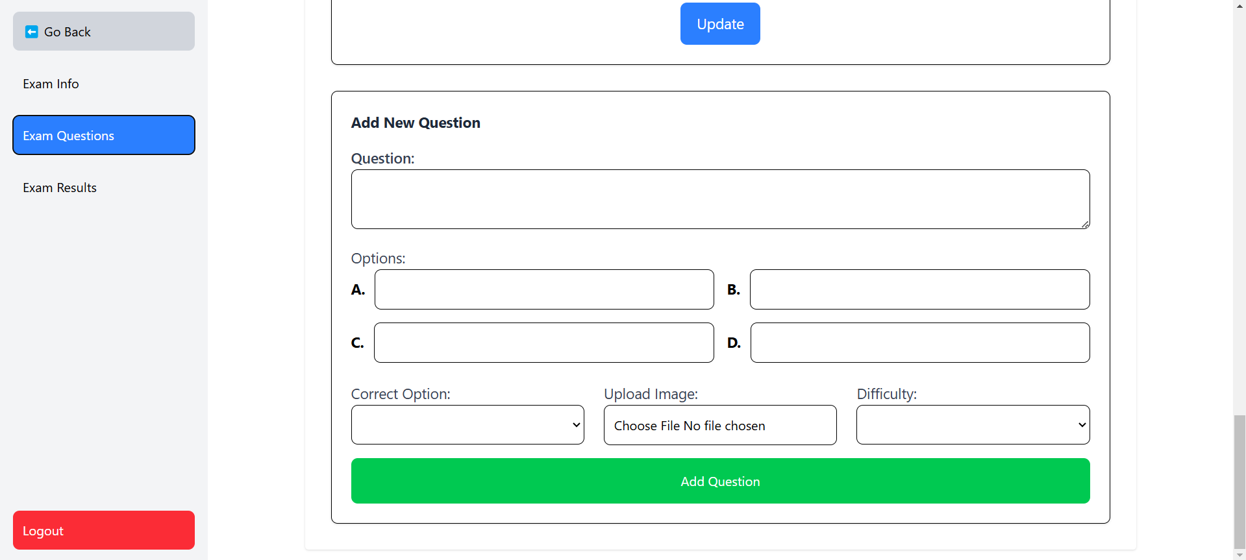

Exam Results

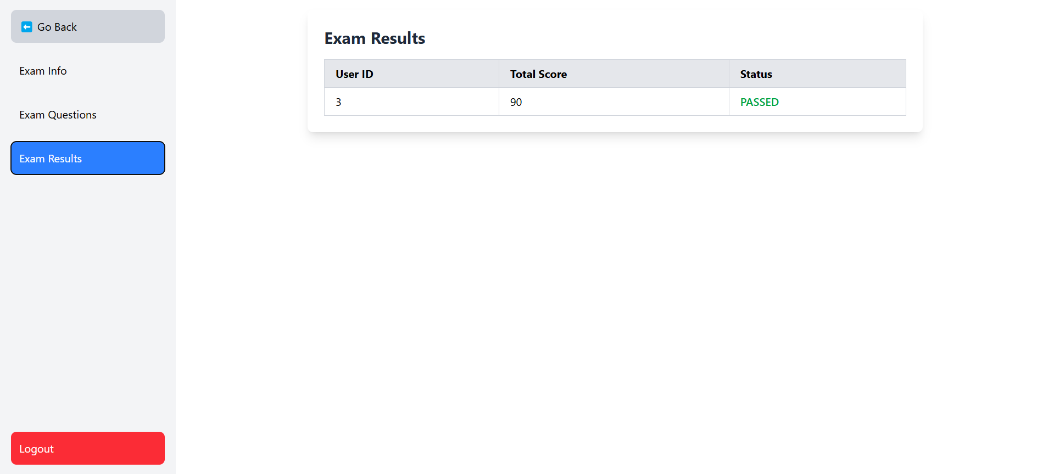

**Role: Student**

Exams Dashboard

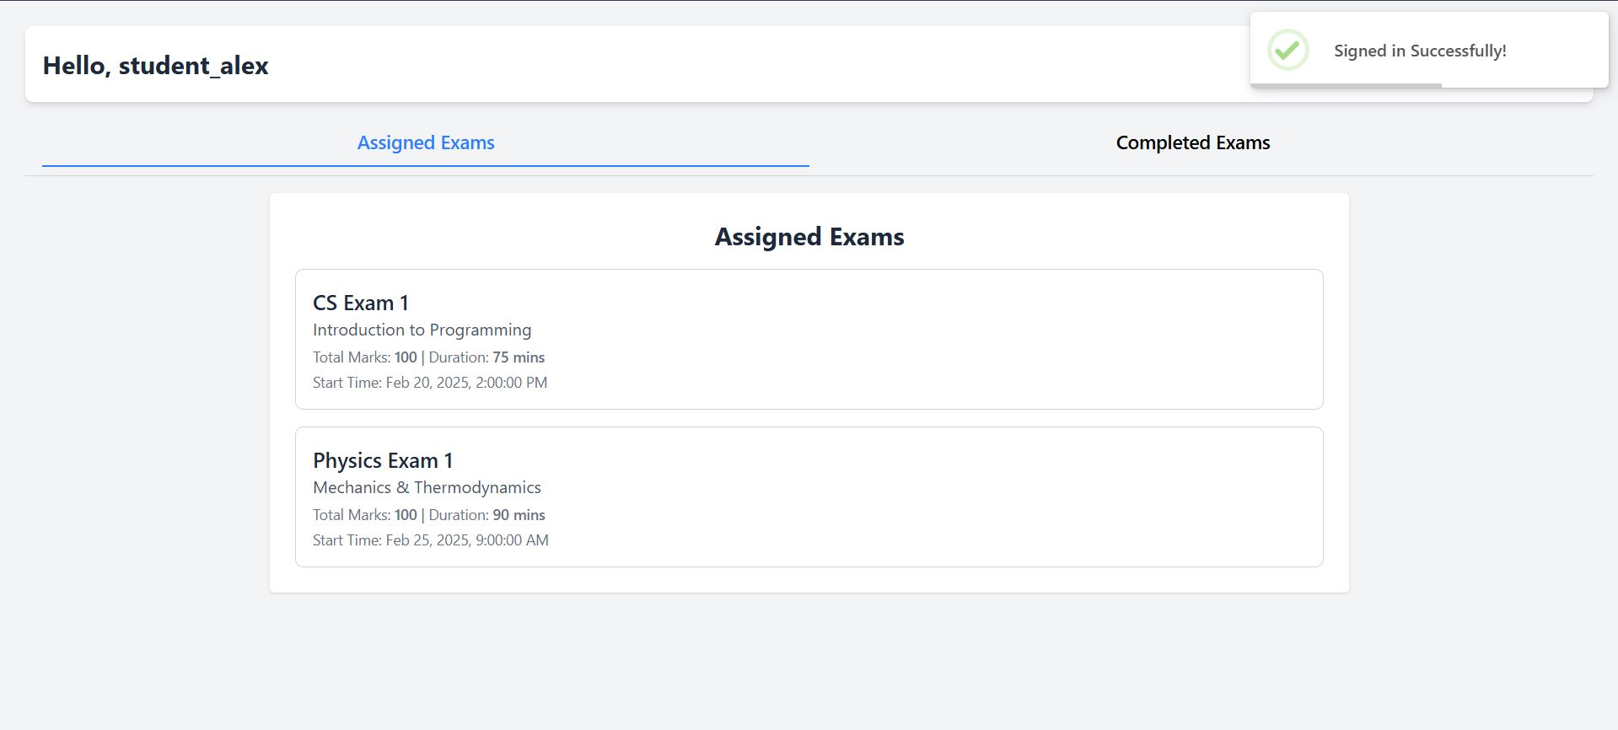

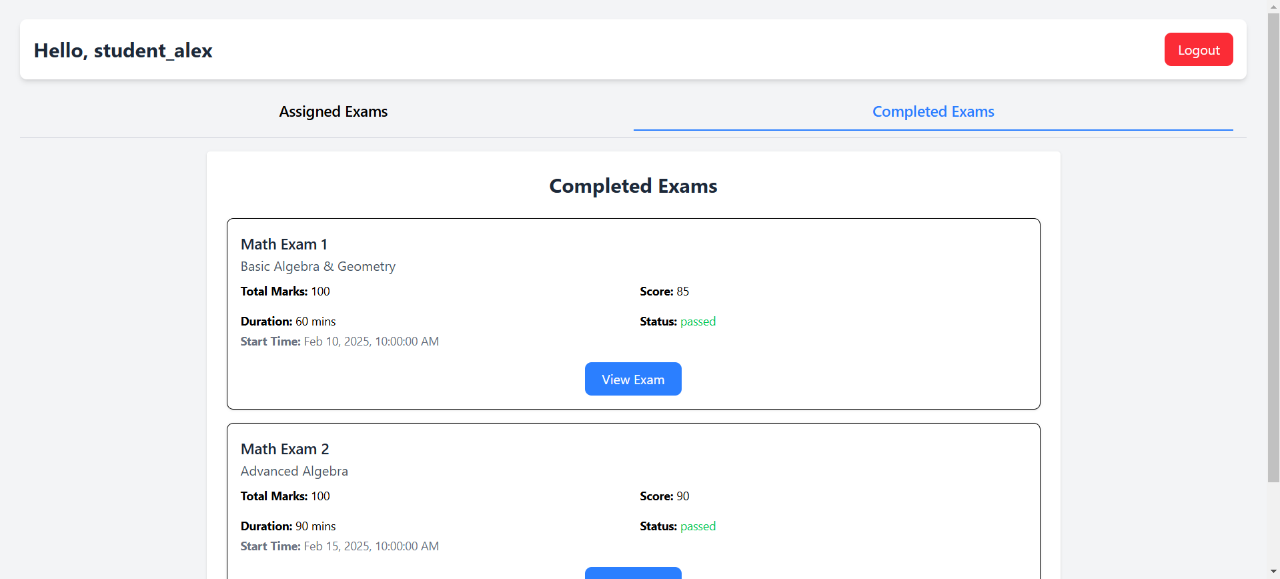

Ongoing Exam

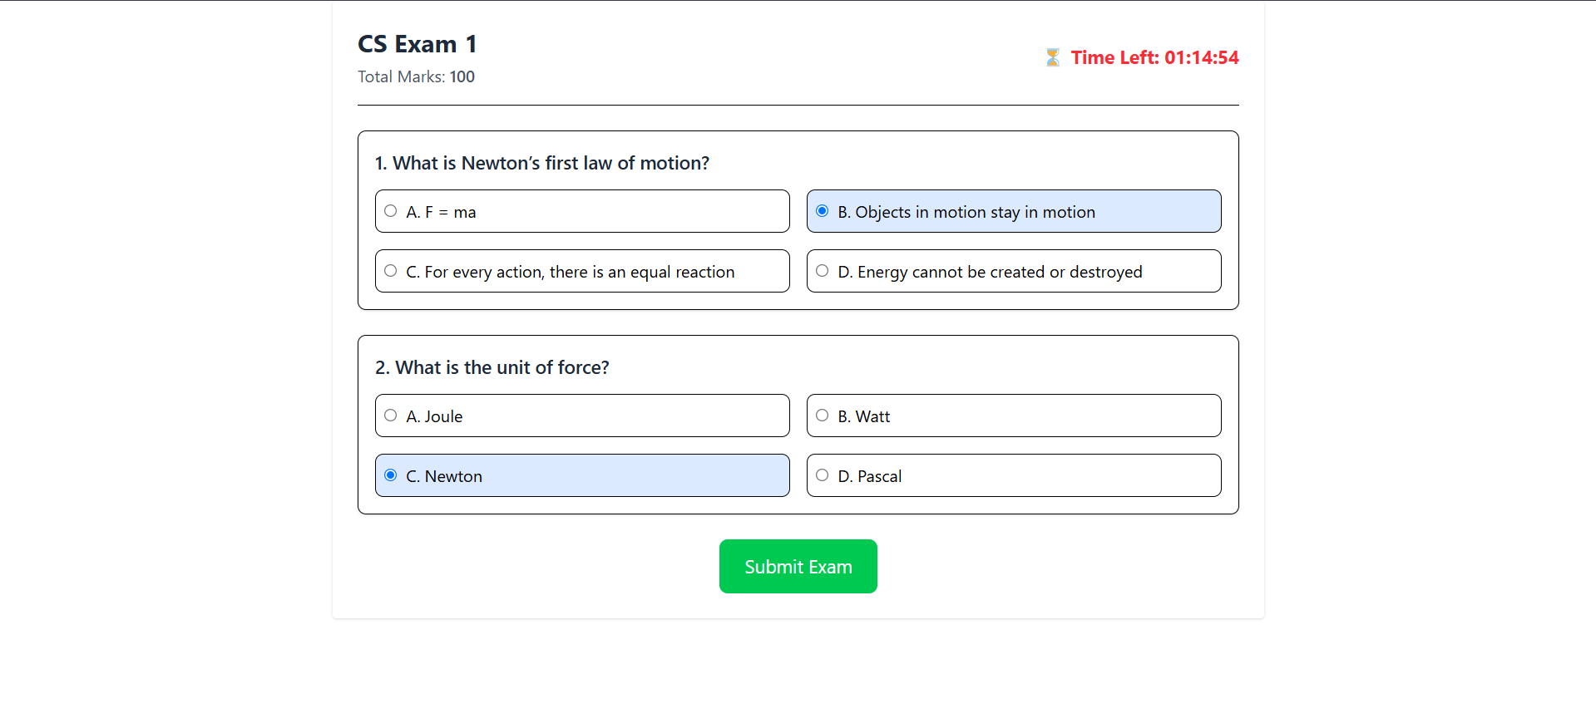

Exam Results

