**Batch: T2**

**Assignment No: 6**

**Title of Assignment: Data Warehouse for Customer Order System**

**Student Name: Shreeyash Shripad Dongarkar**

**Student PRN: 22510025**

**1. Introduction**

1.1 Objective:

The objective of this project is to design and implement a **Data Warehouse** for a customer order processing system. The system supports **Online Analytical Processing (OLAP)** using roll-up, drill-down, slice, and dice features. It enables data-driven decision-making by analysing customer orders, store inventory, and sales data.

1.2 Scope:

The data warehouse covers the following entities:

* Customers (Walk-in & Mail-order)
* Orders and Ordered Items
* Stores and Store Inventory
* Headquarters and Cities
* Time Dimension for trend analysis

**2. Business Requirement**

The enterprise operates multiple **stores across different cities and states**. Customers place orders for various items, and the company aims to **fulfil orders from the nearest stores**. The system needs to provide insights into:

* Sales performance by store, city, and item category
* Customer buying behaviour and order trends
* Inventory levels and fulfilment efficiency

The data warehouse extracts data from the operational databases and allows advanced **OLAP reporting** for analysis.

**3. Functional Specification**

3.1 Input Data

The data warehouse integrates data from **operational databases**, including:

* Customer, Orders, Ordered Items
* Stores, Stored Items, Headquarters
* Time Dimension (Extracted from Order Date)

3.2 Output Data

* Sales analysis by store, city, and item category
* Customer order trends over time
* Inventory and stock level insights
* Customer segmentation (Walk-in, Mail-order, Dual)

**4. Data Warehousing Design**

4.1 Schema Design (Start Schema)

**Dimension Tables**

* **City_Dim** (City_id, City_name, State)
* **Store_Dim** (Store_id, City_id, Phone)
* **Customer_Dim** (Customer_id, Customer_name, City_id, First_order_date, Customer_Type)
* **Item_Dim** (Item_id, Item_Description, Item_Size, Item_Weight, Unit_price)
* **Time_Dim** (Time_id, Order_date, Year, Quarter, Month)

**Fact Table**

* **Orders_Fact** (Order_no, Customer_id, Store_id, Item_id, Quantity_ordered, Ordered_price, Time_id)

4.2 ETL Process

The **ETL (Extract, Transform, Load) process** migrates data from operational databases to the warehouse:

1. **Extract:** Data is pulled from operational tables.
2. **Transform:** Cleaning, deduplication, and formatting.
3. **Load:** Data is inserted into fact and dimension tables using **MERGE** (upsert) operations.

**5. Data Cube Implementation**

The data warehouse supports **OLAP operations** using **ROLLUP** and **CUBE** functions:

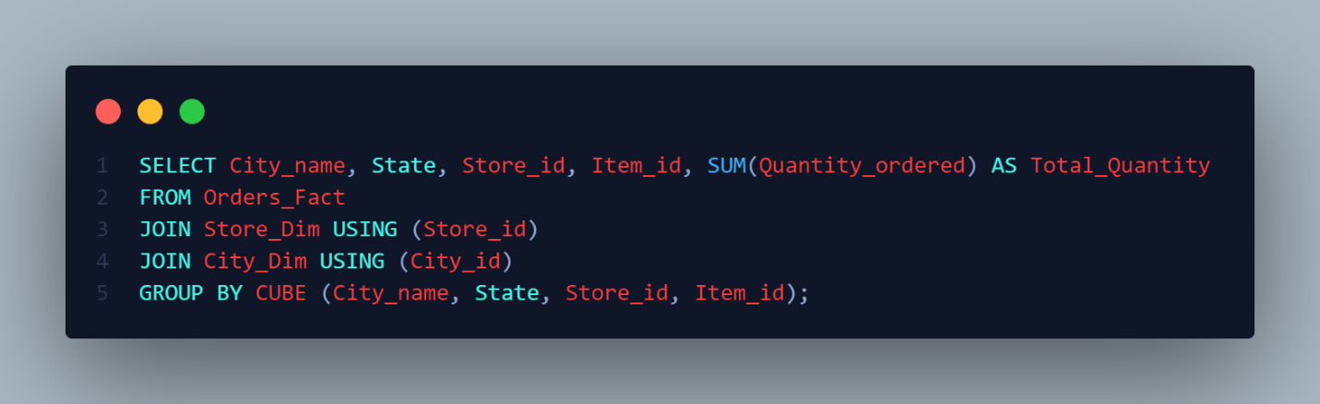

It also supports OLAP Queries like

* + Find all stores that hold a particular item
  + Find all ordered fulfilled by a store
  + Find all stored that hold the item ordered by a customer

**6. Observations**

6.1 OLAP Reports

The OLAP reports generated provide insights into:

* Store-level sales performance
* Customer order trends
* Inventory stock levels

6.2 Data Verification

The reports are validated by comparing:

* Order records in Orders_Fact vs. Orders
* Stock levels in Stored_items vs. Orders_Fact
* Customer purchase behavior trends

**7. Conclusion**

The data warehouse provides a robust analytical platform for tracking **customer orders, inventory levels, and sales trends**. By implementing **OLAP features**, the system enables advanced **business intelligence and decision-making**.

Further improvements include:

* **Machine Learning Models** for demand forecasting.
* **Real-time Data Processing** for live updates.

1) Find all the stores along with city, state, phone, description, size, weight and unit price that hold a particular item of stock.

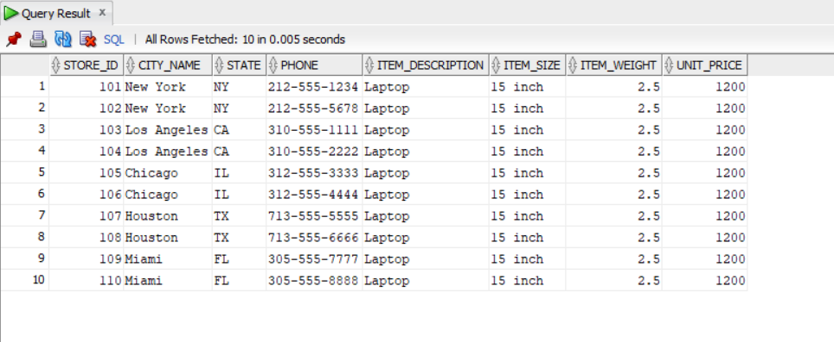

2) Find all the orders along with customer name and order date that can be fulfilled by a given store.

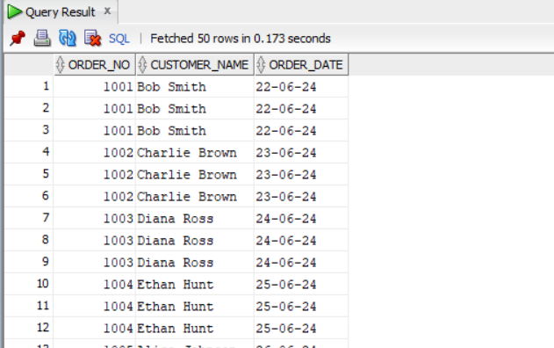

3) Find all stores along with city name and phone that hold items ordered by given customer.

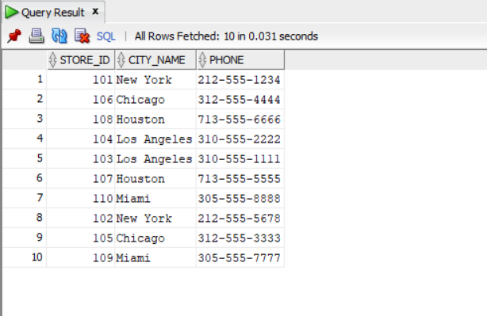

4) Find the headquarter address along with city and state of all stores that hold stocks of an item above a particular level.

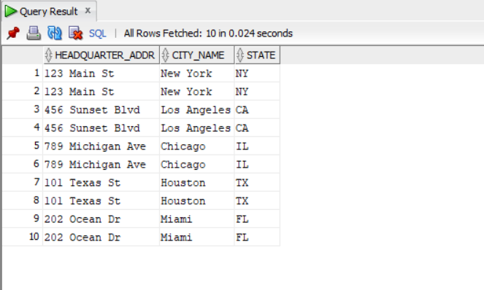

5) For each customer order, show the items ordered along with description, store id and city name and the stores that hold the items.

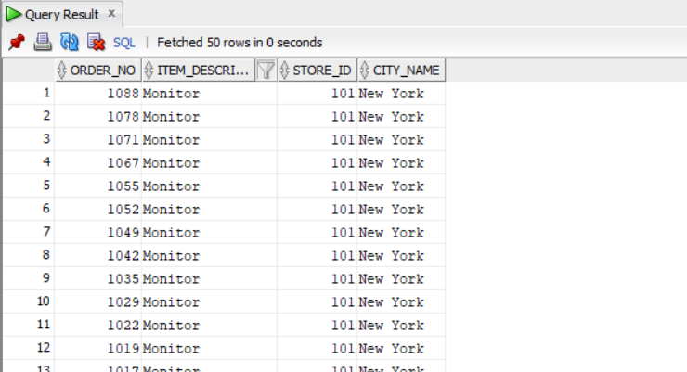

6) Find the city and the state in which a given customer lives.

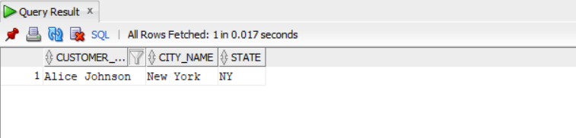

7) Find the stock level of a particular item in all stores in a particular city.

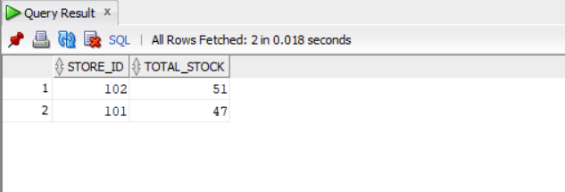

8) Find the items, quantity ordered, customer, store and city of an order.

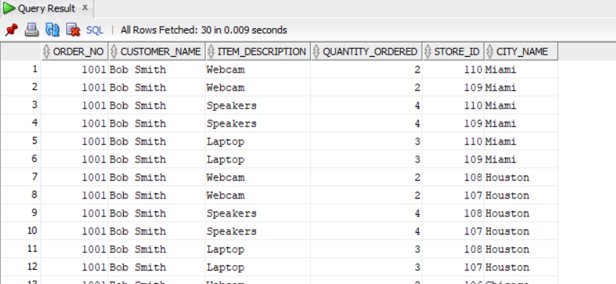

9) Find the walk-in customers, mail order customers and dual customers (both walk-in and mail order).

