Name: Shreeyash Shripad Dongarkar
PRN: 22510025
High Performance Computing Lab (B – 1)
Assignment – 10
Title: Understanding Concepts of CUDA Programming
GitHub Repository

Problem Statement 1:
Execute the following program and check the properties of your GPGPU.
1. %%writefile PS1.cu
2. #include <stdio.h>
3. #include <stdlib.h>
4. #include <cuda_runtime.h>
5.
6. int main()
7. {
8. int deviceCount;
9. cudaGetDeviceCount(&deviceCount);
10. if (deviceCount == 0) {
11. printf("There is no device supporting CUDA\n");
12. return 0;
13. }
14.
15. for (int dev = 0; dev < deviceCount; ++dev) {
16. cudaDeviceProp deviceProp;
17. cudaGetDeviceProperties(&deviceProp, dev);
18.
19. if (dev == 0) {
20. if (deviceProp.major < 1)
21. printf("There is no device supporting CUDA.\n");
22. else if (deviceCount == 1)
23. printf("There is 1 device supporting CUDA\n");
24. else
25. printf("There are %d devices supporting CUDA\n", deviceCount);
26. }
27.
28. printf("\nDevice %d: \"%s\"\n", dev, deviceProp.name);
29. printf(" Major revision number: %d\n", deviceProp.major);
30. printf(" Minor revision number: %d\n", deviceProp.minor);
31. printf(" Total amount of global memory: %zu bytes\n", deviceProp.totalGlobalMem);
32. printf(" Total amount of constant memory: %zu bytes\n", deviceProp.totalConstMem);
33. printf(" Total amount of shared memory per block: %zu bytes\n", deviceProp.sharedMemPerBlock);
34. printf(" Total number of registers per block: %d\n", deviceProp.regsPerBlock);
35. printf(" Warp size: %d\n", deviceProp.warpSize);
36. printf(" Multiprocessor count: %d\n", deviceProp.multiProcessorCount);
37. printf(" Maximum threads per block: %d\n", deviceProp.maxThreadsPerBlock);
38. printf(" Maximum block dimensions: %d x %d x %d\n",
39. deviceProp.maxThreadsDim[0], deviceProp.maxThreadsDim[1], deviceProp.maxThreadsDim[2]);
40. printf(" Maximum grid dimensions: %d x %d x %d\n",
41. deviceProp.maxGridSize[0], deviceProp.maxGridSize[1], deviceProp.maxGridSize[2]);
42. printf(" Memory pitch: %zu bytes\n", deviceProp.memPitch);
43. printf(" Texture alignment: %zu bytes\n", deviceProp.textureAlignment);
44. printf(" Clock rate: %d kilohertz\n", deviceProp.clockRate);
45. }
46. }
47.

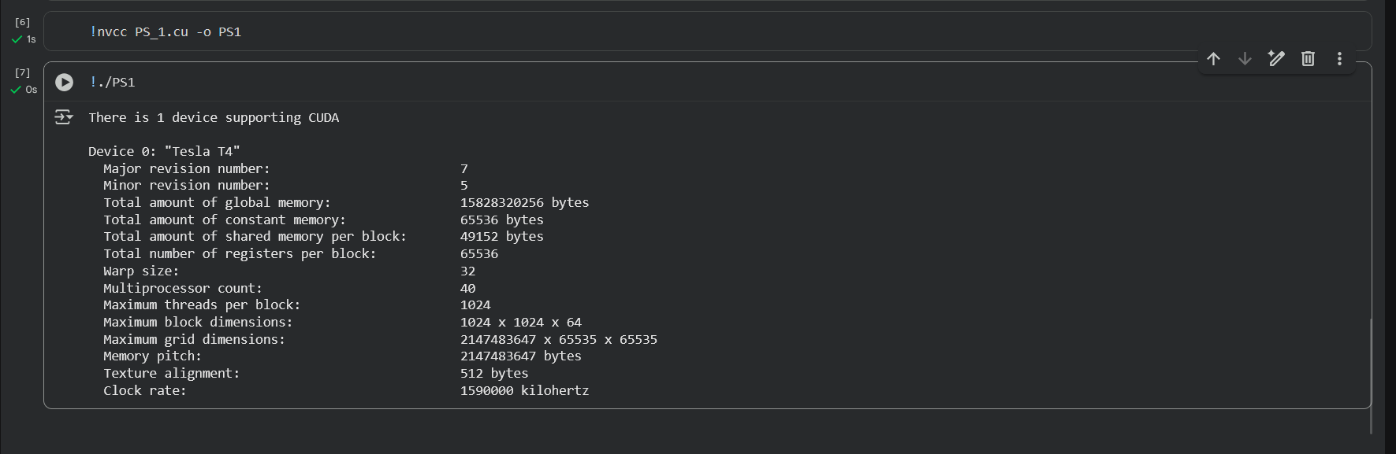

Problem Statement 2:
Write a program to where each thread prints its thread ID along with hello world. Launch the kernel with one block and multiple threads.
1. %%writefile PS2.cu
2. #include <stdio.h>
3. #include <cuda_runtime.h>
4.
5. // CUDA kernel: each thread computes its global thread ID
6. __global__ void helloFromThreads_buffer(int* threadIDs, int totalThreads) {
7. int globalID = threadIdx.x + blockIdx.x * blockDim.x;
8. if (globalID < totalThreads) {
9. threadIDs[globalID] = globalID;
10. }
11. }
12.
13. void checkCudaError(const char* msg) {
14. cudaError_t err = cudaGetLastError();
15. if (err != cudaSuccess) {
16. printf("CUDA error after %s: %s\n", msg, cudaGetErrorString(err));
17. }
18. }
19.
20. int main() {
21. int threadsPerBlock = 4;
22. int numBlocks = 1;
23. int totalThreads = threadsPerBlock * numBlocks;
24.
25. int bufferSize = totalThreads * sizeof(int);
26.
27. int* h_threadIDs = (int*)malloc(bufferSize);
28. int* d_threadIDs;
29. cudaMalloc((void**)&d_threadIDs, bufferSize);
30.
31. cudaMemset(d_threadIDs, -1, bufferSize);
32.
33. helloFromThreads_buffer<<<numBlocks, threadsPerBlock>>>(d_threadIDs, totalThreads);
34. checkCudaError("kernel launch");
35.
36. cudaDeviceSynchronize();
37. checkCudaError("cudaDeviceSynchronize");
38.
39. cudaMemcpy(h_threadIDs, d_threadIDs, bufferSize, cudaMemcpyDeviceToHost);
40. checkCudaError("cudaMemcpy");
41.
42. for (int i = 0; i < totalThreads; ++i) {
43. printf("Hello World from thread %d!\n", h_threadIDs[i]);
44. }
45.
46. cudaFree(d_threadIDs);
47. free(h_threadIDs);
48.
49. return 0;
50. }
51.

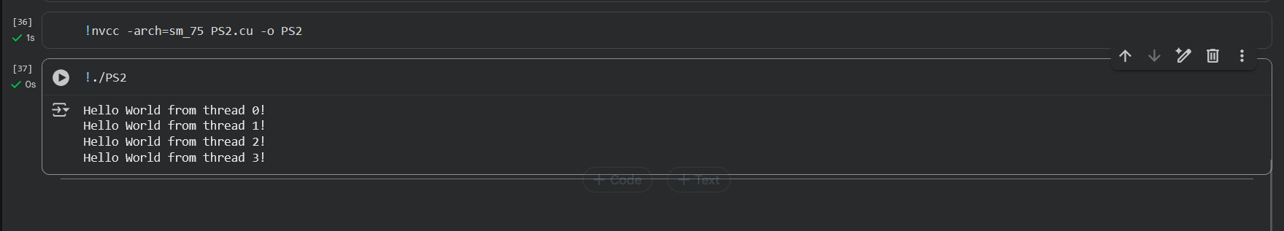
Problem Statement 3:
Write a program to where each thread prints its thread ID along with hello world. Lauch the kernel with multiple blocks and multiple threads.
1. %%writefile PS2.cu
2. #include <stdio.h>
3. #include <cuda_runtime.h>
4.
5. // CUDA kernel: each thread computes its global thread ID
6. __global__ void helloFromThreads_buffer(int* threadIDs, int totalThreads) {
7. int globalID = threadIdx.x + blockIdx.x * blockDim.x;
8. if (globalID < totalThreads) {
9. threadIDs[globalID] = globalID;
10. }
11. }
12.
13. void checkCudaError(const char* msg) {
14. cudaError_t err = cudaGetLastError();
15. if (err != cudaSuccess) {
16. printf("CUDA error after %s: %s\n", msg, cudaGetErrorString(err));
17. }
18. }
19.
20. int main() {
21. int threadsPerBlock = 4;
22. int numBlocks = 2;
23. int totalThreads = threadsPerBlock * numBlocks;
24.
25. int bufferSize = totalThreads * sizeof(int);
26.
27. int* h_threadIDs = (int*)malloc(bufferSize);
28. int* d_threadIDs;
29. cudaMalloc((void**)&d_threadIDs, bufferSize);
30.
31. cudaMemset(d_threadIDs, -1, bufferSize);
32.
33. helloFromThreads_buffer<<<numBlocks, threadsPerBlock>>>(d_threadIDs, totalThreads);
34. checkCudaError("kernel launch");
35.
36. cudaDeviceSynchronize();
37. checkCudaError("cudaDeviceSynchronize");
38.
39. cudaMemcpy(h_threadIDs, d_threadIDs, bufferSize, cudaMemcpyDeviceToHost);
40. checkCudaError("cudaMemcpy");
41.
42. for (int i = 0; i < totalThreads; ++i) {
43. printf("Hello World from thread %d!\n", h_threadIDs[i]);
44. }
45.
46. cudaFree(d_threadIDs);
47. free(h_threadIDs);
48.
49. return 0;
50. }
51.

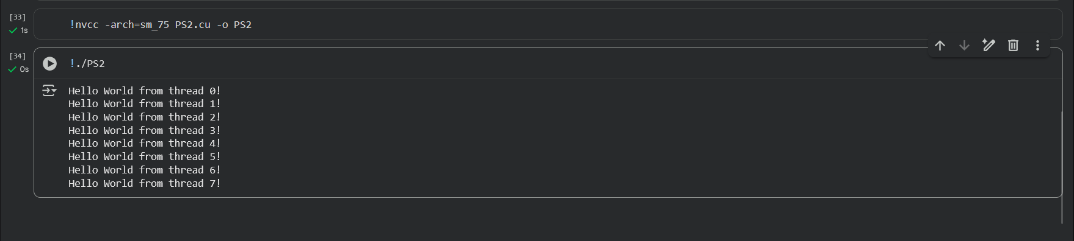

Problem Statement 4:
Write a program to where each thread prints its thread ID along with hello world. Lauch the kernel with 2D blocks and 2D threads.
1. %%writefile PS4.cu
2. #include <stdio.h>
3. #include <cuda_runtime.h>
4.
5. // CUDA kernel for 2D blocks and 2D threads
6. __global__ void helloFromThreads2D() {
7. // 2D thread index within its block
8. int threadX = threadIdx.x;
9. int threadY = threadIdx.y;
10.
11. // 2D block index within the grid
12. int blockX = blockIdx.x;
13. int blockY = blockIdx.y;
14.
15. // Calculate a unique global thread index in the grid
16. int globalX = blockX * blockDim.x + threadX;
17. int globalY = blockY * blockDim.y + threadY;
18.
19. printf("Hello World from block(%d,%d), thread(%d,%d) → global(%d,%d)\n",
20. blockX, blockY, threadX, threadY, globalX, globalY);
21. }
22.
23. int main() {
24. dim3 threadsPerBlock(4, 2); // 4 threads in x, 2 in y per block
25. dim3 numBlocks(2, 2); // 2 blocks in x, 2 in y grid
26.
27. helloFromThreads2D<<<numBlocks, threadsPerBlock>>>();
28.
29. cudaDeviceSynchronize();
30.
31. return 0;
32. }
33.

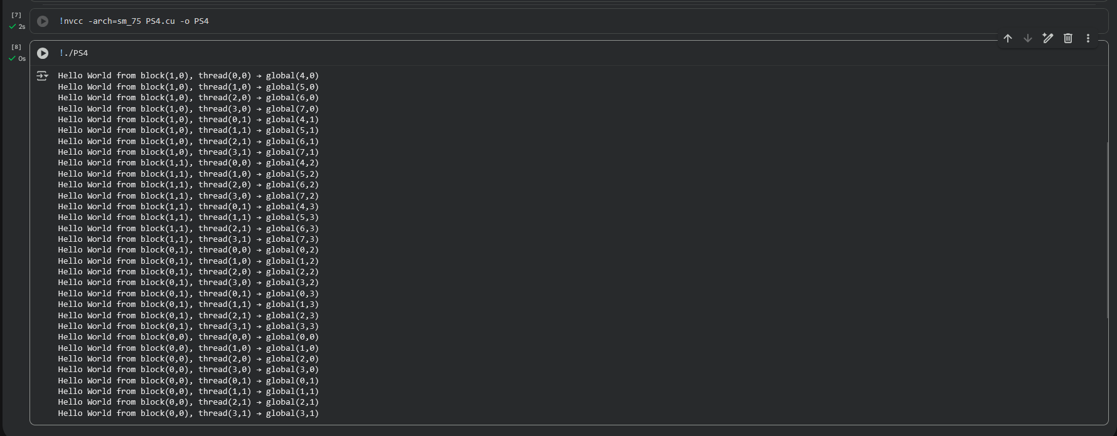

Problem Statement 5:
Write a CUDA C program that performs element-wise addition of two vectors A and B of size N. The result of the addition should be stored in vector C.
Details:
- Initialize the vectors A and B with random numbers.
- The output vector C[i] = A[i] + B[i], where i ranges from 0 to N-1.
- Use CUDA kernels to perform the computation in parallel.
- Write the code for both serial (CPU-based) and parallel (CUDA-based) implementations.
- Measure the execution time of both the serial and CUDA implementations for different values of N (e.g., N = 10^5, 10^6, 10^7).
Task:
- Calculate and report the speedup (i.e., the ratio of CPU execution time to GPU execution time).

1. %%writefile PS5.cu
2. #include <stdio.h>
3. #include <stdlib.h>
4. #include <cuda.h>
5. #include <time.h>
6.
7. __global__ void vectorAdd(const float *A, const float *B, float *C, int N) {
8. int i = blockIdx.x * blockDim.x + threadIdx.x;
9. if (i < N) C[i] = A[i] + B[i];
10. }
11.
12. void initializeVectors(float *A, float *B, int N) {
13. for (int i = 0; i < N; i++) {
14. A[i] = (float)(rand() % 100) / 10.0;
15. B[i] = (float)(rand() % 100) / 10.0;
16. }
17. }
18.
19. void vectorAddCPU(const float *A, const float *B, float *C, int N) {
20. for (int i = 0; i < N; i++) C[i] = A[i] + B[i];
21. }
22.
23. int main() {
24. int N = 1e6;
25. size_t size = N * sizeof(float);
26.
27. float *h_A = (float *)malloc(size);
28. float *h_B = (float *)malloc(size);
29. float *h_C_cpu = (float *)malloc(size);
30. float *h_C_gpu = (float *)malloc(size);
31.
32. srand(time(NULL));
33. initializeVectors(h_A, h_B, N);
34.
35. clock_t start_cpu = clock();
36. vectorAddCPU(h_A, h_B, h_C_cpu, N);
37. clock_t end_cpu = clock();
38. double cpu_time = ((double)(end_cpu - start_cpu)) / CLOCKS_PER_SEC;
39.
40. float *d_A, *d_B, *d_C;
41. cudaMalloc((void **)&d_A, size);
42. cudaMalloc((void **)&d_B, size);
43. cudaMalloc((void **)&d_C, size);
44.
45. cudaMemcpy(d_A, h_A, size, cudaMemcpyHostToDevice);
46. cudaMemcpy(d_B, h_B, size, cudaMemcpyHostToDevice);
47.
48. int blockSize = 256;
49. int numBlocks = (N + blockSize - 1) / blockSize;
50.
51. cudaEvent_t start_gpu, stop_gpu;
52. cudaEventCreate(&start_gpu);
53. cudaEventCreate(&stop_gpu);
54. cudaEventRecord(start_gpu);
55.
56. vectorAdd<<<numBlocks, blockSize>>>(d_A, d_B, d_C, N);
57.
58. cudaEventRecord(stop_gpu);
59. cudaEventSynchronize(stop_gpu);
60.
61. cudaMemcpy(h_C_gpu, d_C, size, cudaMemcpyDeviceToHost);
62.
63. float gpu_time = 0;
64. cudaEventElapsedTime(&gpu_time, start_gpu, stop_gpu);
65. gpu_time /= 1000.0;
66.
67. int correct = 1;
68. for (int i = 0; i < N; i++) {
69. if (fabs(h_C_cpu[i] - h_C_gpu[i]) > 1e-5) {
70. correct = 0;
71. break;
72. }
73. }
74.
75. printf("\n=== Vector Addition ===\n");
76. printf("Vector Size: %d\n", N);
77. printf("CPU Time: %.6f s\n", cpu_time);
78. printf("GPU Time: %.6f s\n", gpu_time);
79. printf("Speedup (CPU/GPU): %.2fx\n", cpu_time / gpu_time);
80. printf("Verification: %s\n", correct ? "SUCCESS" : "FAILED");
81.
82. free(h_A);
83. free(h_B);
84. free(h_C_cpu);
85. free(h_C_gpu);
86. cudaFree(d_A);
87. cudaFree(d_B);
88. cudaFree(d_C);
89.
90. return 0;
91. }
92.

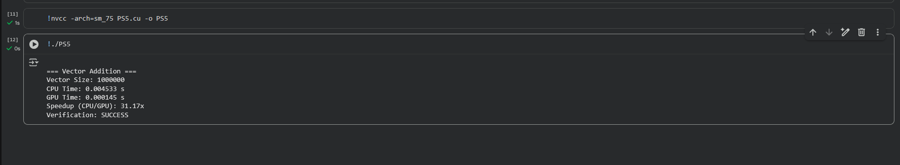

Problem Statement 6:
Write a CUDA C program to perform element-wise addition of two matrices A and B of size M x N. The result of the addition should be stored in matrix C.
Details:
- Initialize the matrices A and B with random values.
- The output matrix C[i][j] = A[i][j] + B[i][j] where i ranges from 0 to M-1 and j ranges from 0 to N-1.
- Write code for both serial (CPU-based) and parallel (CUDA-based) implementations.
- Measure the execution time of both implementations for various matrix sizes (e.g., 100x100, 500x500, 1000x1000).
Task:
- Calculate the speedup using the execution times of the CPU and GPU implementations.

1. %%writefile PS6.cu
2. #include <stdio.h>
3. #include <stdlib.h>
4. #include <cuda.h>
5. #include <time.h>
6.
7. __global__ void matrixAdd(float *A, float *B, float *C, int M, int N) {
8. int row = blockIdx.y * blockDim.y + threadIdx.y;
9. int col = blockIdx.x * blockDim.x + threadIdx.x;
10. int idx = row * N + col;
11. if (row < M && col < N) C[idx] = A[idx] + B[idx];
12. }
13.
14. void initializeMatrix(float *A, float *B, int M, int N) {
15. for (int i = 0; i < M * N; i++) {
16. A[i] = (float)(rand() % 100) / 10.0;
17. B[i] = (float)(rand() % 100) / 10.0;
18. }
19. }
20.
21. void matrixAddCPU(float *A, float *B, float *C, int M, int N) {
22. for (int i = 0; i < M * N; i++) C[i] = A[i] + B[i];
23. }
24.
25. int main() {
26. int M = 1000, N = 1000;
27. size_t size = M * N * sizeof(float);
28.
29. float *h_A = (float *)malloc(size);
30. float *h_B = (float *)malloc(size);
31. float *h_C_cpu = (float *)malloc(size);
32. float *h_C_gpu = (float *)malloc(size);
33.
34. srand(time(NULL));
35. initializeMatrix(h_A, h_B, M, N);
36.
37. clock_t start_cpu = clock();
38. matrixAddCPU(h_A, h_B, h_C_cpu, M, N);
39. clock_t end_cpu = clock();
40. double cpu_time = ((double)(end_cpu - start_cpu)) / CLOCKS_PER_SEC;
41.
42. float *d_A, *d_B, *d_C;
43. cudaMalloc((void **)&d_A, size);
44. cudaMalloc((void **)&d_B, size);
45. cudaMalloc((void **)&d_C, size);
46.
47. cudaMemcpy(d_A, h_A, size, cudaMemcpyHostToDevice);
48. cudaMemcpy(d_B, h_B, size, cudaMemcpyHostToDevice);
49.
50. dim3 blockSize(16, 16);
51. dim3 numBlocks((N + blockSize.x - 1) / blockSize.x, (M + blockSize.y - 1) / blockSize.y);
52.
53. cudaEvent_t start_gpu, stop_gpu;
54. cudaEventCreate(&start_gpu);
55. cudaEventCreate(&stop_gpu);
56. cudaEventRecord(start_gpu);
57.
58. matrixAdd<<<numBlocks, blockSize>>>(d_A, d_B, d_C, M, N);
59.
60. cudaEventRecord(stop_gpu);
61. cudaEventSynchronize(stop_gpu);
62.
63. cudaMemcpy(h_C_gpu, d_C, size, cudaMemcpyDeviceToHost);
64.
65. float gpu_time = 0;
66. cudaEventElapsedTime(&gpu_time, start_gpu, stop_gpu);
67. gpu_time /= 1000.0;
68.
69. int correct = 1;
70. for (int i = 0; i < M * N; i++) {
71. if (fabs(h_C_cpu[i] - h_C_gpu[i]) > 1e-5) {
72. correct = 0;
73. break;
74. }
75. }
76.
77. printf("\n=== Matrix Addition ===\n");
78. printf("Matrix Size: %dx%d\n", M, N);
79. printf("CPU Time: %.6f s\n", cpu_time);
80. printf("GPU Time: %.6f s\n", gpu_time);
81. printf("Speedup (CPU/GPU): %.2fx\n", cpu_time / gpu_time);
82. printf("Verification: %s\n", correct ? "SUCCESS" : "FAILED");
83.
84. free(h_A);
85. free(h_B);
86. free(h_C_cpu);
87. free(h_C_gpu);
88. cudaFree(d_A);
89. cudaFree(d_B);
90. cudaFree(d_C);
91.
92. return 0;
93. }
94.

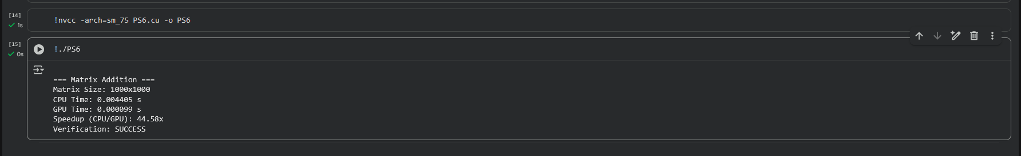

Problem Statement 7:
Write a CUDA C program to compute the dot product of two vectors A and B of size N. The dot product is defined as:
Details:
- Initialize the vectors A and B with random values.
- Implement the dot product calculation using both serial (CPU) and parallel (CUDA) approaches.
- Measure the execution time for both implementations with different vector sizes (e.g., N = 10^5, 10^6, 10^7).
- Use atomic operations or shared memory reduction in the CUDA kernel to compute the final sum.
Task:
- Calculate and report the speedup for different vector sizes.

1. %%writefile PS7.cu
2. #include <stdio.h>
3. #include <stdlib.h>
4. #include <cuda.h>
5. #include <time.h>
6.
7. __global__ void dotProductKernel(float *A, float *B, float *result, int N) {
8. __shared__ float cache[256];
9. int tid = blockIdx.x * blockDim.x + threadIdx.x;
10. int cacheIndex = threadIdx.x;
11.
12. float temp = 0.0f;
13. while (tid < N) {
14. temp += A[tid] * B[tid];
15. tid += blockDim.x * gridDim.x;
16. }
17.
18. cache[cacheIndex] = temp;
19. __syncthreads();
20.
21. int i = blockDim.x / 2;
22. while (i != 0) {
23. if (cacheIndex < i)
24. cache[cacheIndex] += cache[cacheIndex + i];
25. __syncthreads();
26. i /= 2;
27. }
28.
29. if (cacheIndex == 0)
30. atomicAdd(result, cache[0]);
31. }
32.
33. void initializeVectors(float *A, float *B, int N) {
34. for (int i = 0; i < N; i++) {
35. A[i] = (float)(rand() % 100) / 10.0;
36. B[i] = (float)(rand() % 100) / 10.0;
37. }
38. }
39.
40. float dotProductCPU(float *A, float *B, int N) {
41. float sum = 0.0f;
42. for (int i = 0; i < N; i++)
43. sum += A[i] * B[i];
44. return sum;
45. }
46.
47. int main() {
48. int N = 1e5;
49. size_t size = N * sizeof(float);
50.
51. float *h_A = (float *)malloc(size);
52. float *h_B = (float *)malloc(size);
53. float h_result_cpu = 0.0f, h_result_gpu = 0.0f;
54.
55. srand(time(NULL));
56. initializeVectors(h_A, h_B, N);
57.
58. clock_t start_cpu = clock();
59. h_result_cpu = dotProductCPU(h_A, h_B, N);
60. clock_t end_cpu = clock();
61. double cpu_time = ((double)(end_cpu - start_cpu)) / CLOCKS_PER_SEC;
62.
63. float *d_A, *d_B, *d_result;
64. cudaMalloc((void **)&d_A, size);
65. cudaMalloc((void **)&d_B, size);
66. cudaMalloc((void **)&d_result, sizeof(float));
67. cudaMemcpy(d_A, h_A, size, cudaMemcpyHostToDevice);
68. cudaMemcpy(d_B, h_B, size, cudaMemcpyHostToDevice);
69. cudaMemcpy(d_result, &h_result_gpu, sizeof(float), cudaMemcpyHostToDevice);
70.
71. int blockSize = 256;
72. int numBlocks = 256;
73.
74. cudaEvent_t start_gpu, stop_gpu;
75. cudaEventCreate(&start_gpu);
76. cudaEventCreate(&stop_gpu);
77. cudaEventRecord(start_gpu);
78.
79. dotProductKernel<<<numBlocks, blockSize>>>(d_A, d_B, d_result, N);
80.
81. cudaEventRecord(stop_gpu);
82. cudaEventSynchronize(stop_gpu);
83.
84. cudaMemcpy(&h_result_gpu, d_result, sizeof(float), cudaMemcpyDeviceToHost);
85.
86. float gpu_time = 0;
87. cudaEventElapsedTime(&gpu_time, start_gpu, stop_gpu);
88. gpu_time /= 1000.0;
89.
90. printf("\n=== Dot Product Computation ===\n");
91. printf("Vector Size: %d\n", N);
92. printf("CPU Result: %.4f\n", h_result_cpu);
93. printf("GPU Result: %.4f\n", h_result_gpu);
94. printf("CPU Time: %.6f s\n", cpu_time);
95. printf("GPU Time: %.6f s\n", gpu_time);
96. printf("Speedup (CPU/GPU): %.2fx\n", cpu_time / gpu_time);
97.
98. free(h_A);
99. free(h_B);
100. cudaFree(d_A);
101. cudaFree(d_B);
102. cudaFree(d_result);
103.
104. return 0;
105. }
106.
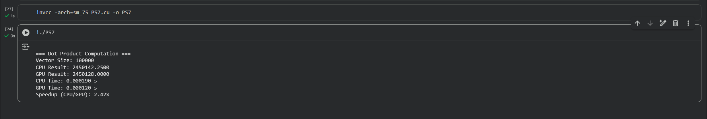
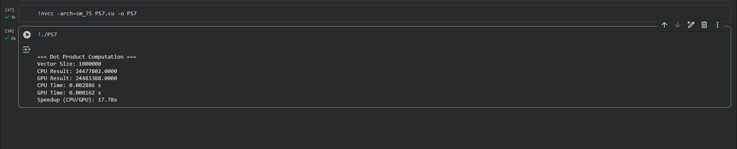
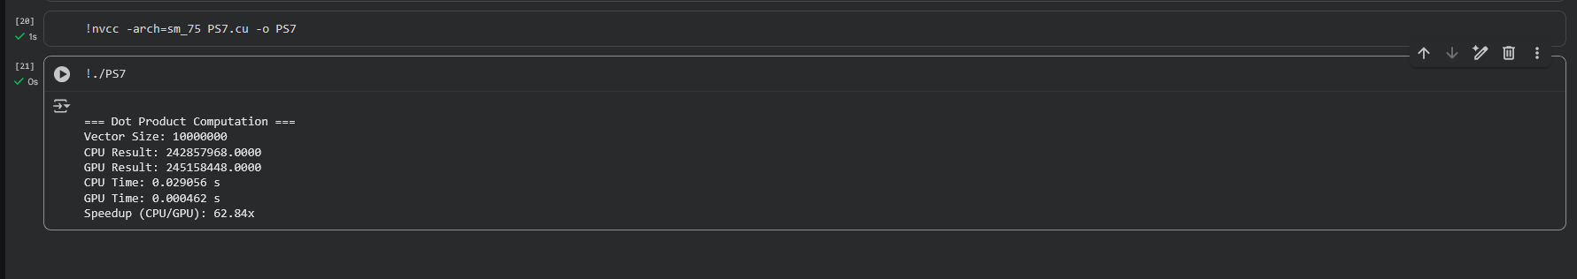

Problem Statement 8:
Write a CUDA C program to perform matrix multiplication. Given two matrices A (MxN) and B (NxP), compute the resulting matrix C (MxP) where:
Details:
- Initialize the matrices A and B with random values.
- Write code for both serial (CPU-based) and parallel (CUDA-based) implementations.
- Measure the execution time of both implementations for various matrix sizes (e.g., 100x100, 500x500, 1000x1000).
Task:
- Calculate the speedup by comparing the CPU and GPU execution times.

1. %%writefile PS8.cu
2. #include <stdio.h>
3. #include <stdlib.h>
4. #include <cuda.h>
5. #include <time.h>
6.
7. __global__ void matrixMultiply(float *A, float *B, float *C, int M, int N, int P) {
8. int row = blockIdx.y * blockDim.y + threadIdx.y;
9. int col = blockIdx.x * blockDim.x + threadIdx.x;
10. if (row < M && col < P) {
11. float sum = 0.0f;
12. for (int k = 0; k < N; ++k)
13. sum += A[row * N + k] * B[k * P + col];
14. C[row * P + col] = sum;
15. }
16. }
17.
18. void initializeMatrix(float *A, int rows, int cols) {
19. for (int i = 0; i < rows * cols; ++i)
20. A[i] = (float)(rand() % 100) / 10.0f;
21. }
22.
23. void matrixMultiplyCPU(float *A, float *B, float *C, int M, int N, int P) {
24. for (int i = 0; i < M; ++i)
25. for (int j = 0; j < P; ++j) {
26. float sum = 0.0f;
27. for (int k = 0; k < N; ++k)
28. sum += A[i * N + k] * B[k * P + j];
29. C[i * P + j] = sum;
30. }
31. }
32.
33. int main() {
34. int M = 500, N = 500, P = 500;
35. size_t size_A = M * N * sizeof(float);
36. size_t size_B = N * P * sizeof(float);
37. size_t size_C = M * P * sizeof(float);
38.
39. float *h_A = (float *)malloc(size_A);
40. float *h_B = (float *)malloc(size_B);
41. float *h_C_cpu = (float *)malloc(size_C);
42. float *h_C_gpu = (float *)malloc(size_C);
43.
44. srand(time(NULL));
45. initializeMatrix(h_A, M, N);
46. initializeMatrix(h_B, N, P);
47.
48. clock_t start_cpu = clock();
49. matrixMultiplyCPU(h_A, h_B, h_C_cpu, M, N, P);
50. clock_t end_cpu = clock();
51. double cpu_time = ((double)(end_cpu - start_cpu)) / CLOCKS_PER_SEC;
52.
53. float *d_A, *d_B, *d_C;
54. cudaMalloc((void **)&d_A, size_A);
55. cudaMalloc((void **)&d_B, size_B);
56. cudaMalloc((void **)&d_C, size_C);
57. cudaMemcpy(d_A, h_A, size_A, cudaMemcpyHostToDevice);
58. cudaMemcpy(d_B, h_B, size_B, cudaMemcpyHostToDevice);
59.
60. dim3 blockSize(16, 16);
61. dim3 numBlocks((P + blockSize.x - 1) / blockSize.x, (M + blockSize.y - 1) / blockSize.y);
62.
63. cudaEvent_t start_gpu, stop_gpu;
64. cudaEventCreate(&start_gpu);
65. cudaEventCreate(&stop_gpu);
66. cudaEventRecord(start_gpu);
67.
68. matrixMultiply<<<numBlocks, blockSize>>>(d_A, d_B, d_C, M, N, P);
69.
70. cudaEventRecord(stop_gpu);
71. cudaEventSynchronize(stop_gpu);
72.
73. cudaMemcpy(h_C_gpu, d_C, size_C, cudaMemcpyDeviceToHost);
74.
75. float gpu_time = 0;
76. cudaEventElapsedTime(&gpu_time, start_gpu, stop_gpu);
77. gpu_time /= 1000.0;
78.
79. printf("\n=== Matrix Multiplication ===\n");
80. printf("Matrix Sizes: A(%dx%d), B(%dx%d), C(%dx%d)\n", M, N, N, P, M, P);
81. printf("CPU Time: %.6f s\n", cpu_time);
82. printf("GPU Time: %.6f s\n", gpu_time);
83. printf("Speedup (CPU/GPU): %.2fx\n", cpu_time / gpu_time);
84.
85. free(h_A);
86. free(h_B);
87. free(h_C_cpu);
88. free(h_C_gpu);
89. cudaFree(d_A);
90. cudaFree(d_B);
91. cudaFree(d_C);
92.
93. return 0;
94. }
95.

