Name: Shreeyash S. Dongarkar

PRN: 22510025

Machine Learning Lab

Assignment No. 9

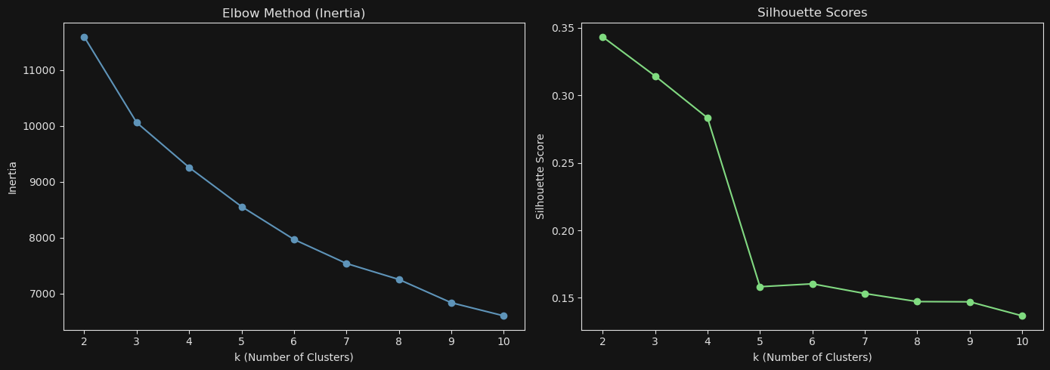

Since the Elbow Method does not provide a clear point of inflection, we will rely on the Silhouette Score to determine the optimal number of clusters. Based on the analysis, the highest Silhouette Score is observed when the number of clusters is set to 2. Therefore, we select **2** as the optimal number of clusters for K-Means.

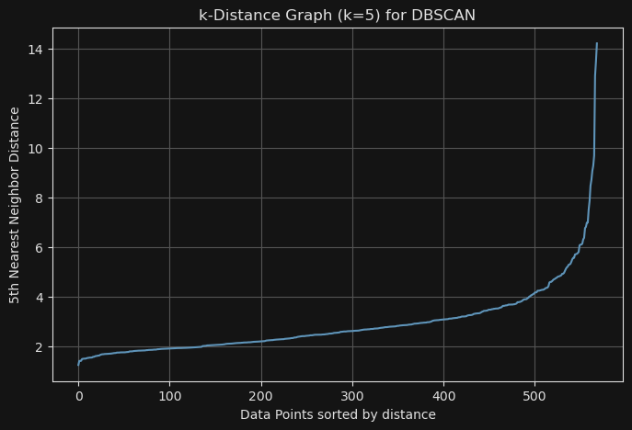

To determine the optimal min_samples and eps parameters for DBSCAN, we use the **k-nearest neighbors (k-NN) distance graph**. From the graph, we observe a noticeable elevation or elbow point in the distance values between approximately **2 and 2.5**. Therefore, we choose the eps value within this range.

For the min_samples parameter, we typically set it based on the **k** value used to generate the k-NN graph, as it represents the number of neighbors considered when detecting the elbow. This approach works well because min_samples = k ensures consistency between how density is measured in the graph and how it is used in DBSCAN. Hence, we set min_samples equal to **k**.



We can see here moderate purity as Homogeneity is around 0.5

Completeness 0.69 indicate members of same class tend to fall into same cluster more consistently

And 0.68 ARI indicate good level of agreement with true lables