**Batch: T7**

**Practical No: 10**

**Title of Assignment: Projects using MySQL, NodeJs and ExpressJs, ReactJs**

**Student Name: Shreeyash Shripad Dongarkar**

**Student PRN: 22510025**

Personal Task Manager:

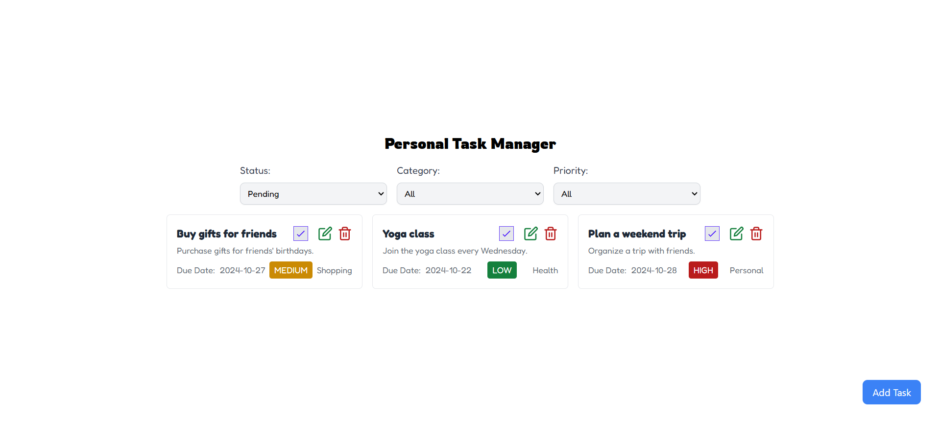

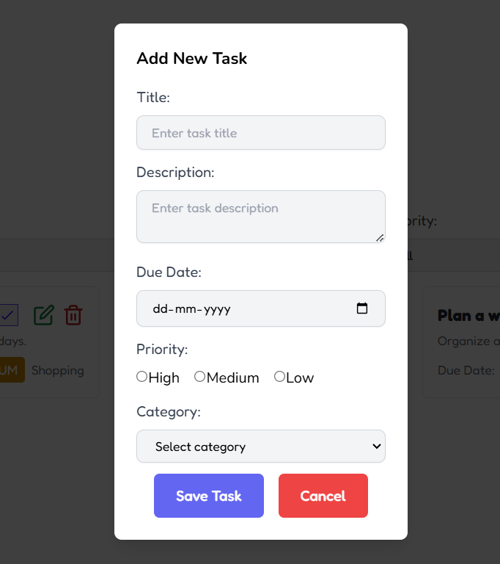

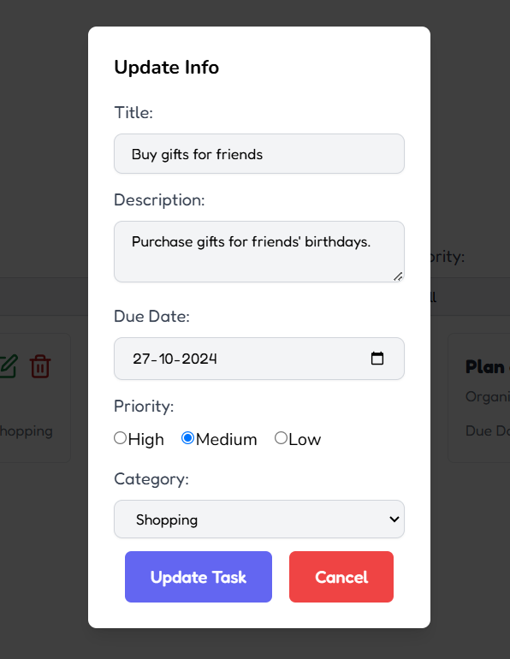

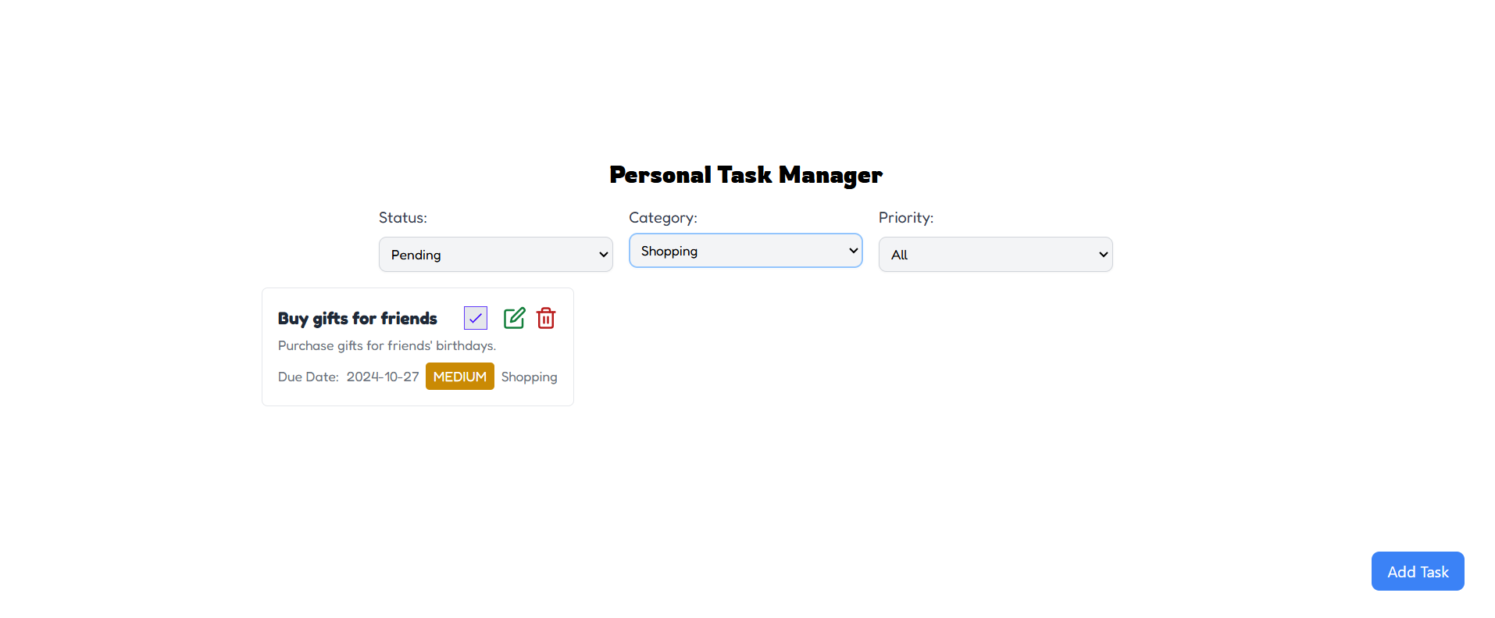

Event Planner:

