**Batch: T7**

**Practical No: 3**

**Title of Assignment: Study of JavaScript**

**Student Name: Shreeyash Shripad Dongarkar**

**Student PRN: 22510025**

**Problem Statement 1: Basics of JavaScript**

Developed a program to determine the count of prime numbers from a given comma-separated input. The program reads and processes the input, identifies prime numbers based on the mathematical definition (a prime number is divisible only by 1 and itself), and accurately counts and displays the total number of prime numbers.

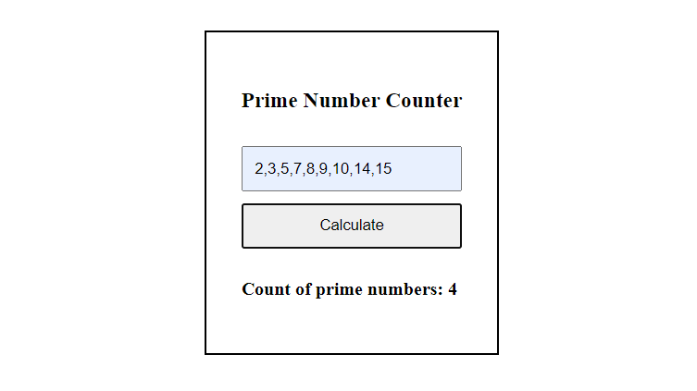

**Problem Statement 2: Password Validator**

Implemented a password validation program that checks the strength of a user-provided password. The program verifies that the password meets several criteria: it must be at least 8 characters long and include at least one uppercase letter, one lowercase letter, one digit, and one special character. The program dynamically updates the user interface by displaying a message indicating whether the password is valid or invalid, with corresponding color-coded feedback.

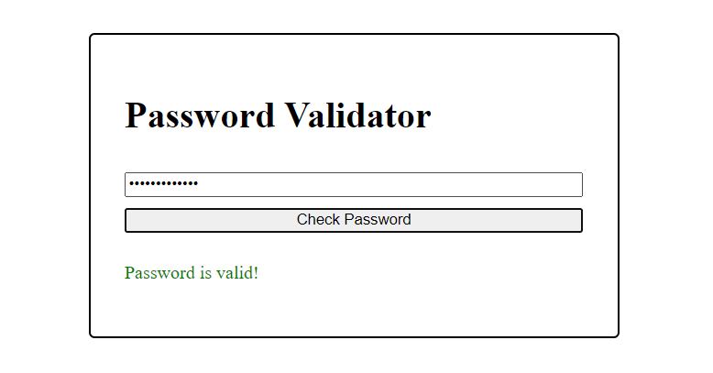

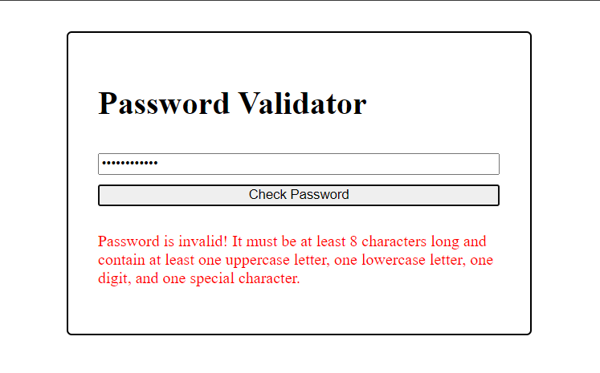

**Problem Statement 3: Web Development**

Technologies Used: HTML CSS and JS

Made a Tech store using HTML, CSS and JS where I implement functionality of Add to Card button using JS and used HTML and CSS for displaying the contents of web page considering a fictional store of Mobiles and Laptops.

