**Batch: T7**

**Practical No: 5**

**Title of Assignment: Study and Implementation of ReactJS**

**Student Name: Shreeyash Shripad Dongarkar**

**Student PRN: 22510025**

**1) What is React and what problem does it solve?**

React is a JavaScript library developed by Facebook, used for building user interfaces, particularly for single-page applications (SPAs). It's designed to make the process of creating dynamic, interactive, and efficient front-end applications easier and more intuitive.

**What React Is:**

* **Component-Based**: React encourages breaking down the UI into reusable components. Each component manages its own state and can be composed to build complex UIs.
* **Declarative**: React allows developers to describe how the UI should look based on the current application state. When the state changes, React efficiently updates and renders the necessary components.

**Problems React Solves:**

1. **Efficient Updates**: In traditional web development, manually updating the DOM (Document Object Model) can be cumbersome and error-prone. React uses a virtual DOM to efficiently manage and update only the parts of the UI that need to change, reducing the performance overhead.
2. **Complex UIs**: Building complex UIs with traditional approaches can lead to unmanageable and intertwined code. React's component-based architecture promotes modularity and reusability, making it easier to manage and scale large applications.
3. **State Management**: React introduces a clear way to manage state within components, reducing bugs and improving maintainability. The one-way data flow (unidirectional data binding) helps keep the data predictable and easy to debug.
4. **Cross-Platform Development**: React’s architecture is adaptable across different platforms. With React Native, developers can build mobile apps using the same React components, reducing development time and cost.

**2) What are React Components and how they are used?**

React components are the building blocks of a React application. They are independent, reusable pieces of code that define how a particular part of the user interface (UI) should look and behave. Components allow developers to break down complex UIs into smaller, manageable parts, making the code more modular and easier to maintain.

Types of React Components:

1. Functional Components:

- Definition: These are simple JavaScript functions that return JSX (JavaScript XML), which is the syntax used by React to describe the UI.

- Usage: Functional components are primarily used to render UI. They can also use hooks (like `useState` and `useEffect`) to manage state and lifecycle events.

- Example:

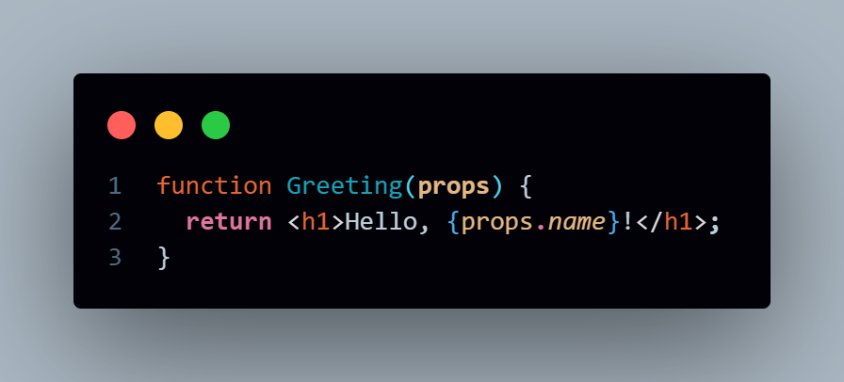

2. Class Components:

- Definition: These are ES6 classes that extend `React.Component`. They have a `render()` method that returns JSX.

- Usage: Class components can manage their own state and lifecycle methods (like `componentDidMount`, `componentDidUpdate`).

- Example:

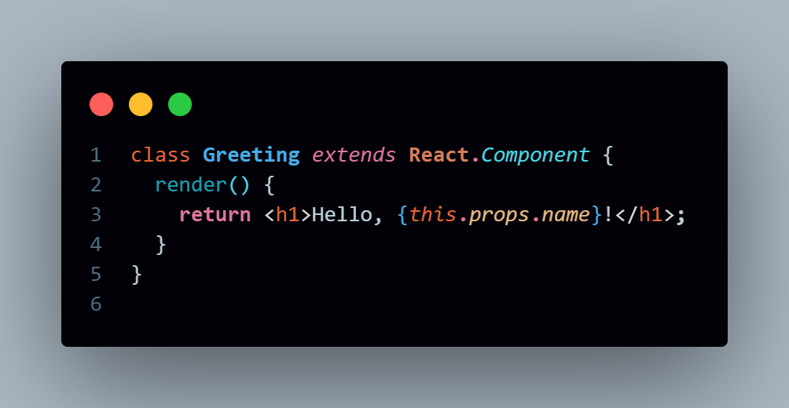

How React Components Are Used:

1. Composition:

- Components can be composed together to create complex UIs. For example, a `Header` component, a `Content` component, and a `Footer` component can be combined to create a `Page` component.

- Example:



2. Props (Properties):

- Components can receive data via `props`, which are like function arguments. Props allow components to be dynamic and reusable.

- Example:

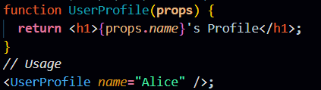 ```

3. State:

- Components can have their own internal state, which is managed within the component. State allows components to react to user inputs or other events.

- Example using a functional component with hooks:

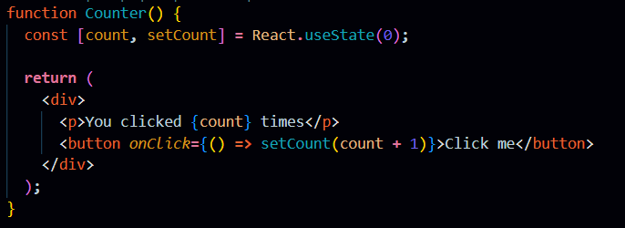

4. Lifecycle Methods (Class Components):

- Class components have lifecycle methods like `componentDidMount`, `componentDidUpdate`, and `componentWillUnmount` to perform actions at different stages of a component's life.

- Example:

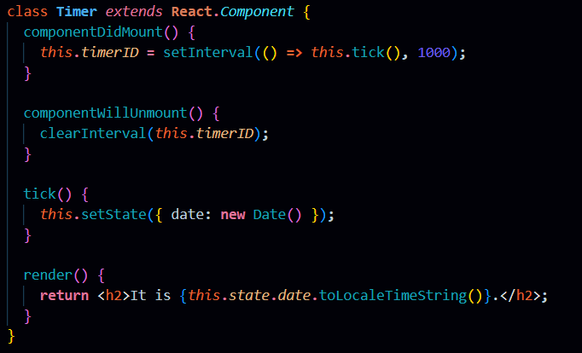

Advantages of Using React Components:

- Reusability: Components can be reused across different parts of an application, reducing code duplication.

- Maintainability: By breaking down the UI into smaller parts, it's easier to manage and maintain the codebase.

- Separation of Concerns: Components encapsulate their behavior, styling, and state, leading to cleaner and more organized code.

- Testability: Individual components can be tested in isolation, improving the reliability of the application.

React components are essential to building modern web applications, allowing developers to create dynamic, interactive, and maintainable UIs efficiently.

**3) What is JSX in React?**

JSX (JavaScript XML) is a syntax extension for JavaScript used in React to describe the UI structure. It looks similar to HTML but is actually a way to write elements inside JavaScript. JSX makes it easier to visualize the UI components you're creating and integrates seamlessly with the React framework.

**Key Features of JSX:**

1. **HTML-like Syntax**:
   * JSX allows you to write HTML-like code directly within JavaScript, which React transforms into React elements. This makes the code more readable and easier to understand, especially when defining the structure of UI components.
   * Example:



1. **Embedding JavaScript Expressions**:
   * JSX allows you to embed JavaScript expressions within the HTML-like syntax. You can do this using curly braces {}. This makes it easy to dynamically display values or execute JavaScript logic within your UI.
   * Example:



1. **Attributes**:
   * You can pass attributes to JSX elements just like you would in HTML, but since JSX is JavaScript, the attribute names are camelCased. For example, class becomes className, and for becomes htmlFor.
   * Example:



1. **Children**:
   * JSX elements can have children, just like HTML elements. You can nest elements within each other, which helps in creating complex UIs.
   * Example:



1. **Conditional Rendering**:
   * You can use JavaScript conditional statements like ternary operators within JSX to conditionally render elements.
   * Example:

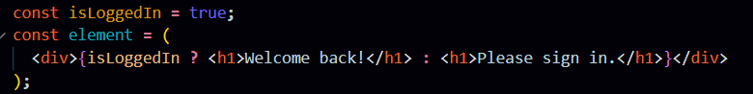

1. **JavaScript Expressions**:
   * You can perform calculations, call functions, and use any valid JavaScript expressions inside JSX.
   * Example:

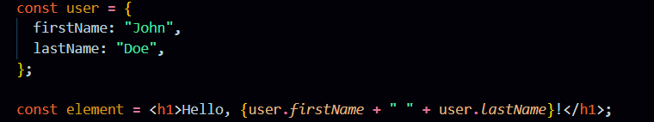

**Why Use JSX?**

* **Improved Readability**: JSX closely resembles the structure of the rendered UI, making the code more intuitive and easier to understand.
* **Integration with JavaScript**: Since JSX is JavaScript, you can easily integrate it with other JavaScript logic, making it a powerful tool for creating dynamic UIs.
* **Prevents Injection Attacks**: React automatically escapes JSX expressions to protect against injection attacks. This means you can safely include user input in your JSX without worrying about XSS (Cross-Site Scripting) attacks.

**How JSX Works:**

Under the hood, JSX is not HTML; it’s syntactic sugar for React.createElement(). When you write JSX, a tool like Babel (a JavaScript compiler) transforms it into JavaScript calls that React understands.

Example transformation:

const element = <h1>Hello, world!</h1>; is transformed to:

const element = React.createElement('h1', null, 'Hello, world!');

This transformation makes JSX a powerful and expressive way to build React components.

**4) What are props in React and how they differ from state?**

In React, props and state are two key concepts used for managing data and controlling the behaviour of components. While they are both used to store information that influences what a component renders, they have different purposes and characteristics.

What Are Props?

Props (short for "properties") are arguments passed to React components, allowing you to pass data from a parent component to a child component. Props are used to make components dynamic and reusable by allowing them to receive different data each time they are used.

Key Characteristics of Props:

* Read-Only: Props are immutable, meaning that once they are passed to a component, they cannot be modified by that component. This makes the component's behaviour predictable.
* Passed Down from Parent: Props are typically passed from a parent component to a child component. The child component can access these props to determine what content or behaviour to display.
* Used for Component Configuration: Props are often used to configure how a component should behave or what data it should display. For example, a Button component could receive a label prop to determine what text to display on the button.

Example of Props:



In this example, the Welcome component receives a name prop from its parent, App, and uses it to display a personalized greeting.

What Is State?

State is a built-in object in React components used to store data that can change over time. Unlike props, state is managed internally by the component and can be updated by the component itself. When a component's state changes, React re-renders the component to reflect the new state.

Key Characteristics of State:

* Mutable: Unlike props, state is mutable and can be updated using the setState function (in class components) or useState hook (in functional components).
* Managed Within the Component: State is typically managed within the component that owns it. The component can initialize state, update it, and use it to determine what to render.
* Triggers Re-Rendering: When state changes, React triggers a re-render of the component to reflect the new state in the UI.

Example of State:

In this example, the Counter component uses the useState hook to manage the count state. When the button is clicked, setCount updates the count, causing the component to re-render with the new value.

Key Differences Between Props and State:

* Source:
  + Props: Passed to a component by its parent.
  + State: Managed within the component itself.
* Mutability:
  + Props: Immutable; cannot be changed by the receiving component.
  + State: Mutable; can be updated by the component.
* Purpose:
  + Props: Used to pass data and configuration to a component from outside.
  + State: Used to manage data that changes over time and needs to affect the component's rendering.
* Reusability:
  + Props: Make components reusable by allowing different data to be passed to the same component.
  + State: Manages dynamic behaviour within a component.

**5) What is state in React and how does it work?**

In React, state refers to a special object that holds information about the component's current situation or data that may change over time. It allows React components to manage and track changes in the data that influence what the component renders on the screen.

**How State Works in React:**

1. **Initialization**:
   * In functional components, state is initialized using the useState hook.
   * In class components, state is typically initialized in the constructor or directly within the class as a property.
2. **Updating State**:
   * State is mutable, meaning it can be updated. However, it should never be modified directly. Instead, you use functions like setState (in class components) or the updater function provided by useState (in functional components).
   * When state is updated, React triggers a re-render of the component to reflect the new state.
3. **Re-Rendering**:
   * When state changes, React automatically re-renders the component and its child components to reflect the new state in the UI. This reactivity is what makes React powerful for building dynamic applications.
   * The re-rendering process is efficient, as React only updates the parts of the DOM that have changed, thanks to its virtual DOM.
4. **State and Lifecycle**:
   * In class components, state is often tied to the component lifecycle methods (e.g., componentDidMount, componentDidUpdate, componentWillUnmount). These methods allow developers to run code at specific points in a component’s lifecycle.
   * In functional components, hooks like useEffect can be used to achieve similar effects as lifecycle methods.

**6) What are React Lifecycle methods and why are they important?**

React lifecycle methods are special methods in class components that allow developers to hook into different stages of a component's life cycle, such as when the component is created, updated, or destroyed. These methods are important because they give developers control over what happens during these stages, enabling them to execute code at the right moment in the component's life.

**Lifecycle Phases in React:**

A React component's lifecycle can be broadly divided into three phases:

1. **Mounting**: This is the phase when the component is being created and inserted into the DOM.
2. **Updating**: This phase occurs when the component's state or props change, causing a re-render.
3. **Unmounting**: This is the phase when the component is being removed from the DOM.

**Key Lifecycle Methods:**

**1. Mounting Phase:**

These methods are called when a component is being created and added to the DOM.

* **constructor(props)**:
  + This method is called before the component is mounted. It’s used for initializing state, binding event handlers, and performing other setup tasks.
* **static getDerivedStateFromProps(props, state)**:
  + This method is called right before rendering the component. It allows the state to be updated based on changes in props. It’s rarely used but can be useful in specific scenarios.
* **componentDidMount()**:
  + This method is called immediately after the component is mounted. It’s commonly used for making network requests, setting up subscriptions, or any DOM-related operations.

**2. Updating Phase:**

These methods are called when the component’s state or props change, causing it to re-render.

* **shouldComponentUpdate(nextProps, nextState)**:
  + This method allows you to prevent unnecessary re-renders by returning false if the component doesn’t need to update. It’s used to optimize performance.
* **getSnapshotBeforeUpdate(prevProps, prevState)**:
  + This method is called right before the changes from the virtual DOM are flushed to the DOM. It allows you to capture some information (e.g., scroll position) from the DOM before it gets updated.
* **componentDidUpdate(prevProps, prevState, snapshot)**:
  + This method is called immediately after the component updates. It’s a good place to handle any updates that depend on the DOM or perform additional side effects based on the previous state or props.

**3. Unmounting Phase:**

This method is called when a component is being removed from the DOM.

* **componentWillUnmount()**:
  + This method is called just before the component is unmounted and destroyed. It’s used to clean up any side effects, such as canceling network requests, removing event listeners, or clearing timers.

**Importance of Lifecycle Methods:**

* **Control Over Component Behavior**: Lifecycle methods give developers fine-grained control over how a component behaves during its life cycle, allowing them to manage side effects, performance, and data fetching effectively.
* **Performance Optimization**: Methods like shouldComponentUpdate allow developers to prevent unnecessary renders, which can significantly improve the performance of an application.
* **Side Effects Management**: Lifecycle methods provide the right place to manage side effects like API calls, subscriptions, and DOM updates, ensuring that they happen at the appropriate time and are properly cleaned up.
* **Legacy Class Components**: While React now encourages the use of functional components with hooks (like useEffect), lifecycle methods are still crucial for maintaining and understanding older React codebases built with class components.

**7) Elaborate following with respect to ReactJs**

**1. Event Handling in React**

* **Definition**: Event handling in React is the process of capturing and responding to user inputs or browser actions, such as clicks, keyboard inputs, and form submissions.
* **How It Works**:
  + React uses synthetic events, which are cross-browser wrappers around the browser's native events. This ensures that events behave consistently across different browsers.
  + Event handlers in React are defined as functions and are passed directly to JSX elements as props.
  + Event names are camelCased in React, unlike the lowercase names in HTML.
* **Example**:

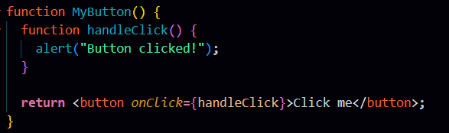

**Special Considerations**:

* + In class components, event handlers need to be bound to the component instance, usually done in the constructor, or by using arrow functions.
  + In functional components, you typically define event handlers as arrow functions or regular functions within the component's body.

**2. Conditional Rendering in React**

* **Definition**: Conditional rendering in React refers to the ability to render different UI elements or components based on certain conditions or state values.
* **How It Works**:
  + Conditional rendering is implemented using JavaScript's conditional operators, such as if, else, ternary operators, or logical && and || operators within JSX.
* **Example**:

javascript

Copy code

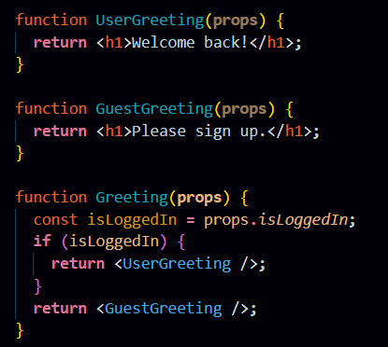

**3. Lists and Keys in React**

* **Definition**: Lists in React are used to render multiple items dynamically by iterating over an array. Keys are unique identifiers for list items that help React optimize rendering.
* **How It Works**:
  + When rendering a list of elements, React requires a key prop on each list item to uniquely identify it.
  + The key helps React determine which items have changed, been added, or been removed, thus improving the performance of list rendering.
* **Example**:

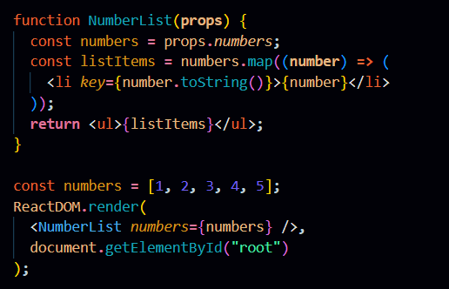

**4. Forms in React**

* **Definition**: Forms in React are used to capture user input. React handles forms differently compared to traditional HTML forms by managing the form state through React's state management system.
* **How It Works**:
  + React controls form elements (like input, textarea, select) by binding their values to component state.
  + Form data is managed through state, and updates are handled using event handlers like onChange.
* **Controlled vs. Uncontrolled Components**:
  + **Controlled Components**: Form elements where the form data is handled by the React component's state.
  + **Uncontrolled Components**: Form elements where the form data is handled by the DOM, typically using ref to access the form values.

**5. Hooks in React**

* **Definition**: Hooks are functions that allow you to use React state and lifecycle features in functional components. Introduced in React 16.8, they enable more powerful and reusable code structures.
* **Common Hooks**:
  + **useState**: Allows you to add state to a functional component.
  + **useEffect**: Lets you perform side effects (e.g., data fetching, subscriptions) in functional components.
  + **useContext**: Provides a way to access React Context in functional components.
  + **useReducer**: A more advanced state management hook, useful for handling complex state logic.
* **Benefits of Hooks**:
  + **Simplifies Code**: Hooks allow you to write cleaner and more concise functional components.
  + **Reusability**: Custom hooks enable the reuse of stateful logic across multiple components.
  + **Improved Readability**: Hooks provide a more straightforward approach to managing state and side effects in components.

**6. React Router**

* **Definition**: React Router is a popular library used to handle routing in React applications. It enables navigation between different views or pages in a React application without reloading the page.
* **How It Works**:
  + React Router uses a declarative syntax to define routes and render corresponding components based on the current URL.
  + It manages the browser history and URL updates while maintaining the SPA (Single Page Application) behavior.
* **Key Features**:
  + **Dynamic Routing**: Routes can be defined dynamically based on app state.
  + **Nested Routes**: Allows for complex routing structures within applications.
  + **Route Parameters**: Supports passing parameters in the URL to dynamic routes.

**7. State Management in React**

* **Definition**: State management in React involves managing the state of various components and sharing state across multiple components. As applications grow, managing state becomes more complex, necessitating state management solutions.
* **How It Works**:
  + **Local State**: Managed within individual components using useState or this.state.
  + **Global State**: Managed using libraries like Redux, MobX, or React Context, which allow state to be shared across multiple components.
* **Challenges**:
  + **State Propagation**: Passing state between deeply nested components can lead to "prop drilling," where props are passed down through multiple levels.
  + **Consistency**: Ensuring that all components have the correct and updated state at all times.
* **State Management Libraries**:
  + **Redux**: A predictable state container that centralizes the app's state and uses actions to describe state changes.
  + **MobX**: A reactive state management library that uses observables for state management.
  + **React Context API**: Provides a simpler way to share global state across components without prop drilling.

**8. React Context API**

* **Definition**: The React Context API is a built-in feature that allows you to share state and data across multiple components without passing props down manually at every level. It provides a way to manage global state.
* **How It Works**:
  + **Context**: A context is created using React.createContext() and provides a Provider component to pass the state down and a Consumer component or the useContext hook to access the state.
  + It's especially useful for managing global app themes, authenticated user data, or any state that needs to be accessible throughout the application.
* **Best Practices**:
  + Avoid overusing Context for all state management needs, as it can lead to complex and hard-to-debug code. For complex state logic, consider using state management libraries like Redux.
  + Use Context primarily for data that truly needs to be shared across many components.

**8) How can you optimize performance of React Application?**

**1. Use React.memo for Component Memoization**

* **What It Does**: React.memo is a higher-order component that prevents a functional component from re-rendering if its props haven't changed.
* **When to Use**: Apply React.memo to functional components that re-render frequently with the same props.

**2. Optimize with useCallback and useMemo**

* **useCallback**: Memoizes a function so that it is only recreated when its dependencies change. This is useful for preventing unnecessary re-renders when passing callbacks to child components.
* **useMemo**: Memoizes the result of a computation, avoiding costly recalculations on every render.

**3. Code Splitting with React.lazy and Suspense**

* **What It Does**: Load parts of your application on demand, reducing the initial load time.
* **How to Implement**: Use React.lazy() for dynamic imports and Suspense for handling loading states.

**4. Avoid Inline Function Definitions in JSX**

* **Issue**: Inline functions create a new function instance on every render, potentially causing unnecessary re-renders.
* **Solution**: Define functions outside of the JSX or use useCallback.

**5. Use PureComponent or shouldComponentUpdate in Class Components**

* **What It Does**: PureComponent automatically implements shouldComponentUpdate, which performs a shallow comparison of props and state.
* **When to Use**: Use for class components where re-renders can be avoided if props or state have not changed.

**6. Efficient List Rendering with Keys**

* **Unique Keys**: Ensure that list items have unique and stable keys to help React efficiently identify which items have changed.

**7. Throttling and Debouncing Event Handlers**

* **What It Does**: Throttling and debouncing limit the frequency of function execution, especially for events like scrolling or resizing.
* **How to Implement**: Use libraries like lodash to implement these techniques.

**8. Optimize Images**

* **Use Modern Formats**: Serve images in modern formats like WebP to reduce file size.
* **Lazy Load Images**: Use the loading="lazy" attribute to defer offscreen images.

**9. Use the React Developer Tools Profiler**

* **What It Does**: The Profiler helps identify which components are rendering and how long each render takes.
* **How to Use**: Analyze and optimize components that take the most time to render.

**10. Minimize Re-renders with React Context**

* **Memoize Context Values**: Prevent unnecessary re-renders by memoizing context values.
* **Split Context**: Avoid using a single context for unrelated state to reduce unnecessary updates.

**11. Server-Side Rendering (SSR) and Static Site Generation (SSG)**

* **SSR/SSG**: Improves initial load time by rendering content on the server or at build time, rather than on the client.
* **Tools**: Use frameworks like Next.js for easy implementation of SSR and SSG.

**12. Tree Shaking and Code Splitting**

* **Tree Shaking**: Remove unused code during the build process with tools like Webpack.
* **Code Splitting**: Break down your code into smaller chunks to be loaded as needed.

**13. Avoid Expensive Reconciliation**

* **What It Is**: Reconciliation is the process React uses to determine which parts of the UI need to be updated.
* **Optimization**: Use shouldComponentUpdate or React.memo to avoid deep tree comparisons and unnecessary re-renders.

**14. Lazy Loading for Components and Resources**

* **Lazy Load**: Delay the loading of components and other resources until they are needed, improving the initial load time.

**15. Bundle Optimization**

* **Minify JavaScript**: Use tools like Terser to minify JavaScript and reduce the size of your bundles.
* **Split Bundles**: Use Webpack to split your bundles into smaller chunks, reducing the amount of code loaded initially.