**Batch: T7**

**Practical No: 6**

**Title of Assignment: Study and Implementation of ReactJS**

**Student Name: Shreeyash Shripad Dongarkar**

**Student PRN: 22510025**

Installation Steps:

Please go to respective directory for each problem statement and then you can use ‘npm install’ command to install all the required dependencies and then ‘npm run dev’ to run the project.

**Problem Statement 1: To-Do List Application with State Management**

Here I've used React to render the UI, leveraging states for dynamic behavior and passing props for managing the state across components. For styling, I've utilized Tailwind CSS to achieve a clean and responsive design.

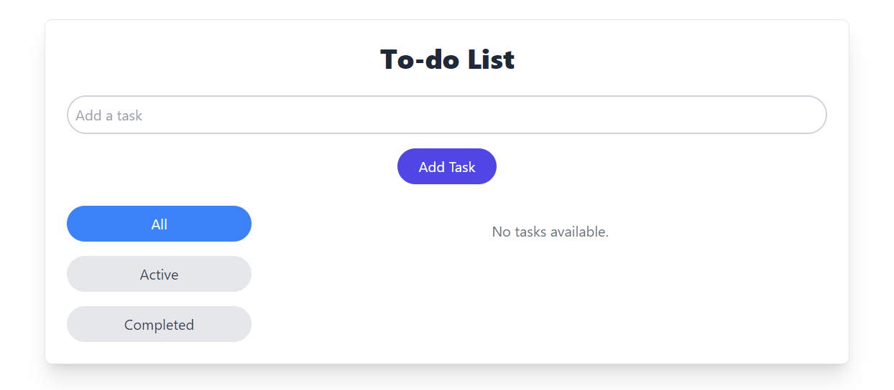

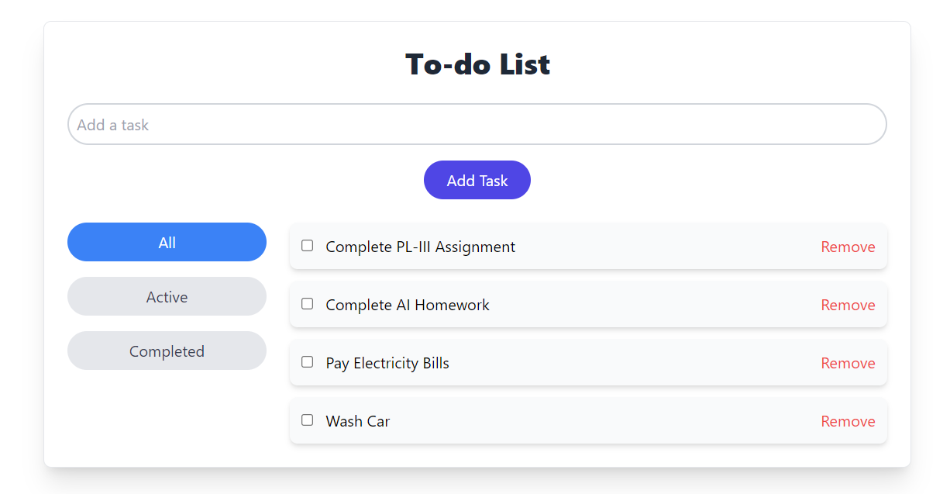

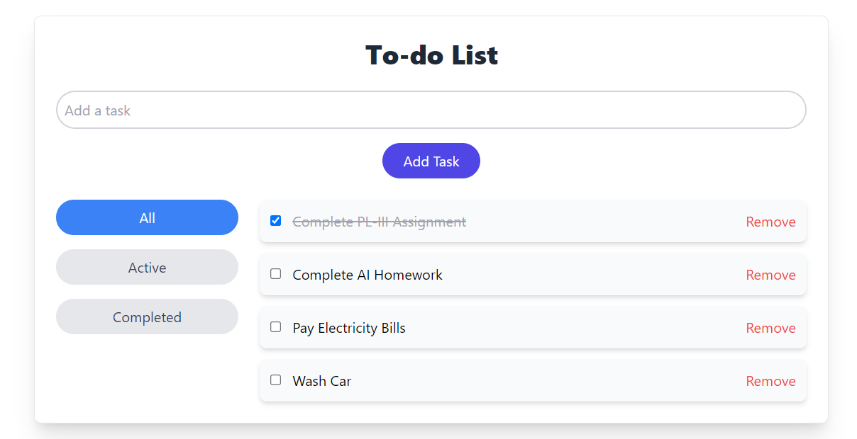

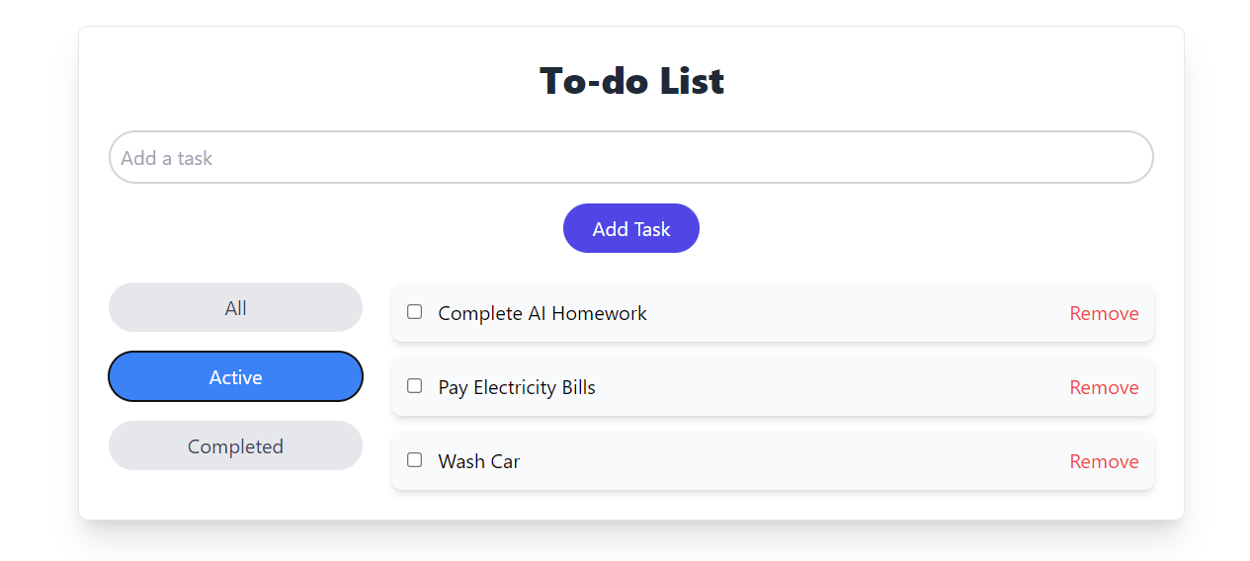

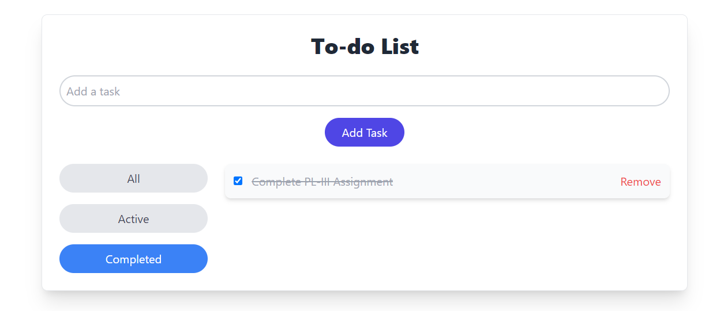

**Problem Statement 2: E-Commerce Cart System**

I've utilized React to build the UI, managing dynamic behavior through state and passing props to handle state across components. For the design, I integrated Material UI, ensuring a sleek and modern interface.

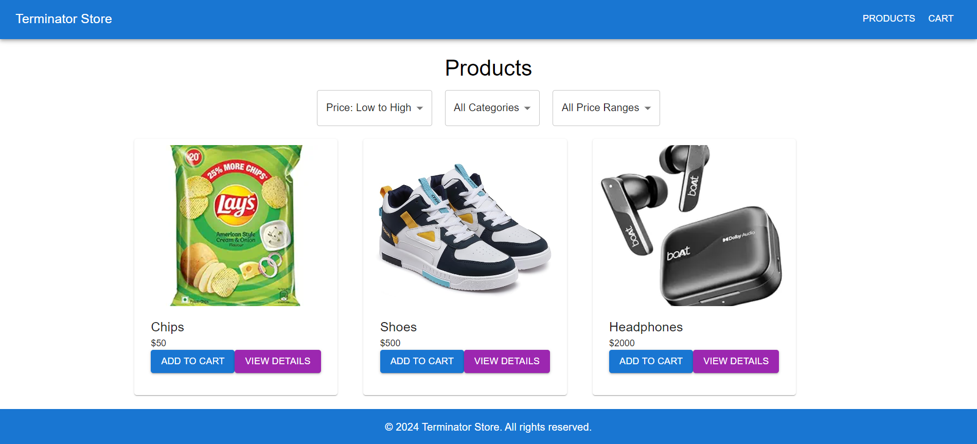

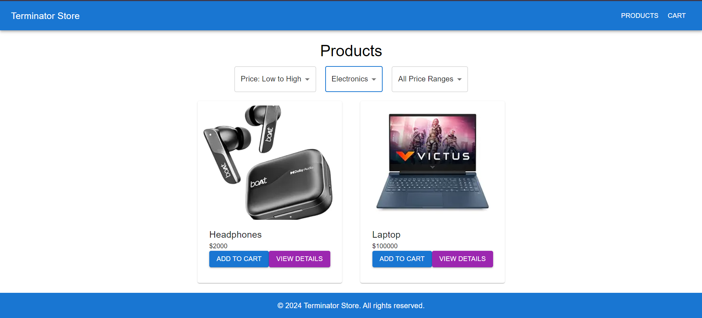

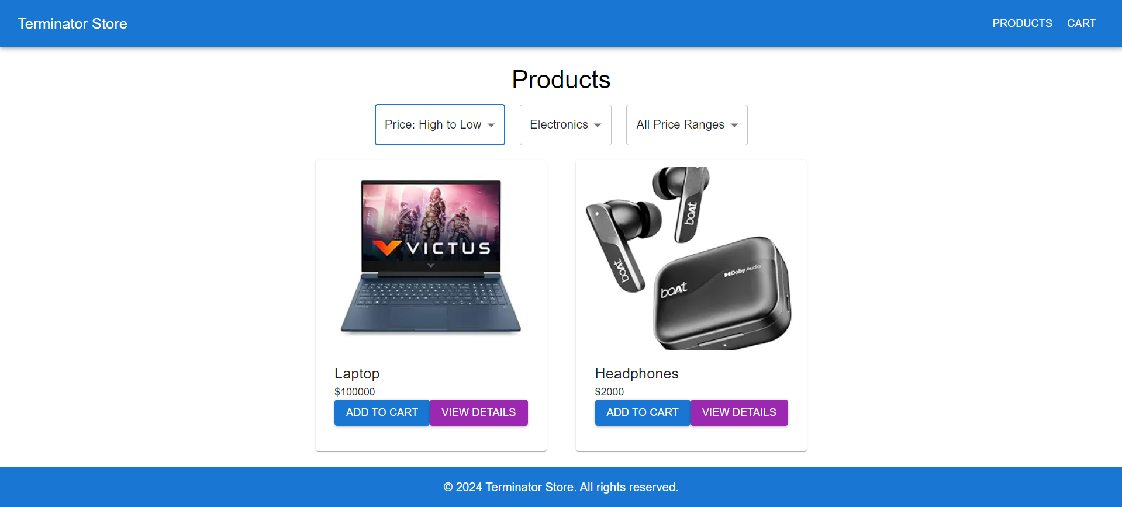

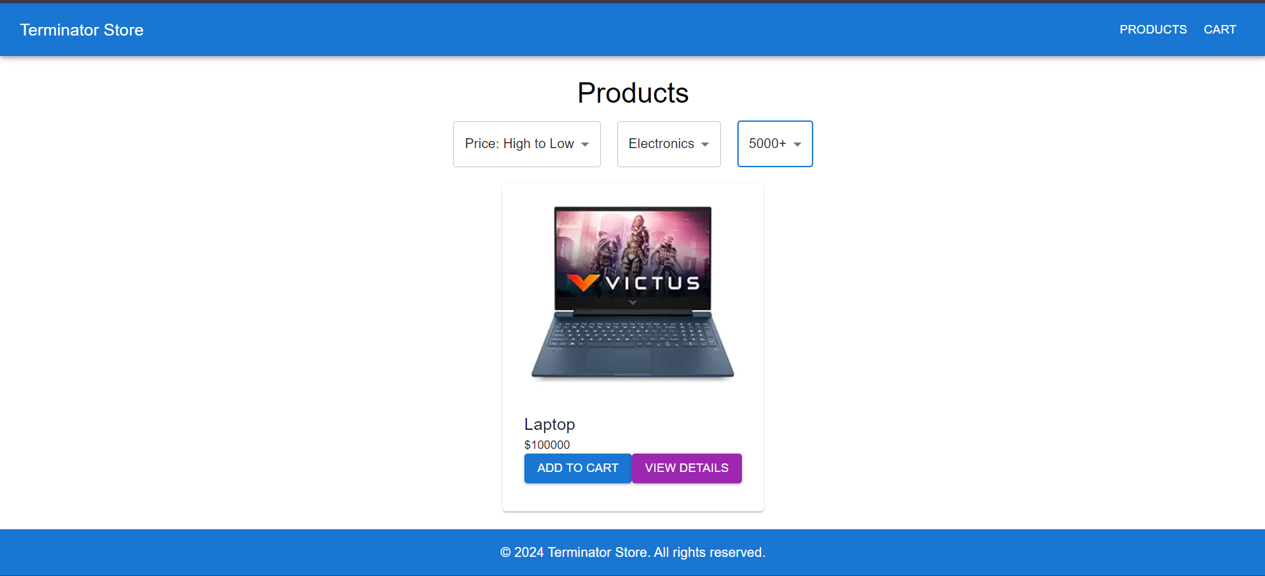

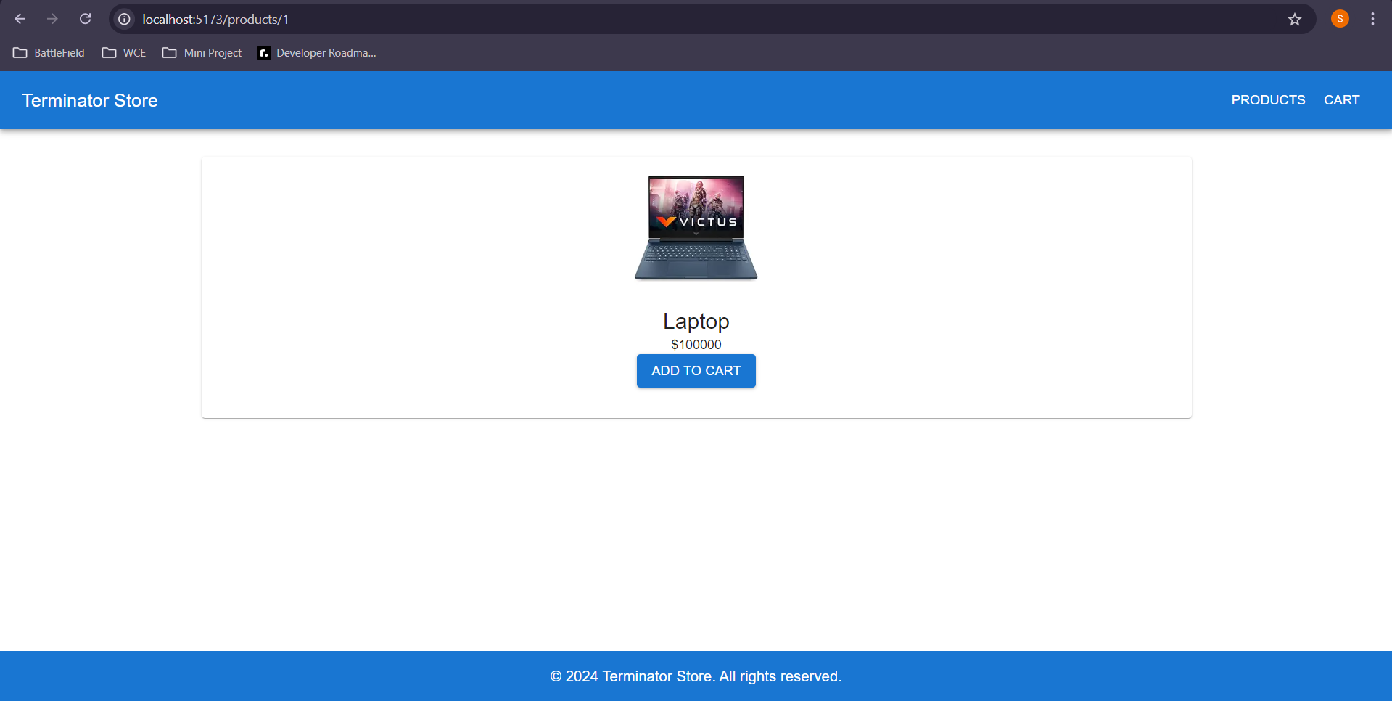

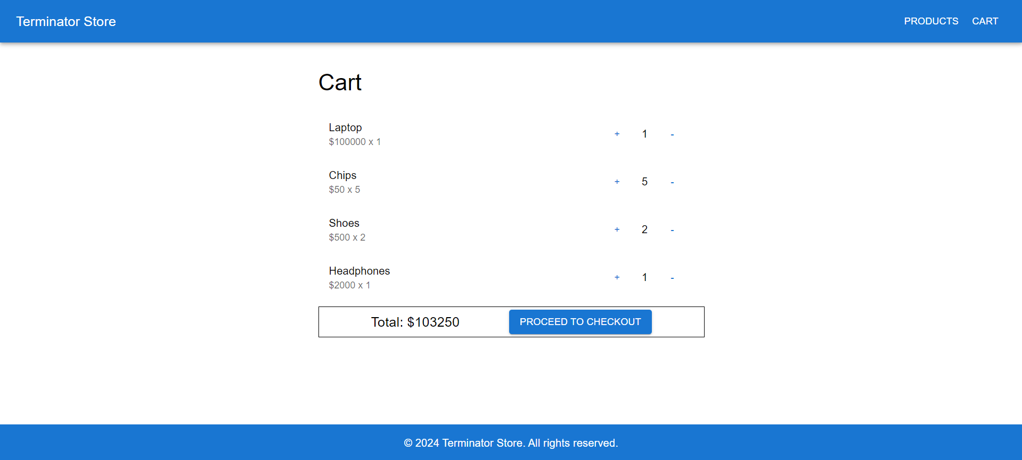

**Problem Statement 3: User Authentication with Context API**

I've implemented the login and logout functionality using the Context API for state management, ensuring a streamlined flow across the application. Tailwind CSS has been used to design a clean and responsive user interface.

