**Batch: T7**

**Practical No: 8**

**Title of Assignment: Study and Implementation of Express.Js**

**Student Name: Shreeyash Shripad Dongarkar**

**Student PRN: 22510025**

**Problem Statement 1: Introduction to Node.js**

**1) What is Node.js, and how does it differ from traditional server-side platforms like Apache or PHP?**

=> Node.js is a JavaScript runtime built on Chrome's V8 engine that allows developers to execute JavaScript code server-side. This enables JavaScript to be used for server-side scripting, allowing for the creation of dynamic web applications. Here are some key features and differences between Node.js and traditional server-side platforms like Apache and PHP:

**Key Features of Node.js:**

1. **Non-blocking I/O**: Node.js uses an event-driven, non-blocking I/O model, which means it can handle multiple connections simultaneously without being blocked by slow operations. This makes it particularly well-suited for I/O-heavy applications, such as real-time chat applications and APIs.
2. **Single-threaded Model**: Node.js operates on a single-threaded event loop, which allows it to handle numerous connections concurrently without the overhead of thread management. This is different from traditional web servers that typically create a new thread or process for each incoming request.
3. **JavaScript Everywhere**: With Node.js, developers can use JavaScript for both client-side and server-side development, leading to a more cohesive development experience and potentially reduced context switching.
4. **NPM (Node Package Manager)**: Node.js has a rich ecosystem of libraries and packages available through NPM, making it easy to extend functionality and use third-party modules.
5. **Asynchronous Programming**: Node.js encourages asynchronous programming, making it easier to build scalable applications that can handle many connections without blocking.

**Differences from Traditional Server-Side Platforms:**

1. **Architecture**:
   * **Node.js**: Uses an event-driven, non-blocking architecture, which allows it to handle many concurrent connections efficiently.
   * **Apache/PHP**: Typically uses a multi-threaded or process-based model where a new thread or process is spawned for each request, which can lead to higher resource consumption under heavy loads.
2. **Language**:
   * **Node.js**: Primarily uses JavaScript.
   * **Apache/PHP**: PHP is a server-side scripting language commonly used with the Apache HTTP Server. While Apache can serve any type of content, PHP is specifically designed for web development.
3. **Performance**:
   * **Node.js**: Due to its non-blocking I/O and single-threaded model, Node.js often performs better for applications that require high concurrency, such as real-time applications and APIs.
   * **Apache/PHP**: Can be slower for high-concurrency applications because of the overhead of managing multiple threads or processes.
4. **Use Cases**:
   * **Node.js**: Ideal for real-time applications (like chat applications), REST APIs, microservices, and applications that require high concurrency.
   * **Apache/PHP**: Traditionally used for serving dynamic web pages, content management systems (like WordPress), and applications where traditional server-side rendering is sufficient.

**2) What is purpose of V8 Engine in Node.js?**

=> The V8 engine plays a crucial role in Node.js, serving as its underlying JavaScript runtime environment. Here are the primary purposes and features of the V8 engine in Node.js:

**1. JavaScript Execution**

* **Fast Execution**: V8 compiles JavaScript code into native machine code before executing it, which significantly enhances performance compared to interpreting the code line by line. This just-in-time (JIT) compilation allows Node.js to execute JavaScript code rapidly, making it suitable for high-performance applications.

**2. Memory Management**

* **Garbage Collection**: V8 includes an efficient garbage collector that automatically manages memory allocation and deallocation. This helps prevent memory leaks and optimizes memory usage, ensuring that applications run smoothly without manual memory management.

**3. Optimizations**

* **Runtime Optimizations**: V8 employs various optimization techniques, such as inline caching and hidden classes, to speed up the execution of frequently used code. This dynamic optimization process helps improve performance over time as the engine learns about the code being executed.

**4. Support for ECMAScript Features**

* **Modern JavaScript Syntax**: V8 supports the latest ECMAScript (JavaScript) standards, allowing developers to use modern language features, such as async/await, promises, destructuring, and more. This makes it easier to write clean and efficient code.

**5. Event Loop and Non-blocking I/O**

* **Asynchronous Programming Model**: V8 works closely with Node.js's event-driven architecture, allowing it to handle asynchronous operations efficiently. The event loop, powered by V8, enables Node.js to manage multiple concurrent connections without blocking the execution thread.

**6. Cross-platform Compatibility**

* **Portability**: V8 is designed to be portable and can run on various platforms, including Windows, macOS, and Linux. This cross-platform capability allows Node.js applications to be deployed and executed consistently across different environments.

**7. C++ Integration**

* **Native Addons**: V8 allows developers to write native C++ addons, which can be integrated into Node.js applications for performance-critical operations or to leverage existing C/C++ libraries. This extensibility is valuable for applications requiring high-performance computing or integration with native modules.

**3) Explain the single-threaded, event-driven architecture of Node.js.**

=> Node.js utilizes a single-threaded, event-driven architecture that distinguishes it from traditional multi-threaded server models. This design allows Node.js to handle multiple connections efficiently without the overhead of managing multiple threads. Here’s a detailed explanation of how this architecture works:

**1. Single-Threaded Model**

* **Event Loop**: Node.js operates on a single thread, meaning it uses one main execution thread for running JavaScript code. This main thread is called the event loop. While it may seem limiting, this design simplifies the programming model and avoids complexities associated with multi-threading, such as race conditions and deadlocks.
* **Non-Blocking I/O**: Node.js employs non-blocking I/O operations, which allows the event loop to initiate I/O tasks (like reading files, querying databases, etc.) and then continue processing other tasks without waiting for the I/O operation to complete. When an I/O operation completes, a callback function associated with that operation is invoked to handle the result.

**2. Event-Driven Architecture**

* **Event Loop Mechanism**: The event loop continuously checks for events and processes them. When an asynchronous operation completes, the event loop picks up the callback from a queue (also known as the callback queue) and executes it. This cycle allows Node.js to efficiently manage multiple operations simultaneously.
* **Callbacks and Promises**: In Node.js, callbacks are functions passed as arguments to asynchronous functions. When the asynchronous operation finishes, the callback is executed. Promises and async/await syntax also facilitate handling asynchronous operations, making the code cleaner and easier to read.

**3. How it Works in Practice**

1. **Handling Requests**: When a request is received, the Node.js application does not create a new thread for it. Instead, it processes the request using the main event loop.
2. **Initiating Asynchronous Tasks**: If the request involves I/O operations (like database access or file reading), Node.js sends these tasks to the underlying system (using system libraries) and moves on to the next task without blocking.
3. **Event and Callback Processing**: Once the I/O operation completes, the system triggers an event. The event loop then places the associated callback in the callback queue.
4. **Executing Callbacks**: The event loop continues to run, checking the callback queue. When the main thread is free, it executes the callbacks in the order they were received.

**4. Advantages of this Architecture**

* **High Concurrency**: The single-threaded, non-blocking model allows Node.js to handle a large number of concurrent connections without the overhead of thread management, making it highly efficient for I/O-bound applications.
* **Simplicity**: Developers can write asynchronous code without dealing with the complexities of multi-threading, making it easier to build scalable applications.
* **Performance**: Since Node.js can handle many operations simultaneously, it is well-suited for real-time applications, such as chat applications, online gaming, and collaborative tools.

**5. Limitations**

* **CPU-Intensive Tasks**: While Node.js excels at I/O-bound tasks, it may struggle with CPU-intensive operations. If a task requires significant processing power, it can block the event loop, causing delays in handling other requests. For such cases, developers often use worker threads or offload heavy computations to separate processes.

**4) Why is Node.js considered non-blocking?**

=> Node.js is considered non-blocking primarily due to its event-driven architecture and the way it handles I/O operations. Here’s a breakdown of what makes Node.js non-blocking and why this is a significant feature:

**1. Asynchronous I/O Operations**

* **Non-Blocking I/O Model**: In Node.js, when an I/O operation (such as reading a file, querying a database, or making a network request) is initiated, it does not wait for the operation to complete before moving on to the next task. Instead, the operation is started, and control is returned immediately to the event loop. This means that Node.js can continue executing other code while the I/O operation is being processed.

**2. Event Loop Mechanism**

* **Event Loop**: The event loop is the core of Node.js's non-blocking behavior. It continuously checks for events and processes them. When an asynchronous operation completes, its associated callback is added to a queue. The event loop picks up these callbacks and executes them only when the main thread is free, ensuring that the execution of one task doesn’t block others.

**3. Callbacks and Promises**

* **Callbacks**: Node.js uses callbacks to handle the results of asynchronous operations. When initiating an I/O operation, developers provide a callback function that will be called once the operation completes. This allows the application to remain responsive while waiting for I/O operations to finish.
* **Promises and Async/Await**: Modern JavaScript features like Promises and the async/await syntax further facilitate non-blocking code. They allow developers to write asynchronous code in a more readable and manageable way, making it easier to handle multiple I/O operations without blocking the execution flow.

**5) What is npm and how it is used in Node.js?**

=> NPM (Node Package Manager) is a package manager for JavaScript and is the default package manager for Node.js. It plays a crucial role in the Node.js ecosystem by facilitating the management of libraries, frameworks, and other tools that can be easily installed, shared, and updated. Here’s an overview of NPM, its features, and how it is used in Node.js:

**What is NPM?**

1. **Package Management**: NPM allows developers to install and manage third-party libraries or packages that can be used in their Node.js applications. These packages can range from simple utility libraries to complex frameworks.
2. **Registry**: NPM has a vast online registry where developers can publish their packages and share them with the community. The registry contains millions of packages that can be easily accessed and integrated into projects.
3. **CLI Tool**: NPM provides a command-line interface (CLI) that allows developers to interact with the package management system directly from the terminal. This includes commands for installing, updating, and removing packages.

**Key Features of NPM**

* **Dependency Management**: NPM automatically manages package dependencies, ensuring that all required packages are installed and up to date. It resolves version conflicts and helps avoid "dependency hell."
* **Scripts**: NPM allows developers to define custom scripts in the package.json file, making it easy to automate tasks like testing, building, or starting an application.
* **Version Control**: NPM manages package versions, enabling developers to specify which versions of a package their project depends on, ensuring stability and consistency.
* **Global and Local Installations**: NPM supports both global and local installations of packages. Global packages are installed system-wide and can be used across different projects, while local packages are installed within a specific project directory.

**6) What is module in Node.js? How do you export and import modules in Node.js?**

=> In Node.js, a **module** is a self-contained piece of code that encapsulates functionality, allowing developers to organize and reuse code effectively. Modules can be built-in (like fs for file system operations), third-party (installed via NPM), or custom modules created by developers.

**Benefits of Using Modules**

1. **Encapsulation**: Modules allow you to encapsulate code, keeping related functionality together and exposing only what is necessary.
2. **Reusability**: Once a module is created, it can be reused across different parts of an application or even in other applications.
3. **Maintainability**: Breaking code into modules makes it easier to maintain and test.

**Exporting and Importing Modules**

**1) Using CommonJs Modules**

- Here you can export functions, objects or variables from a module using module.exports or exports and we can import using require() function.

**-** Here modules are loaded synchronously and this behavior is suitable for servers-side applications.

**2) Using ES6 Modules**

**-** If we are using an environment that supports ES6 modules we can use import and export directly.

- This imports module asynchronously and is suitable for client-side applications.

**7) What is the difference between require() and import in Node.js?**

=> The differences between require() and import in Node.js without using a table format:

**1. Module System**

* **require()**: This is part of the CommonJS module system, which has been the standard for Node.js since its inception. It allows you to load modules synchronously.
* **import**: This belongs to the ES6 module system (ESM), which is a standardized module format introduced in ECMAScript 2015 (ES6). It allows for more flexible module loading, including asynchronous loading.

**2. Syntax**

* **require()**: You use it like this: const module = require('module');.
* **import**: The syntax is different. You can import a default export using import module from 'module'; or named exports with import { namedExport } from 'module';.

**3. Loading Behavior**

* **require()**: Modules are loaded synchronously. When the code hits a require() statement, it reads and executes the module immediately.
* **import**: Imports are asynchronous, meaning they can be loaded in the background, allowing the execution of other code to continue.

**4. Execution Timing**

* **require()**: The module is executed at the point where require() is called. If you try to use a module before requiring it, you’ll get an error.
* **import**: All imports are hoisted to the top of the module. This means you can use imported functions or variables anywhere in the module, even before the import statement appears.

**5. Dynamic Imports**

* **require()**: While you can conditionally load modules using require(), it doesn't support dynamic imports like ES6 modules.
* **import**: Supports dynamic imports using the import() function, allowing you to load modules on demand, which is especially useful for optimizing performance in web applications.

**6. File Extension**

* **require()**: Typically used with .js files.
* **import**: Commonly used with .mjs files or .js files when the "type": "module" field is set in package.json.

**7. Compatibility**

* **require()**: It is fully supported in all versions of Node.js.
* **import**: Requires Node.js version 12 or higher and needs specific configuration (like using .mjs files or setting "type": "module" in package.json) to work properly.

**8) How can you create a custom module in Node.js?**

=> Steps to create a custom module

Step 1: Create a New File for Your Module

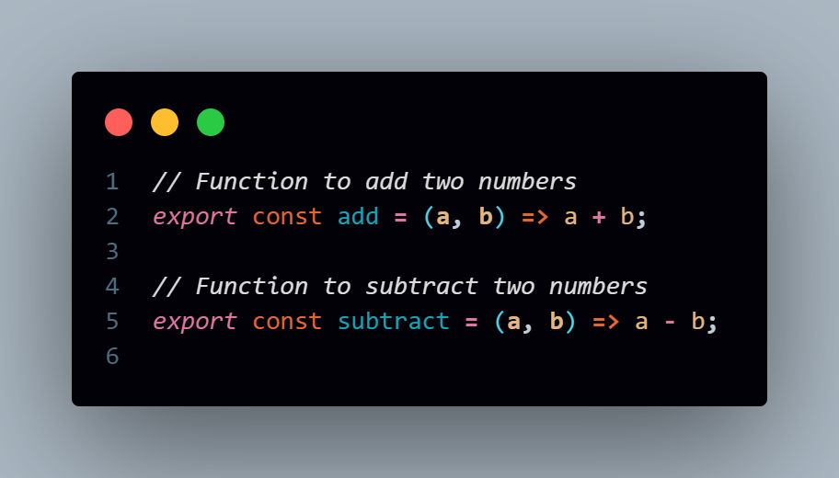

Step 2: Create Main File to use your Module

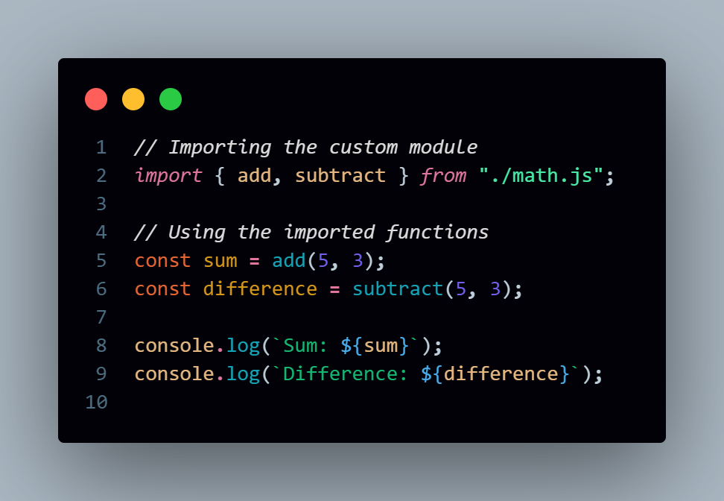

**9) What is the role of the package.json file in a Node.js project?**

=> The package.json file is a crucial component of a Node.js project. It serves multiple roles, providing essential information about the project, managing dependencies, and defining various project configurations. Here are the key roles of the package.json file:

**1. Project Metadata**

* **Basic Information**: It contains metadata about the project, including:
  + name: The name of the project.
  + version: The current version of the project.
  + description: A brief description of the project.
  + author: The name of the author or organization.
  + license: The license under which the project is distributed.
  + repository: Information about the source code repository (e.g., GitHub).

**2. Dependencies Management**

* **Listing Dependencies**: It specifies the dependencies required for the project. This includes:
  + dependencies: Packages needed for the application to run in production.
  + devDependencies: Packages needed only for development (e.g., testing frameworks, build tools).

**3. Scripts Section**

* **Defining Scripts**: It allows you to define custom scripts to automate tasks. You can run these scripts using npm run <script-name>.

**4. Configuration Options**

* **Project Configuration**: It can hold configuration options for various tools and packages. For example, you can specify settings for build tools, linters, or testing frameworks directly in the package.json.

**5. Entry Point**

* **Main File**: It defines the main entry point of the application through the main field. This tells Node.js which file to load when the module is required.

**6. Version Control**

* **Semantic Versioning**: The package.json file supports semantic versioning, allowing you to specify the versioning strategy for your dependencies. This helps in managing updates and compatibility.

**7. Install Instructions**

* **Install Dependencies**: When you run npm install, it reads the package.json file to install all the listed dependencies and devDependencies automatically.

**8. Engines and Compatibility**

* **Node.js Version**: It can specify the version of Node.js (or other engines) that the project is compatible with, helping to prevent runtime issues.

**10) How do you install a package globally and locally using npm?**

=>

**Installing a Package Locally**

When you install a package locally, it gets added to the node_modules directory of your project, and its version will be recorded in your package.json file. This is the most common way to install packages, as it ensures that the package is specific to the project.

**Command to install a package locally:** npm install <package-name>

**Installing a Package Globally**

When you install a package globally, it becomes available system-wide, allowing you to run it from the command line in any project. Global installations are typically used for command-line tools.

**Command to install a package globally:** npm install -g <package-name>

**11) What is the difference between asynchronous and synchronous programming in Node.js?**

=> The difference between asynchronous and synchronous programming in Node.js primarily revolves around how operations are executed and managed, especially in terms of blocking and non-blocking behavior.

**1. Synchronous Programming**

* **Blocking Nature**: In synchronous programming, operations are executed one after the other, meaning the execution of code stops until the current operation completes. This can lead to blocking, where the entire program waits for a long-running operation to finish before moving on.
* **Execution Flow**: The flow of execution is straightforward and linear. Each line of code is executed in order, and the next line waits for the current one to finish.
* **Use Cases**: Synchronous programming is often simpler and easier to understand for operations that are quick and do not involve waiting, like simple calculations or immediate file reads.

**2. Asynchronous Programming**

* **Non-Blocking Nature**: In asynchronous programming, operations can be initiated and then continue without waiting for their completion. This means the program can execute other code while waiting for a long-running operation to finish.
* **Execution Flow**: The flow is more complex and may not be linear. Callbacks, promises, or async/await syntax are used to handle the completion of asynchronous operations.
* **Use Cases**: Asynchronous programming is beneficial for I/O operations, such as reading files, making HTTP requests, or accessing databases, where waiting for a response can leads to efficient use of resources.

**12) How do you create an HTTP server in Node.js?**

=> **Step 1: Import the http Module**

First, you need to import the http module that comes with Node.js. This module provides functionalities to create and manage an HTTP server.

**Step 2: Create the Server**

The http.createServer() method is used to create an HTTP server. This method takes a callback function that will be executed whenever a request is made to the server. The callback function has two parameters:

* req (request): Represents the incoming request.
* res (response): Represents the outgoing response.

**Step 3: Listen on a Port**

After creating the server, you need to specify a port where the server will listen for incoming requests. Use the server.listen() method to bind the server to a specific port.

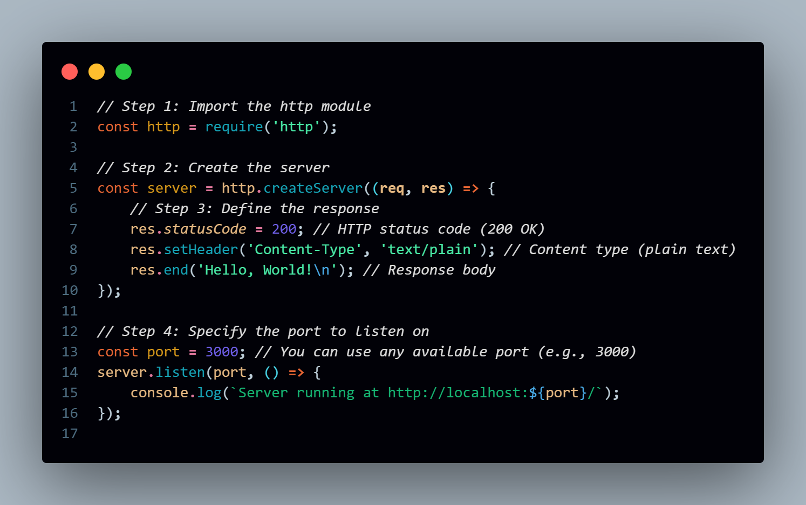

**13) What is the difference between http.createServer() and using frameworks like Express.js?**

=> The main difference between using http.createServer() (the built-in Node.js HTTP module) and using a framework like **Express.js** lies in the level of abstraction and ease of use. Express simplifies and enhances the process of building web applications, while http.createServer() provides more basic, lower-level control.

**1. Level of Abstraction**

* **http.createServer()**:
  + It is low-level and provides only the basic tools needed to handle HTTP requests and responses.
  + You have to manually handle things like parsing URL parameters, routing, request body parsing (e.g., JSON or form data), handling cookies, and more.
  + The developer has more control but needs to write more code for common tasks.
* **Express.js**:
  + It provides a higher-level abstraction over http.createServer() and includes built-in features for routing, middleware, parsing, and more.
  + Express simplifies handling requests and responses, allowing you to focus on your application logic instead of boilerplate code.
  + It offers a rich ecosystem of middleware to handle features like authentication, logging, input validation, error handling, etc.

**2. Routing**

* **http.createServer()**:
  + Routing is manual. You need to inspect req.url and req.method to define and manage routes.
* **Express.js**:
  + Routing is much simpler and cleaner with Express. You can define routes using the app.get(), app.post(), etc. methods.

**3. Middleware Support**

* **http.createServer()**:
  + No built-in support for middleware. You need to write your own logic to handle tasks like logging, authentication, input validation, etc.
  + Handling features like body parsing (e.g., JSON, URL-encoded data) requires using additional packages and writing custom middleware-like logic.
* **Express.js**:
  + Express has built-in support for middleware, which allows you to easily extend the functionality of your app by adding multiple layers of functionality to the request/response cycle.
  + There are many third-party middleware packages available, such as morgan for logging, body-parser for parsing request bodies, etc.

**4. Request Parsing**

* **http.createServer()**:
  + Manually parsing request bodies (e.g., JSON, URL-encoded, or multipart form data) requires extra code and third-party libraries.
  + You typically have to handle streams and buffers for request data, which adds complexity.
* **Express.js**:
  + Express makes it easy to parse incoming request bodies using built-in middleware like express.json() and express.urlencoded() for JSON and URL-encoded data.

**5. Third-Party Integrations**

* **http.createServer()**:
  + While it can be extended using third-party libraries, you need to integrate and manage these libraries manually.
  + Things like authentication, templating engines, and session management are not included out-of-the-box.
* **Express.js**:
  + Express has a large ecosystem of plugins and middleware for features like session management (express-session), authentication (e.g., Passport.js), and templating engines (e.g., Pug, EJS).
  + You can easily extend your application by installing and configuring these packages with minimal setup.

**6. Code Readability and Maintenance**

* **http.createServer()**:
  + The code can become hard to maintain as the app grows because you need to handle routing, parsing, and middleware manually.
  + More boilerplate code is needed to perform common web tasks.
* **Express.js**:
  + Express abstracts away much of the complexity, making the code cleaner and easier to maintain.
  + You can focus on your application logic, while Express takes care of the routing, middleware, and request handling.

**7. Performance**

* **http.createServer()**:
  + Since it's a more minimal, low-level API, it can be slightly faster than Express because there’s less overhead.
  + However, this performance gain is generally minimal in most real-world applications and can be outweighed by the extra development effort.
* **Express.js**:
  + Express is built on top of http.createServer(), so there is some additional overhead. However, this performance trade-off is often negligible, especially given the simplicity and developer productivity it offers.

**Problem Statement 2: Middleware (Express.Js)**

**1) What is middleware in Node.js particularly in context of Express.js?**

=> In the context of **Express.js**, **middleware** refers to functions that have access to the **request object (req)**, the **response object (res)**, and the **next middleware function** in the application’s request-response cycle. Middleware functions can perform tasks such as:

* Executing code
* Modifying the req and res objects
* Ending the request-response cycle
* Calling the next middleware function

If a middleware function doesn't end the request-response cycle (e.g., by sending a response), it must call next() to pass control to the next middleware function. Otherwise, the request will hang.

**Key Features of Middleware in Express.js**

1. **Executed in Order**: Middleware is executed in the order it is defined in your Express app.
2. **Chained Execution**: Middleware functions can pass control to the next function by calling next(). Without calling next(), the request won't move forward in the chain.
3. **Multiple Uses**: Middleware can be used to handle a wide range of tasks like:
   1. Request Logging
   2. Request Parsing (JSON, form data)
   3. Authentication
   4. Error Handling

**2) How do you create custom middleware in Express.Js?**

=> Creating custom middleware in Express.js is straightforward. You simply define a function that takes three arguments: req, res, and next. This function can perform any tasks you want—like logging requests, modifying the request or response objects, or handling errors—and must call next() to pass control to the next middleware in the stack (unless you end the request-response cycle by sending a response).

**Steps to Create Custom Middleware**

1. **Define the Middleware Function**: Create a function that takes req, res, and next as parameters.
2. **Implement the Logic**: Write the code for the logic you want to execute.
3. **Call next()**: If you want the request to continue to the next middleware, call next(). If you’re ending the response, you don’t need to call next().
4. **Use the Middleware in Your Express App**: Register the middleware using app.use() or with specific routes.

**3) Explain how middleware is executed in order in an Express.js application.**

=> In an Express.js application, middleware is executed in the order in which it is defined. This sequential execution allows developers to control the flow of requests through the application and perform various tasks at different stages of the request-response lifecycle.

**How Middleware Execution Works**

1. **Order of Definition**: Middleware functions are registered using app.use() or specific route handlers (app.get(), app.post(), etc.). The order in which these middleware functions are defined in the code determines the order of their execution.
2. **Request Lifecycle**: When a request is received by the Express server, it goes through the following steps:
   * The server checks the incoming request against the defined middleware in the order they were registered.
   * Each middleware function is called in sequence until one of the following conditions is met:
     + The middleware calls next(), which passes control to the next middleware function.
     + The middleware ends the request-response cycle by sending a response to the client.
3. **Conditional Execution**: Middleware can be conditionally executed based on the request method or URL. This allows you to have specific middleware functions handle certain routes or request types.
4. **Error Handling**: If an error occurs in any middleware, it can be passed to the next middleware in the stack by calling next(err), where err is the error object. This is typically caught by an error-handling middleware defined later in the stack.

**Problem Statement 3: File System Module**

**1) How do you read and write files using the fs module in Node.js?**

=> In Node.js, the fs (File System) module allows you to interact with the file system for reading, writing, and managing files. You can perform both asynchronous and synchronous file operations using the fs module.

1) Reading Files:

- We can use fs.readFile() to read a file asynchronously meaning the code doesn’t block execution while waiting for the file to be read.

- If fs.readFileSync() used then it blocks execution until the file is fully read.

2) Writing Files:

- We can use fs.writeFile() to write to a file asynchronously meaning the code doesn’t block execution while waiting for the file to be written.

- If fs.writeFileSync() used then it blocks execution until the file is fully written.

**2) What is the difference between fs.readFile() and fs.readFileSync()?**

=> The main difference between fs.readFile() and fs.readFileSync() in Node.js is **how they handle reading files** with respect to **asynchronous vs. synchronous** execution.

1) fs.readFile() (Asynchronous)

- This is asynchronous means when this is used it does not block execution of the program. When you call it, Node.js continues executing subsequent code while the file is being read in the background. Once the file reading is complete, a callback function is invoked with the result.

2) fs.readFileSync() (Synchronous)

- This is synchronous and blocks the execution of the rest of the program until the file is fully read. The code following the fs.readFileSync() call will not be executed until the file reading operation is complete. The function returns the file content or throws an error, which can be handled with a try-catch block.

**3) How can you check if a file or directory exists in Node.js?**

=> In Node.js, you can check if a file or directory exists using a few different methods provided by the fs (File System) module. The most common ones are fs.existsSync() for synchronous checks and fs.access() for asynchronous checks. fs.existsSync() is a simple and straightforward way to check if a file or directory exists. It blocks execution until it completes, which makes it useful in cases where blocking is acceptable. fs.access() checks the existence of a file or directory asynchronously. This method does not block the event loop, making it a better choice for production applications where non-blocking behavior is preferred.

**4) How do you handle file operations in an asynchronous manner?**

=> In Node.js, asynchronous file operations are a common pattern for handling I/O tasks, ensuring non-blocking, efficient code execution. The fs (File System) module provides several asynchronous methods for file operations like reading, writing, and appending files. These methods rely on callbacks, promises, or async/await patterns to handle the completion of the file operation without blocking the event loop.

1) Using callbacks for Asynchronous File Operations

- The typical format for the callback is callback(err, result), where err contains any error encountered and result contains the operation's result (like file data).

2) Using Promises for Asynchronous File Operations

- To avoid "callback hell" (i.e., deeply nested callbacks), Node.js introduced fs.promises, which provides a promise-based API for handling file operations.

3) Using async/await for Asynchronous File Operations

- The async/await syntax, built on top of promises, makes asynchronous code look more like synchronous code, making it more readable and easier to manage.

**Problem Statement 4: Database Connectivity**

**1) How do you connect to a SQL or Oracle database from a Node.js application?**

**=> To connect to a SQL or Oracle database from a Node.js application, you need to use specific packages that allow interaction with these databases.**

**1. Install the mysql2 package: npm install mysql2**

**2. Create a connection:**

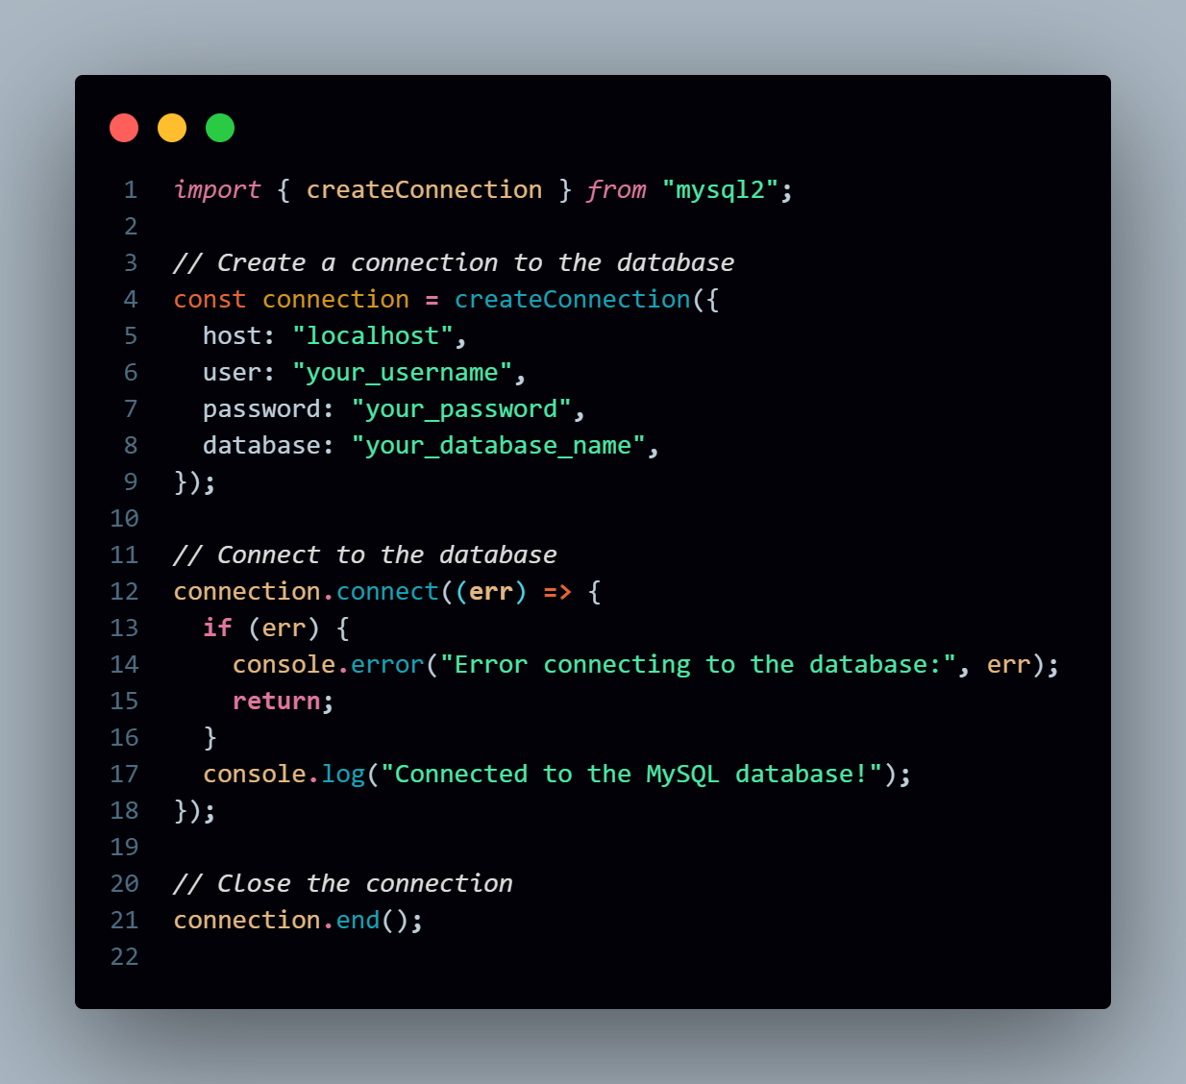

**2) What is the purpose of the mysql2 library in Node.js?**

=> The mysql2 library in Node.js serves the purpose of enabling applications to interact with MySQL databases. It allows you to perform various database operations, such as running queries, inserting data, updating records, and managing database connections, all from a Node.js application.

**1) Database Connectivity:** mysql2 provides a way to connect your Node.js application to a MySQL database. It handles the creation, management, and termination of database connections.

2) **Executing Queries:** You can execute SQL queries (e.g., SELECT, INSERT, UPDATE, DELETE) directly from Node.js using this library. It returns the results in an easy-to-work-with format (arrays or objects).

3) **Prepared Statements (SQL Injection Protection):** One of the main advantages of mysql2 is its support for prepared statements, which help prevent SQL injection attacks. Prepared statements separate the SQL code from the user input, making queries safer.

4) **Support for Promises and Callbacks:** mysql2 supports both traditional callback-based operations and the newer, more flexible promise-based operations. This is useful for asynchronous programming, especially when using async/await syntax.

5) **Efficient and Optimized:** mysql2 is built to be fast and efficient, making it more performant compared to the older mysql library. It offers better performance due to binary protocol support, especially when dealing with large data sets.

6) **Compatibility with MySQL Features:** The mysql2 library fully supports MySQL features, including:

* Transactions
* Binary data handling
* Stored procedures
* MySQL's native PreparedStatements and PreparedStatements caching

7) **Connection Pooling:** mysql2 provides built-in support for connection pooling, which is essential for optimizing performance when handling multiple requests to a database. Connection pooling reuses database connections to avoid the overhead of constantly creating and closing new connections.

8) **UTF-8 and Unicode Support:** mysql2 ensures that Unicode characters are handled correctly, making it suitable for applications that require multi-language support or need to handle special characters.

9) **Streaming Query Results:** mysql2 allows streaming of large query results in chunks, which is helpful when working with very large datasets that could overwhelm your application’s memory if loaded all at once.

**3) Explain how you would perform basic CRUD operations (Create, Read, Update, Delete) using MySQLand Node.js.**

=> Performing basic CRUD (Create, Read, Update, Delete) operations using MySQL and Node.js involves interacting with a MySQL database via SQL queries.

**A. Create (Insert Data into the Database)**

To insert data into a table, use the INSERT INTO statement.

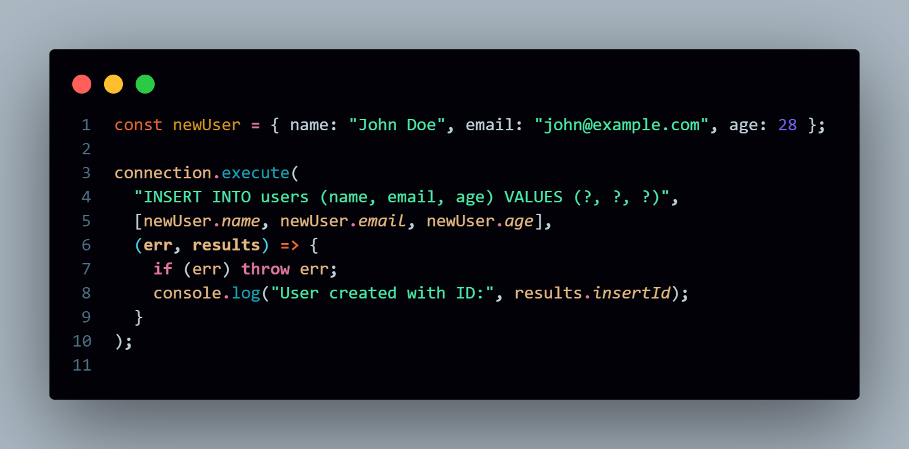

**B. Read (Retrieve Data from the Database)**

To retrieve data, use the SELECT statement.

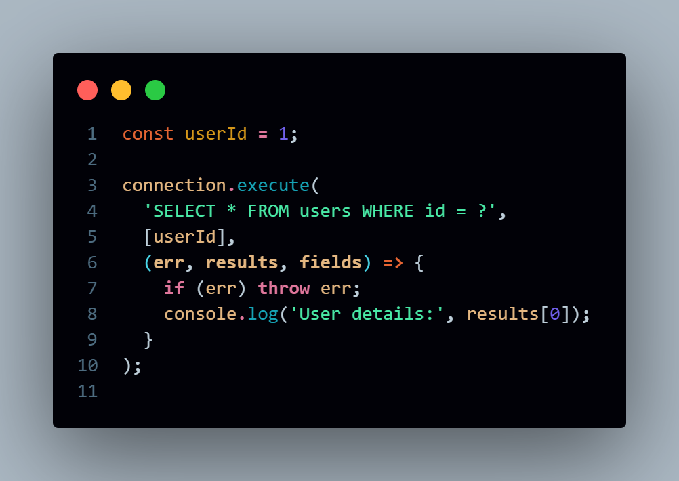

**C. Update (Modify Existing Data in the Database)**

To update data, use the UPDATE statement.

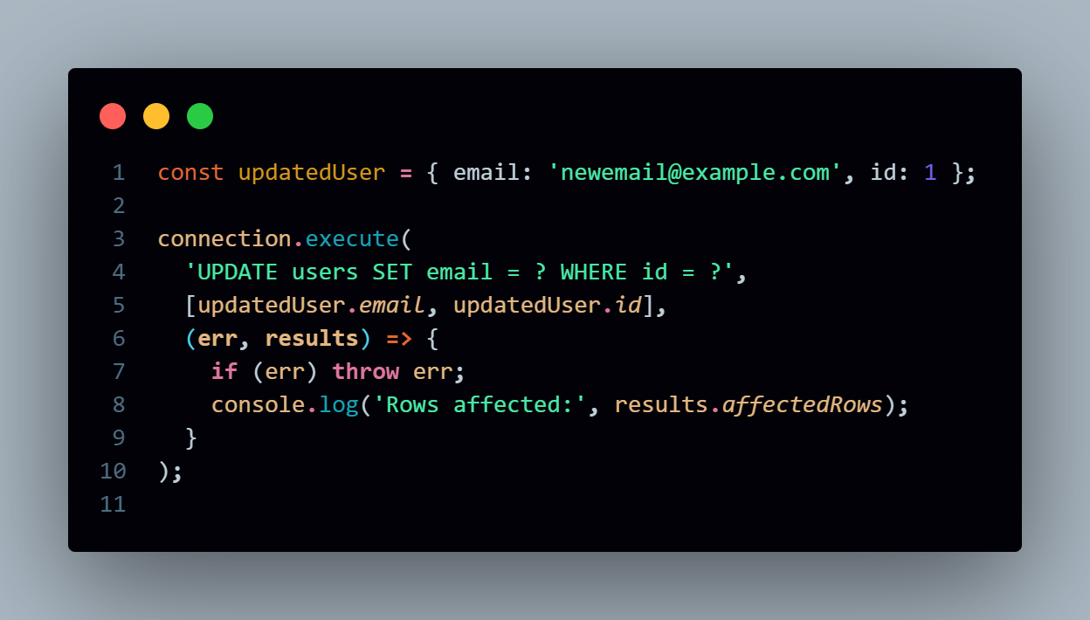

**D. Delete (Remove Data from the Database)**

To delete data, use the DELETE statement.

