## Problem 3 – Sheets

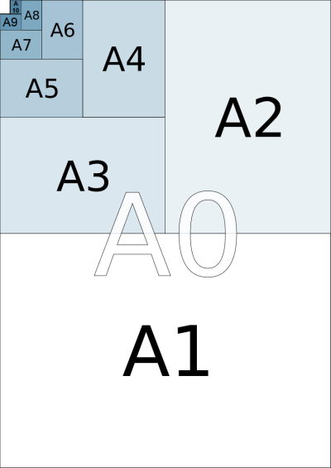Asya loves confetti. One day she decided to create exactly **N** small **pieces** of sheets **with paper size A10**.

A10 is a standard for paper sizes. A9 is another standard that is **twice as bigger** as A10, so A9 can be **cut** into 2 pieces of size A10. A8 is twice as bigger as A9 and so on. A0 is twice as bigger as A1. See the picture on the left.

Asya has **only** **one sheet of each type** (totally 11 sheets). She wants to have **exactly N pieces** of size A10 by cutting **as few sheets as possible**.

**Asya should not have any wasted sheets.**

Write a program for her.

For example if we want to cut sheets into 9 pieces with the size of A10, we will use the only A7 sheet (cut into 8 pieces of size A10) and the only sheet with size A10. Then we will use 2 sheets. All other 9 sheets will not be used.

### Input

On the only line of the input there will be the number N.

The input data will always be valid and in the format described. There is no need to check it explicitly.

### Output

Print the sizes of the sheets that **will not be used** after Asya’s cutting. Print one size on a single line.

The order of the paper sizes **doesn’t** matter. See the examples below.

### Constraints

* **N** will be between 0 and 2046, inclusive.
* Allowed work time for your program: 0.1 seconds. Allowed memory: 16 MB.

### Examples

|  |  |
| --- | --- |
| **Example**  **input** | **Example**  **output** |
| 1 | A9  A8  A7  A6  A5  A4  A3  A2  A1  A0 |

|  |  |
| --- | --- |
| **Example**  **input** | **Example**  **output** |
| 9 | A9  A8  A6  A5  A4  A3  A2  A1  A0 |

|  |  |
| --- | --- |
| **Example**  **input** | **Example**  **output** |
| 666 | A0  A10  A2  A5  A8  A4 |

|  |  |
| --- | --- |
| **Example**  **input** | **Example**  **output** |
| 1337 | A1  A3  A4  A8  A9 |