## Problem 2 – Joro the Rabbit

### Joro is a rabbit. But he is no ordinary rabbit – he just loves to jump around. But jumping around without any precalculated direction is too ordinary, so he likes jumping in just a given direction and to make it more fun, the jumping is done in a circle. By given terrain, help Joro find longest fun and not ordinary route of jumps.

You are given the terrain as sequence of numbers. The terrain should form a circle, so the last number is before the first, and the first is after the last.

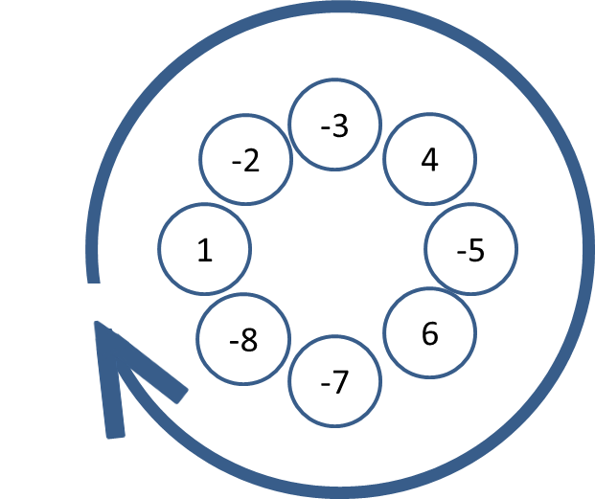

Joro can enter the terrain from every position, jump only on numbers **larger** than the one he is on, only in direction left-to-right and with the same step. Joro’s jumping steps range from 1 to the size of the terrain. **Joro cannot jump on position that he already visited**.

**Example**:

In the sample above, the best route is **-7**, **-5**, **-3**, **1** with **length** **4** and **step 6**.

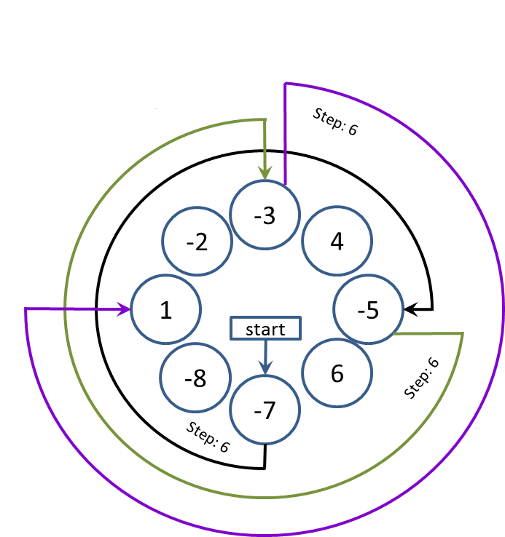

### Input

The input data should be read from the console.

On the first line you will be given the terrain- numbers separated with “, ” (comma and space).

### Output

The output data should be printed on the console.

The output should contain the maximal number of positions visited by Joro, using any of the possible steps.

### Constraints

* **The numbers in the terrain** will be between 1 and 2 500 inclusive.
* Each of the numbers in the terrain will be **between -1000 and 1000**
* Allowed working time for your program: 0.2 seconds. Allowed memory: 16 MB.

### Examples

|  |  |
| --- | --- |
| **Input example** | **Output example** |
| 1, -2, -3, 4, -5, 6, -7, -8 | 4 |
| 1, 2, 3, 4, 5, 6, 7, 8, 9, 10, 0 | 11 |
| 1, 1, 1 | 1 |