|  |  |  |
| --- | --- | --- |
| PyCitySchools Analysis | | |
|  |  |  |

# By Terra Vaughn

# Analysis overview

This report includes an analysis of math and reading standardized test scores for grades 9 through 12 based on the school budgets and school size for a particular school district. The goal of the analysis is to assist the school board and mayor in making strategic decisions regarding future school budgets and priorities.

**Part I** of the analysis includes a look at the data.

**Part II** addresses trends that are observable based on the data.

# Part I

**District Summary**



**School Summary**

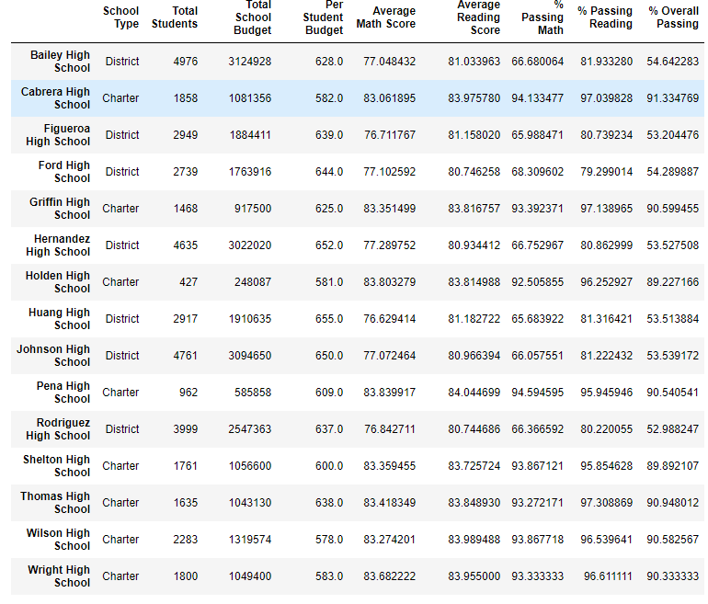

**Top Performing Schools (By % Overall Passing)**

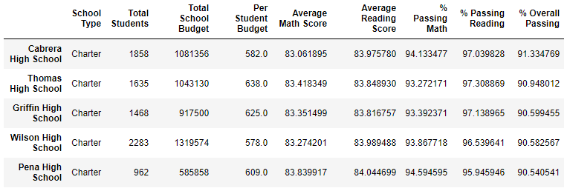

**Bottom Performing Schools (By % Overall Passing)**

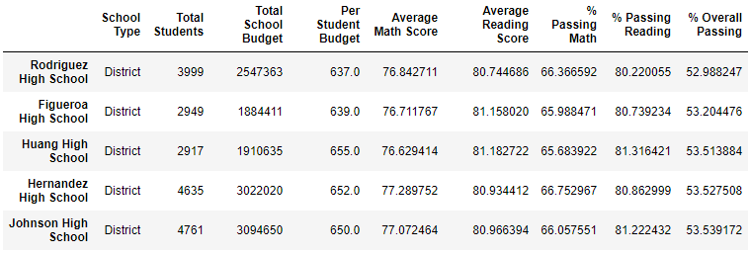

**Math Scores By Grade**

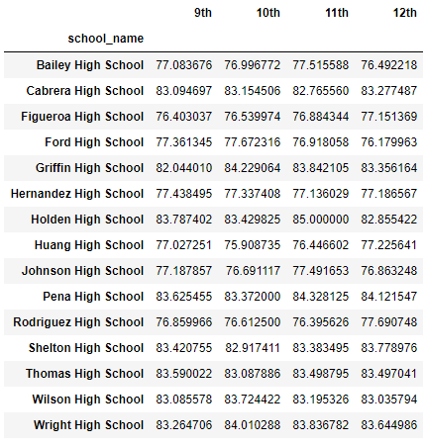

**Reading Scores By Grade**

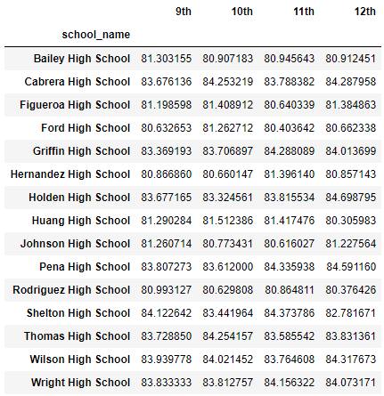

**Scores by School Spending**

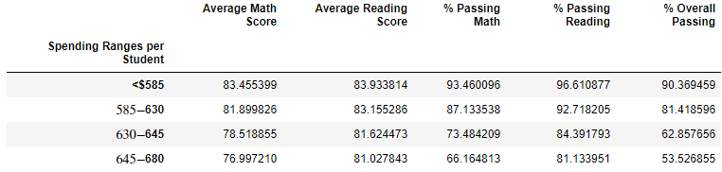

**Scores by School Size**

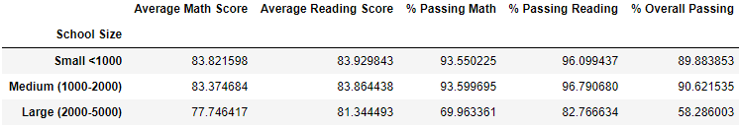

**Scores by School Type**

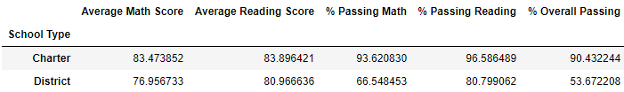

# Part II

Two observable trends:

1. Based on this data, the top 5 performing schools were Charter schools, and the bottom 5 performing schools were District schools.

2. Based on this data, the schools with a per student spending rate of less than $585 had higher math and reading scores as compared to schools with spending rates higher than $585 per student.