Minor Project (BTCS607N)-Weekly Progress Report

Project Title: TerraInsights: Sustainable Fertilizer Usage Optimizer for Higher Yield
Group ID: Group - 14
Branch & Section: B.tech CSE-DS(IBM) AI&DS-IBM
Date: 19 Jan 2026 - 25 Jan 2026
1. Executive Summary
- Current Sprint: Sprint 1 of 6
- Sprint Goal: Complete design documentation and convert requirements into a clear implementation plan.
- Status: On Track (Green)
- Detailed Progress: This week the project concentrated on complete design documentation and convert requirements into a clear implementation plan. The team completed work around prepared a draft class diagram, a sequence diagram for the recommendation request flow, and a clearer module interaction sketch connecting ml, api, and ui responsibilities. In practical terms, the technical tasks covered TI-104 implementation plan drafting, TI-105 functional module breakdown, TI-106 data field mapping., while testing status moved to 2 checks with a 100% pass rate. The main observation for the week was: Resolved a requirement mismatch where the dashboard originally needed fewer inputs than the dataset columns required.
2. UML & OOAD Progress
- Diagrams Completed this week: Prepared a draft class diagram, a sequence diagram for the recommendation request flow, and a clearer module interaction sketch connecting ML, API, and UI responsibilities.
- Diagrams Revised: Use case diagram revised after adding AgroGuide, Govt Schemes, and Store support modules.
- Required Diagram Added: Sequence Diagram - Captures the request path from Farmer input to backend prediction and recommendation response.
- OO Concept Applied: Used separation of concerns by defining independent responsibilities for the UI, API, persistence, and ML pipeline to keep the design maintainable.

Required Diagram Image
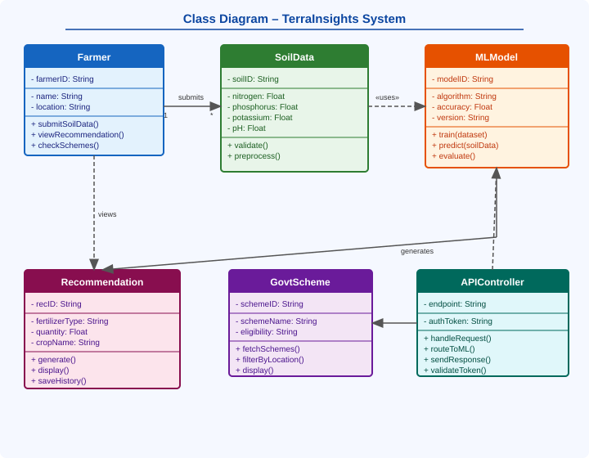
3. Technical Execution (DevOps & Git)
- Jira Tasks Completed: TI-104 implementation plan drafting, TI-105 functional module breakdown, TI-106 data field mapping.
- Git Activity:
  - Active Branches: main
  - Merged Pull Requests: N/A - local prototype planning stage.
- CI/CD Status: Documentation and implementation plan reviewed manually; no automated build configured yet.
4. Testing Summary
- Total Unit Tests: 2
- Pass Rate: 100%
- Key Bug Identified: Resolved a requirement mismatch where the dashboard originally needed fewer inputs than the dataset columns required.
5. Goals for Next Week
- Start dataset exploration and preprocessing strategy for model training.
- Set up the ML training script and choose the initial classification model.

Mentor Signature Project Guide Signature

