Minor Project (BTCS607N)-Weekly Progress Report

Project Title: TerraInsights: Sustainable Fertilizer Usage Optimizer for Higher Yield
Group ID: Group - 14
Branch & Section: B.tech CSE-DS(IBM) AI&DS-B
Date: 26 Jan 2026 - 01 Feb 2026
1. Executive Summary
- Current Sprint: Sprint 2 of 6
- Sprint Goal: Understand the fertilizer dataset and prepare a reusable ML training workflow.
- Status: On Track (Green)
- Detailed Progress: This week the project concentrated on understand the fertilizer dataset and prepare a reusable ml training workflow. The team completed work around completed a component diagram for ml-backend-frontend interaction and a preprocessing workflow diagram showing how raw agricultural data is prepared before model training. In practical terms, the technical tasks covered TI-201 dataset audit, TI-202 feature classification, TI-203 preprocessing pipeline design., while testing status moved to 4 checks with a 100% pass rate. The main observation for the week was: Solved the issue of mixed categorical and numeric features by planning one-hot encoding plus scaling inside a single pipeline.
2. UML & OOAD Progress
- Diagrams Completed this week: Completed a component diagram for ML-backend-frontend interaction and a preprocessing workflow diagram showing how raw agricultural data is prepared before model training.
- Diagrams Revised: Class diagram refined to include prediction history storage and model artifact usage.
- Required Diagram Added: Component Diagram - Explains how dataset processing, model training, backend serving, and frontend consumption connect as separate components.
- OO Concept Applied: Encapsulated preprocessing and model training inside a pipeline-oriented design to improve reuse.
Required Diagram Image
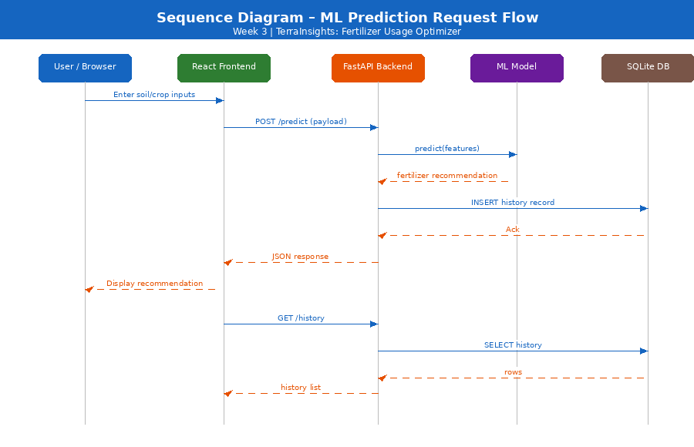
3. Technical Execution (DevOps & Git)
- Jira Tasks Completed: TI-201 dataset audit, TI-202 feature classification, TI-203 preprocessing pipeline design.
- Git Activity:
  - Active Branches: main
  - Merged Pull Requests: N/A - local iterative development.
- CI/CD Status: Training script prepared and reviewed through manual execution planning; still no formal CI service configured.
4. Testing Summary
- Total Unit Tests: 4
- Pass Rate: 100%
- Key Bug Identified: Solved the issue of mixed categorical and numeric features by planning one-hot encoding plus scaling inside a single pipeline.
5. Goals for Next Week
- Implement the actual training script and persist the trained artifact.
- Prepare backend dependencies and database schema for prediction history.

Mentor Signature Project Guide Signature

