Minor Project (BTCS607N)-Weekly Progress Report

Project Title: TerraInsights: Sustainable Fertilizer Usage Optimizer for Higher Yield
Group ID: Group - 14
Branch & Section: B.tech CSE-DS(IBM) AI&DS-IBM
Date: 02 Feb 2026 - 08 Feb 2026
1. Executive Summary
- Current Sprint: Sprint 2 of 6
- Sprint Goal: Train the first working ML model and prepare backend data storage foundations.
- Status: On Track (Green)
- Detailed Progress: This week the project concentrated on train the first working ml model and prepare backend data storage foundations. The team completed work around created the local deployment diagram and updated the prediction sequence so it now includes history logging into sqlite after each successful recommendation. In practical terms, the technical tasks covered TI-204 train_model.py implementation, TI-205 SQLite schema definition, TI-206 backend package setup., while testing status moved to 6 checks with a 100% pass rate. The main observation for the week was: Resolved database schema uncertainty by narrowing history storage to the most important prediction fields.
2. UML & OOAD Progress
- Diagrams Completed this week: Created the local deployment diagram and updated the prediction sequence so it now includes history logging into SQLite after each successful recommendation.
- Diagrams Revised: Component diagram updated to show SQLite persistence and FastAPI service boundaries.
- Required Diagram Added: Deployment Diagram - Shows the local machine hosting the frontend, backend, database, and trained model artifact during development.
- OO Concept Applied: Applied abstraction through SQLAlchemy base models so persistence details remain separate from API logic.
Required Diagram Image
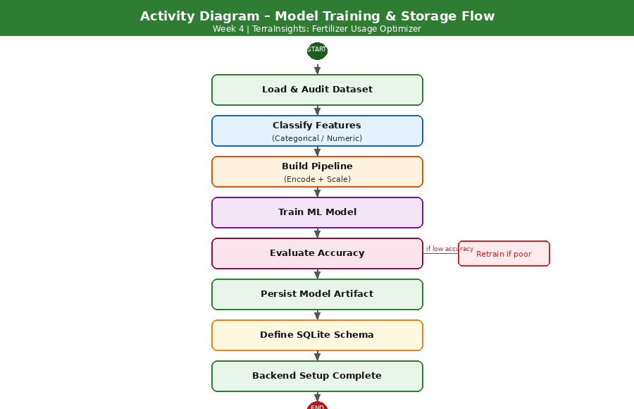
3. Technical Execution (DevOps & Git)
- Jira Tasks Completed: TI-204 train_model.py implementation, TI-205 SQLite schema definition, TI-206 backend package setup.
- Git Activity:
  - Active Branches: main
  - Merged Pull Requests: N/A - local iterative development.
- CI/CD Status: ML artifact generated locally; backend dependency files prepared; smoke verification done through manual runs.
4. Testing Summary
- Total Unit Tests: 6
- Pass Rate: 100%
- Key Bug Identified: Resolved database schema uncertainty by narrowing history storage to the most important prediction fields.
5. Goals for Next Week
- Build FastAPI endpoints for prediction and history retrieval.
- Connect the persisted model artifact to the backend startup flow.

Mentor Signature Project Guide Signature

