Minor Project (BTCS607N)-Weekly Progress Report

Project Title: TerraInsights: Sustainable Fertilizer Usage Optimizer for Higher Yield
Group ID: Group -14
Branch & Section: B.tech CSE-DS(IBM) AI&DS-IBM
Date: 09 Feb 2026 - 15 Feb 2026
1. Executive Summary
- Current Sprint: Sprint 3 of 6
- Sprint Goal: Develop the prediction API and integrate the trained model into backend execution.
- Status: On Track (Green)
- Detailed Progress: This week the project concentrated on develop the prediction api and integrate the trained model into backend execution. The team completed work around finished the backend package diagram and documented the api request lifecycle so the prediction service, database session, and history storage responsibilities are easy to trace. In practical terms, the technical tasks covered TI-301 FastAPI app bootstrap, TI-302 /predict endpoint creation, TI-303 /history endpoint creation., while testing status moved to 8 checks with a 100% pass rate. The main observation for the week was: Fixed model path resolution so the backend can load the saved ML artifact from the shared project structure.
2. UML & OOAD Progress
- Diagrams Completed this week: Finished the backend package diagram and documented the API request lifecycle so the prediction service, database session, and history storage responsibilities are easy to trace.
- Diagrams Revised: Prediction workflow diagram revised after aligning request payload fields with the dataset schema.
- Required Diagram Added: Package Diagram - Organizes backend files such as main, models, database, and ML assets into a clean package view.
- OO Concept Applied: Used dependency injection with FastAPI database sessions to keep endpoint logic clean and testable.
Required Diagram Image
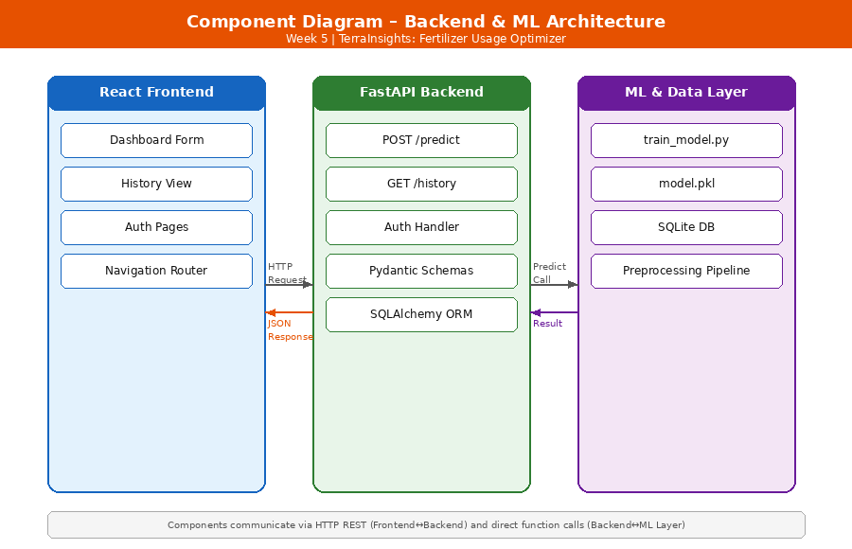
3. Technical Execution (DevOps & Git)
- Jira Tasks Completed: TI-301 FastAPI app bootstrap, TI-302 /predict endpoint creation, TI-303 /history endpoint creation.
- Git Activity:
  - Active Branches: main
  - Merged Pull Requests: N/A - local iterative development.
- CI/CD Status: API boot verified locally; model loading and history write flow checked manually.
4. Testing Summary
- Total Unit Tests: 8
- Pass Rate: 100%
- Key Bug Identified: Fixed model path resolution so the backend can load the saved ML artifact from the shared project structure.
5. Goals for Next Week
- Validate end-to-end request handling with realistic dashboard inputs.
- Begin frontend scaffolding with React, routing, and core pages.

Mentor Signature Project Guide Signature

