Minor Project (BTCS607N)-Weekly Progress Report

Project Title: TerraInsights: Sustainable Fertilizer Usage Optimizer for Higher Yield
Group ID: Group - 14
Branch & Section: B.tech CSE-DS(IBM) AI&DS-IBM
Date: 16 Feb 2026 - 22 Feb 2026
1. Executive Summary
- Current Sprint: Sprint 3 of 6
- Sprint Goal: Stabilize backend payload handling and prepare the application for frontend integration.
- Status: At Risk (Yellow)
- Detailed Progress: This week the project concentrated on stabilize backend payload handling and prepare the application for frontend integration. The team completed work around expanded the backend sequence diagram to include request validation, model inference, database write-back, and structured response return after each prediction call. In practical terms, the technical tasks covered TI-304 payload validation refinement, TI-305 history persistence check, TI-306 API error handling., while testing status moved to 10 checks with a 90% pass rate. The main observation for the week was: Numeric values from incoming payloads needed strict type conversion to avoid validation and inference inconsistencies.
2. UML & OOAD Progress
- Diagrams Completed this week: Expanded the backend sequence diagram to include request validation, model inference, database write-back, and structured response return after each prediction call.
- Diagrams Revised: Class and sequence diagrams updated after tightening Pydantic field types and database flow.
- Required Diagram Added: Class Diagram - Represents key backend entities such as PredictionInput and PredictionHistory along with their responsibilities.
- OO Concept Applied: Strengthened data encapsulation by using a dedicated PredictionInput schema to validate all request attributes.
Required Diagram Image
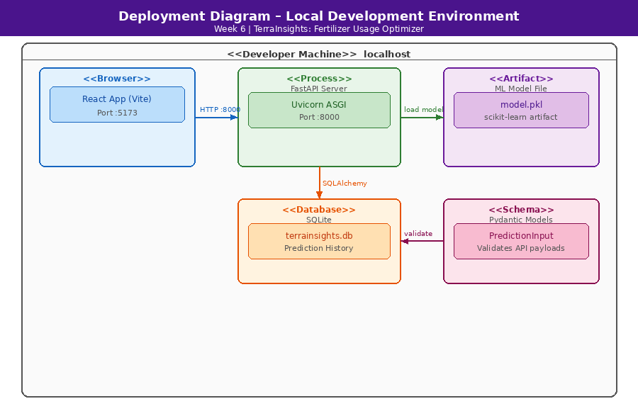
3. Technical Execution (DevOps & Git)
- Jira Tasks Completed: TI-304 payload validation refinement, TI-305 history persistence check, TI-306 API error handling.
- Git Activity:
  - Active Branches: main
  - Merged Pull Requests: N/A - local iterative development.
- CI/CD Status: Backend functional but awaiting frontend integration; manual endpoint checks passing after validation fixes.
4. Testing Summary
- Total Unit Tests: 10
- Pass Rate: 90%
- Key Bug Identified: Numeric values from incoming payloads needed strict type conversion to avoid validation and inference inconsistencies.
5. Goals for Next Week
- Set up the React + Vite frontend shell and route structure.
- Design premium UI screens for landing, auth, profile, and about modules.

Mentor Signature Project Guide Signature

