Minor Project (BTCS607N)-Weekly Progress Report

Project Title: TerraInsights: Sustainable Fertilizer Usage Optimizer for Higher Yield
Group ID: [Fill Group ID]
Branch & Section: CSE - [Fill Section]
Date: 13 Apr 2026 – 18 Apr 2026
1. Executive Summary
- Current Sprint: Sprint 6 of 6
- Sprint Goal: Carry out final validation, confirm prediction history logging, and strengthen project documentation.
- Status: On Track (Green)
- Detailed Progress: This week the project concentrated on carry out final validation, confirm prediction history logging, and strengthen project documentation. The team completed work around completed the final revision set for sequence, component, and deployment diagrams so the documentation now matches the implemented terrainsights prototype more closely. In practical terms, the technical tasks covered TI-601 end-to-end smoke testing, TI-602 history endpoint verification, TI-603 technical documentation updates., while testing status moved to 18 checks with a 100% pass rate. The main observation for the week was: Handled the model-not-loaded scenario gracefully so backend failures are surfaced clearly instead of silently breaking prediction requests.
2. UML & OOAD Progress
- Diagrams Completed this week: Completed the final revision set for sequence, component, and deployment diagrams so the documentation now matches the implemented TerraInsights prototype more closely.
- Diagrams Revised: Prediction history flow updated after validating the stored fields and backend response lifecycle.
- Required Diagram Added: History Flow Sequence Diagram - Focuses on how prediction history is saved and later retrieved for review.
- OO Concept Applied: Refined persistence design by keeping prediction history as a dedicated entity with a focused responsibility.
Required Diagram Image
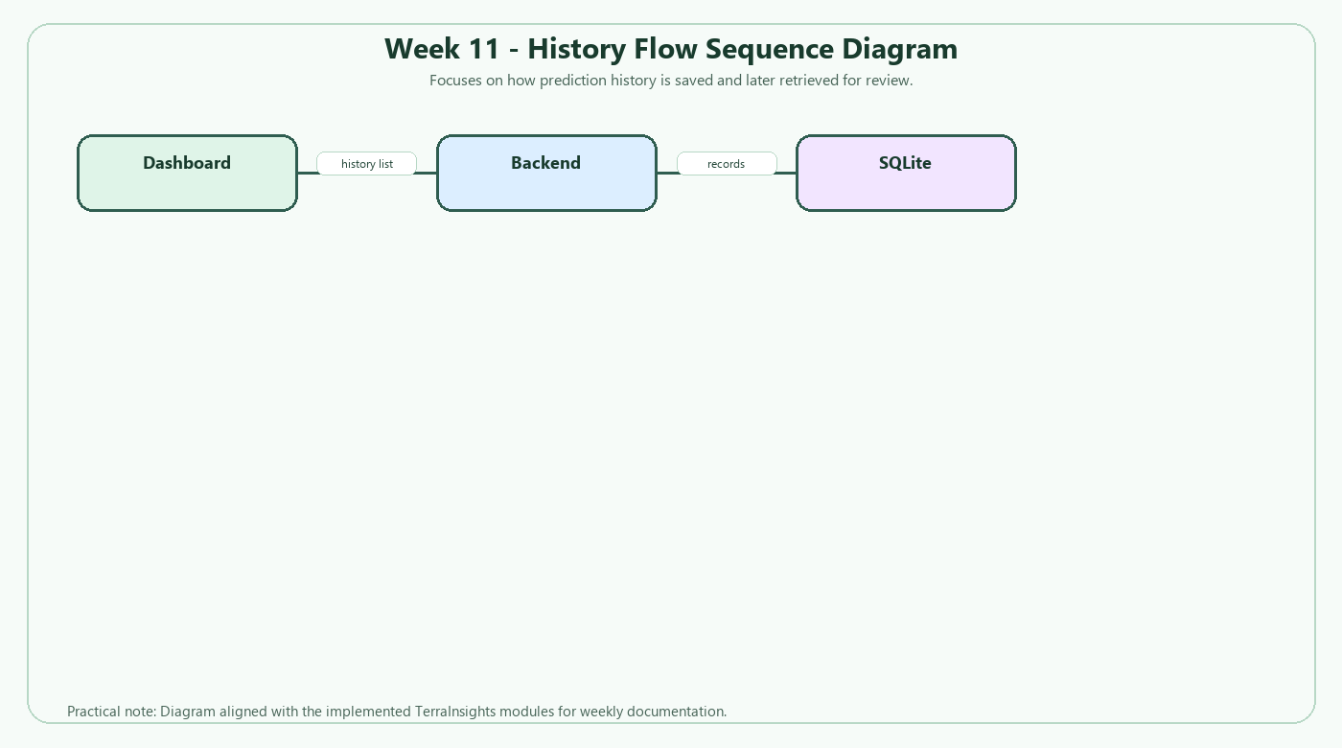
3. Technical Execution (DevOps & Git)
- Jira Tasks Completed: TI-601 end-to-end smoke testing, TI-602 history endpoint verification, TI-603 technical documentation updates.
- Git Activity:
  - Active Branches: main
  - Merged Pull Requests: N/A - local iterative development.
- CI/CD Status: Manual build, API, and inference checks passing; deployment remains local but release-ready for demo use.
4. Testing Summary
- Total Unit Tests: 18
- Pass Rate: 100%
- Key Bug Identified: Handled the model-not-loaded scenario gracefully so backend failures are surfaced clearly instead of silently breaking prediction requests.
5. Goals for Next Week
- Prepare final report package and demo talking points for submission.
- Do a last consistency pass on naming, folder structure, and weekly deliverable wording.

Mentor Signature Project Guide Signature

