
AUTOMATED ENVIRONMENTAL MONITORING NETWORKS
User Manual
Aquatos Web LTX
IP data logger for water-level and water monitoring
Logger Type 1500
TerraTransfer GmbH
Ottostrasse 19a · 44867 Bochum · Germany
Phone: +49 2327 83 44 85-1
www.terratransfer.de
Edition: April 2026 · Document no. TT-ANL-LTX-001

Table of Contents
Table of Contents 2
I Disclaimer 3
II Safety Instructions 4
III Specific Safety Instructions 5
Part 1 Scope of Delivery 6
Part 2 Introduction 7
Part 3 Installation 8
3.1 Mechanics 8
3.2 Installation in the Gauge Tube 8
3.3 Antenna Mounting 9
3.4 Inserting the SIM Card 9
3.5 Inserting and Replacing Batteries 10
3.6 Initial Commissioning 10
Part 4 Configuration with BlueShell 11
4.1 About BlueShell 11
4.2 Software Installation 11
4.3 Main Menu and Connection 11
4.4 Button Menu – Functions at a Glance 12
4.5 Device Parameters – Basic Settings 13
4.6 System Parameters (sys-param) 15
4.7 Tare Function and Channel Settings 16
4.8 Alarm Configuration 18
4.9 Terminal – Firmware Updates and Diagnostics 18
Part 5 Operation 20
5.1 Connecting Sensors (SDI-12) 20
5.2 Starting Measurement 20
Part 6 Maintenance 22
6.1 BlueShell – Local Configuration Software 22
6.2 Data Logger 22
Part 7 Troubleshooting 25
Part 8 Repair 26
Part 9 Technical Data 27
Technical Specifications – Data Logger 27
Part 10 Operator Obligations and Disposal 28
10.1 Operator Obligations 28
European Union 28
Worldwide 28
10.2 Dismantling and Disposal 28
Before Dismantling 28
Disposal 28
EU WEEE Directive 29
Contact 30

I Disclaimer
The information contained in this manual reflects the state of the art at the time of publication. Subsequent updates may occur.
This manual does not cover every detail of the design, production or variants of the device and does not address every situation that may arise during installation, operation or maintenance. TerraTransfer GmbH shall not be liable for any incidental, indirect, special or consequential damages arising from or related to this documentation and the information contained herein – even if TerraTransfer has been advised of the possibility of such damages.
If you identify any defects in a TerraTransfer product, please report them to TerraTransfer GmbH. We will do everything possible to resolve the issue promptly.
Copyright: No part of this work may be reproduced in any form or by any means without the written permission of the publisher. TerraTransfer GmbH permits users to print parts of the documentation in paper form exclusively for their own use.
Trademark Notice: Products and services of TerraTransfer GmbH referenced in this document are trademarks or registered trademarks of TerraTransfer GmbH. Other product names used may be trademarks of their respective owners.
© 2026 TerraTransfer GmbH. All rights not expressly granted are reserved.

II Safety Instructions
Read the user manual, including all operating instructions, completely before installing, connecting and commissioning the Aquatos Web LTX. This manual describes the intended operation of the product. It is aimed at qualified specialist personnel familiar with, and trained in, installation, assembly, wiring, commissioning and operation.
- Keep this manual readily available for future reference.
- If you have any questions about the contents of this manual (or parts of it), please contact TerraTransfer GmbH or an authorised dealer for further support.
- The Aquatos Web LTX is intended for use in hydrometry and environmental monitoring.
- Before starting work, check the functionality and integrity of the system.
- Inspect the Aquatos Web LTX for any visible defects. In particular, check fasteners, connections, mechanical parts, internal and external communication equipment, and power and supply lines.
- If defects that could impair operational safety are identified, work must be stopped. This applies to defects identified both before and during work.
- Do not operate the Aquatos Web LTX in potentially explosive atmospheres.
- This user manual defines the ambient and climatic conditions as well as the mechanical and electrical requirements. Installation, wiring, commissioning and operation must strictly comply with these specifications.
- Maintenance work may only be carried out when no tools or machines are in operation.
- Protective devices removed for maintenance must be refitted immediately after completion.
- Do not, under any circumstances, perform electrical or mechanical diagnostics, inspections or repairs yourself. Return the product to TerraTransfer GmbH for servicing. See Chapter 8 (Repair) for return instructions.
Caution: Disposal notice: After decommissioning, the Aquatos Web LTX must be disposed of in accordance with local waste and environmental regulations. The Aquatos Web LTX must never be disposed of with household waste.
Caution: The device's inputs and outputs are protected against electrostatic discharge and overvoltage (ESD). Never touch the electronic components! If components must be handled, discharge yourself first, e.g. by touching grounded metal parts.

III Specific Safety Instructions
- This manual describes the operation of the Aquatos Web LTX measuring system.
- The Aquatos Web LTX is designed for hydrological measurements, in particular for recording groundwater and surface water levels.
- Work near flowing water carries an increased risk of drowning. The operator must equip the workplace with suitable safety and rescue equipment (life jacket, life ring, rope or similar).

Part 1 Scope of Delivery
The standard scope of delivery of the Aquatos Web LTX comprises:
- Aquatos Web LTX – IP data logger in a tubular housing (V4A stainless steel)
The Aquatos Web LTX can optionally be ordered with the following accessories:
- Hydrostatic pressure sensor (Piezo Type 0312 or Ceramic Type 0420)
- Antenna (rod, helix or below-ground antenna)
- Batteries (pre-installed)
Note: Lithium batteries are classified as dangerous goods. The additional effort may affect shipping costs.

Part 2 Introduction
Thank you for choosing a TerraTransfer GmbH product. We wish you much success with your new device.
TerraTransfer GmbH develops, manufactures, sells and operates high-quality measuring instruments, data loggers and communication technology. Our products are developed with a passion for environmental monitoring – with a deep understanding of the quality, accuracy and robustness that field metrologists require.
This manual will help you understand, install and operate the Aquatos Web LTX. If any information is missing or unclear, please do not hesitate to contact us.
The Aquatos Web LTX (TerraTransfer Logger Type 1500) is an ultra-low-power IP data logger developed for recording water level and temperature in groundwater and surface waters as well as for general water-monitoring applications. As standard, the Aquatos Web LTX is supplied with a combined water-level and water-temperature sensor with an accuracy of 0.1 % FS (full-scale). The vented pressure sensors automatically compensate for air-pressure and temperature fluctuations, providing corrected readings at all times.
Type number: The device is identified in the firmware and in the BlueShell software as Logger Type 1500. This type number uniquely identifies the hardware generation and is visible, for example, in the terminal window (“Device Typ: 1500”).
The Aquatos Web LTX is equipped with a Bluetooth 5 (BLE) interface for local communication. For remote data transmission, current Aquatos Web LTX devices use the LTE-M cellular standard (4G / LTE Cat M) with fallback to NB-IoT and 2G / GSM – depending on network availability at the site. Data is transmitted encrypted via HTTPS directly to the Sensormanager web portal; end-to-end encryption of the measurement data is based on AES-128-CBC (recommended by the German BSI).
Transmission is based on IP protocols and uses cellular mobile networks. On this basis, even large monitoring networks can be conveniently deployed, operated and maintained with minimal effort. Because data transmission uses existing cellular networks, no additional field infrastructure is required – the measurement data is delivered directly to your server.
The data logger uses the cellular network time to synchronise its internal clock, ensuring an accurate time reference at all times.

Part 3 Installation
This chapter contains the following sections:
- 3.1 Mechanics
- 3.2 Installation in the Gauge Tube
- 3.3 Antenna Mounting
- 3.4 Inserting the SIM Card
- 3.5 Inserting and Replacing Batteries
- 3.6 Initial Commissioning

3.1 Mechanics
The housing consists of two V4A stainless-steel tubes and an internal plastic insert that holds the battery and electronics.
The seals and sealing surfaces must not be soiled or damaged.
Before reassembly, inspect the seals and sealing surfaces. If the O-rings are still adequately greased, no additional greasing is required; otherwise re-grease with a suitable silicone or O-ring grease (e.g. Korasilon Paste, high-viscosity).
Caution: Never force the seals into place.
The desiccant (silica gel) must be replaced when necessary. The desiccant pouches are located inside, underneath the upper metal sleeve: to access them, loosen the head cap (antenna side) and slide the sleeve off the plastic sensor body.
Note: Check the O-ring seal each time you reassemble the unit; damaged seals must be replaced. Reference values for the humidity inside the housing: up to 50 % is uncritical, from 70 % the desiccant pouches should be replaced promptly, above 85 % the humidity is too high. Replacement desiccant is available from TerraTransfer; alternatively, most desiccants can be regenerated by drying at 120 °C to 150 °C for approx. 20 minutes.

3.2 Installation in the Gauge Tube
For installation in a 2" tube, the rim of the cap is placed on the rim of the tube.
For installation in 3" or 4" tubes, an adapter ring is required. Adapter rings from 3" upwards feature an opening for dipmeters. The antennas are mounted individually depending on the installation type: for below-ground installations, below-ground antennas are available – they are clamped between the frame and the cap.
Helix antennas are used for above-ground monitoring points. To mount them, drill a centred hole in the cap with a suitable drill bit. The antenna is then screwed through the hole onto the cap. Inside buildings, a rod antenna can be screwed directly onto the logger. After installation, a comparison measurement with a dipmeter should be performed.

3.3 Antenna Mounting
The device features a standard FME connector. Ensure the antenna is fully connected and, if necessary, align it slightly to obtain the best signal.
Note: We strongly recommend a site visit to assess the quality and stability of the cellular coverage at antenna height. Under unstable or weak coverage, the logger may consume more energy than necessary through repeated connection attempts. A common solution is to mount the antenna higher – contact us if you need support selecting an antenna for your site.

3.4 Inserting the SIM Card
The Aquatos Web LTX uses a nano-SIM. The SIM-card holder (push-pull / friction-fit) is located on the side of the plastic sensor body, underneath the upper metal sleeve.
To access the SIM-card holder, loosen the head cap (antenna side) – the head cap protects the antenna connector and at the same time forms the anchor ring for the 2" tube mounting. Slide the upper metal sleeve off the plastic sensor body. Rotate the opened logger so that the lateral cut-out with the push-pull holder is visible. Insert the nano-SIM into the holder. To remove it, press lightly on the card; it can then be pulled out of the holder.
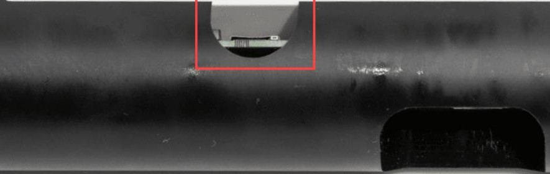

3.5 Inserting and Replacing Batteries
The battery compartment is located underneath the lower metal sleeve. To access it, loosen the foot cap (sensor side) and slide the lower metal sleeve off the plastic sensor body.
Suitable batteries: 2 × lithium mono D-cells, 3.6 V DC. Only high-current-capable batteries are suitable, so that the peak currents needed for data transmission can be supplied. A proven battery is the SAFT LSH 20. Batteries of this type are available from specialist dealers.
Caution: To avoid damage, only suitable batteries may be used.
Notes
- Observe the correct battery polarity. Incorrect insertion can damage the micro-fuse (repairable only at the factory) or the electronics.
- The two batteries are connected in parallel to increase capacity and service life. The positive terminals of both batteries share the same central conductor terminal.
The electronics include a backup capacitor that bridges brief interruptions of the power supply (e.g. during a battery change). Date and time are preserved. If the interruption lasts too long, the logger performs a restart, indicated by approx. ten flashes of the green LED. The device is then ready for operation; the system time is automatically synchronised with the next data transmission over the cellular network. If you do not wish to wait for the next automatic transmission, you can trigger a transmission manually on site.
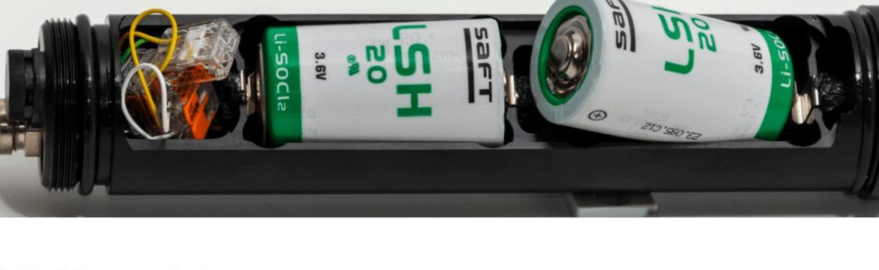

3.6 Initial Commissioning
Due to European transport regulations, the devices are shipped without batteries installed (de-energised). For information on inserting the batteries, see Section 3.5 (Inserting and Replacing Batteries).

Part 4 Configuration with BlueShell
Configuration of the Aquatos Web LTX is carried out using the TerraTransfer BlueShell software. Communication between the PC and the logger takes place locally via Bluetooth Low Energy (BLE). BlueShell allows you to configure the logger's parameters and view current readings directly.

4.1 About BlueShell
TerraTransfer BlueShell is an advanced software solution for local communication between a PC or laptop (at least Windows 10 and Bluetooth 5.0) and a BLE data logger. The software is the central interface for setting up the Bluetooth connection. With BlueShell, you can adjust logger settings and visualise captured measurement data in real time.

4.2 Software Installation
To install TerraTransfer BlueShell, follow these steps:
- Open the website sensormanager.net/files in your browser.
- Open the “BlueShell” folder.
- Download the installer with the file extension “.exe”.
- Run the downloaded file. Follow the installation wizard to install the software on your device.

4.3 Main Menu and Connection
The BlueShell user interface is divided into three areas:
- Menu bar (left): Contains the buttons for accessing configuration, help and other functions.
- Main window (centre): Shows current information and readings of the selected logger.
- List of available loggers (right): All detected data loggers appear here. Select the logger you want to view its data or settings for.
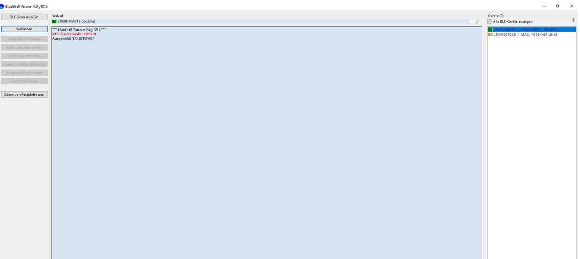
Establishing a Connection
To establish a Bluetooth connection between the PC and the Aquatos Web LTX, follow these steps:
- Select logger: All available data loggers appear in the right-hand panel. Select the logger you want to connect to.
- Initiate connection: Click “Connect”. A dialog for entering the Bluetooth PIN opens.
- Enter Bluetooth PIN: Each data logger has its own 6-digit Bluetooth PIN. Enter this PIN. It is then stored on the device (PC, tablet or smartphone) so that you do not have to enter it again for subsequent connections on that device. When using a different device, the PIN must be entered once on the new device.
- Complete the connection: Once the PIN has been entered correctly, the connection is established automatically. You can now read out data and configure the logger.

4.4 Button Menu – Functions at a Glance
Once the connection has been established successfully, the functions used to operate the data logger are enabled in the left-hand menu bar.
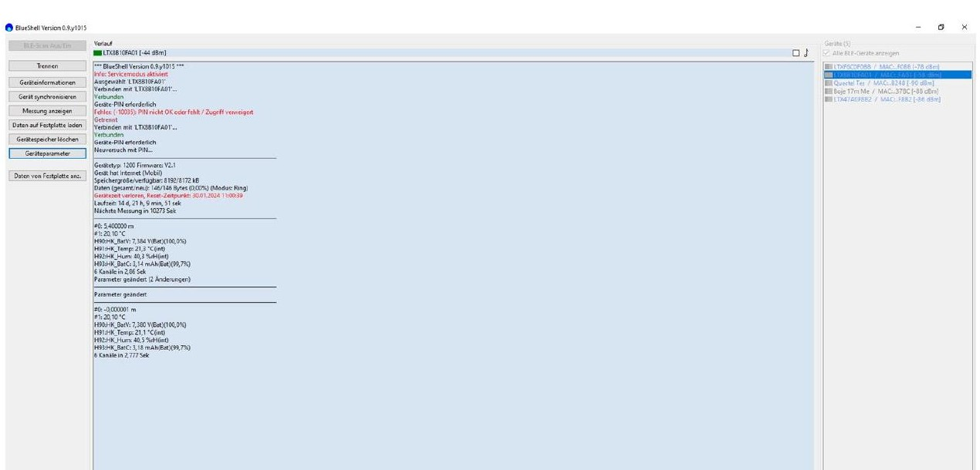
Device Information
Provides a comprehensive overview of key logger properties: storage capacity, operating hours to date and model type. Useful for assessing the performance and capacity of the device.
Synchronise Device
Synchronises the logger's clock with your PC. The date and time of the computer are transferred to the logger. This ensures a consistent time base for all recorded readings – important for precise tracking and analysis.
Show Measurement
Displays the current readings of the connected sensors. In addition, the internal status data (housekeeping values, HK values) – such as humidity, battery voltage and device temperature – are shown. Essential for assessing ambient conditions and the device's health in real time.
Download Data to Disk
Transfers the readings stored in the logger to your PC. The data is saved as a CSV file that can easily be included in analyses and reports – essential for long-term data backup and evaluation.
Erase Device Memory
Erases the entire logger memory. Useful for making space for new measurements after existing data has been backed up.
Caution: Before erasing, make sure that all important data has been downloaded beforehand.
Device Parameters
Opens a settings menu in which the logger's parameters can be configured – for optimised data acquisition tailored to your requirements and operating conditions.
Disconnect
Properly terminates the Bluetooth connection between the logger and the PC. This ensures that any ongoing transfers are cleanly completed and prevents data loss or corruption.

4.5 Device Parameters – Basic Settings
The “Device Parameters” dialog is where all the essential operating settings of the logger are configured:
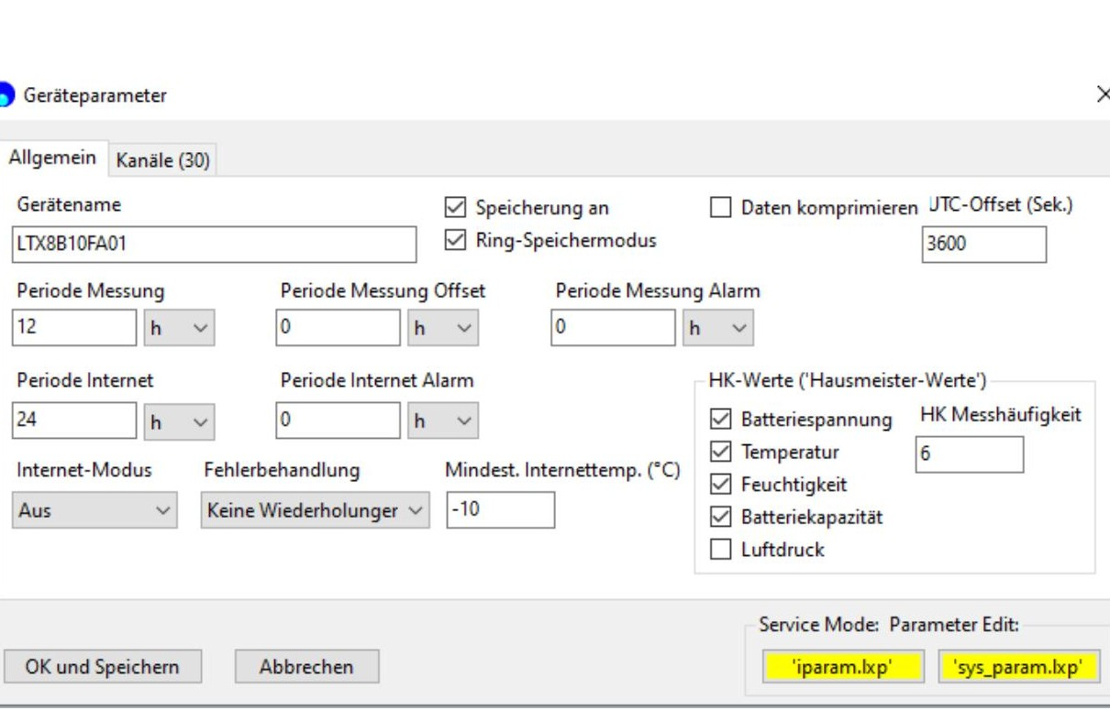
Device Name
A unique name can be assigned to each data logger, e.g. a monitoring-point number or a street name. This name is adopted by the online system and shown throughout all downstream processing – making identification and management easier. Do not use special characters.
Measurement Interval
Defines the time between two measurements. The measurement interval can be adjusted as required.
Measurement Interval Offset
For measurement intervals of 5 minutes or more, after the first reading the logger automatically selects a modular time for the next measurement (e.g. every full hour for a 1-hour interval). The offset shifts that point in time. Example: an offset of 2 hours with a 12-hour interval schedules the readings for 02:00 and 14:00.
Measurement Interval on Alarm
Defines the interval at which the logger measures in the event of an alarm.
Transmission Interval
Defines the frequency of internet transmissions; values between 5 minutes and 24 hours are possible.
Transmission Interval on Alarm
Defines the interval at which the logger transmits data to the server in the event of an alarm. This allows for a faster response to unexpected events.
Enable Data Logging
Important – if not yet enabled: Tick this box so that the logger records measurement data. Without this setting, no data will be stored.
Internet Mode
Activates data transmission over the cellular network. For standard use, the “low power” option is sufficient.
System Parameters (iparam / sys-param)
To access these special parameters, service mode must be enabled in the general settings. The “Product Activation” field can be ignored.
HK Values (Housekeeping Values)
The HK values comprise measurements the logger can take even without a connected sensor: internal humidity, battery voltage and device temperature. These values are enabled by default and stored on the server. For additional values (e.g. battery capacity), a corresponding channel must be set up on the server side to avoid error messages.
UTC Offset
By default, the data loggers use Coordinated Universal Time (UTC). To adapt the time to the local time zone, enter the corresponding value in seconds in the “UTC offset” field. Examples: 3600 seconds corresponds to Central European Time (CET, UTC+1); 7200 seconds corresponds to Central European Summer Time (CEST, UTC+2).

4.6 System Parameters (sys-param)
The system parameters (sys-param) configuration defines the network and connection settings:
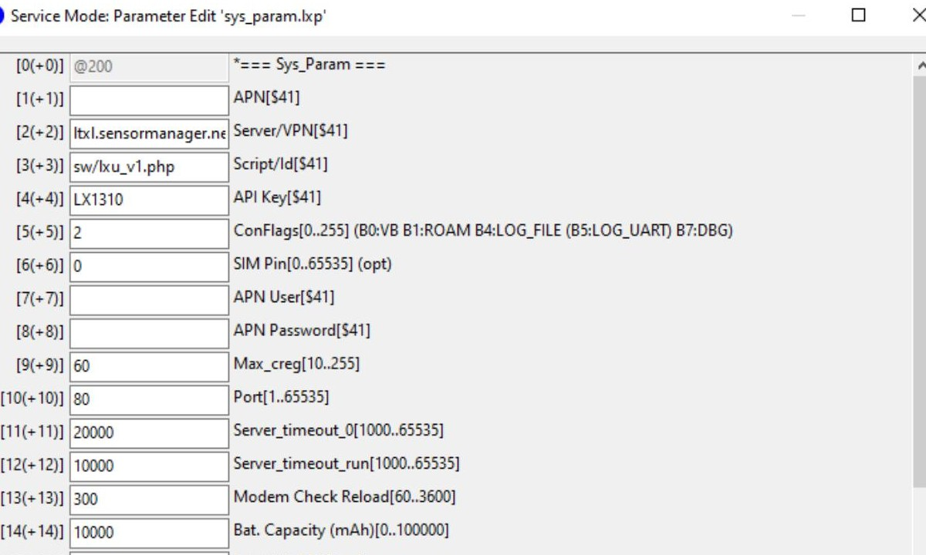
- Field 2 (Server / VPN): Address of the target server with which the logger establishes a connection.
- Field 3 (Script / ID): Name or path of the server-side receiving script that processes the transmitted data.
- Field 6 (SIM PIN): If required: PIN of the SIM card.
- Field 7 (APN user): Access Point Name (APN) for the cellular connection.
- Field 8 (APN password): Password for the APN.
All other fields are intended for special configurations and should not be changed without appropriate expertise – incorrect values can cause connectivity problems or other malfunctions.
Internal Parameters (iparam)
The internal parameters (iparam) provide detailed configuration options for advanced users. For standard operation, the basic settings are sufficient. We recommend making changes via the standard parameter settings wherever possible, to improve usability and avoid misconfiguration.

4.7 Tare Function and Channel Settings
Under the “Channels” tab (top left, next to “General”) you can define the type of connected sensor, choose the unit and access the tare function.
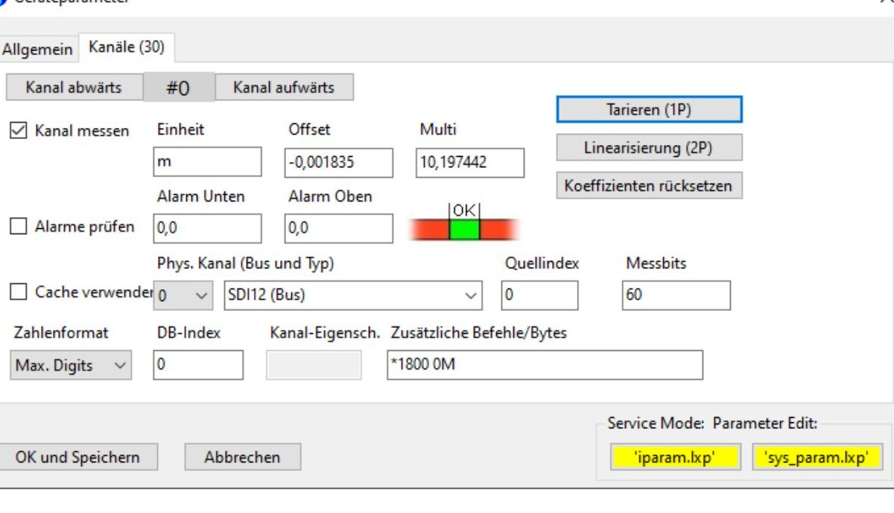
Use “Channel down” and “Channel up” to navigate through the logger's channels. The specific measurement unit can be set for each sensor. The tare function is accessed via the “Tare” button at the top right.
Offset
The offset is a correction value that is subtracted from the measured value to obtain the desired result. Example: the logger reads a water level of 10 m but should display an elevation above sea level of 110 m – an offset of −100 must be entered (10 − (−100) = 110). The correct offset value can also be calculated automatically via the tare function. Note: positive numbers are subtracted, negative numbers are added.
Multi (Multiplier)
The default setting of the multiplier is 1.0000. Prefixing a minus sign (−) inverts the measured value – useful for distinguishing between water column and depth-to-water. This setting can also account for the water density. A value of 1.00000 calibrates for fresh water. For salt water, the percentage value can be adjusted (e.g. 3 % salinity corresponds to a multiplier of 0.997000).
Setting the Depth-to-Water
To tare the water level as depth-to-water using a dipmeter, follow these steps:
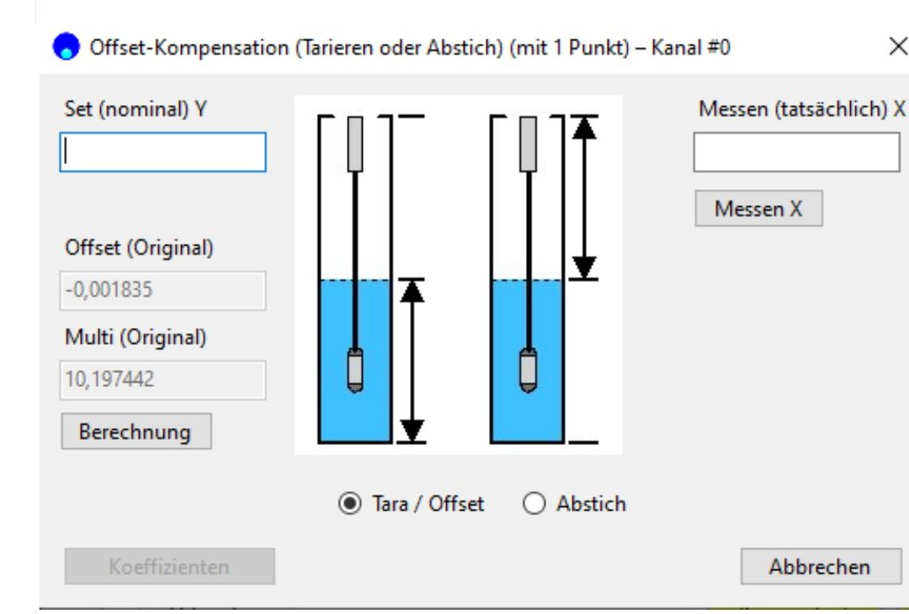
- Take a measurement: Use “Measure X” to determine the current sensor value.
- Select depth-to-water: Select the “Depth-to-Water” option at the lower centre of the screen.
- Enter measured value: Enter the depth-to-water measured with the dipmeter in the “Set” field (top left).
- Run calculation: Click “Calculate” to determine the required coefficients.
- Apply coefficients: Finally, click “Coefficients” to save the adjustments.
Tare for Water Level
For measuring water levels in water bodies:
- Tare option: Make sure that “Tare” is selected to measure the water level.
- Enter local value: Enter the value determined on site (elevation above sea level or another gauge datum) in the “Set” field.
- Activate calculation: Click “Calculate” again. The multiplier (multi) and offset are adjusted automatically.

4.8 Alarm Configuration
The alarm function should be enabled so that the logger can respond specifically to alarm conditions – for example, with shorter measurement intervals or faster data transmission to the server compared with standard operation. This event-driven control is essential for collecting more data in critical situations and responding in a timely manner. As soon as the readings return to the normal range, the logger reverts to the standard measurement intervals.
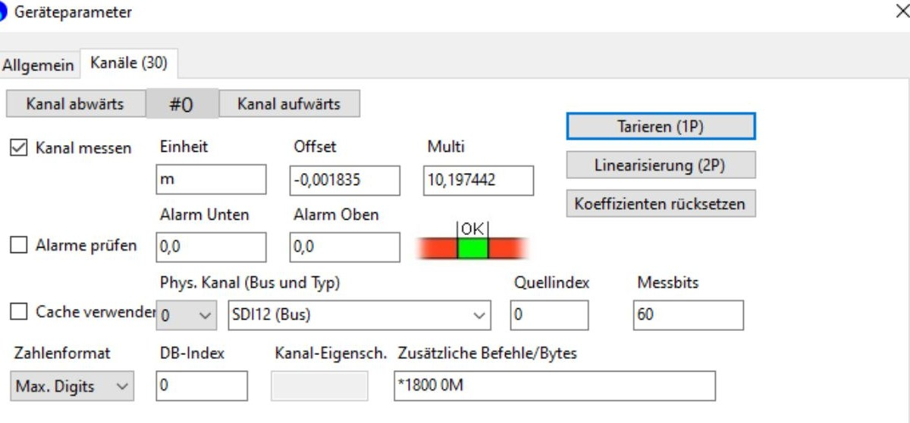
Setting Thresholds
- Lower threshold: If the reading reaches or falls below the set value, the logger enters the alarm state. Example water level: level drops below 1 m → alarm. Example depth-to-water: distance from groundwater surface to ground level < 1 m → alarm.
- Upper threshold: If the reading reaches or exceeds the set value, the logger enters the alarm state. Example water level: level exceeds 5 m → alarm. Example depth-to-water: distance from groundwater surface to ground level < 5 m → alarm.

4.9 Terminal – Firmware Updates and Diagnostics
In the terminal window (accessible in the software settings) you can perform a variety of actions – including firmware updates and diagnostics. The terminal provides a selection of commands for fine-grained control and diagnostics.
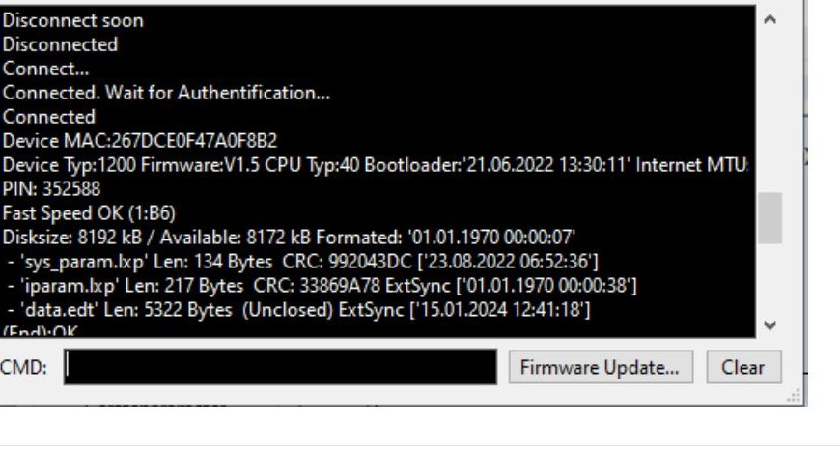
Important user command: i
The command “i” triggers an immediate internet transmission to the server. This lets you check whether the logger is configured correctly and data is being transmitted successfully, without waiting for the next scheduled transmission.
Modem Configuration Commands
@$qeu – Configures the modem for Europe / worldwide operation on GSM / LTE-M without LTE-NB (NarrowBand IoT).
@$qwl – Configures the modem for Europe / worldwide operation on GSM, LTE-M and LTE-NB.
@$qlm – Configures the modem for Europe / worldwide operation exclusively on LTE-M (without LTE-NB and GSM).
Internet Transmission Commands
i3 – Starts an internet transmission with a longer network search – suitable for weak or unstable networks.
i – Standard internet transmission with no additional network diagnostics.
i128 – Detailed internet transmission with display of network type, provider, etc. Particularly useful for troubleshooting transmission problems.
Device and Modem Control Commands
R – Resets the device without affecting device memory or parameters.
M – Turns the modem off (power saving or restart in the event of a malfunction).
m – Turns the modem on and re-establishes the network connection.
Note: These commands provide advanced control and diagnostic options in the field and should be used judiciously and only as needed to preserve system integrity and communication efficiency.

Part 5 Operation

5.1 Connecting Sensors (SDI-12)
The Aquatos Web LTX is designed for use with SDI-12 sensors that comply with the SDI-12 standard. The sensors are connected internally.
- Low-power sensors: The Aquatos Web LTX is powered by two non-rechargeable lithium batteries. Use only low-power sensors; high-current sensors may not be compatible.
- No external connectors: There are no external connectors or terminations.
- Internal connections: Open the lower end of the sensor housing to access the terminals. The internal WAGO lever terminals provide a secure connection.
- Wire colours: See the colour table (below).
- 3-wire connection: Use a 3-wire connection for each sensor.
- Cable entry: Cables are routed through the cable gland at the lower end.
Caution: Cable glands and housing parts must be carefully closed and secured to prevent the ingress of moisture.

SDI-12 Pin Assignment
Pin colour | Cable colour | Signal
White | White | SDI-12 – 12 V, out
Yellow | Yellow | SDI-12 – GND
Green | Green | SDI-12 DATA

WAGO Lever Terminal (dimensions in mm)
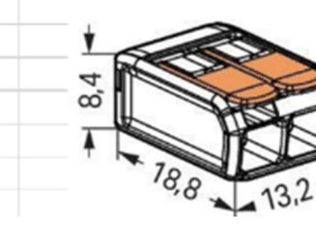

5.2 Starting Measurement
The Aquatos Web LTX begins measuring as soon as the batteries are inserted and the device is powered.
- User settings: The measurement parameters depend on the user-defined settings (see Chapter 4):
  - Measurement interval (scan rate)
  - Logging interval (log rate)
  - Transmission interval (data transmission rate)
- Local memory: The Aquatos Web LTX stores a copy of the measurement data in its local memory (ring buffer). When the memory is full, the oldest data is overwritten.
- Alarm monitoring: The Aquatos Web LTX can monitor alarm thresholds and issue alerts when a threshold is exceeded (see Section 4.8).

Part 6 Maintenance

6.1 BlueShell – Local Configuration Software
The software itself does not require any special maintenance. We recommend installing new updates regularly to keep the software up to date.

6.2 Data Logger
Our loggers require only minimal maintenance. Do not use sharp tools or aggressive cleaning agents. Replace the batteries only when necessary. Never open the battery compartment in rain or damp conditions – moisture can cause system failures.
Replacing the Desiccant
Under humid operating conditions, the silica gel must be replaced regularly. The self-monitoring function provides information on the humidity inside the housing. As a guideline: up to 50 % is uncritical, from 70 % monitor the value, and no later than above 85 % the desiccant pouches must be replaced. We recommend replacing the pouches (2 g of silica gel each). The desiccant is available from local specialist dealers.
Caution: If the desiccant is not replaced in time, the humidity may, over time, approach saturation – which can lead to electronic failures.
Checking Tightness
If humidity rises sharply within a short time, the hermetic seal may be compromised. This is often caused by material expansion due to large temperature changes. To prevent damage, O-rings and cable glands should be replaced.
Lubrication of the Seals
The seals should always be well greased. Each time the logger is opened (battery change, SIM card change, etc.), check whether the O-rings are still adequately lubricated – if so, no additional greasing is required; otherwise re-grease with a suitable grease. Use only high-viscosity silicone pastes (e.g. Korasilon Paste, high-viscosity); unsuitable greases can cause the O-rings to swell or be damaged. The Aquatos Web LTX has a total of four sealing rings: two at the ends of the plastic sensor body and two in the middle, next to the dividing wall between the two halves of the body. The image below shows the seals (black O-rings) at the lower end of the sensor body and two seals in the central area.
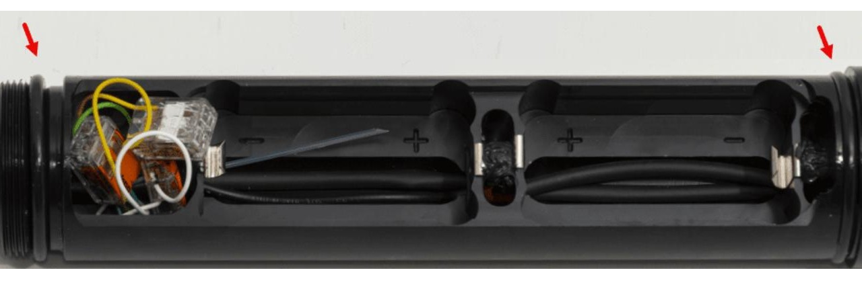
Regular Inspections
- Check the physical condition of the logger and housing for any signs of damage or wear.
- Check the antenna and connections for a secure fit and absence of corrosion.
Battery Care
- Monitor battery status regularly and replace the batteries in good time to ensure uninterrupted operation.
- When replacing the batteries, observe the correct polarity – incorrect polarity can cause damage.
Data Analysis
- Schedule regular data downloads to ensure data integrity and prevent data loss.
- Back up the data in multiple locations to protect against loss.
Calibration
- Perform regular sensor calibrations to maintain measurement accuracy.
- Follow the manufacturer's instructions regarding calibration intervals and procedures.
Cleaning
- Keep the logger housing clean to prevent deposits and soiling.
- Do not use aggressive chemicals; a soft cloth and a mild detergent are generally sufficient.
Environmental Observation
- Assess the environmental conditions around the logger – e.g. water levels and potential sources of contaminants.
- Make sure the monitoring point is free of deposits or obstacles that could impair operation.
Firmware Updates
- Check for recommended firmware updates from the manufacturer and install them.
- Use the BlueShell software (terminal window) to install updates.
Site Inspections
- Carry out periodic site inspections to assess the operating environment and cellular coverage.
- Address issues with signal strength or environmental changes promptly.
Documentation
- Maintain a log of all maintenance work: inspections, repairs, calibrations.
- Document any changes at the monitoring point that may affect performance.
Note: If you need further assistance, please contact TerraTransfer GmbH customer support.

Part 7 Troubleshooting
Data Logger
- Housing damaged: Please contact customer support and return the device for servicing.
- Cable damaged: Please contact customer support and return the device for servicing.
- Humidity inside the housing is rising:
  - Reference values: up to 50 % humidity is uncritical, from 70 % monitor the value, and no later than above 85 % replace the desiccant pouches. Replace the desiccant pouches (2 g of silica gel). Desiccant is available from local or specialist dealers.
  - If humidity rises sharply in a very short time (e.g. from < 50 % to above 85 % within a few days), the hermetic seal may be damaged – often due to material expansion following large temperature changes. Replace the O-rings and cable glands to prevent consequential damage. Contact customer support.

Part 8 Repair
Precision instruments and data loggers from TerraTransfer GmbH are manufactured in quality-assured processes. All production and assembly sites are ISO 9001 certified. Every unit is tested and calibrated at the factory before shipping. This ensures that TerraTransfer products deliver their full performance upon delivery.
Despite thorough quality assurance, faults can occur within or outside the warranty period. In rare cases, a product may not match the order.
In such cases, TerraTransfer GmbH's return and repair policy applies. For you as the customer, this means:
- Contact TerraTransfer GmbH using the repair request form and decontamination declaration (available on request or on our website).
- In return, you will receive a reference number that must be quoted on all further correspondence and on the shipping documents.
- Please include as much information and/or a clear description of the fault as possible with the return documents – this supports our test engineers in making a diagnosis.
- Only ship the goods after you have received the reference number. Returns without a reference number will not be refused, but may lead to processing delays.
Customs requirements for warranty or non-warranty repair returns: clarify with the national customs / tax authorities the details, processes and documents required for duty-free returns. There are usually specific customs tariff codes (e.g. HS code 9802.00) that certify the item is being returned for repair and has no commercial value.
Customs documents / shipping papers should clearly state: “Goods being returned to manufacturer for repair – No Commercial Value”. Returns must include a commercial invoice on company letterhead. TerraTransfer GmbH reserves the right to invoice time spent correcting incorrect customs documents.
Note: Please pack returns carefully and securely. Transport damage is not covered by our warranty and may incur costs.

Part 9 Technical Data

Technical Specifications – Data Logger
Product name | Aquatos Web LTX
Logger type | Type 1500 (firmware identifier)
Input channels | SDI-12, 24 channels, high resolution
Communication | Remote transmission:  • LTE-M (4G / LTE Cat M), bidirectional · fallback to NB-IoT (LTE-NB) and 2G / GSM  • Data transmission via HTTPS (TLS-encrypted)  • Direct connection to the Sensormanager web portal  Local: Bluetooth® 5 (BLE) – browser-based configuration without an app  Note: earlier models used 3G / UMTS and 433 MHz (licence-free ISM band).
Power supply | 2 × SAFT LSH 20 lithium batteries, 3.6 V, 13,500 mAh (non-rechargeable). Up to 10 years of operating life, or approx. 2 million measurements / 25,000 transmissions per device.
Data memory | Internal memory for up to 250,000 readings, non-volatile  Logging interval: freely definable, minimum 2 s  Measurement and transmission cycles freely programmable
Materials and ambient conditions | Housing: stainless steel (V4A), ABS plastic inner carrier  Protection rating: IP68  Operating temperature: −25 °C to +85 °C (no icing)  Designs: above-ground (protective housing) or below-ground (gauge-tube installation)
Dimensions / weight | Ø 48.5 mm · length 411.5 mm · 1.5 kg (without sensor)
Conformity | CE (RED 2014/53/EU, EMC 2014/30/EU) · RoHS compliant
Encryption | AES-128-CBC end-to-end (BSI-recommended) · BLE authentication with challenge-response and 6- to 16-digit PIN · fully encrypted firmware, signed updates only (BLE or OTA)
Alerting | SMS / e-mail on threshold exceedance · self-diagnostics (battery, signal, temperature, humidity)

Part 10 Operator Obligations and Disposal
This chapter contains the following sections:
- 10.1 Operator Obligations
- 10.2 Dismantling / Disposal

10.1 Operator Obligations

European Union
Within the European single market, it is the operator's responsibility to comply with the following legal provisions: the national transposition of Framework Directive 89/391/EEC and the associated individual directives – in particular 2009/104/EC on the minimum safety and health requirements for the use of work equipment by workers at work.

Worldwide
The operator must obtain any required operating permits. In addition, national and regional environmental regulations must be observed – independently of local rules on the following topics:
- Occupational safety
- Disposal
Connections: local regulations for electrical installations and connections must be observed.

10.2 Dismantling and Disposal
When disposing of the devices and accessories, comply with local regulations on environmental protection, waste disposal and occupational safety.

Before Dismantling
- Electrical equipment: switch devices off. Disconnect electrical loads from the power supply – whether they are connected to the mains or another power source.
- Mechanical equipment: secure all loose parts. Prevent the device from moving in an uncontrolled manner.
- Releasing mechanical fasteners: note that devices can be heavy and releasing the fastening may result in mechanical instability.

Disposal
Operators of waste equipment must collect it separately from unsorted municipal waste. This applies in particular to waste electrical and electronic equipment.
Electrical and electronic equipment must not be disposed of as household waste! Waste equipment is to be collected separately and disposed of through local collection and take-back systems.
Integrated or supplied batteries and accumulators must be separated from the devices and disposed of at the designated collection points. At the end of their life cycle, the lithium batteries must be disposed of in accordance with the applicable statutory requirements.

EU WEEE Directive
As a participant in the environmental market, TerraTransfer GmbH supports waste prevention and recycling. Please note:
- Prevent before recycling.
- Recycle before disposal.
The devices are to be disposed of in accordance with Directive 2012/19/EU. Observe the national transposition of the directive as well as any accompanying or supplementary laws and regulations.

Contact
TerraTransfer GmbH
Ottostrasse 19a
44867 Bochum · Germany
Phone: +49 2327 83 44 85-1
E-mail: info@terratransfer.de
Web: www.terratransfer.de
HRB 6778 · Local Court Bochum · Managing Director: Marcel Delker
© 2026 TerraTransfer GmbH · All rights reserved.
Document no. TT-ANL-LTX-001 · Edition 04/2026

