
AUTOMATED ENVIRONMENTAL MONITORING
User Manual
Piezo Pressure Sensor Type 0312
Submersible probe for high-precision water level and gauge measurement
TerraTransfer GmbH
Ottostraße 19a · 44867 Bochum · Germany
Phone: +49 2327 83 44 85-1
www.terratransfer.de

Issue: April 2026 · Document No. TT-ANL-PIE-002

I Disclaimer
The information contained in this manual reflected the state of the art at the time of publication. Subsequent updates are possible. This manual does not cover all details of the design, production or variants of the device, nor does it cover every possible situation that may arise during installation, operation or maintenance.
TerraTransfer GmbH shall not be liable for incidental, indirect, special or consequential damages arising from or related to this documentation and the information contained herein — even if TerraTransfer has been informed of the possibility of such damages.
Copyright: No part of this work may be reproduced, transmitted, processed, duplicated or published in any form without the written permission of TerraTransfer GmbH.
© 2026 TerraTransfer GmbH. All rights not expressly granted are reserved.

II Safety Instructions
Read this user manual including all operating instructions completely before installing, connecting and commissioning the Piezo Pressure Sensor Type 0312. This manual describes the intended operation of the product. It is intended for qualified specialist personnel familiar with installation, assembly, wiring, commissioning and operation.
ℹ Note: Keep this manual for future reference and pass it on when transferring the device to third parties.

Symbols Used
⚠ Caution: Indicates possible impairment of the device or measurement if not observed.
ℹ Note: Provides useful additional information or recommendations.

General Safety Rules
- Inspect the device for visible damage before commissioning. Do not commission damaged devices.
- Use the sensor only within the limits specified in the technical data.
- Unauthorised modifications to the device are prohibited and will void the warranty.
- Observe applicable electrical safety regulations when working on the electrical connection.

III Specific Safety Instructions

Pressure Membrane
⚠ Caution: The stainless steel pressure membrane (standard: AISI 316L; optional at extra cost: AISI 316 Ti) is approx. 20 µm thin and sensitive. Do not bring sharp, pointed or hard objects near the membrane. Clean only with clear water and a soft cloth.
The protective cap is fitted to the sensor during transport and storage. Remove it only immediately before installation.

Capillary and Vent Cable
The sensor operates with relative (gauge) pressure. The vent capillary inside the cable provides the atmospheric reference. Ensure that the cable outlet opening at the logger end of the capillary remains dry and permeable to air at all times.
⚠ Caution: If the capillary is kinked, pinched or filled with water, the sensor will deliver incorrect readings. Always route the cable without tension and with sufficient bending radius (min. 15× cable diameter).

Reverse Polarity Protection
⚠ Caution: The power supply input is not protected against reverse polarity. Damage caused by reverse polarity is excluded from the warranty. Maximum input current: 100 mA.

Electrostatic Discharge (ESD)
The sensor contains electrostatically sensitive components. Observe standard ESD precautions when connecting (potential equalisation, do not touch connector contacts without earthing).

Part 1 Scope of Delivery

Standard Delivery
- 1× TerraTransfer Piezo Pressure Sensor Type 0312, piezoresistive submersible probe (vented capillary)
- 1× Signal cable, sealed and vented, typically 10 m (different length on request)
- This user manual
- FAT test report with device-specific BLE PIN

ℹ Note: The cable length is manufactured individually according to the order. The cable is permanently attached to the sensor.

Optional Accessories
- Sensor cage to protect against mechanical damage and fouling
- Aquatos Web LTX — compatible online data logger with LTE-M mobile communication
- Aquatos mini — compatible offline data logger for local BLE readout

Part 2 Introduction

2.1 Field of Application
The Piezo Pressure Sensor Type 0312 is a piezoresistive submersible probe for high-precision, continuous measurement of water levels and gauges. Typical applications include:
- Groundwater monitoring wells and boreholes
- Surface waters: rivers, lakes, ponds
- Pressure pipelines and tanks
- Flood early warning systems
- Salt water and brackish water (housing always AISI 316 Ti; membrane AISI 316L standard, AISI 316 Ti optional at extra cost)

2.2 Intended Use
The Piezo Pressure Sensor Type 0312 is intended exclusively for the use described in the previous section. Any use beyond this is considered unintended. TerraTransfer GmbH accepts no liability for damage resulting from unintended use.
⚠ Caution: The sensor is not approved for use in explosive atmospheres (ATEX).

2.3 Features and Operating Principle
The Type 0312 measures the hydrostatic pressure of a water column using an oil-filled, laser-welded stainless steel pressure membrane (piezoresistive). The housing is made of AISI 316 Ti. The standard membrane is AISI 316L; for particularly aggressive media, an AISI 316 Ti membrane is available at extra cost. The measured gauge pressure (difference from atmospheric pressure via the capillary in the cable) is converted into a digital SDI-12 data value that is queried by the connected data logger.
In addition, the sensor measures water temperature with high precision (±0.1 °C) and provides both measured values via the SDI-12 interface.
The integrated Open-SDI12-Blue platform also enables wireless configuration and diagnostics via Bluetooth 5 (BLE) using the BLX.JS Dashboard.
ℹ Note: Bluetooth communication is intended exclusively for configuration and diagnostics. Measurement data transmission to the data logger always takes place via SDI-12.

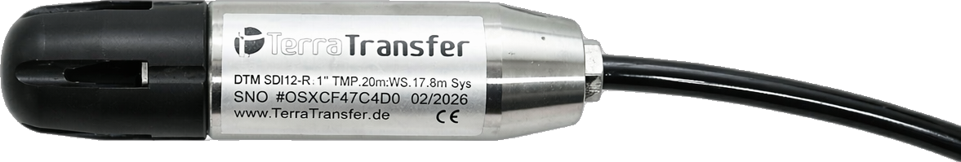
Fig. 1: Piezo Pressure Sensor Type 0312 — overall view with protective cap fitted

Part 3 Installation

3.1 Mechanical Design and Dimensions
The Piezo Pressure Sensor Type 0312 is housed in a cylindrical enclosure made of AISI 316 Ti (DIN 1.4571). The pressure membrane is AISI 316L as standard; an AISI 316 Ti membrane is available at extra cost for particularly corrosive or saline media — the housing remains identical in both versions. Dimensions: approx. 100 × 25 mm (length × diameter), weight approx. 160 g.
The sensor is fitted with a POM protective cap that protects the pressure membrane from damage during transport and storage. The cap is removable without tools and must be removed before installation.

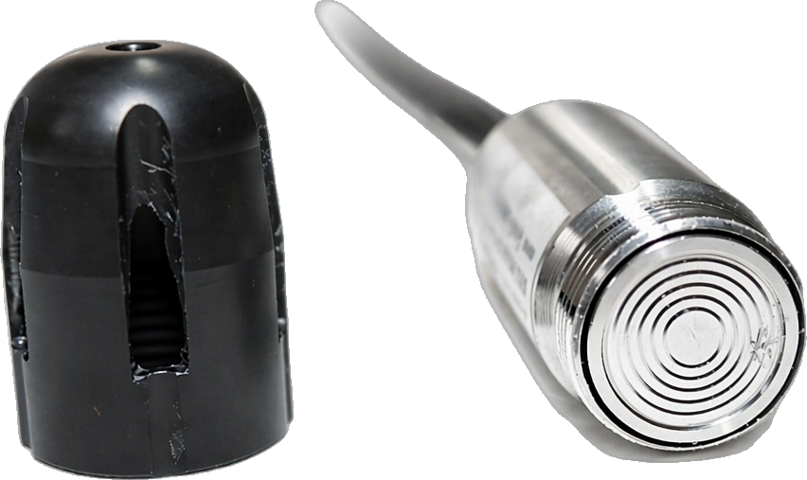
Fig. 2: Protective cap removed — oil-filled stainless steel pressure membrane visible
ℹ Note: Minimum pipe diameter: 1 inch (25.4 mm). TerraTransfer recommends a protective tube made of plastic, steel or stainless steel for installation in groundwater monitoring wells.

3.2 Installation in the Measurement Tube
- Remove the protective cap by rotating anti-clockwise and keep it.
- Insert the sensor vertically, pressure membrane facing down, into the protective or measurement tube.
- Route the cable without tension and without kinking. Minimum bending radius: at least 15× cable diameter.
- For cable lengths over 50 m, use an additional support cable for strain relief.
- Avoid potential differences between measurement and connection point (prevent earth loops).
- Do not install the sensor in the immediate vicinity of motors, pumps, valves or heat sources.

⚠ Caution: Do not apply mechanical force to the probe. The pressure membrane is approx. 20 µm thin and sensitive to mechanical impact.

3.3 Cable Connection to the Data Logger
The signal cable of the Type 0312 has three conductors. Connect them to the SDI-12 terminal of the data logger as follows:

Wire Colour | Function | Description
Brown | SDI-12 DATA | SDI-12 data line (bidirectional)
White | VCC / Supply | Supply voltage 5–16 V DC via SDI-12 bus
Green | GND | Ground / Shield

ℹ Note: Multiple sensors can be operated in parallel on the SDI-12 bus (the Aquatos data logger supports up to 24 measurement channels, total cable length max. 500 m). Each sensor requires a unique SDI-12 address (0–9, A–Z, a–z). The factory address of the Type 0312 is '0'.

3.4 Initial Start-Up
- Connect the sensor as described in Section 3.3.
- Verify correct fit, cable length and bending radius.
- Power the data logger. The sensor requires no separate power supply — it is powered via the SDI-12 bus.
- Configure the sensor using the BLX.JS Dashboard (see Part 4).
- Start a test measurement and check the plausibility of the measured values.

Part 4 Configuration
The Piezo Pressure Sensor Type 0312 is configured via the BLX.JS Dashboard. BLX.JS is a browser-based application that communicates directly with the sensor via Bluetooth 5 (BLE). No app installation is required.

4.1 Opening the BLX.JS Dashboard
Open the BLX.JS Dashboard in a supported browser:

Platform | Supported Browser
Windows / macOS / Linux | Google Chrome, Microsoft Edge
Android | Google Chrome, Microsoft Edge
iOS (iPhone / iPad) | Bluefy Browser (free on App Store)

URL: https://ltxdata.net/ttblx/
ℹ Note: Firefox and Safari do not support Web Bluetooth and are therefore not suitable.

4.2 Establishing a Connection
- Ensure the sensor is powered (data logger switched on or test supply connected).
- Activate Bluetooth on your device.
- Open https://ltxdata.net/ttblx/ in a supported browser.
- Click “Connect Device”. A list of available devices appears.
- Select the Piezo Pressure Sensor Type 0312 from the list.
- Enter the device-specific BLE PIN when prompted (printed on the sensor or in the enclosed FAT test report). Default: 0000.
⚠ Caution: The PIN is never transmitted in plain text. After multiple incorrect entries, the device temporarily locks the BLE connection.

4.3 Setting Measurement Interval and Parameters
The following parameters can be adjusted in the “Settings” section:
- Measurement interval (typically 1, 5, 15 or 60 minutes)
- Depth offset: distance from sensor to reference level (for direct level reading in m above sea level)
- Temperature compensation: enable or disable
- Device name (for easier identification when using multiple sensors)

4.4 Configuring the SDI-12 Address
When multiple sensors are operated on one data logger, each sensor must have a unique SDI-12 address. The address is configured in the BLX.JS Dashboard under “Terminal”:
- Send the SDI-12 command “0AC!” to change the address from '0' to 'C' (example).
- Valid addresses: 0–9, A–Z, a–z
ℹ Note: The SDI-12 address can also be changed via the data logger, provided it supports SDI-12 address change commands. Refer to the data logger manual.

Part 5 Operation

5.1 Starting Measurements
After configuration is complete, the sensor starts measuring automatically at the set interval. No further steps are required.

5.2 Reading Measurement Values
The Type 0312 transmits the following measured values on SDI-12 request:

Measured Value | Unit | Description
Pressure (gauge) | bar | Reference: atmospheric pressure via capillary
Water depth (calculated) | m | Calculated from pressure, configurable
Temperature | °C | Water temperature, high precision ±0.1 °C
Supply voltage * | V | Only with aM1! / aMC1! command

5.3 SDI-12 Command Set
The command set of the Type 0312 follows the SDI-12 standard V1.3:

Command | Description
aAn! | Change address from 'a' to 'n' ('?' as wildcard allowed).
aI! | Identify sensor — returns device identifier and firmware version.
aM! / aMC! | Start measurement. D command returns 2 values: (1) pressure, (2) temperature.
aM1! / aMC1! | Start measurement. D command returns 3 values: (1) pressure, (2) temperature, (3) supply voltage.
aD0! | Read measured values — always execute after an M command.

5.4 Operation with Aquatos Data Loggers
The Piezo Pressure Sensor Type 0312 is approved for use with the following Aquatos data loggers from TerraTransfer:

Data Logger | Description
Aquatos Web LTX | Online logger with LTE-M mobile communication. Data transmission and remote access via Sensormanager web portal.
Aquatos mini | Offline BLE logger for local readout via smartphone or tablet.

ℹ Note: The Aquatos nano is not recommended as it has an integrated pressure sensor and does not support an external pressure probe.

Part 6 Maintenance

6.1 Cleaning the Pressure Membrane
Depending on water quality and service duration, deposits, biofilm or scale may form on the membrane. Clean the sensor regularly (recommended: once a year, more frequently in heavily loaded water).
- Remove sensor from the measurement tube.
- Remove the protective cap (if not already done).
- Gently wipe off deposits with clear water and a soft cloth or sponge.
- For scale deposits: briefly immerse in diluted acetic acid (max. 5 %), then rinse thoroughly with tap water.
- Allow the sensor to dry and check for visible damage.
⚠ Caution: Do not use abrasives, solvents, pointed tools or high-pressure cleaners. The stainless steel pressure membrane is approx. 20 µm thin and sensitive to mechanical impact.

6.2 Cable and Capillary
Check the connecting cable annually for kinks, pressure marks and damage to the cable sheathing. The capillary inside the cable must always be free and permeable to air.
- Cable outlet at the sensor: check for tightness and secure fit
- Capillary end at the logger connection: keep dry and unobstructed
- No water at the capillary inlet (e.g. from condensation in the switchgear cabinet)

6.3 Calibration Interval
The sensor leaves the factory calibrated. For measurement-critical applications, we recommend a field calibration against a known water level every 2–3 years. Contact TerraTransfer for calibration enquiries.

Part 7 Troubleshooting

Symptom | Possible Cause | Action
No SDI-12 signal | Cable connection interrupted or incorrect wiring | Check cable connection. Measure supply voltage (5–16 V). Check SDI-12 address in BLX.JS Dashboard.
Constant or implausible value | Capillary pinched or blocked | Check cable for kinks; replace cable if necessary.
Erratic fluctuation | Water entered capillary | Remove sensor from tube, check capillary end.
BLE connection not possible | Distance too large or wrong browser | Max. BLE range approx. 10 m outdoors. Use supported browser (Chrome/Edge/Bluefy).
PIN forgotten / locked | Too many failed attempts | Leave sensor without supply voltage for 10 minutes, then retry. If permanently locked: return to TerraTransfer.
Error code 1101 / 1102 | Sensor not responding | Check supply voltage and cable.
Error code 1103 | Timeout | Check bus for overload (too many sensors, cable fault).
Error code 1104 | Sensor busy | Wait for measurement to complete and repeat command.
Error code 1105 | Memory error | Switch device off briefly. If error persists: return to TerraTransfer.
Error code 1106 | No calibration coefficients | Return to TerraTransfer for recalibration.

Part 8 Repair and Return
Repairs to the Piezo Pressure Sensor Type 0312 may only be carried out by TerraTransfer GmbH or authorised specialist personnel. Unauthorised intervention in the device will void the warranty.

Return Procedure
- Contact TerraTransfer by phone or e-mail before returning to obtain an RMA number.
- Pack the device securely with adequate padding. Ensure the sensor is dry and clean. Refit the protective cap.
- Enclose a brief fault description and your contact details.
- Send the device to the TerraTransfer service address (see Contact).

Part 9 Technical Data

9.1 Mechanical
Housing material | Stainless steel AISI 316 Ti (DIN 1.4571)
Pressure membrane (standard) | Stainless steel AISI 316L, piezoresistive, oil-filled, laser-welded (approx. 20 µm)
Pressure membrane (option) | Stainless steel AISI 316 Ti — for saline and aggressive media, at extra cost
O-ring | FKM
Protective cap | POM (polyoxymethylene), removable without tools
Cable | Vented signal cable with vent capillary (open conductors)
Cable length | Typically 10 m (manufactured individually to order, permanently attached)
Dimensions | Approx. 100 × 25 mm (length × diameter)
Weight | Approx. 160 g (without cable)
Protection class | IP68
Conformity | CE (RED, EMC) · RoHS-compliant

9.2 Electrical / Communication
Supply voltage | 5–16 V DC (SDI-12 bus)
Current consumption (measurement) | <4 mA for approx. 300 ms
Current consumption (standby) | <0.015 mW
Current consumption (continuous mode) | constant <4 mA
Maximum input current | 100 mA
Interface | SDI-12 V1.3
Short-range radio | Bluetooth 5 (BLE), Open-SDI12-Blue platform (nRF52)
BLE security | Challenge-response authentication, AES-128-CBC
BLE range | Approx. 10 m in open field (depending on environment)
Configuration | BLX.JS Dashboard (browser-based, no app download)
Factory SDI-12 address | '0'

9.3 Measurement
Pressure principle | Piezoresistive, gauge pressure with vent capillary
Measuring ranges | 5 · 10 · 20 · 30 · 100 mWC (see nameplate)
Overpressure resistance | 4× rated pressure range
Accuracy | ±0.15 % FS
Long-term stability | typ. ±0.1 % FS per year (for ranges < 1.5 bar: ±3 mbar)
Temperature measurement | Yes, integrated
Temperature accuracy | ±0.1 °C

9.4 Environmental
Operating temperature membrane/cell (compensated) | −5 °C to +50 °C (non-icing)
Operating temperature membrane/cell (operation) | −20 °C to +85 °C (non-icing)
Operating temperature electronics | −40 °C to +85 °C
Storage temperature | −40 °C to +85 °C
Protection class | IP68 (continuous submersion)
Medium | Water (also saline and mineral-rich, slightly aggressive)

Part 10 Operator Obligations and Disposal

Operator Obligations
The operator is obliged to use the sensor in accordance with this manual and to operate it only in perfect condition. Defective devices must be taken out of service immediately.

Disposal (EU WEEE Directive)
Under the EU WEEE Directive (2012/19/EU), waste electrical equipment must be disposed of separately from household waste. Return waste devices to municipal collection points or to TerraTransfer GmbH for professional disposal.
⚠ Caution: This device must not be disposed of with normal household waste. Incorrect disposal may cause environmental damage.

Contact
For questions about this product, for services or spare parts orders, please contact:

TerraTransfer GmbH
Ottostraße 19a
D-44867 Bochum

Phone: +49 (0)2327 83 44 85-1
Fax: +49 (0)2327 83 44 85-7
E-Mail: info@terratransfer.de
Web: www.terratransfer.de

Commercial register: Amtsgericht Bochum HRB 6778
Managing Director: Marcel Delker

