
AUTOMATED ENVIRONMENTAL MONITORING NETWORKS
User Manual
TerraTransfer Sensormanager
Online portal for automated environmental monitoring networks
TerraTransfer GmbH
Ottostrasse 19a · 44867 Bochum · Germany
Phone: +49 2327 83 44 85-1
www.terratransfer.de
Edition: April 2026 · Document no. TT-ANL-SM-001

Table of Contents
I Disclaimer
II About this manual
1 System overview
1.1 Purpose of the Sensormanager
1.2 Monitoring-network components
1.3 Data flow
1.4 Security
2 Login and start view
2.1 Login
2.2 Start view of the online portal
3 Status monitor
3.1 Meaning of threshold values
3.2 Column “Transmission interval”
3.3 Column “Map” and column selection
3.4 Logger status
4 Measured values and charts
4.1 Logger context menu
4.2 Chart view
5 Importing, editing and exporting measured values
5.1 Exporting measured values
5.2 Importing measured values
5.3 Editing, deleting and restoring measured values
6 Document management and logger files
6.1 Document management
6.2 Logger files
7 Map and citizen portal
7.1 Map functionality
7.2 Citizen portal
8 Alarm management
8.1 Alarm groups and alarms
8.2 Creating alarms
8.3 SMS notifications
8.4 E-mail notifications
8.5 Editing and deleting alarm groups
8.6 Alarm notifications
9 User, group and logger administration
9.1 Group administration
9.2 User administration
9.3 Logger administration
9.4 Logger coordinates
9.5 Configuring measuring points
10 Automatic exports
10.1 Creating an automatic export
10.2 Export error notifications
11 Group exports
12 Isolines
12.1 Configuration
12.2 Logger import from CSV
12.3 Isoline map and tools
13 Maintenance and operation
14 FAQ – frequently asked questions
15 Legal notice

I Disclaimer
The information contained in this manual reflected the state of the art at the time of publication. Subsequent updates are possible and will be supplied as needed.
The Sensormanager is continuously being further developed. Individual screenshots may therefore differ from the current user interface. The fundamental workflows and terminology remain unaffected.
TerraTransfer GmbH shall not be liable for any incidental, indirect, special or consequential damages arising from this documentation and the information it contains – even if TerraTransfer has been advised of the possibility of such damages.
Copyright: No part of this document may be reproduced without the written permission of the publisher. TerraTransfer GmbH permits users to print parts of the documentation on paper exclusively for their own use.
Trademark notice: Products and services of TerraTransfer GmbH are trademarks or registered trademarks of TerraTransfer GmbH. Other product names used may be trademarks of their respective owners.
© 2026 TerraTransfer GmbH. All rights not expressly granted are reserved.

II About this manual
This manual describes the operation of the TerraTransfer Sensormanager – the central online platform for running TerraTransfer monitoring networks. It is aimed at users who already have a user account and manage loggers, measured values, alarms and exports.

Target audience
- Case handlers and water ecologists who retrieve and analyse measurement data
- Monitoring-network administrators who create loggers, manage users and groups and configure exports
- Technical staff who set up alarms and maintain measuring points

Typographic conventions
Important passages are highlighted as colour-coded side bars:
Note | Additional information that makes working with a function easier – highlighted in blue.
Caution | Important warning about possible data loss or irreversible actions – highlighted in red. Please read before proceeding.

1 System overview

1.1 Purpose of the Sensormanager
The TerraTransfer Sensormanager is the central web-based operating platform for automated environmental monitoring networks. It receives, stores and visualises measured values from TerraTransfer data loggers and makes them available through a browser-based portal.
The Sensormanager is designed not only to provide fast access to the measurement data, but also to give an intuitive overview of the condition of the devices in the monitoring network. It can be operated on TerraTransfer servers or on a customer-owned server.

1.2 Monitoring-network components
The following product families feed data directly into the Sensormanager:
Aquatos Web LTX (Logger Type 1500): IP data logger with integrated LTE-M cellular communication for water-level and water monitoring. Delivers measured values autonomously to the backend via cellular network and can be operated online.
Aquatos mini / Aquatos nano: Compact offline data loggers without a modem. Measured values are read out on site via BLE and subsequently imported into the Sensormanager.
Monitoring buoys: Self-contained monitoring buoys for surface waters that transmit their measured values via LTE-M to the Sensormanager.
Measurement chains: Multi-point measurement chains (e.g. temperature profiles) with SDI-12 interface, connected to an Aquatos logger with cellular communication.
Climate stations: Combination sensors (precipitation, temperature, wind, humidity, radiation) that feed into the Sensormanager via an Aquatos logger with cellular communication.
Note: All of the devices listed above deliver measured values to the same backend. In the Sensormanager they all appear uniformly as “loggers” with their associated sensor channels. Local access to TerraTransfer devices is exclusively via Bluetooth Low Energy (BLE) – there is no cable, USB or SD-card interface.

1.3 Data flow
Depending on the device, transmission to the backend takes place in different ways:
- Devices with a cellular modem (Aquatos Web LTX, monitoring buoys, climate stations, measurement chains with a gateway) transmit cyclically or event-driven via LTE-M directly to the backend
- Offline loggers (Aquatos mini, Aquatos nano) are read out on site via BLE; the data are subsequently imported into the Sensormanager
After the data are received, they are stored in the database and are immediately available in the portal. Logger configuration (measurement interval, sensor channels) is performed locally via BLE. The metadata (name, sensor designations, conversion factors) are maintained in the Sensormanager.

1.4 Security
- Communication with the portal is exclusively via HTTPS (TLS)
- User accounts with a multi-level permission system (sysadmin, admin, admin_sms, user, guest, mapview)
- Data transmission between LTX logger and backend is encrypted (AES-128-CBC)
- BLE access to loggers is secured with challenge-response authentication

2 Login and start view

2.1 Login
For your login to the TerraTransfer online system you have received access credentials (username and password) from us. Enter these credentials on your login page.
Data transmission is encrypted via HTTPS. In the standard installation, you reach the Sensormanager at https://www.sensormanager.net. For an on-premise installation, use the address provided by your IT department.
Caution: Storing the password in the browser cookie carries an increased security risk. Make sure that no unauthorised persons can gain access to your user credentials.

2.2 Start view of the online portal
The online portal is divided into three areas:
- Left side: overview of your sensor network
- Right side: status monitor and charts, organised in tabs
- Top bar: logout and language selection
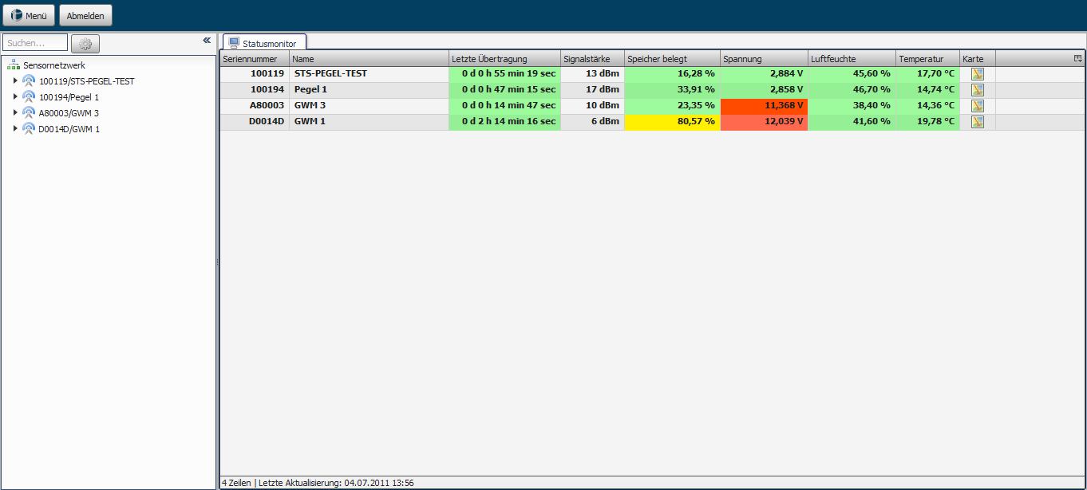
Figure 1: Start view of the online portal with sensor network (left) and status monitor (right).

3 Status monitor
The status monitor provides a fast and intuitive overview of device status with respect to signal strength, memory usage and other important parameters. The traffic-light display of the individual values gives you a quick and intuitive overview of the state of your sensor network.

3.1 Meaning of threshold values
- Green: parameter values are in an optimal state
- Yellow: parameter values are in an acceptable state
- Red: parameter values are in a critical state
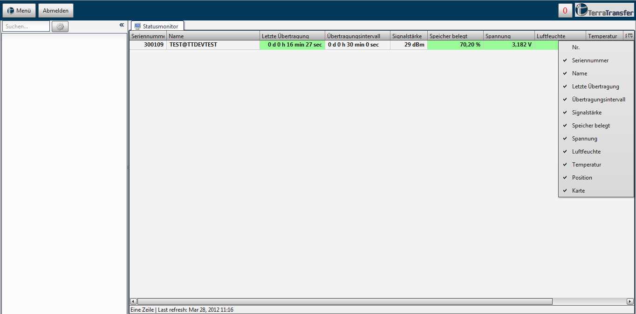
Figure 2: Status monitor with traffic-light display of the most important metrics.

3.2 Column “Transmission interval”
The colour of the Transmission interval column is calculated based on the configured interval:
- Last transmission < 3× interval: green
- 3× to 6× interval: yellow
- > 6× interval: red
- If no transmission interval is defined, no colour is displayed

3.3 Column “Map” and column selection
The Map column provides an OpenStreetMap view of each sensor’s location. The last column of the status monitor opens a list for showing or hiding individual column contents.

3.4 Logger status
In the status monitor, the Logger status column shows whether errors occurred when importing measured values into the database. If the values were imported successfully, the column is shown in green. If an error occurred, the column is shown in red.
When you click the corresponding column, a window opens in which the status messages (successful and failed import attempts) are listed. Once you have resolved the cause of a failed import attempt, you can tick the Error resolved column. Only when all faulty status messages have been resolved does the Logger status column in the status monitor turn green again.
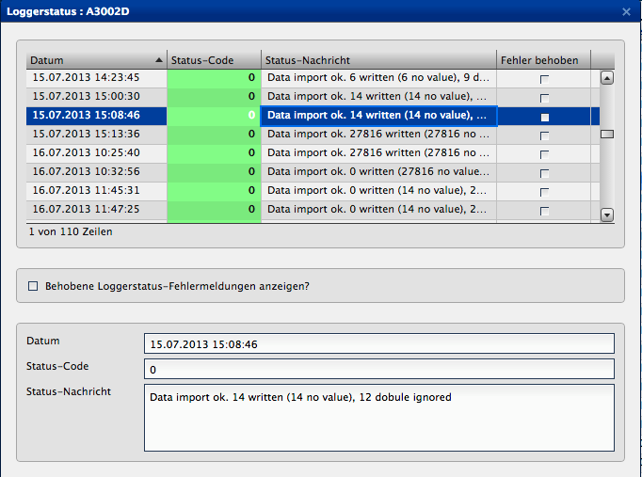
Figure 3: Logger-status dialogue with import messages.

3.4.1 Successful import message
Example: Data import ok. 100 written (20 no value), 20 double ignored
- 100 measured values were written to the database
- 20 of these were empty values (stored with the g2d files for consistency but not shown in the chart)
- 20 duplicate values were filtered out beforehand (e.g. resulting from repeated import attempts of the same file)

3.4.2 Typical error messages
Logger not found in database: The logger has not yet been created in the logger administration. Create the logger (see chapter 9.3) so that the measured values can be associated with its serial number.
Channel mismatch: The channel assignment on the logger does not match the one configured in the portal. Adjust the channels accordingly.
No data: The logger transmitted an empty g2d file (e.g. a manual transmission without a measurement). Subsequent errors and zero values in the status monitor are to be expected in this case.
Cannot read HKHum / HKTemp / HKBat: These are not real errors but status messages. Not all loggers and measuring-point set-ups record all housekeeping values (housing temperature, humidity, battery voltage). The message can be ignored in such cases.
Cannot read transmission interval: Offline loggers without a modem (Aquatos mini, Aquatos nano) do not provide a transmission interval. This message can be ignored for such devices.

4 Measured values and charts
The left-hand window shows your entire sensor network. Here you can select individual devices. To get the expanded view, click the triangle to the left of the device name – the corresponding sensor channels are then displayed.
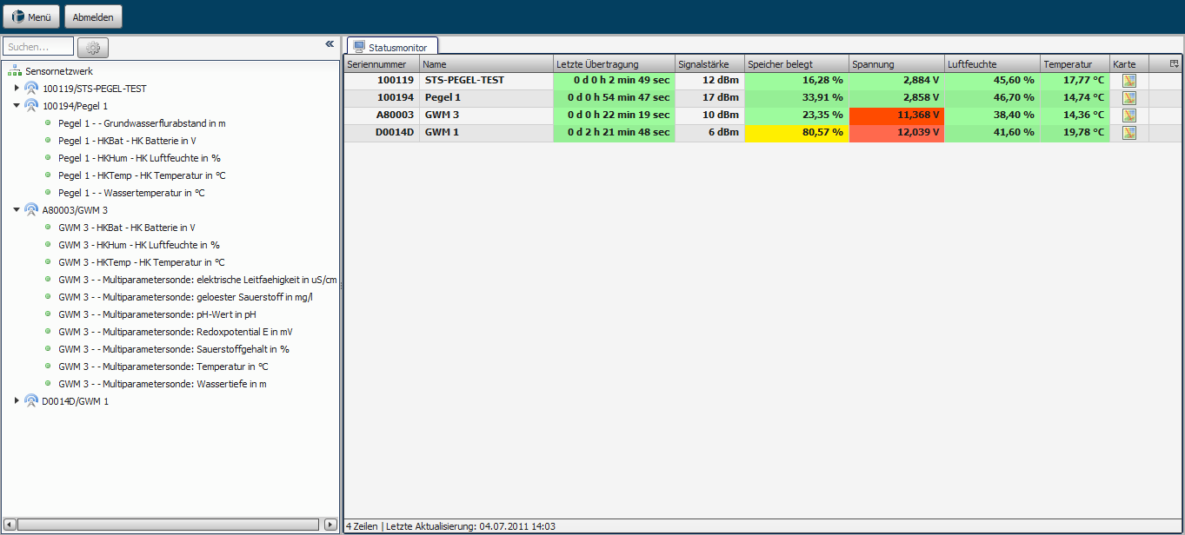
Figure 4: Sensor network with expanded sensor channels of a logger.

4.1 Logger context menu
A right-click on a device offers three options:
- Show hydrograph: displays the hydrograph in the right-hand window
- Show hydrograph in a new chart: opens the measured values in a separate chart
- Export measured values …: opens a dialogue for selecting a time range and format

4.2 Chart view
To open a chart view, double-click the desired entry in the sensor network. A Chart tab opens showing the most recent measurement results.
For older measurement results, the Time range button offers predefined options (last 7 days, last month etc.) or alternatively a free choice of start and end time. The default setting is to display the last month. The table below the chart can be shown or hidden using the button in the top right-hand corner.
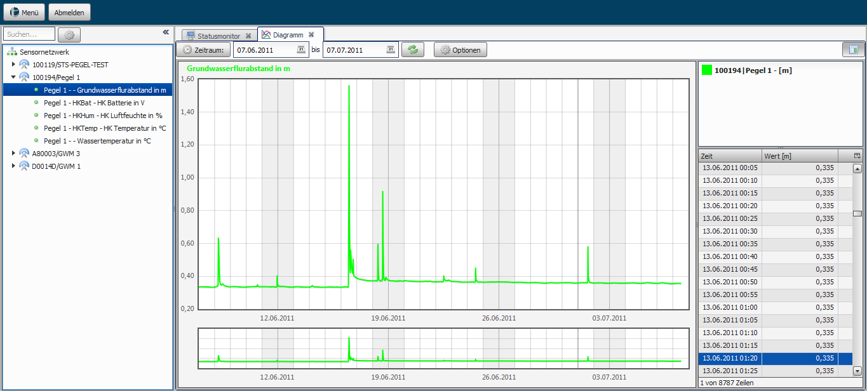
Figure 5: Chart view with time-range selection and measured-value table.

4.2.1 Relative precipitation
When displaying a relative precipitation sensor (NIEDrel / PRECIPRel), an additional selection box is shown in the chart that lets you adjust the display of the relative precipitation. You can either choose a predefined time range or define your own.
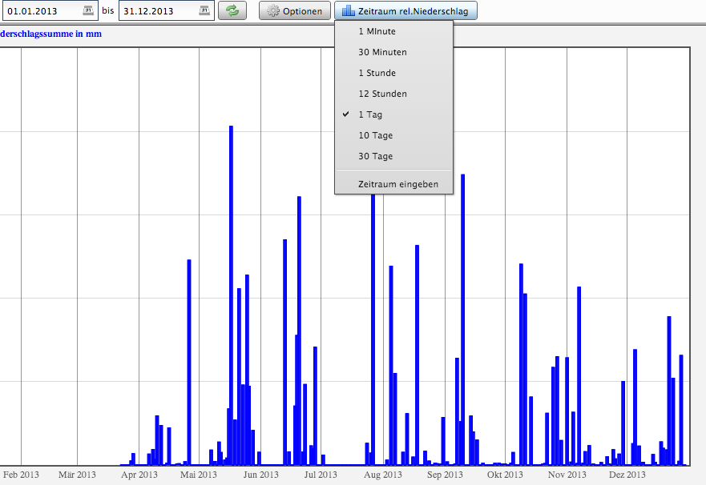
Figure 6: Relative-precipitation display with additional time-range selection.

4.2.2 Chart options
To access the chart options, click the Options button directly above the chart.
- Couple table to chart: when hovering over measured values in the chart, the corresponding rows in the table are highlighted.
- Flip left y-axis: the y-axis is inverted (useful, for example, for groundwater drawdown).
- Zoom: off / x direction / y direction / both directions.
- Crosshair: off / vertical line / horizontal line / cross.
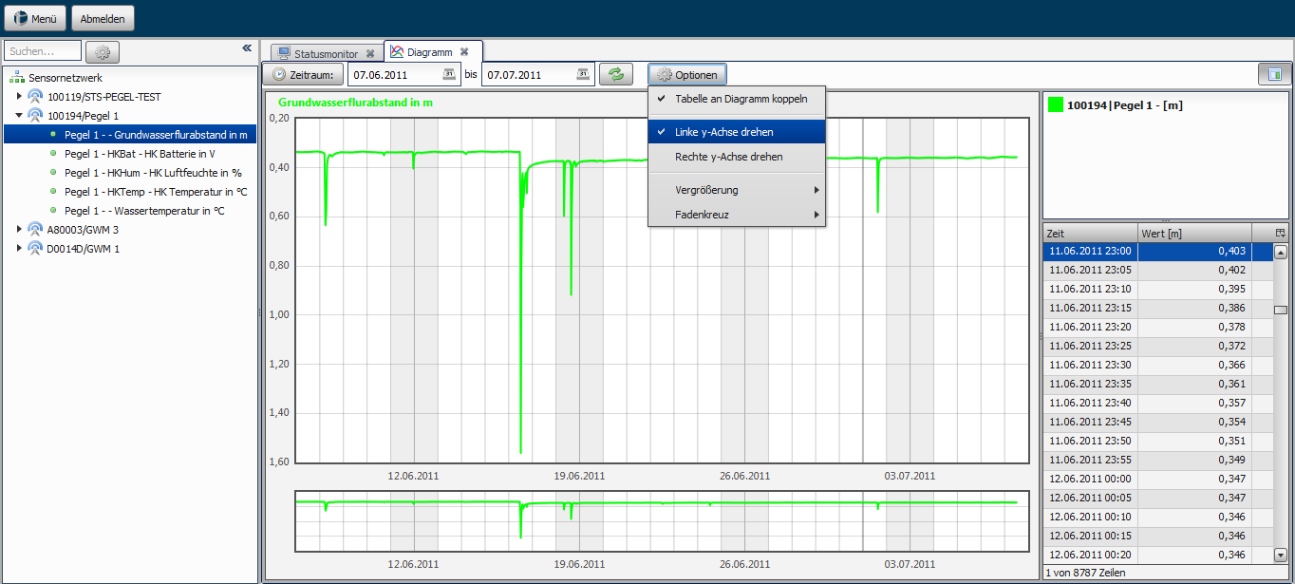
Figure 7: Opening the chart options.

4.2.3 Displaying multiple sensors
The portal lets you display two measured values (e.g. water level and water temperature) in a single chart. Click on a second value within a device in your sensor network. To switch between the values, click the desired parameter in the top right-hand box.
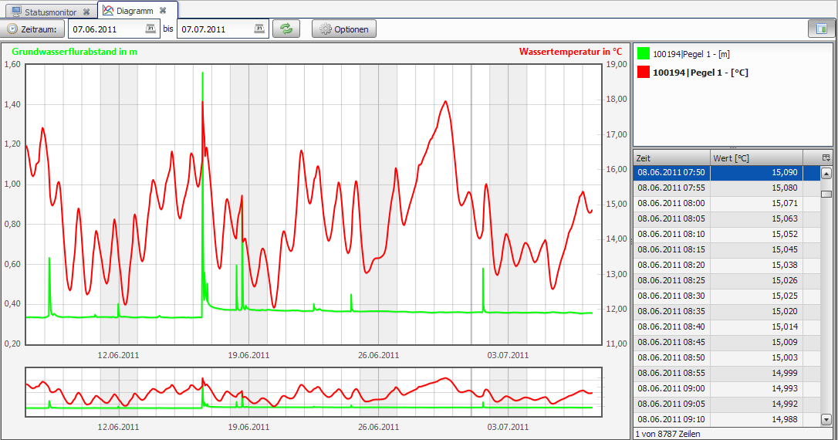
Figure 8: Multiple sensors displayed in one chart.

4.2.4 Moving modular views
All modules (chart, user management, etc.) are built modularly and can be moved within the application. This allows two or more charts, for example, to be compared directly side by side. Left-click the tab title, keep the mouse button held down and drag the module to the desired position.
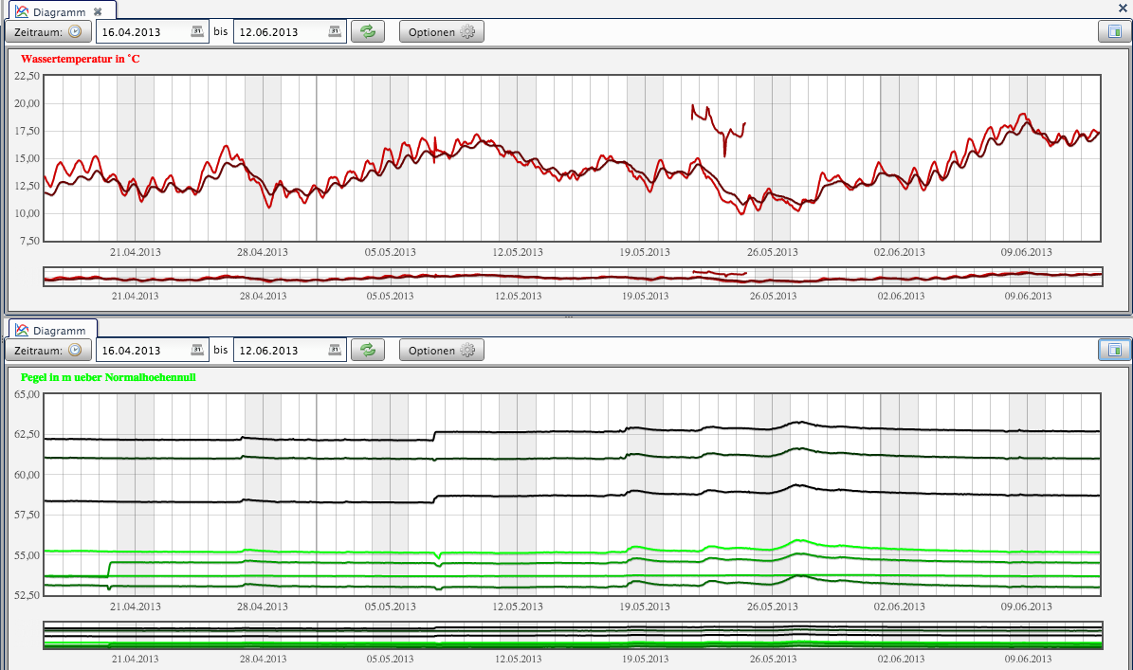
Figure 9: Modular layout – several charts side by side.

4.2.5 Zoom functionality
The chart dynamically scales the values of the defined time range. The lower chart provides an overview, while detailed analysis is performed in the upper chart. To zoom, drag with the left mouse button to select a region – this works in both the upper display and the lower overview.
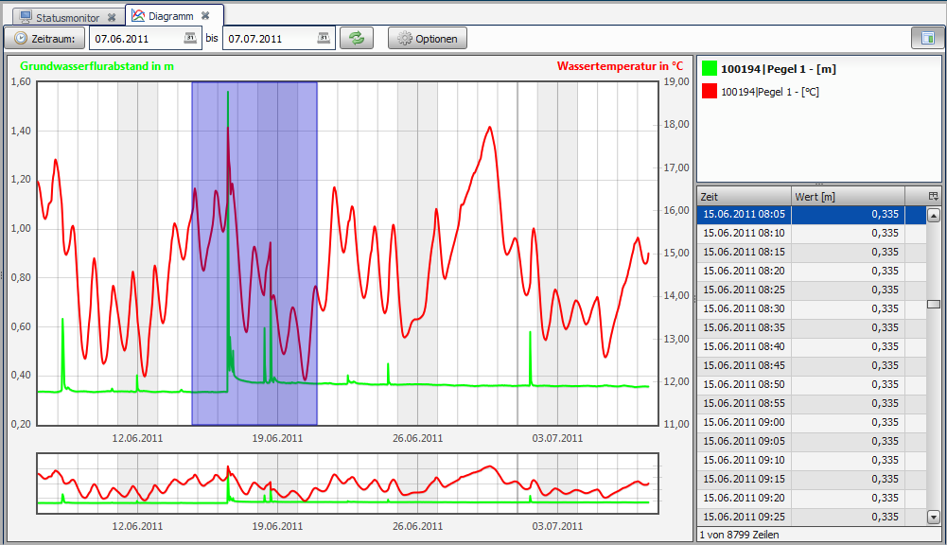
Figure 10: Zoom functionality in the chart.

4.2.6 Visual display of event thresholds
Threshold exceedances or undershoots can be displayed for each sensor to visualise limit violations in the measurement field. The horizontal solid line in the chart shows your individually configured threshold for the corresponding sensor.
Event thresholds are defined in the logger administration (see chapters 9.3.2 and 9.3.3).
Enable/disable for all sensors: Options → Show event thresholds.
Individually per sensor: Right-click in the sensor overview → context menu → Edit min/max thresholds.
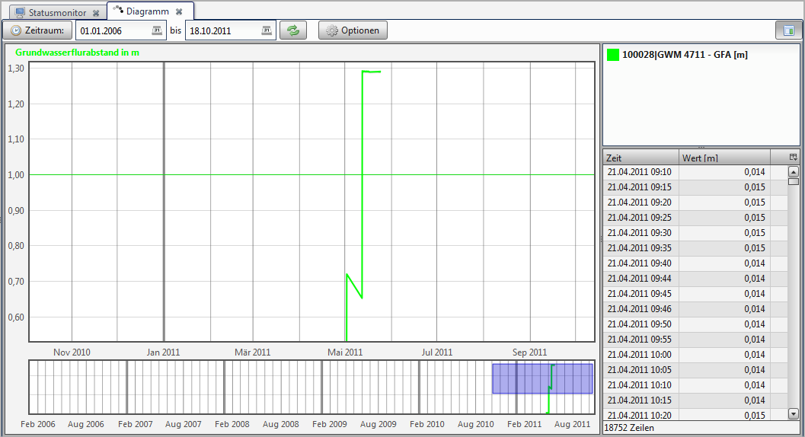
Figure 11: Visual display of event thresholds in the chart.

4.2.7 Adjusting sensor colour
To change the display colour of a sensor, right-click the sensor and select Change colour. To restore the default colour, use Restore colour.
Caution: The chart must be restarted once for the default colour to be restored.
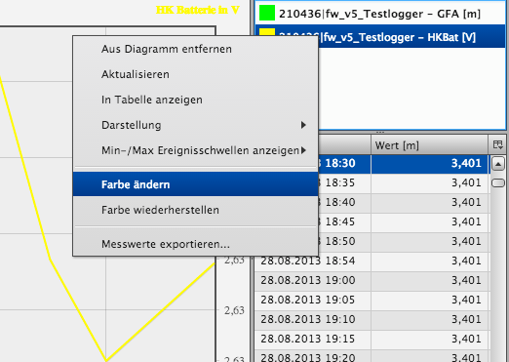
Figure 12: Colour selection for a sensor.

5 Importing, editing and exporting measured values

5.1 Exporting measured values
To export measured values, select a time range, the export mode and the format. The following export modes are available:
- Standard export: all measured values in the time range are exported
- ΔH export: only measured values that exceed a defined height-difference value
- Average export: mean values within an interval (minute, hour, day)
Available export formats:
CSV | Spreadsheets and statistics software – two header rows, timestamp and measured value
HydroPro | HydroPro import
Hydras3 | OTT Hydras 3
WISKI | Kisters WISKI / HyPremo (OEM)
Aquainfo | Aquainfo formats
HygrisC | HygrisC format used by German state environmental agencies
TMCSV | Extended TerraTransfer CSV
RVCSV | Project/measuring-point-specific CSV
Aquafin | Aquafin format (standard export only)
KH-15 | KH-15 format with project/measuring-point name

5.1.1 CSV format
The CSV format is particularly suited to local analysis in spreadsheet software (Microsoft Excel, OpenOffice Calc) or statistics tools (STATISTICA, SPSS). The export contains two header rows (serial number/logger name, value type/unit) and two columns (timestamp, measured value).

5.1.2 ΔH export
The ΔH export only exports measured values that exceed a defined ΔH value (positive and negative height difference) and lie above an optional ΔH start value. The function is also available for automatic and group exports (see chapters 10 and 11).

5.1.3 Average export
For average exports, only the mean values within an interval (minute, hour, day) are calculated and exported.

5.1.4 Relative precipitation
When exporting a relative precipitation sensor (NIEDrel / PRECIPRel), the Relative precipitation option is offered automatically.

5.2 Importing measured values
Raw data (G2D files) can be imported into the database via the import interface. Click the import icon above the sensor network; a dialogue for selecting the files then opens.
If the logger does not yet exist, the folder structure on the file system is created automatically. However, the logger itself must be created in the logger administration so that it appears in the portal (see chapter 9.3).
Caution: If you have edited or deleted individual measured values, a renewed import will reset them to their original state.
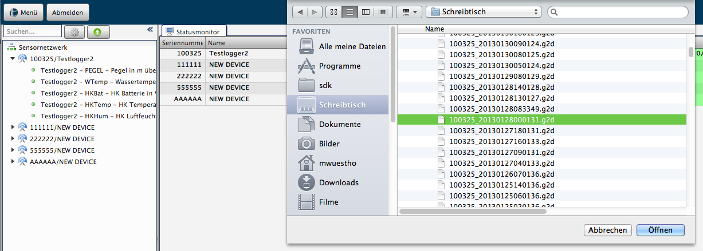
Figure 13: Import dialogue for raw data (G2D files).

5.3 Editing, deleting and restoring measured values
Measured values can be edited, deleted or restored directly in the database. Right-click the measured value and use the context menu. Several values can be selected with Ctrl + left-click or Shift + left-click.
Caution: The raw data (G2D files) are not affected by the editing. If measured values are imported again via the import function, your changes will be overwritten.
Relative precipitation sensors cannot be edited because they contain interpolated values. The context menu is automatically disabled for these sensors.
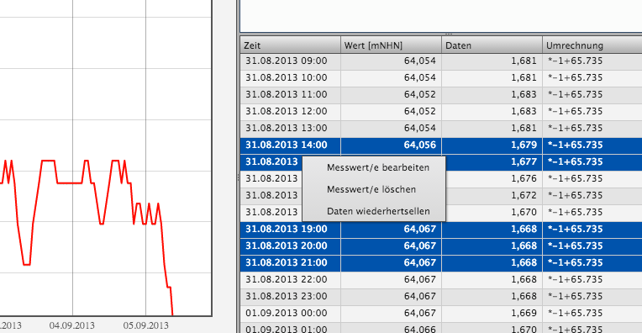
Figure 14: Dialogue for editing several measured values with an addition/subtraction factor.

5.3.1 Deleting measured values
After selection you are asked whether you want to delete the measured values. All selected values are then deleted.

5.3.2 Restoring data
Only measured values that you have previously edited are restored. Deleted values are restored via the import function (chapter 5.2). If a conversion is defined (see chapter 9.3.3), the result of raw data and conversion is always restored.

5.3.3 Editing measured values
Depending on the number of selected measured values, a different dialogue opens: for a single value you can overwrite it directly; for multiple values you can specify a factor that is added to or subtracted from all values.

6 Document management and logger files

6.1 Document management
Right-click a logger in the sensor network to reach Document administration. Here you can save, delete or display documents such as plans, drawings and site photos on the server. Supported formats: PDF, JPG, PNG.
In addition, a schematic measuring-point plan can be generated. The following predefined installation scenarios are available:
- Water-level gauge
- Groundwater measuring point referenced to the top of the casing pipe
- Groundwater measuring point referenced to the ground surface
The parameters can optionally be entered and are automatically transferred to the plan once saved. For selected sensor types you can create a measuring-point plan. The current sensor value is shown in the field with the red border. The Refresh measured value button loads the latest value from the database and updates it in the plan.
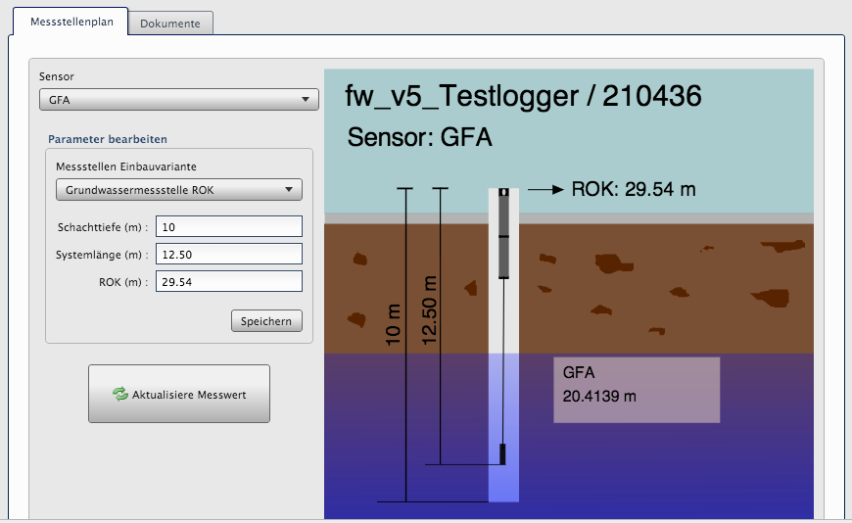
Figure 15: Schematic measuring-point plan in document management.

6.2 Logger files
You can display the raw data (RAW), logger parameters (PAR) and log files (LOG) in separate tabs. To do so, click the download icon in the corresponding column.
Note: For the current logger generation (Aquatos Web LTX, Aquatos mini, Aquatos nano), local access is made exclusively via BLE using BlueShell or BLX.JS (see separate user manual).
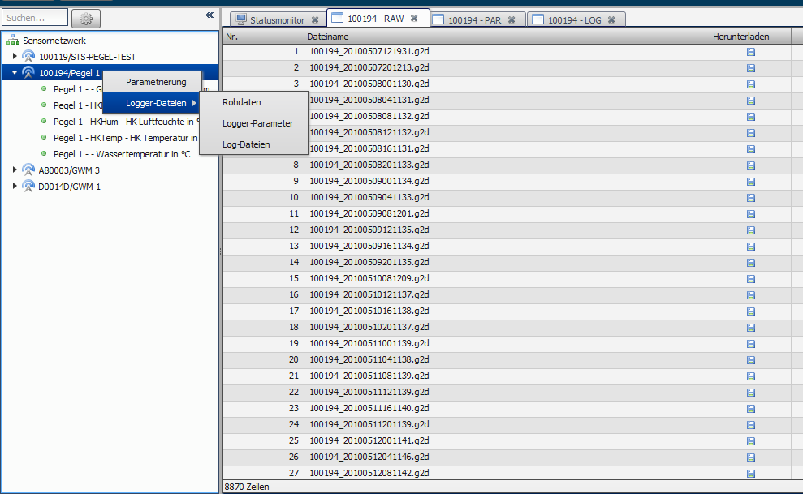
Figure 16: Overview of logger files (RAW, PAR, LOG).

7 Map and citizen portal

7.1 Map functionality
The map function is launched from the status monitor via the map link. The map is then centred on the selected logger.

7.1.1 Navigation
- Navigation via the left-hand navigation bar or directly with the mouse
- Mouse wheel forward/back: zoom into / out of the map
- Hold the left mouse button: pan the map
- The overview map (bottom right) can optionally be activated

7.1.2 Displaying measured values
To display the measured values, left-click a logger. A section then opens on the right-hand side containing:
- A quick overview of the latest values from all sensors of the logger
- The complete measurement history – you can select one or two sensors and see their values in the chart
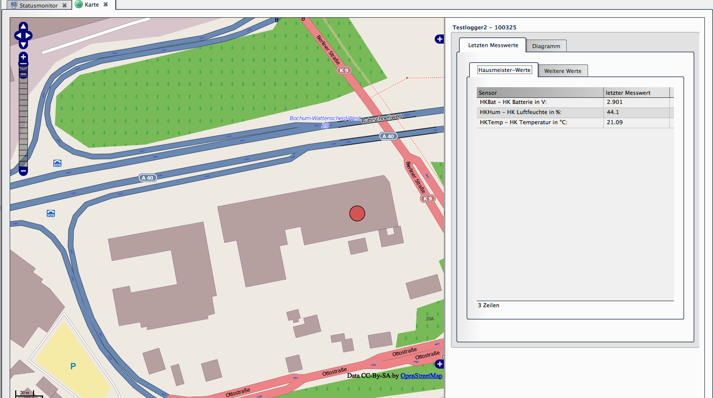
Figure 17: Map with logger selection and measurement history shown on the right.

7.2 Citizen portal
The citizen portal offers a map-based view of your monitoring network and can be launched directly from your website via a link.
Direct access via automatic login:
https://your-website.example/onlineportal?username=username&password=password
Caution: The automatic login transmits the username and password as URL parameters. Create a separate user with the permission level mapview exclusively for this purpose – never use an administrative account.
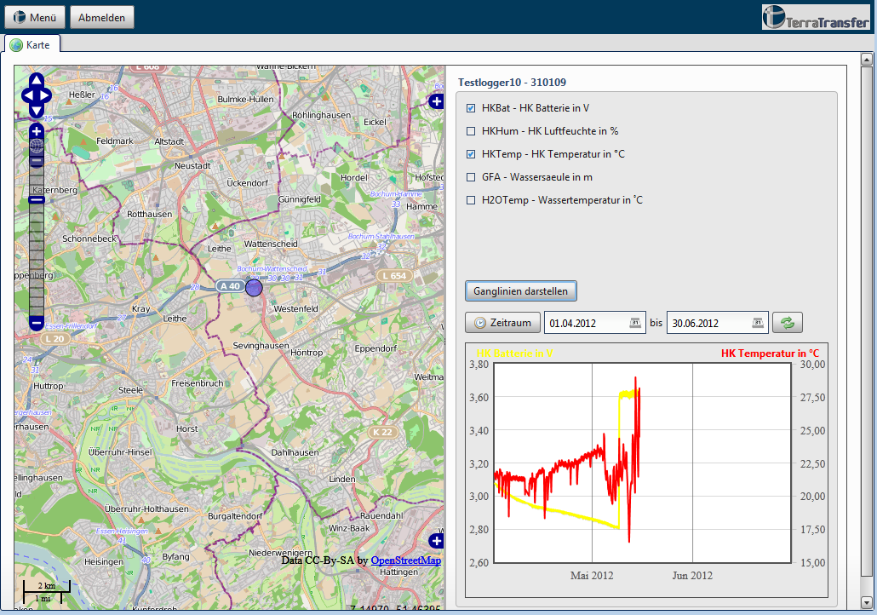
Figure 18: Citizen portal with publicly visible measuring points.

8 Alarm management
Alarm management lets you configure SMS or e-mail notifications that are sent automatically as soon as a measured value exceeds or falls below a defined range.

8.1 Alarm groups and alarms
Alarm groups let you structure and organise individual alarms – for example one group per sensor type or per location.
Note: Alarm groups are used only to structure the display. There is no if-then relationship between individual alarms. Alarms are always evaluated and triggered individually.
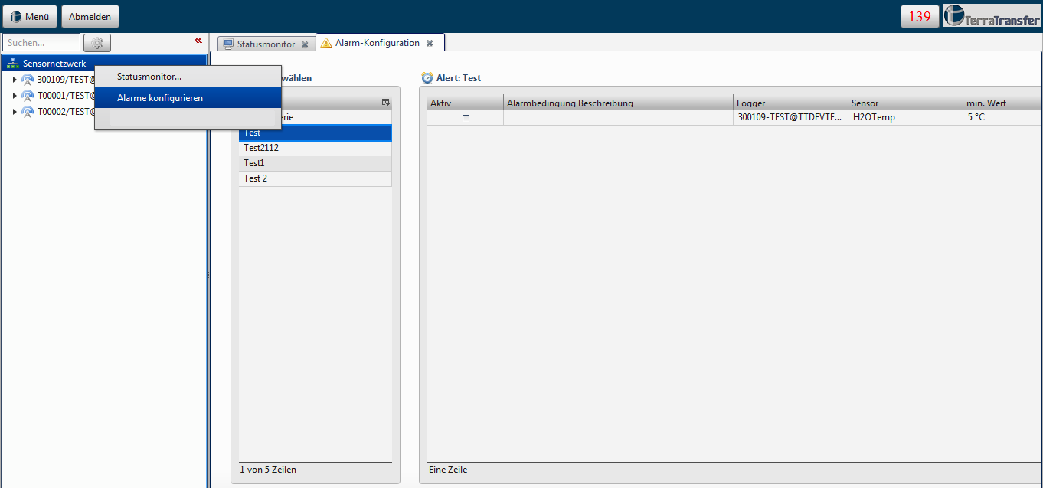
Figure 19: Alarm-management overview with alarm groups (left) and alarms (right).

8.2 Creating alarms
Open alarm management via Menu → Configure alarms. If no alarm group exists yet, create one with the green plus button. Enter a name and an optional description.
After confirming, you are automatically forwarded to the alarm configuration. Once you have configured the alarm, click Save. The alarm group and the alarm are created; you are then taken to the alarm overview.

8.2.1 Configuring an alarm
You can choose whether the alarm monitors a logger or a sensor:
Monitor logger: You receive a notification when a logger exceeds the configured transmission interval.
Monitor sensor: You are notified when a sensor’s measured value exceeds or falls below a limit.

8.2.2 Sensor monitoring
- Alarm description: short text describing the alarm
- Select logger: sorted by serial number, displayed as “ID – serial number – logger name”
- Select sensor: displayed as “ID – data type – description – unit”
- Alarm parameters: set minimum and/or maximum values
- Notification interval in hours or minutes (Help button for details)
- Configure SMS and/or e-mail notifications
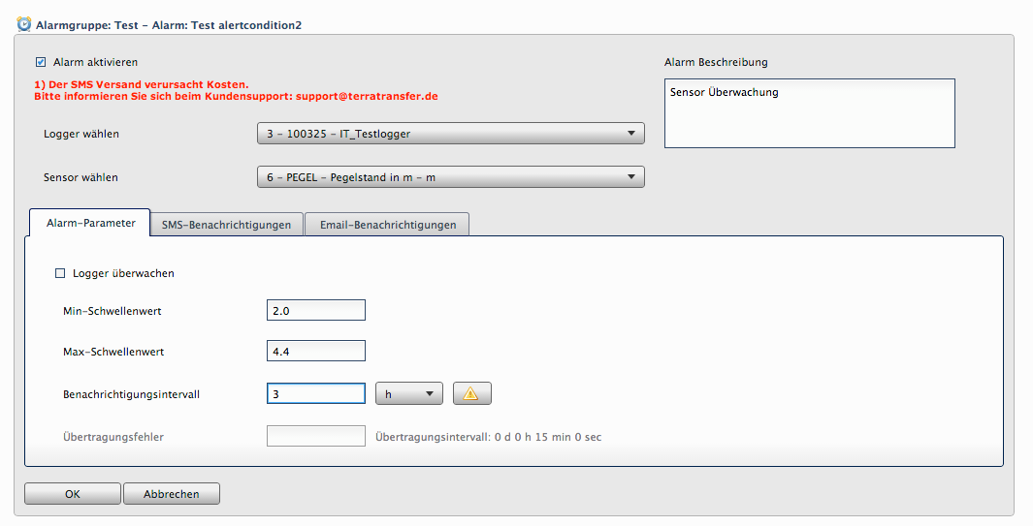
Figure 20: Configuring an alarm – sensor monitoring with min/max values.

8.2.3 Logger monitoring
- Alarm description: short text
- Select logger
- Sensor: not applicable
- Min/max values: not applicable
- Notification interval
- Transmission errors: how often the transmission interval may be exceeded before the alarm is triggered
- SMS and/or e-mail notifications

8.3 SMS notifications
Note: The SMS notification function is an optional extra service that must be booked separately. Costs apply for each SMS sent. For more information, please contact info@terratransfer.de.
- Enter the mobile number as the target (without a leading +, e.g. 0049XXXXXXX)
- Right-clicking the text field offers predefined placeholders for dynamic content
- Recommended: “Load standard text (min./max. limit defined)” – the text snippet correctly outputs the limits you have set
- Several recipients per alarm are possible; use the Enable checkbox to disable a recipient temporarily
- Same message for further recipients: right-click the message → Apply text to all messages
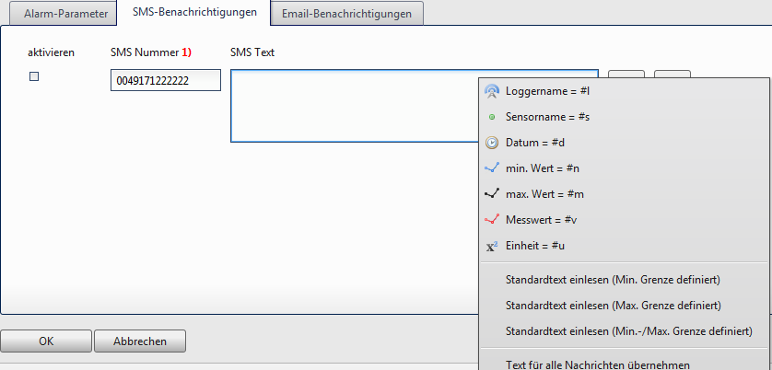
Figure 21: SMS notification – recipient and message template.

8.4 E-mail notifications
The only difference to SMS configuration is that a subject line is required – this field is mandatory.

8.5 Editing and deleting alarm groups
On the left-hand side of the alarm configuration screen you will find the overview of alarm groups. Select a group and use the buttons Create alarm group, Delete alarm group and Edit alarm group.
When selecting a group, the associated alarms are automatically loaded into the table on the right. To edit an alarm, select it and click the Edit button; creating or deleting works analogously via the corresponding buttons.

8.6 Alarm notifications
In the top right-hand corner you can see the number of triggered alarm notifications. Click the icon for more details.
Individual alarm notifications can be marked as read via the Read column. The Mark all alarms as read button marks all of them at once.
Note: For audit purposes, alarm messages are never fully deleted from the database. They can be re-displayed at any time via the Show read alarms option. Read alarms are not counted in the number of active alarm notifications.

9 User, group and logger administration
Open the corresponding module via Menu → User, group and logger administration. The sub-areas for configuration are available in a new tab.
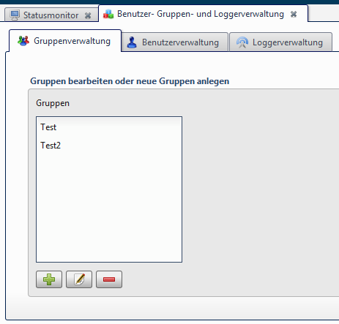
Figure 22: Entry point of user, group and logger administration.

9.1 Group administration
Groups are used to link users and loggers. A group defines which users are members and which loggers the group has access to.

9.1.1 Creating a group
- Click the Create group button
- Enter the group name
- Enter a group description (optional)
- Assign users and loggers to the group using the arrow buttons
- Save the configuration
If no users or loggers exist yet, save the group for now and assign users/loggers later.
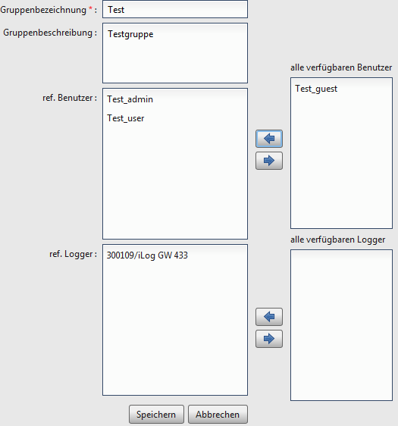
Figure 23: Dialogue for creating a new group.

9.2 User administration
In user administration you create the accounts that can log in to the portal. The available functions are Create user, Edit user and Delete user.

9.2.1 Creating a user
- Enter the username and password (mandatory fields, at least 6 characters)
- Select the user level (see table below)
- Assign one or more groups
- Save
Note: The sysadmin user type can only be enabled by TerraTransfer.
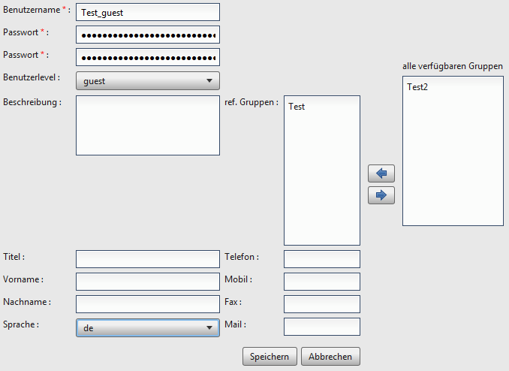
Figure 24: Creating a user – mandatory fields are marked with a red asterisk.

9.2.2 User levels
The user level determines which functions are available in the portal:
sysadmin | Full access including system maintenance (granted only by TerraTransfer)
admin_sms | Administrator with SMS sending
admin | Administrator without SMS sending
user | Standard user: charts, exports, editing of measured values
guest | View only (map, chart, status monitor)
mapview | Map view only (typical for the citizen portal)

9.3 Logger administration
In logger administration you can create, edit and delete loggers as well as configure measuring points (chapter 9.5). The corresponding button also lets you edit the site coordinates at any time (chapter 9.4).

9.3.1 Creating a standard logger
- Click the Create logger button
- Select the language for sensor designations (DE/EN/NL/RU)
- Select the logger class: AQUATOS-web, AQUATOS-mini or AQUATOS-nano
- Select the logger type – eight standard types per language are available
- Select the battery type: 3 V alkaline, 3.6 V lithium or 12 V
- Enter the number of loggers (up to 24 at once)
- Assign group(s)
- Enter the serial number and ident key (supplied by TerraTransfer)
- Save
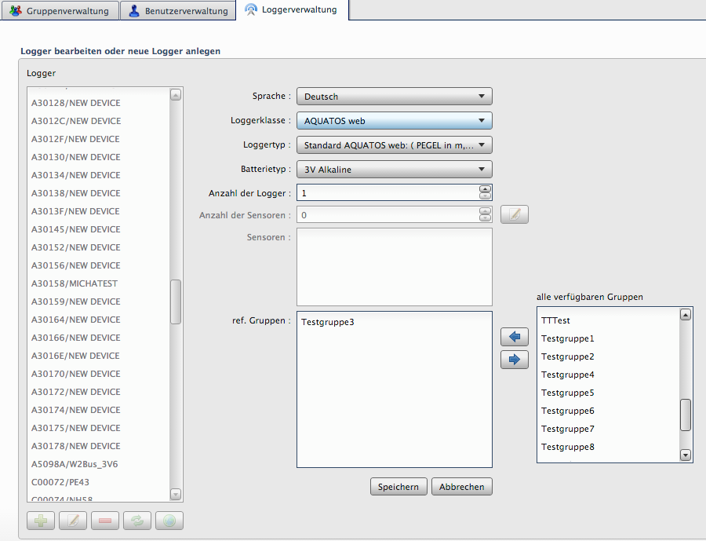
Figure 25: Dialogue for creating new loggers.
Note: The serial number and ident key were provided by TerraTransfer upon delivery. For questions, please contact info@terratransfer.de.

9.3.2 Creating a custom logger
For special configurations (e.g. measurement chains, climate stations, buoys with individual sensor arrangements), choose the logger type Custom AQUATOS web, mini or nano. In the next step, specify the number of sensors and configure them individually.
Caution: TerraTransfer loggers usually have three HK sensors (housekeeping) for housing temperature, humidity and battery voltage. Account for these sensors when specifying the number of sensors – they must also be created in the next step.
For each sensor you configure:
- Sensor ID (assigned automatically)
- Sensor description (no special characters). If left empty, the sensor type is used as the name
- Sensor type (predefined data type in the selected language)
- Channel assignment – HK sensors always occupy the last channels
Caution: If you have selected the sensor description and click Apply, the last sensor description may not be applied. Click once in an already-filled field (e.g. Channel assignment) before clicking Apply, so that all entries are reliably applied.
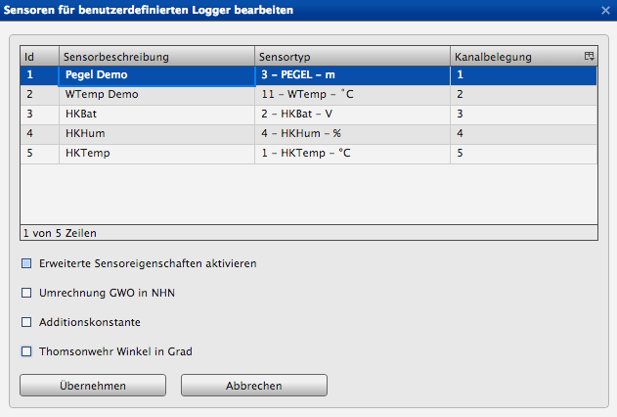
Figure 26: Sensor configuration for a custom logger.

9.3.3 Optional sensor properties
You can define extended properties for each sensor. Note: GWO conversion and addition constant are mutually exclusive – only one of these options can be active at a time.
GWO → NHN conversion: Enter a factor for your ground surface or top-of-casing elevation referenced to NHN. The measured values are then converted using the formula (value × −1 + factor) – you obtain the groundwater level referenced to German ordnance datum (NHN).
Addition constant: Measured value + addition constant.
Thomson-weir angle: Enter the angle in degrees only – the discharge is calculated automatically.
Min/max event thresholds: Limit values for visualisation in the chart (see chapter 4.2.6).
Note: The raw data always remain untouched. If the conversion is already configured on the logger itself, it does not need to be specified here as well.
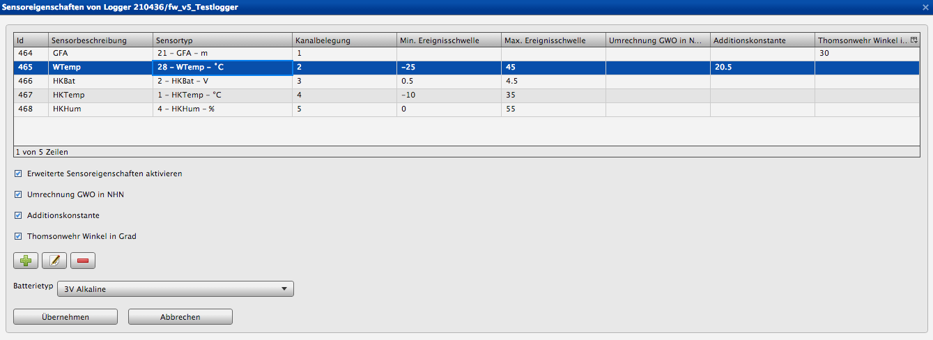
Figure 27: Extended sensor properties – conversion, addition constant and thresholds.

9.3.4 Editing a logger
After selecting a logger and clicking Edit, you can modify the following parameters:
- Sensor description
- Sensor type
- Channel assignment
- Extended sensor properties
- Battery type
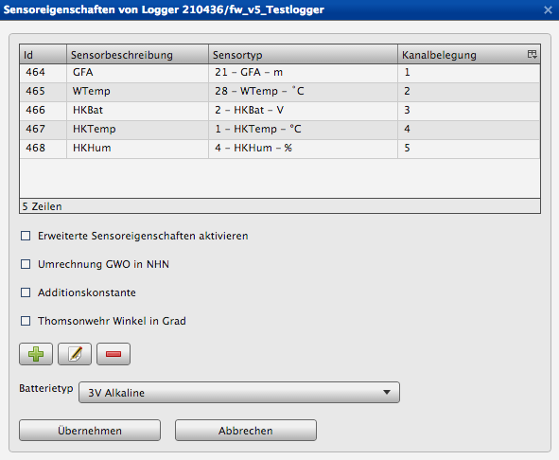
Figure 28: Editing a logger – sensor list with Edit / Add / Delete.
Caution: After changing the sensor description, always click in another field before applying changes – otherwise the last change may not be saved.

9.3.5 Deleting / deactivating a logger
When deleting a logger, three options are available:
- Deactivate logger only: logger and measured values remain in the database. No user except the sysadmin can see or access the logger.
- Delete measured values only: all values are deleted, the logger remains.
- Delete logger and measured values: both the values and the logger are permanently deleted.
Caution: Measured values are permanently deleted from the database. They can be restored via the import function (chapter 5.2), but make sure beforehand that all the raw data are available.
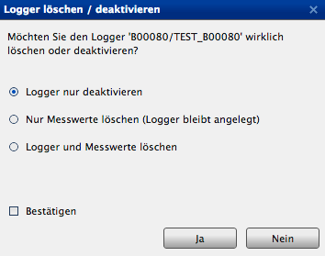
Figure 29: Delete dialogue with a confirmation checkbox.

9.3.6 Reference check
Before a logger is deleted or a sensor edited, the Sensormanager checks whether the logger is referenced by exports or alarms. Deletion or editing is only possible after the references have been resolved. The dialogue lists which alarms, automatic and group exports refer to the logger. Edit or remove these as described in chapters 8, 10 and 11.

9.3.7 Activating a logger
Deactivated loggers are marked in the list with a corresponding icon. When you select a deactivated logger, a dialogue automatically appears in which you can reactivate it. If you confirm with Yes, the logger becomes visible again for all referenced users.

9.4 Logger coordinates
You can edit the location of loggers in the Coordinates and transformation screen. The following options are available:
- Enter coordinates directly in the WGS84 world coordinate system (lat/lon)
- Enter coordinates from another reference system and have them automatically transformed to WGS84 (specify the EPSG code)
Note: A PostGIS extension in the database is used for the transformation. The required EPSG code refers to the source system (e.g. EPSG 25832 for ETRS89 / UTM 32N).
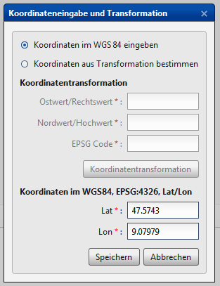
Figure 30: Coordinates dialogue with optional transformation.

9.5 Configuring measuring points
Use the Measuring-point configuration screen to assign a logger to a new or existing measuring point. The following four cases are covered:
- An existing logger is installed at an existing measuring point
- An existing logger is installed at a new measuring point
- A new logger is installed at an existing measuring point
- A new logger is installed at a new measuring point
In all cases you can choose whether the old measuring point is dissolved or preserved:
Dissolve: The old measuring point A is deleted from the database. The raw data are also deleted.
Preserve: The old measuring point A receives a new serial number (starting with H, e.g. H00001). Measured values and raw data are associated with this preserved measuring point.
Caution: After preservation, the old raw data can no longer be imported into the database for technical reasons, because the mapping of file names is missing. New raw data from measuring point B continue to be imported as usual.
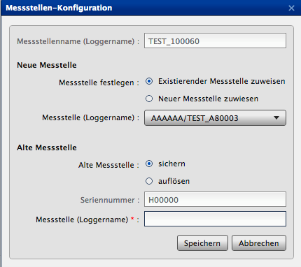
Figure 31: Measuring-point configuration with options for new and old measuring points.

10 Automatic exports
Automatic exports forward measured values, immediately after a logger’s transmission, to a shared FTP directory or a local storage address. Several data formats are available.
Open the module via Menu → Configure automatic exports. In the list of your existing exports:
- Deactivated exports are marked with a pause icon
- Exports marked with a warning icon have been automatically deactivated due to an error (see chapter 10.2)

10.1 Creating an automatic export

10.1.1 General configuration
- Name (mandatory)
- Project/measuring-point name (only for RVCSV and KH-15)
- Assign sensor(s) from the available sensors; for Aquafin several sensors are also allowed
- Filter checkbox: narrow the list by sensor type for large monitoring networks
- Export options: Standard, ΔH + ΔH start value, Average, Relative precipitation
Note: The Aquafin export format only allows the Standard export option.
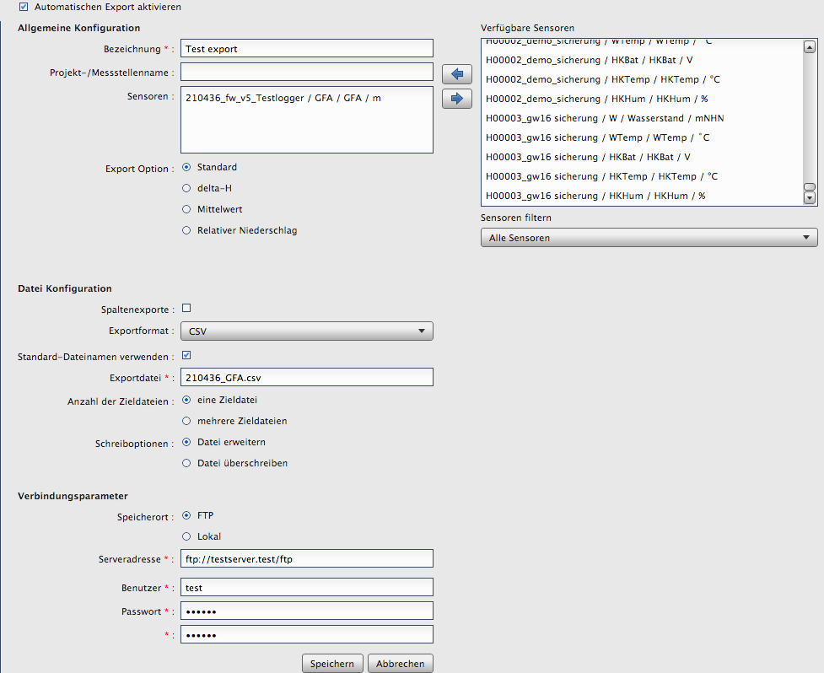
Figure 32: Configuration of an automatic export.

10.1.2 File configuration
- Column exports: column-wise output
- Export format: HydroPro, CSV, Hydras3, WISKI, Aquainfo, HygrisC, TMCSV, Aquafin, KH-15 or RVCSV
- Export file: name of the target file (or use the default file name)
- Number of target files: one (extend or overwrite file) or several (a new file per transmission)
- File time format: minute, hour or day – controls the file naming

10.1.3 Connection parameters
- Storage location: FTP server or local storage
- Server address, user name and password for FTP
Note: The local storage address is assigned only by TerraTransfer for security reasons and cannot be changed. If you need a local storage address, please contact us.
After saving, the export is created and runs automatically from the next transmission of the selected sensor onwards. Manual execution is not possible.

10.1.4 Activating / deactivating an automatic export
Select the export and click Edit. Uncheck the Enable checkbox and save the export.

10.2 Export error notifications
Typical sources of error:
- Wrong user name or password for the FTP server
- Wrong FTP server address (typo or changed address)
- Server outage
Items 1 and 2 can be fixed directly in the portal:
- Correct the export configuration – faulty exports are marked and deactivated in the menu. After removing the cause of the error, enable the export again (chapter 10.1).
- For previously failed export attempts, use the Info button on the main page. The Failed exports dialogue shows all failed attempts – an export is only classified as faulty after five unsuccessful attempts.
Clicking an export displays the parameters (server, user, password) and allows them to be edited directly. At the next transmission interval the server retries the export.

11 Group exports
Group exports let you create exports for multiple sensors at once, save them as a configuration and run them on demand.
Open the module via Menu → Configure group exports. You can create, edit and delete group exports and start a configuration via the Run button.

11.1 Configuration
- Name (mandatory)
- Project/measuring-point name (only for KH-15)
- Export format: CSV, AquaZIS or KH-15
- Start and end time (mandatory)
- Column exports: column-wise
- Export options: Standard, ΔH + ΔH start value, Average

11.2 Selecting sensors
Select one or more sensors from the list of available sensors and apply them with the arrow button. Use the Filter sensors checkbox to restrict the selection to a specific sensor type – helpful for large monitoring networks.
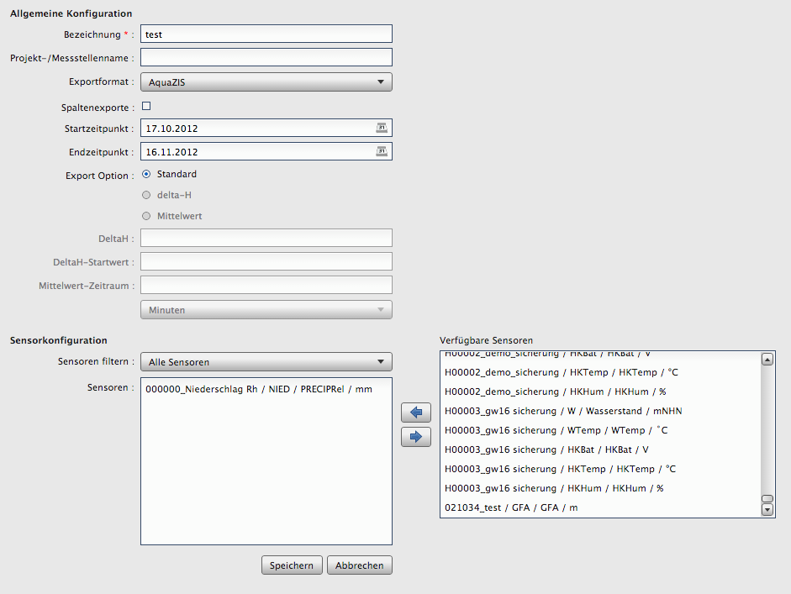
Figure 33: Group export with selected sensors and time range.

12 Isolines
Open the module via Menu → Isolines. You can create, edit and delete isoline configurations and display them on the map using the Run button. Difference maps between two configurations can additionally be generated.
Caution: Differences can only be calculated between configurations of the same sensor type.
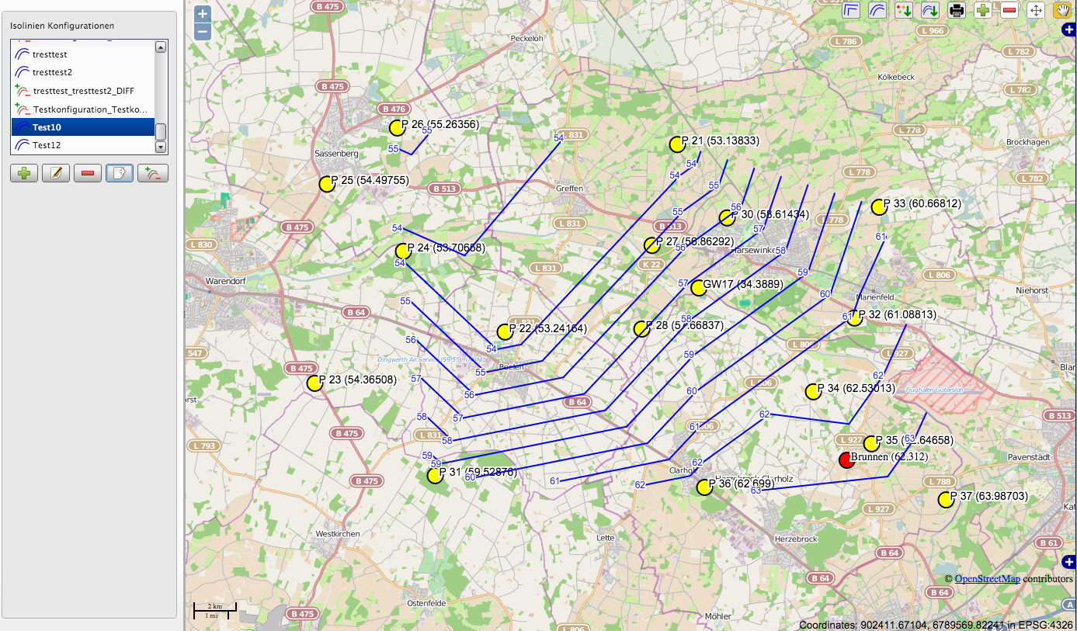
Figure 34: Isoline map with configuration list and tools.

12.1 Configuration
- Name (mandatory)
- Start/end time
- Isoline mode: Average (between start and end) or Point in time (daily mean of the start time)
- Select sensors (arrow buttons, optional filter by sensor type)

12.2 Logger import from CSV
Measuring points from third-party systems can be imported to extend the isoline calculation. Format of the CSV file:
name;lat;lon;value
logger_Imp0;51.596311;6.958117;22.33
logger_Imp1;51.596411;6.959117;34.87
During the import you are asked for the EPSG code of the source system; the coordinates are automatically transformed to WGS84 (EPSG 4326).
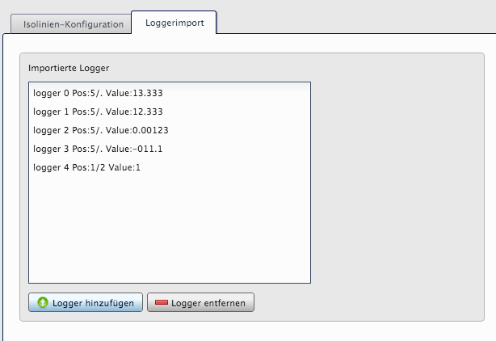
Figure 35: Isoline configuration area with mode and sensor selection.

12.3 Isoline map and tools
After running a configuration, all loggers (including imported ones) are displayed on the map. The menu at the top left offers the following tools:
- Generate isolines
- Smooth isolines
- Export isoline layer as shapefile
- Export logger layer as shapefile
- Print isoline map
- Move support points
- Toggle view mode
- Add support point
- Remove support point
To edit a support point, switch to view mode and click the support point. The dialogue lets you modify the measured value and logger name.

13 Maintenance and operation

13.1 Sensormanager (server-side)
The Sensormanager is maintenance-free for the customer. Pending updates are performed by TerraTransfer Service.
If the software is installed on your own server, external access must be possible. If this is not set up, an update package together with installation instructions will be sent to you.

13.2 Data security and backup
When operating on TerraTransfer servers, regular backups are performed by TerraTransfer. For on-premise installations, data backup is the responsibility of the operator. We recommend daily incremental backups and weekly full backups of the database.

13.3 Browser requirements
For access to the Sensormanager, we recommend the current versions of the following browsers:
- Mozilla Firefox
- Google Chrome
- Microsoft Edge
- Apple Safari
Enabled cookies are mandatory, because the session is stored in a cookie after successful login.

13.4 Encrypted connection
Communication with the Sensormanager is, by default, via a TLS-encrypted HTTPS connection. You can see whether an encrypted connection is in place by the padlock icon in the browser’s address bar.

14 FAQ – frequently asked questions

14.1 Login
The online portal does not start.
- Check that cookies are enabled in the browser – without cookies the session cannot be stored
- Check your internet connection; a weak Wi-Fi or cellular signal can cause the connection to drop
- Clear the browser cache if data are not being updated

14.2 Measured values and import
How do I open raw data sets (RAW/G2D)?
For the current logger generation (LTX, mini, nano), use BlueShell or BLX.JS via the BLE interface. Raw data from older logger generations can be viewed with the CS-Viewer of the earlier GP-Shell software.
How can I change the thresholds used to colour the logger status?
These thresholds are currently configured only by TerraTransfer Service.
Why are values missing in the status monitor (e.g. humidity 0)?
Not all loggers measure all housekeeping values. An Aquatos nano without internal sensors, for example, does not provide housing humidity. The corresponding status messages (Cannot read HKHum, etc.) can be ignored in such cases.

14.3 Alarms
Why am I not receiving SMS notifications?
- Check that the SMS service is activated in your contract
- Verify that the mobile number is entered in the format 0049XXXXXXXX (without a leading +)
- Check that the recipient is enabled via the Enable checkbox

14.4 Exports
My automatic export has been deactivated – what should I do?
The export was deactivated automatically due to repeated errors. Check the connection parameters (FTP address, user name, password), correct the configuration and re-enable the export (see chapter 10.2).

15 Legal notice
TerraTransfer GmbH
Ottostrasse 19a
D-44867 Bochum

Phone: +49 (0)2327 83 44 85-1
Fax: +49 (0)2327 83 44 85-7
E-mail: info@terratransfer.de
Internet: www.terratransfer.de

Registered office: Bochum
Commercial register: Amtsgericht Bochum HRB 6778
VAT ID: DE209458277
Managing Director: Marcel Delker

