
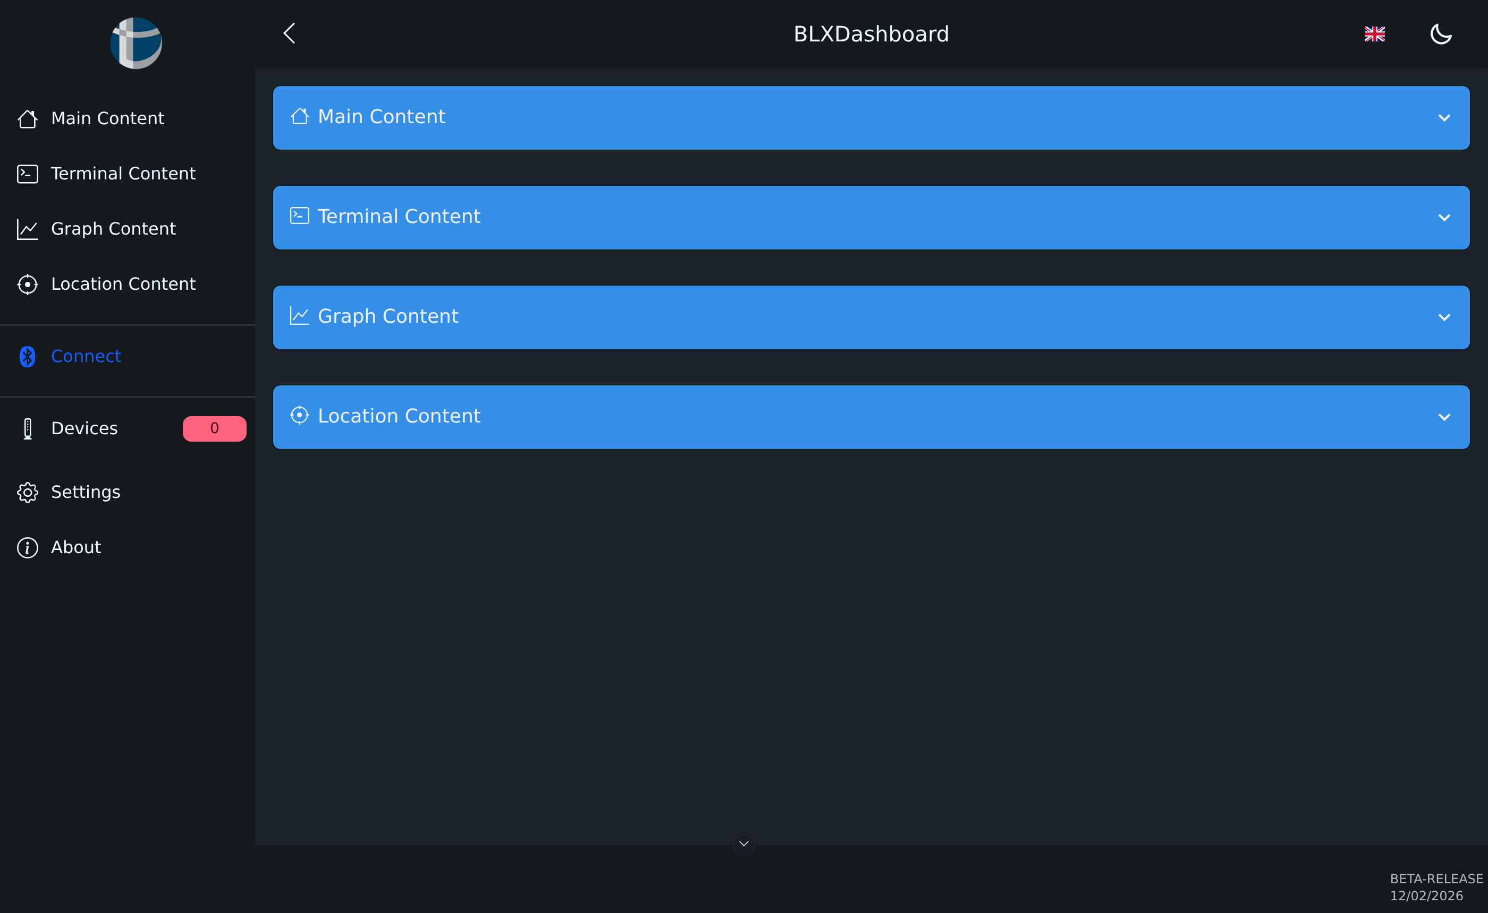
BLX Dashboard
User Manual
Browser-based Configuration and Diagnostics
for TerraTransfer Aquatos Data Loggers and SDI-12 Sensors
TT-ANL-BLX-001 · April 2026

Table of Contents

I Disclaimer
This manual describes the BLX Dashboard in the version Beta-Release of 12/02/2026. Layout and functionality may change in subsequent versions. TerraTransfer GmbH accepts no liability for damages resulting from improper use of the software or incorrect configuration of connected devices.
The software is provided free of charge as a web application. Transmitting measurement data via Bluetooth Low Energy (BLE) requires different browser permissions depending on the end device and operating system. Please check compatibility with your device before productive use.
All product and company names are trademarks or registered trademarks of their respective owners. Errors and changes excepted.

II Safety Instructions
The BLX Dashboard is used for wireless configuration and data retrieval from TerraTransfer measuring devices. Please observe the following general notes:
- Use the application exclusively to configure authorised devices.
- Never share the access PIN of your measuring devices with unauthorised persons.
- After each configuration change, verify by means of a test measurement that the desired values are correctly recorded.
- Only change system parameters if you know their function. Incorrect configurations can lead to data loss or reduced battery life.
- Disconnect safety-critical devices from their control lines before a firmware update.
Note: Bluetooth Permissions: Communication is via Web Bluetooth. The browser will ask for permission to access Bluetooth devices when first connecting. Without this permission, no connection is possible. For security reasons, we recommend granting permission only for trusted devices and only for the duration of the configuration session.

Part 1 Introduction

1.1 What is the BLX Dashboard?
The BLX Dashboard is the browser-based configuration and diagnostics interface from TerraTransfer GmbH. It runs directly in the browser of your PC, tablet or smartphone and requires no installation. Communication with the devices is via Bluetooth Low Energy (BLE 5).
With the BLX Dashboard you can:
- Connect and query Aquatos data loggers (Web LTX, mini, nano).
- Configure SDI-12 sensors on the Open-SDI12-Blue platform (piezo and ceramic pressure sensors, frequency/pulse counters, Modbus converters).
- Read live measured values and display a measurement diagram on screen.
- Set device parameters via an integrated terminal with SDI-12 command set.
- Record the device location on a map.
- Manage multiple devices by name and PIN.

1.2 Accessing the BLX Dashboard
The BLX Dashboard is available at the following address:
https://ltxdata.net/ttblx/
Access it directly in your browser. No login, no account and no installation is required. The application runs entirely locally on your device; the Bluetooth connection to your measuring devices is not routed through a server.

1.3 System Requirements
Browser (Desktop) | Google Chrome, Microsoft Edge or Opera (current version)
Browser (mobile) | Chrome or Edge on Android — Web Bluetooth must be supported
Operating system | Windows 10/11, macOS, Linux or Android
Bluetooth | Bluetooth 4.0 or newer (BLE-capable)
Range | Typically 5–10 m line-of-sight to the device
Network connection | Required once to load the page; not mandatory during operation
Note: Apple iOS / iPadOS: Apple currently does not allow access to Web Bluetooth from the browser. For iPhones and iPads, use a Windows, Android or macOS device. On Windows, the desktop application BlueShell is available as an alternative.

1.4 Scope of Delivery and Accessories
The software is free to use. The following are required:
- A compatible TerraTransfer data logger or sensor.
- The access PIN supplied with the device (6-digit number).
- A Bluetooth-capable end device with a supported browser.

Part 2 Getting Started

2.1 Accessing the Application and Start Page
Open the address https://ltxdata.net/ttblx/ in your browser. The BLX Dashboard start page appears.

Figure 1: BLX Dashboard start page — accordion with main content, terminal content, graph content and location content, and the sidebar on the left.

2.2 Interface Layout
The interface is divided into three areas:
Header (top) | Sidebar toggle on the left, application title in the centre, language selector and dark/light mode toggle on the right
Sidebar (left) | Navigation to main areas, connection setup, device management, settings and info
Main area (centre/right) | Four expandable panels for data, terminal, chart and location

2.3 Setting the Language
By default, the application starts in English. Switch the language by clicking the flag icon in the top-right corner.
- Click the flag in the top-right corner (default: British flag).
- In the drop-down list that opens, select your preferred language.
- The interface switches immediately. All labels and messages now appear in the selected language.

Figure 2: Language selector with the available language list.
Available languages: English, German, Dutch, Italian, French, Spanish, Portuguese, Danish, Finnish, Norwegian, Swedish, Azerbaijani, Turkish, Uzbek, Arabic.

2.4 Dark and Light Mode
To the right of the language selector there is a moon/sun symbol. Clicking it toggles between light and dark display. The selection is saved in the browser.

2.5 Collapsing the Sidebar
The arrow to the left of the title BLXDashboard in the header allows you to collapse and expand the sidebar. This creates more space for the chart and map view on small screens.

Part 3 Connecting to a Device

3.1 Prerequisites
- The TerraTransfer device is switched on or has active batteries.
- You are within approximately 5 to 10 metres line-of-sight of the device.
- Bluetooth is enabled on your PC or smartphone.
- The 6-digit PIN of the device is available (on the housing or in the accompanying document).

3.2 Establishing a BLE Connection
- Click the highlighted Connect entry in the sidebar.
- The browser shows a system window for selecting a Bluetooth device. All reachable TerraTransfer devices appear there with their name (e.g. "TT_LTX_1500_xxxxxx").
- Select the desired device and confirm with Pair.
- The BLX Dashboard requests the PIN. Enter the 6-digit number and confirm.
- After successful authentication, the Main Content, Terminal Content, Graph Content and Location Content panels display data.
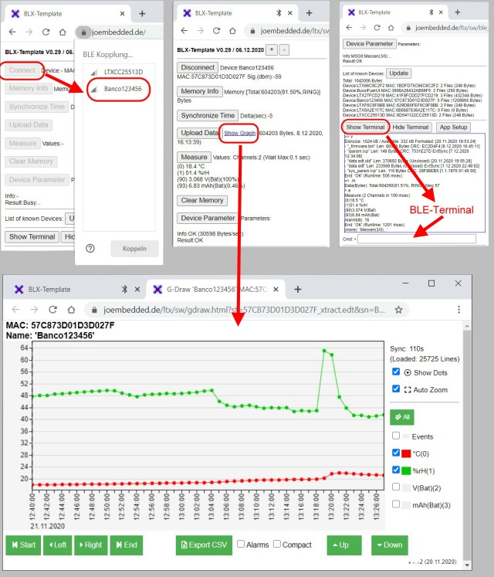
Figure 3: System dialog for Bluetooth device selection in the browser.
Note: Challenge-Response Authentication: The access PIN is never transmitted in plain text. The device sends a random number (challenge), the BLX Dashboard computes a signed response from it, and the device verifies this response. All data transfers within the BLE connection are AES-128-CBC encrypted.

3.3 Disconnecting
The connection is automatically terminated when:
- You close the browser tab or application.
- You leave the radio range.
- The device enters sleep mode after a configurable idle time.
To reconnect, click the Connect button in the sidebar.

Part 4 Main Content Area
The Main Content area shows the most important identification data of the connected device and the current instantaneous measurement.

Figure 4: Main Content panel with fields Name, MAC, Type, Firmware, Sound toggle, Values and Measure button.

4.1 Data Fields
Name | Device name, freely assigned (factory setting e.g. "TT_LTX_1500_xxxxxx")
MAC | Bluetooth address of the device — unique, immutable
Type | Logger type or sensor type (e.g. Type1500, Type0312)
Firmware | Currently installed firmware version
Values | Last measured channels with unit (e.g. level, temperature, pressure)

4.2 Buttons

4.2.1 Measure
Triggers an immediate single measurement of all channels. The results are updated in the Values field and additionally output on the terminal. The measurement does not replace the automatic measurements configured in the logger — it is used for functional verification.

4.2.2 Acoustic Signal (Note Symbol)
A toggle with a note symbol on the right edge switches a short beep on or off for each incoming measurement. Useful when installing sensors if the screen is not in view.

Part 5 Terminal Content Area
The terminal is used for advanced diagnostics and configuration. It is designed for technicians and field service.

Figure 5: Terminal Content panel with output field, input line, Online Transfer and Send buttons.

5.1 Layout
Output field (top) | Black area with system outputs and device responses. Start message: *** BLX Terminal ***
Full-screen icon (top right) | Switches the terminal to full screen
Input line | Text field with >-prompt for entering commands
Online Transfer | Starts a continuous live output. Clicking again ends the mode
Send icon (paper plane) | Sends the entered command to the device

5.2 Working with the Terminal
- Click in the input line.
- Enter the desired command (e.g. info for device information).
- Confirm with the Enter key or click the paper plane icon.
- The response appears in the output field.

5.3 Frequently Used Commands
The following overview shows the most important commands for TerraTransfer loggers and sensors. The complete command set is displayed with the command ?.
> ? # show help
> info # device info (type, firmware, serial number)
> time # read current time
> time yyyy-mm-dd hh:mm:ss # set time
> meas # single measurement of all channels
> log # display measurement data
> log-erase # erase measurement memory
> bat # battery voltage
> sdi-scan # scan SDI-12 bus for sensors
> sdi aI! # SDI-12 identification of sensor "a"
> save # permanently save changed parameters
Warning: The commands log-erase, flash-erase and sys-default delete data or reset parameters. Undo is not possible. Always run the save command after any configuration change, otherwise changes will be lost on the next restart.

5.4 Online Transfer
Online Transfer is a continuous streaming of all sensor values. Each new measurement appears directly in the terminal. The mode is suitable for monitoring sensor installation in the field. Clicking the button again ends the transfer.

Part 6 Graph Content Area
The Graph Content area displays the measured values stored in the device memory as a diagram.

Figure 6: Graph Content panel with chart of logged measurement data.

6.1 Loading Data
- Make sure a connection to the device is established (see Part 3).
- Click the Load data from device button.
- The device transfers the measurement series stored in the logger. Depending on the amount of data, the transfer may take a few seconds.
- After completion, the diagram appears with a time axis (x) and a measured value axis (y). Multiple channels are shown in different colours.

6.2 Operating the Diagram
Zoom | Mouse wheel or two-finger pinch in the diagram
Pan (scroll) | Click and drag with the mouse button held or one finger
Show individual value | Hover the cursor over a measurement point
Show/hide channel | Click on the channel name in the legend
Full screen | Via the full-screen icon at the top right
Note: Data volume: The logger stores internally up to 2 million measured values. For smooth display with large amounts of data, it is recommended to narrow the displayed time range.

Part 7 Location Content Area
The Location Content area shows the position of the device on an interactive map (Leaflet / OpenStreetMap). The coordinates are stored in the device and transmitted with each data transfer.

Figure 7: Location Content panel with map, device dropdown and Edit Location button.

7.1 Elements
Device selection | Drop-down with all known devices. Determines which device is marked and edited on the map
Edit Location | Activates edit mode for the coordinates
Map | OpenStreetMap base. Zoom with + and − or mouse wheel
Record coordinates | Adopts the current position of the end device (GPS / IP location) as the new device location

7.2 Setting the Location — Procedure
- Select the desired device in the drop-down.
- Activate Edit Location. A moveable marker appears on the map.
- Option A: Drag the marker to the desired position with the mouse or finger.
- Option B: Click Record coordinates to adopt the current position of your end device. The browser must allow location access.
- Confirm the new location by clicking Edit Location again.
Note: Location permission in the browser: The Record coordinates button uses the browser's Geolocation API. On first use, a request for location permission will appear. This permission is independent of the Bluetooth permission and can be revoked at any time in the browser settings.

Part 8 Device Management
The Devices entry in the sidebar opens the Device Management. Here all previously connected devices are listed. The number in the red badge to the right of the entry shows how many devices are stored in the dashboard.

Figure 8: Device Management dialog with search field, table Name / PIN / Files / Action and OK and Close buttons.

8.1 Table Columns
Name | Device name as stored in the device itself
PIN | Device-specific access PIN. Stored encrypted in the browser and automatically used on reconnection
Files | Shows stored data downloads (measured values, configurations) of the device
Action | Rename device, change PIN or delete entry

8.2 Searching for Devices
When managing many devices, you can type the name in the Search by name field. The list filters while you type.

8.3 Removing a Device
Via the Action column, you can remove an entry from the local list. The device itself is not changed — on the next connection, the PIN simply needs to be entered again.
Note: Data storage in the browser: All device management data is stored exclusively locally in the browser. When switching to another end device or clearing browser data, the list is lost. Also transfer the PINs of your devices to a secure location.

Part 9 Settings
The Settings entry in the sidebar opens a dialog with application-wide options.

Figure 9: Settings dialog with QR Mode toggle and Save and Cancel buttons.

9.1 QR Mode
QR Mode enables connection via QR codes. Devices with QR stickers (e.g. Modbus converter type 0210 or frequency/pulse counter type 0330) can be connected directly by scanning the code. This replaces manual device selection.
- Open Settings in the sidebar.
- Enable the QR Mode toggle.
- Click Save.
- The Connect button now first activates the camera of your device to scan the QR code.

9.2 Discarding Changes
Click Cancel to close the dialog without applying changes.

Part 10 Info Window
The Info entry in the sidebar opens a compact window with information about the origin of the software. Here you will find:
- The note Powered by TerraTransfer.
- The names of the development company involved.
- A link to further information.
The current version identifier is additionally displayed in the footer of the application (e.g. BETA-RELEASE 12/02/2026).

Part 11 Troubleshooting

11.1 Bluetooth Device Not Visible
- Make sure the device is switched on or has charged batteries.
- Check that you are within radio range (5 to 10 m).
- Enable Bluetooth in the operating system.
- Refresh the browser tab (F5 / Reload) and restart the connection.

11.2 PIN Not Accepted
- The PIN is 6 digits and case-sensitive.
- After several incorrect entries, the BLE connection is automatically terminated. Wait 30 seconds and reconnect.
- The factory PIN can be found on the device housing or in the delivery note.

11.3 Terminal Not Responding
- Check in the Main Content panel whether Name, MAC and Firmware are displayed. If the panel is empty, there is no active connection.
- Clear the input field and first try the simple command info.
- For persistent problems, close and reopen the Terminal Content panel.

11.4 No Chart After Loading Data from Device
- Check whether measured values are stored in the device (command log in the terminal).
- Very large data sets can slow down the display — reduce the display range in the chart.

11.5 Location Coordinates Not Adopted
- Make sure the browser has access to the location of the end device.
- Indoors, GPS reception may be inaccurate. Use manual placement of the marker on the map where possible.
Note: Check browser permissions: In Chrome, open chrome://settings/content/bluetoothDevices and chrome://settings/content/location to view or reset the permissions for ltxdata.net.

Part 12 Appendix

12.1 Compatible TerraTransfer Devices
Aquatos Web LTX (Type 1500) | Flagship data logger with LTE-M — configuration, diagnostics, firmware update
Aquatos mini / nano | Compact data loggers — configuration and data retrieval
Piezo pressure sensor (Type 0312) | Configuration, zeroing, SDI-12 address
Ceramic pressure sensor (Type 0420) | Configuration, zeroing, SDI-12 address
Frequency/pulse counter (Type 0330) | Tipping bucket / water meter calibration
Modbus converter (Type 0210) | Modbus register mapping, query interval

12.2 Security Features at a Glance
Encryption | AES-128-CBC (BSI-recommended) on BLE and during data transfer
Authentication | Challenge-response with 6-digit PIN
Firmware updates | Only signed firmware is accepted
Data storage | Device data and PINs stored exclusively locally in the browser

12.3 Alternative to the Browser Application
For continuous use, extended firmware updates and comprehensive diagnostics on PC, we additionally recommend the desktop program BlueShell (Windows 10/11). BlueShell supplements the BLX Dashboard's functionality with direct USB access, multi-logger batch processing and export functions.

12.4 Contact and Support
Address | TerraTransfer GmbH · Ottostraße 19a · 44867 Bochum · Germany
Phone | +49 2327 83 44 85-1
E-Mail | info@terratransfer.de
Web | www.terratransfer.de
Commercial Register | HRB 6778 Amtsgericht Bochum
Managing Director | Marcel Delker

12.5 Document History
Version | 1.0
Edition | April 2026
Document No. | TT-ANL-BLX-001
Software version | BLX Dashboard Beta-Release 12/02/2026
Author | TerraTransfer GmbH

