R&S® ZVA Vector Network Analyzer: Compression test macro

**Overview of the macro**

The compression test macro aids in testing the compression point of a device as a function of frequency. Measurement settings are customizable. Measurement results can be plotted, exported and saved for future post processing.

**Calibration and pre-testing**

It is necessary to perform system error correction (S-parameters) and power calibration before starting the macro. For information on how to do this, you can watch the video provided by R&S at: <http://www.youtube.com/watch?v=5_L3guAe6gE>

Also, to make sure that the macro finds the compression point at each measured frequency, it is good to have an idea of the expected values to make sure it is included in the power range (at the input of the DUT) you will have to specify. A pre-test for a few frequency points is recommended on the VNA by defining a power sweep. The compression point values at the input and output of the DUT can be displayed by pushing on the ‘Trace Funct’ button, selecting ‘More – 1/3’, Trace statistics and compression point.

If both a frequency sweep and a power sweep including the values of interest are defined on the VNA, it will ease the specification of the parameters for this measurement.

**How to start the macro**

To start the macro, click on System in the drop down menu, select External tool, and click on ‘P1dB vs freq’ (the default name of the macro is ‘RSA PA compression test’). The window shown in Figure 1 will pop up, and it will be added as an application in the taskbar of the Windows operating system (you can click on the Windows button to go back to desktop). Click on Connect (the TCPIP address 127.0.0.1 allows to run the macro directly on the VNA). In the Instrument info area, some details will be displayed about the VNA used for this measurement.

Once the macro is connected to the VNA, the VNA is used in a remote control mode. If you need to go back to the interface of the VNA, you should reduce the interface of the macro and click on ‘Go to Local’.

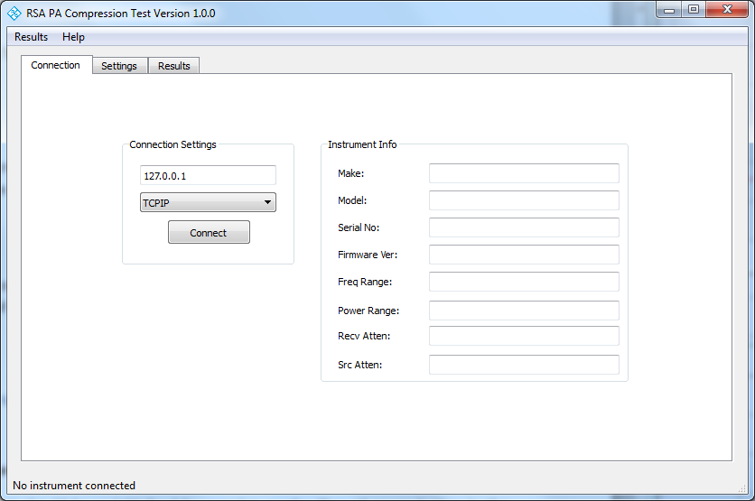

Figure 1 – Compression test macro interface after it is launched

**Measurement preparation**

First of all, click on the Settings tab on top. The Settings panel will be displayed as shown in Figure 2. To enter the frequency and power parameters, you can use the  icon at the bottom right and select a trace, click on each field and specify the values manually. For the IF bandwidth, make sure that it is the same as used during calibration. Finally, the input and output ports, as well as the sweep mode and calibration, should be specified in the General box. A power sweep mode allows to find the compression point at each frequency. The calibration of one of the VNA channels, or previously saved using the calibration manager can be used. Clicking on the  button beside the calibration field will display a list of the possible calibrations.

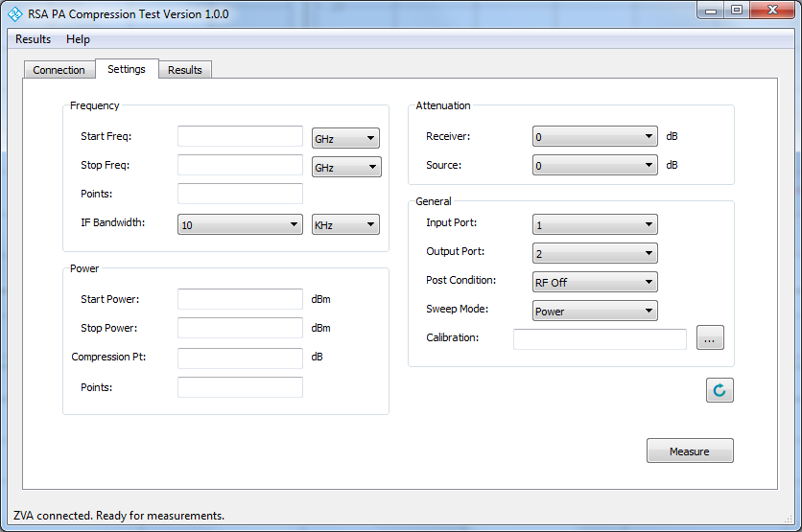

Figure 2 – Settings panel

**Perform measurements**

To start the measurement, simply click on the ‘Measure’ push button at the bottom right. The progression is displayed on the bottom left corner. Once completed, the results can be plotted in the Results tab (see Figure 3). The measured data can be plotted using the drop list on bottom right, and the horizontal and vertical axis can be formatted by clicking on the ‘Axis’ push button on bottom left.

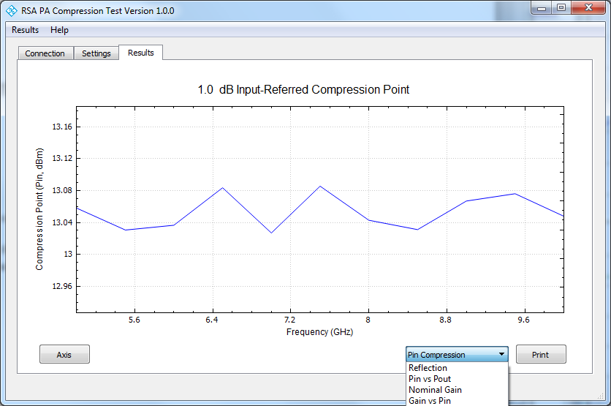

Figure 3 – Results panel

**Export the results**

To export the results, two options are available:

1) In the Results tab (see Figure 3), it is possible to plot the measured data (drop list on bottom right) and format the axis (push button on bottom left). To export the plot as a file, click on the Print push button on the bottom right, and enter a filename;

2) The data can be exported as csv files by clicking on Results in the top menu and selecting Export. A folder name should be specified. This folder contains the compression point and gain values, as well as intermediate gain and power measurements.