CHC6186 Advanced Object-Oriented Programming

Coursework
For this coursework, you will produce in Java two versions of the game Sudoku. One version will have a Graphical User Interface (GUI) and the other version will have a command-line interface (CLI). The GUI version will be constructed according to the principles of Model View Controller, and the CLI version will use the same model. The two versions will from now on be called the GUI version and the CLI version.

Learning Outcomes
This coursework will assess the following learning outcomes.
- Create a software artefact by applying the methodologies of advanced object-oriented programming to a requirements specification
- Consult on-line code libraries to find the classes and methods most appropriate for solving a problem
- Create appropriate documentation that clearly communicates the intended behaviour of a program
This coursework is worth 50% of your module mark; the remaining 50% comes from your exam.

How to Play Sudoku
Sudoku is a logic-based puzzle played on a 9×9 grid, divided into nine 3×3 sub-grids. Some cells are pre-filled with digits from 1 to 9. The player must fill the remaining cells so that:
- Each row contains the digits 1–9 exactly once
- Each column contains the digits 1–9 exactly once
- Each 3×3 sub-grid contains the digits 1–9 exactly once
A reference interface illustrating the intended style of interaction can be found at:
https://sudoku-online.com/
This website is provided for visual and interaction reference only. Not all features of the website are required unless explicitly stated below.See figures 1, 2 and 3.
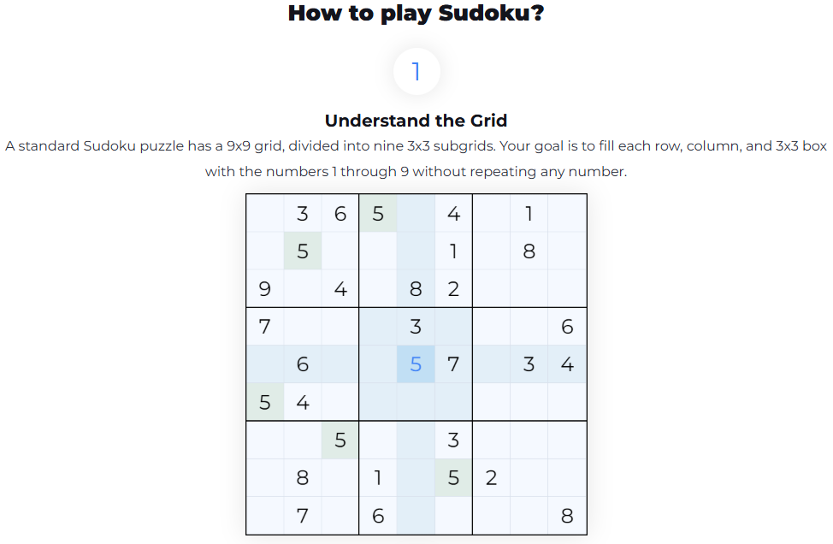
Figure 1: Understand the Grid
For this coursework:
- The grid size is fixed at 9×9
- Puzzle generation is not required
- Puzzles are loaded from a provided file (puzzles.txt)
- The player has unlimited attempts
- Pre-filled cells must not be modified
- The game is considered won when the grid is complete and valid

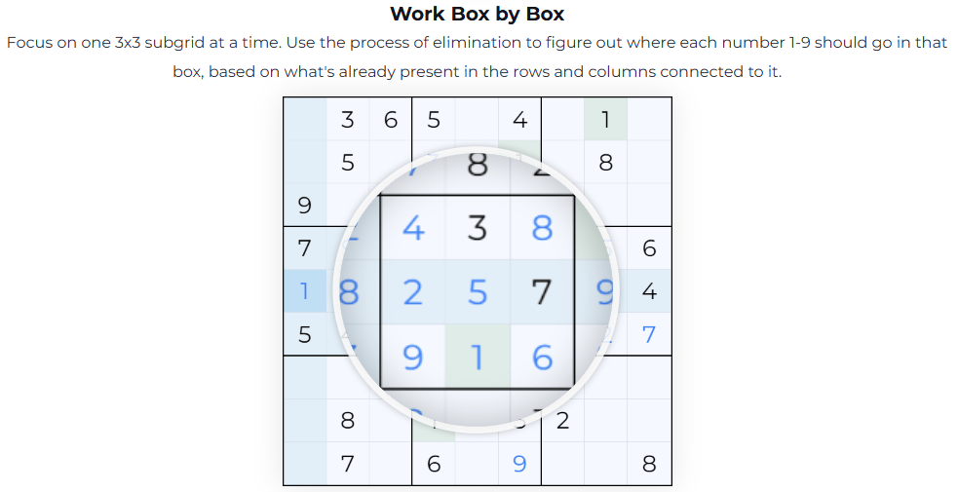
Figure 2: Work Box by Box

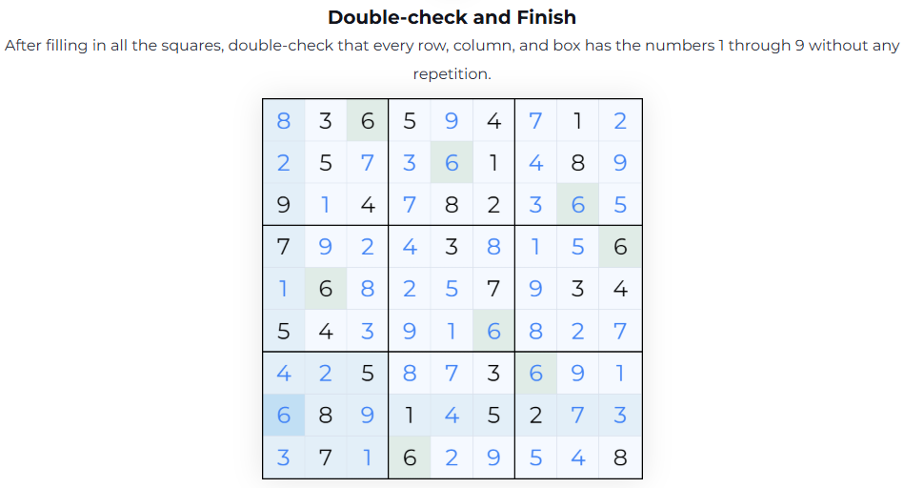
Figure 3: Double-check and Finish
You must implement the game in Java. The website is implemented in JavaScript. Any attempt to submit JavaScript will receive a mark of zero and any Java based on the website’s JavaScript will be treated as plagiarism in the normal way. The website colours may be used.

Functional Requirements
For greater clarity, the description of the GUI and the CLI versions of the game can be summarised in the following list of functional requirements.
FR1 | GUI: Display a confirmation message (e.g., dialog box) when the puzzle is correctly completed.  CLI: Display a textual confirmation message when the puzzle is correctly completed.  Model: All completion detection logic resides in the Model. Completion is triggered only when all cells are correctly filled according to Sudoku rules, ignoring any temporary invalid inputs.
FR2 | The Model is able to validate the board state at any time to detect duplicates to ensure no duplicate numbers in rows, columns, or 3×3 sub-grids.  Validation Feedback Flag:  Enabled: GUI visually highlights invalid cells; CLI outputs messages for invalid moves.  Disabled: Temporary invalid moves may exist, but puzzle completion detection still functions correctly.  Rule: Temporary invalid states do not affect completion detection.
FR3 | The Model includes three boolean flags:  - Validation Feedback Flag – Immediately reports invalid moves.  - Hint Flag – Enables or disables the hint functionality.  - Puzzle Selection Flag – Determines whether puzzles are selected randomly from puzzles.txt or a fixed puzzle is used.  Flags must be stored in the Model.  GUI: Flags can be modified at runtime.  CLI: Runtime modification of flags is not required.
FR4 | Only initially empty cells may be edited.  Pre-filled cells cannot be modified, cleared, or undone.  Only digits 1–9 are valid inputs; other inputs are rejected.  All GUI and CLI operations (including Undo and Hint) must adhere to these rules.
FR5 | For the GUI control buttons:  - Erase: Clears the currently selected editable cell.  - Undo: Reverts the most recent user action affecting the board (single-level undo), affecting only editable cells.  - Hint: Reveals one correct value for an empty cell, respecting the Hint/Solver flag. Cannot overwrite pre-filled cells.  - Reset: Restores the puzzle to its initial state, clearing all user-entered values. Completion is not triggered during reset.  - New Game: Loads a new puzzle from puzzles.txt (must respect the Puzzle Selection Flag), discarding any current game state. Completion is not triggered during loading.
FR6 | For the GUI version:  - Display a 9×9 grid with clear separation of 3×3 sub-grids.  - Distinguish pre-filled cells from editable cells.  - Allow cell selection via mouse or keyboard navigation.  - Accept numeric input via physical keyboard and a virtual on-screen keyboard containing only digits 1–9. (GUI version only) See the figure 4.  - GUI updates must reflect the current state of the Model.
FR7 | For the CLI version:  - Display the Sudoku grid in a readable text format.  - Support commands for: setting a cell value, clearing a cell, undoing the last move, requesting a hint, resetting the puzzle, and starting a new game.  - Use the same Model as the GUI version to ensure consistent logic.
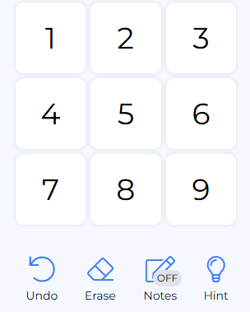
Figure 4: The Keyboard of the Game Sudoku

Non-functional Requirements
The following non-functional requirements also apply
NFR1 | GUI and CLI must be separate programs, each with its own main method.
NFR2 | GUI must strictly follow MVC:  - Model contains no UI logic  - View contains no game logic  - Controller coordinates input and updates the Model
NFR3 | CLI reuses the Model directly and does not define a separate View or Controller. In the CLI version, the CLI class itself is responsible for user interaction and directly invoking Model methods, effectively combining view and controller responsibilities.
NFR4 | Model enforces all Sudoku rules consistently.  Temporary illegal states or invalid inputs do not cause program failure.  Assertions capture Model invariants.
NFR5 | Unit tests must be written using JUnit.  Tests should focus on the Model and include both valid and invalid scenarios.
NFR6 | Include a class diagram illustrating system design.  Include sufficient comments and documentation to explain key design decisions.
NFR7 | Code must be readable, well-structured, and use appropriate naming conventions.  Avoid redundant or duplicated code.

Marking Scheme (See rubric as well).
Model. This should have an interface designed to be convenient for the Controller, View and JUnit class to use with no superfluous public methods, no references to two classes and contain no GUI code. It may consist of several classes but there must be a class called Model or similar that provides the interface and this class should extend Observable. File reading should also be done in the Model. A high mark will be earned for a Model that implements all the required functionality and respects all these constraints. A pass mark will be earned for a Model that implements only some of the required functionality or fails to respect these constraints. | 15%
Controller. This should forward only valid requests to the Model, querying the Model if necessary to find out if the request is valid, and must also enable / disable buttons as described above in the functional requirements. It must have no GUI code, though it may send messages to the View. A high mark will be given to a controller that respects all these constraints and a pass mark will be given to a controller that respects only some of them | 5%
View of GUI version using the Swing framework. It should implement Observer and therefore have an update method that is called when the Model changes. This will be marked according to how many of the functional requirements have been met. A high mark will be given to a view that implements all the requirements and a pass mark will be given to a view that implements only some of them. | 10%
CLI version of the program, using the Model. | 10%
Specification of Model with asserts. This should include invariants for the class as well as pre and post conditions for each public method in the model. This will be marked according to how many of the relevant conditions are included and whether the ones that are included are correct. Partial credit will be available for describing them in English. A high mark will be given to a specification that includes all the relevant constraints. A pass mark will be given to a specification that includes only a few of them. | 10%
Unit testing of the Model in JUnit. There should be three tests, significantly different from each other. You should explain the scenario in comments, i.e., the situation you are testing for. You should write (and then call) methods for the Model that set it into the desired state for the test. It should be easy to determine the state of the Model by reading the code for the unit tests. A high mark will be awarded for significantly different tests that are easy for the marker to interpret. A passing mark will be given to unoriginal second or third tests, or to three tests that are difficult to understand. Your Model may use a separate Board class, but the testing should focus on the Model class, and the specification should also apply to that class. | 10%
Code quality. Use of the code quality practices described in Lecture 1, plus the additional practices of light relevant commenting and correct formatting. Short elegant programs are preferred, and code smells are to be avoided. Note that high marks for this category will only be possible if the GUI fulfils most of the requirements. A high mark will be awarded if all the practices are observed and a pass mark will be awarded if only some of them are. | 10%
Class diagram. This should show how the Model, View and Controller are related to each other, as well as how they interact with library classes such as Observable. Simplicity and clarity will be rewarded. It will be marked according to its accuracy as a representation of the program. A high mark will be awarded for an accurate diagram and a pass mark will be awarded for a less accurate diagram. | 10%
Video presentation that shows you displaying the code and using the program. It will be marked according to timing, presentation and how well you show that you have met the FRs and NFRs in both versions. | 20%

Coursework Management
Students are required to regularly back up all electronic files related to their coursework. Ensure that backups are organized and not solely dependent on a single source of storage, as the loss of files could severely impact your progress. Computer crashes and disk failures will not be accepted as valid excuses for missing or late submissions. Students must use an industry-recognized version control system, such as Git, to track versions of their software development work throughout the module. Additionally, the repository must remain private, both before and after submission. Keep the repository confidential to protect your work.

Submission
Requirements
- Your submission should contain three files (.pdf, .zip, and .mp4).
- The first file is a PDF document containing the design (represented by a UML class diagram), screenshots of the testing, and printed copies of the Java implementation code‌.
- The second file is a .zip file with the Java project.
- The third file is a .mp4 video that is less than 1 GB. If the video is not viewable, it will not receive marks. The video must be a maximum of five minutes long during which you must display most of the relevant functionality and refer to your code. Any recording software can be used so long as it captures your screen and your voice.
- Additionally, you are required to regularly upload your code to a repository (Note: such as GitHub, and you must set it to private.) as per the university counterpart's requirement. Provide the link and screenshots of the repository and the record of the commits in the PDF document. To ensure against plagiarism, frequent and early commits are required. For example, work submitted as one commit on the day of the deadline will be penalized.
- The PDF document is the version that will be marked, but the .zip and .mp4 are requested so that we may run the code.

File Naming Convention
You must save the files with the following names:
  - {YourStudentNumber}-coursework.pdf
  - {YourStudentNumber}-coursework.zip
  - {YourStudentNumber}-coursework.mp4
For example:
  - 202107081314-coursework.pdf
  - 202107081314-coursework.zip
  - 202107081314-coursework.mp4

Submission Deadline:
You must upload from the student website (student.zy.cdut.edu.cn) before TBD
Some students will be selected to give a Zoom presentation, after the exam period. If you are asked to give a Zoom presentation then you must do so.

Formative Feedback
We are giving you the opportunity to receive feedback on the design of your program. To receive this feedback, you need to upload a detailed UML class diagram of your code to student website before TBD. As this is a formative feedback deadline, it will not be possible for you to seek deadline extensions. You will be given a short amount of written feedback on your design within a week. The Week 5 teaching session will go through a worked example in order to help you produce the class diagram.
The class diagram should have all methods and attributes showing. In addition, you should indicate which methods call which other methods. A class diagram with insufficient detail or syntactically nonsensical or not realisable as an actual Java program will make it more difficult for us to give you feedback and will receive a low mark if submitted with the final report.

Academic Conduct
This is an individual piece of work and you will have to work on your own and submit your own original attempt at the assignment. Any code that has been copied from any source (e.g. Stack Overflow, online tutorial, textbooks, other students etc.) must be properly referenced to avoid any suspicion of plagiarism. Refer to the Module Handbook for further information on this. If you need help you can always ask for advice and guidance from the module leader and tutor by email; online sessions can be arranged for further clarification.

Rubric

The work shall be marked according to the following rubric.
 | D | C | B | A
Model | only basic functionality implemented or slightly more than basic but references to View or Controller or superfluous methods | no superfluous methods and no references to View or Controller but only the basics of functionality implemented | no superfluous methods and no references to View or Controller but only the basics of functionality implemented | convenient to use with no superfluous methods, all required functionality and no references to View or Controller, extends Observable, calls setChanged and notifyObservers
Controller | zero of the requirements: only valid requests, querying Model first, enables/disables buttons without GUI code | one out of only valid requests, querying Model first, enables/disables buttons without GUI code | two out of only valid requests, querying Model first, enables/disables buttons without GUI code | only valid requests, has references to both Model and View, converting UI interactions into methods to change the Model, querying Model first, enables/disables buttons without GUI code
GUI View | no view update method or update method implementing very few of the FRs | update method in view implementing some of the FRs | update method in view implementing most of the FRs | update method in view implementing all the FRs, uses Swing, has Model and Controller as attributes, displays board and allows Controller to change the view e.g. enable/disable options, implements Observer and calls addObserver
CLI class | CLI version implementing very few of the FRs | CLI version implementing some of the FRs | CLI version implementing most of the FRs | CLI version implementing all the FRs, using same Model as the GUI version, but no Controller and is demonstrated on the video
Specification of  Model with asserts | a few pre/postconditions described in English | suitable pre/post conditions for most public methods but in English | suitable pre/post conditions for most public methods expressed in some logic | suitable pre/post conditions for all public methods and class invariants all expressed as statements of formal logic
Unit testing of  Model with JUnit | one test with the scenario poorly described or not at all | tests all essentially similar or only one or two or scenario being tested poorly described | third test not significantly different or scenario being tested not described with sufficient care | three significantly different tests of the model with all scenarios exactly described and with all inputs satisfying the preconditions
Code quality practices | most code quality practices not observed | some code quality practices observed but many not | most code quality practices observed but some clearly not | all code quality practices observed including light correct commenting, suitable identifier names (constants, methods, classes etc) in appropriate cases, indentation, lack of code smells (long methods, repeated code, lack of modularity)
Class diagram | Inadequate class diagram with serious mistakes in attributes, methods and relationships between classes | Adequate class diagram with mistakes in attributes, methods and relationships between classes | Good class diagram with only a few mistakes in attributes, methods, visibility or relationships between classes | Excellent class diagram with all attributes and methods indicated with correct visibilities and correct relationships between classes all shown
Video Presentation | Very poor presentation with insufficient coverage of FRs and NFRs, poorly presented and overly long | Passable presentation covering FRs or NFRs or well-presented or at least appropriate length | Quite good presentation but missing some details of FRs and NFRs or poorly presented or overly long | Excellent presentation with full explanation of most FRs and NFRs, referencing the code, well presented and within time limit

