AXE PLAY
VENUE APP GAME REFERENCE
Game list, rules/instructions, and current Axe Arcade visual reference for Tommy
Purpose: Recreate the current lane-game experience in Venue App while preserving the simple tablet workflow Axe Play customers already know. The wording below is transcribed from the current RKd/Axe Arcade screens where visible, with First to 21/51 and Open Throwing added as functional descriptions.

1. Current Game Selection Screen
- League Style
- Bucket List
- First to 21/51
- Magic Number
- Tic Tac Toe
- Around the World
- Open Throwing

2. Game Rules / Instructions

League Style
HOW TO PLAY
Each game consists of 10 throws per player.
Players throw 5 axes during their first turn, then rotate targets.
Players then take another 5 throws each.
HOW TO SCORE
Axe must stick to the target to count.
If between 2 scoring rings, the higher point value is awarded.
IMPLEMENTATION NOTE
Preserve the familiar 10-throw, two-round format. The current screen presents these rules as a modal overlay above the game-selection screen.

Bucket List
HOW TO PLAY
Each player takes 3 throws per turn.
The axe must stick in the target for an item to be checked from the list.
If between 2 scoring rings, the higher point value is awarded.
Players must hit 3 of each numbered ring and bullseye.
Items can be closed out in any order.
Optional challenge - hit 3 blue balls!
IMPLEMENTATION NOTE
This is effectively a checklist/challenge game. Progress should remain visible so players can see which target values have been completed.

First to 21/51
HOW TO PLAY
Players take turns throwing and add the value of each scoring throw to their running total. Before starting, select a target score of either 21 or 51. The first player to reach the selected total exactly wins. If a throw would take the player over the target total, the game applies the existing over-score penalty/reset behavior rather than awarding the win.
HOW TO SCORE
A stuck axe scores the point value of the highest ring it lands in. The game continuously displays each player's running total.
IMPLEMENTATION NOTE
Keep this game fast and self-explanatory. The title itself does most of the teaching. Preserve RKd's existing exact-score/over-score behavior when Tommy implements the logic.

Magic Number
HOW TO PLAY
Each player takes 3 throws per turn.
During first round, only 1s count toward final score.
During second round, only 2s count toward final score.
And so on, through bullseyes.
Optional challenge - go for 3 blue balls!
IMPLEMENTATION NOTE
The active scoring value changes by round. The interface should make the current required number obvious.

Tic Tac Toe
HOW TO PLAY
Players take turns throwing at the target to hit a point value corresponding to a square on the tic tac toe board.
Example board shown on the current screen:
1 2 3
4 6 4
3 2 1
If the player hits the target, they mark an 'X' or 'O' in the corresponding grid square.
IMPLEMENTATION NOTE
The board is randomly generated. The same scoring value may appear in multiple squares. When that happens, the player chooses which matching square receives the X or O. A 6/bullseye is not necessarily the center square.

Around the World
HOW TO PLAY
Players take turns throwing to complete a successive run of scores on the target.
Players must hit the 1 ring before moving on to the 2 ring, and so on.
Players move from 1 to bullseye, then bullseye to 1.
If you make it, you take it - if you stick the axe in the number required, keep throwing!
Hitting a blue ball takes the player to the last shot in the sequence.
IMPLEMENTATION NOTE
The game should clearly show each player's current required target value and advance immediately after a successful hit.

Open Throwing
HOW TO PLAY
Open Throwing is the no-game / free-throw mode. Players throw normally without a structured competition, required sequence, turn limit, or target score. The lane remains available for casual practice, instruction, warm-up, or groups that simply want to throw without playing one of the scored games.
HOW TO SCORE
No game score is required. If desired, the interface may still acknowledge individual hits and misses using Axe Play's randomized hit/miss messages.
IMPLEMENTATION NOTE
This should be the simplest mode in Venue App: minimal setup, immediate access to throwing, and an easy path back to Browse Games.

3. Aesthetic / User Interface Reference
- Dark/black overall interface with a wood-target image or texture as the main visual background.
- Axe Play logo centered near the top of the screen.
- Lane number displayed prominently on the lane home screen (example: 'Lane 4').
- Large yellow rectangular game buttons arranged in two columns.
- Game-selection screen uses: League Style / Bucket List; First to 21/51 / Magic Number; Tic Tac Toe / Around the World; Open Throwing / Go Back.
- Primary action button on the lane screen: yellow 'BROWSE GAMES' button.
- Selected/focused controls use a bright yellow outline.
- Game instructions appear as a dark translucent modal overlay, allowing the game-selection screen to remain visible behind it.
- Instruction headings use high-contrast white/light-blue text: game name, 'HOW TO PLAY', and when applicable 'HOW TO SCORE'.
- Large centered 'CLOSE' button at the bottom of the instructions modal.
- Overall design should be simple enough to operate quickly on the existing lane tablets; avoid clutter or multi-step navigation.

4. Important Functional Notes for Venue App
- The game system is used with Axe Play's existing standard wood targets. There are no projectors.
- Customers interact with tablets at the lanes; lane monitors provide the visual/game experience.
- Preserve the ability to browse between games without restarting the lane session.
- Keep game rules available from the game-selection interface so customers can quickly check how a game works.
- Hit/miss feedback should use the separate Axe Play hit/miss message list already provided.
- Where a rule or edge-case is unclear during development, duplicate current RKd/Axe Arcade behavior first rather than inventing new scoring logic.

5. Screenshot Reference
The screenshots supplied with this document show the current Axe Arcade lane home screen, game-selection menu, and instruction overlays. They should be treated as the visual/UX reference for the first Venue App test build; the goal is functional familiarity, not a pixel-for-pixel copy.
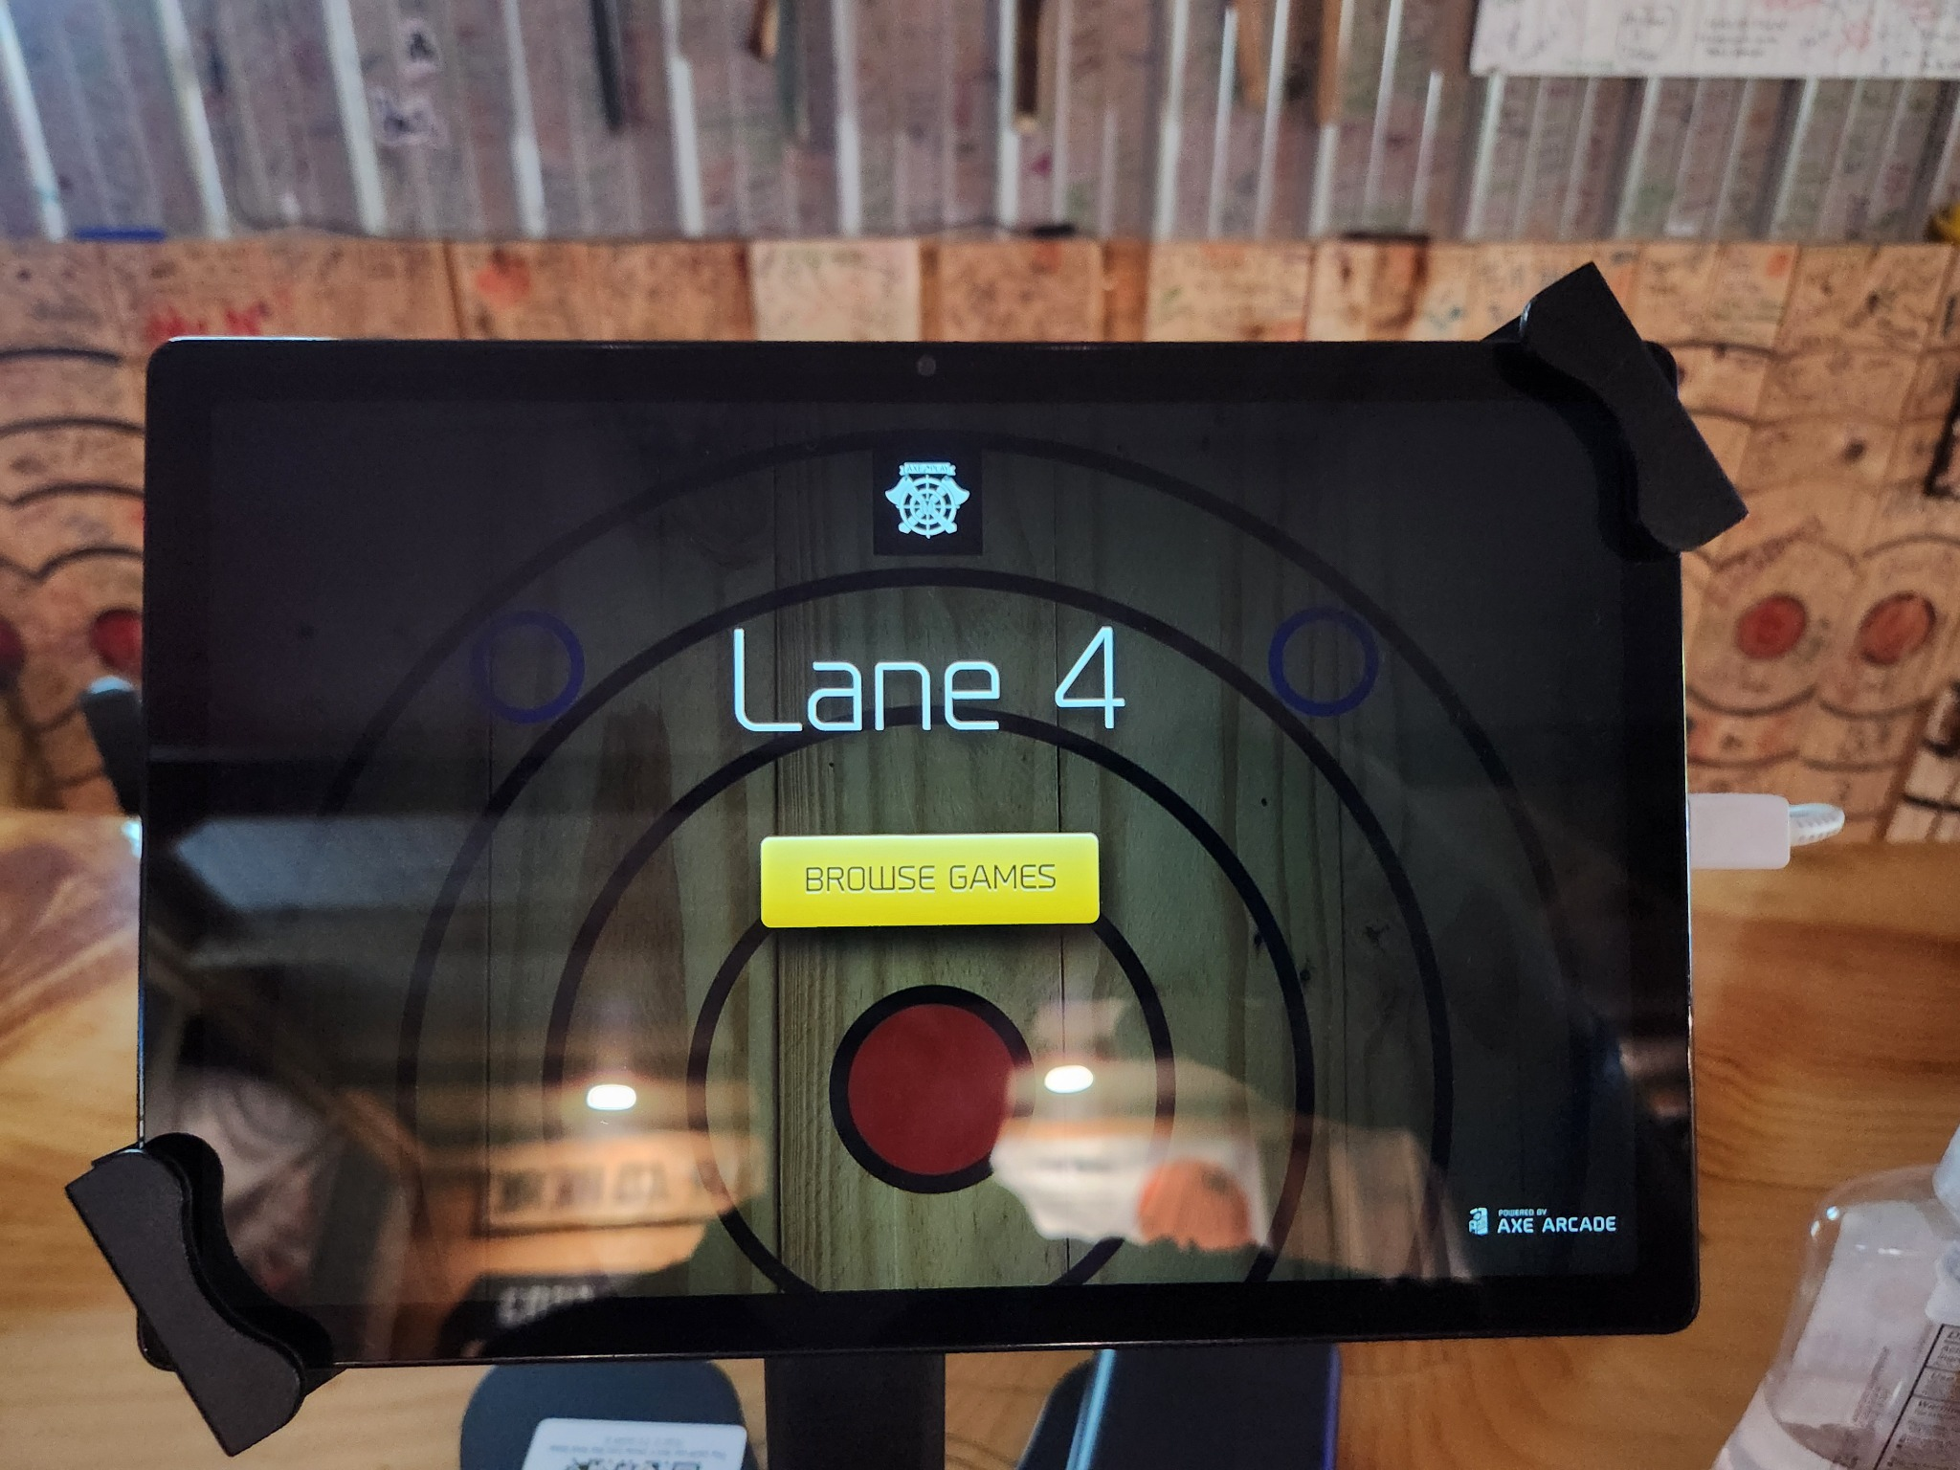
Current lane home screen
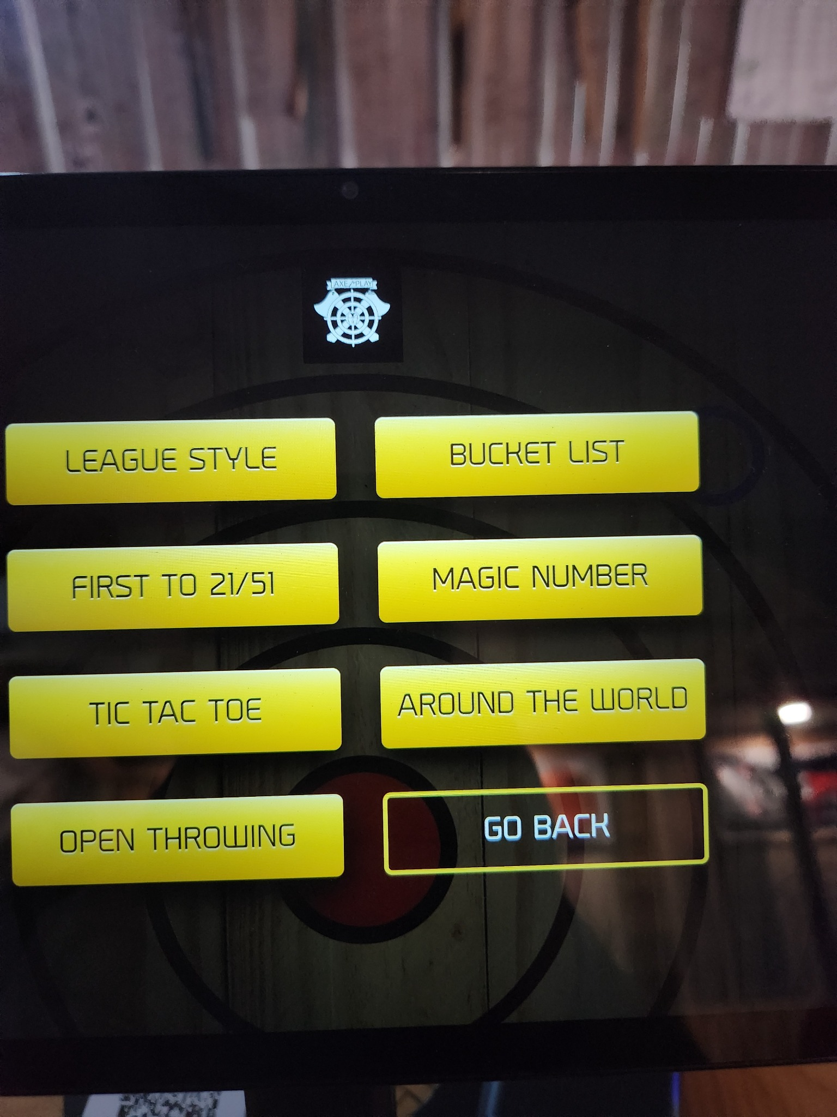
Current Browse Games screen
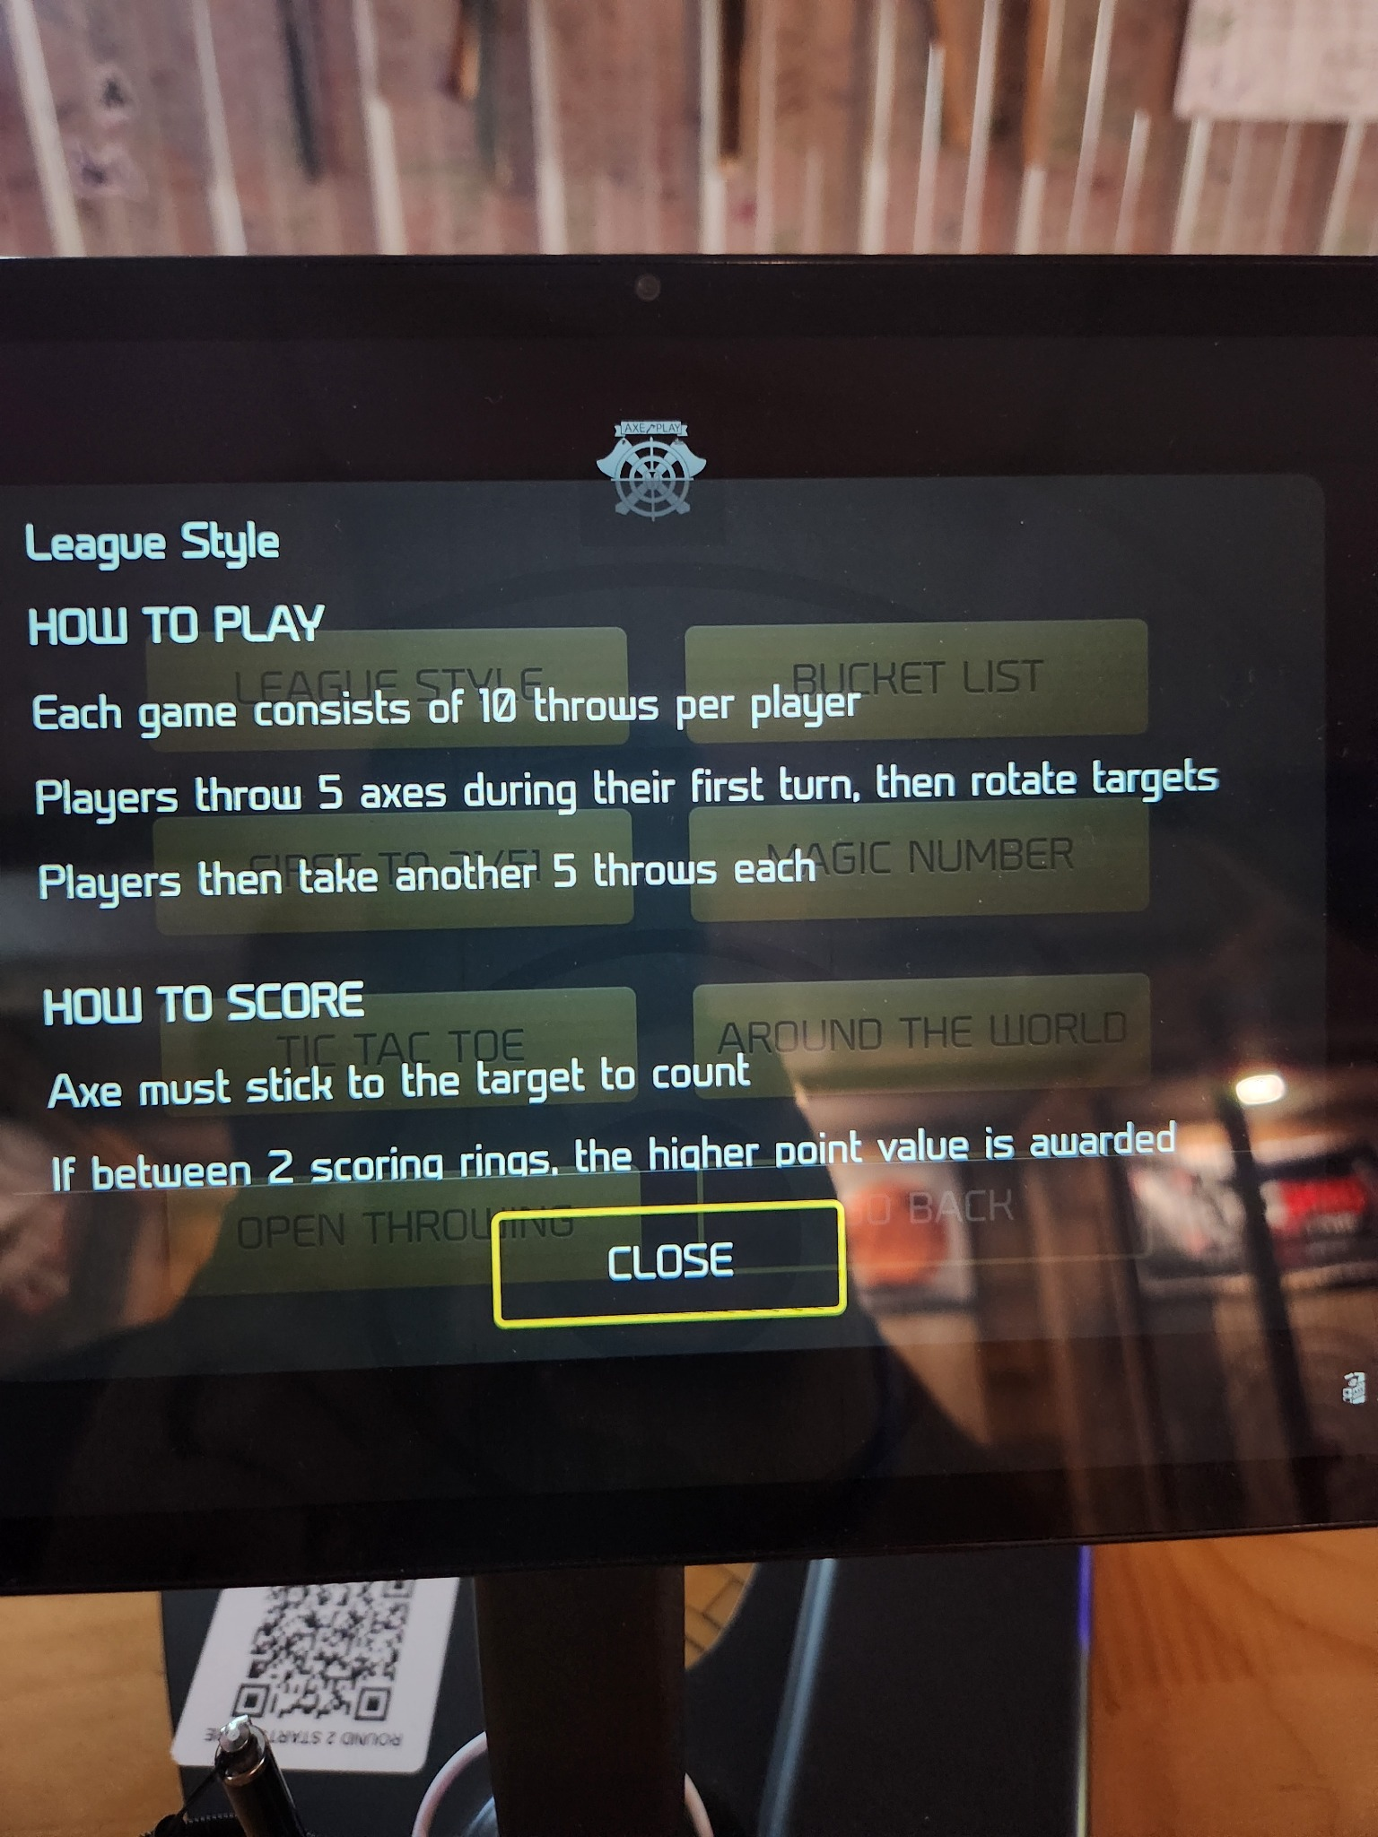
League Style instructions
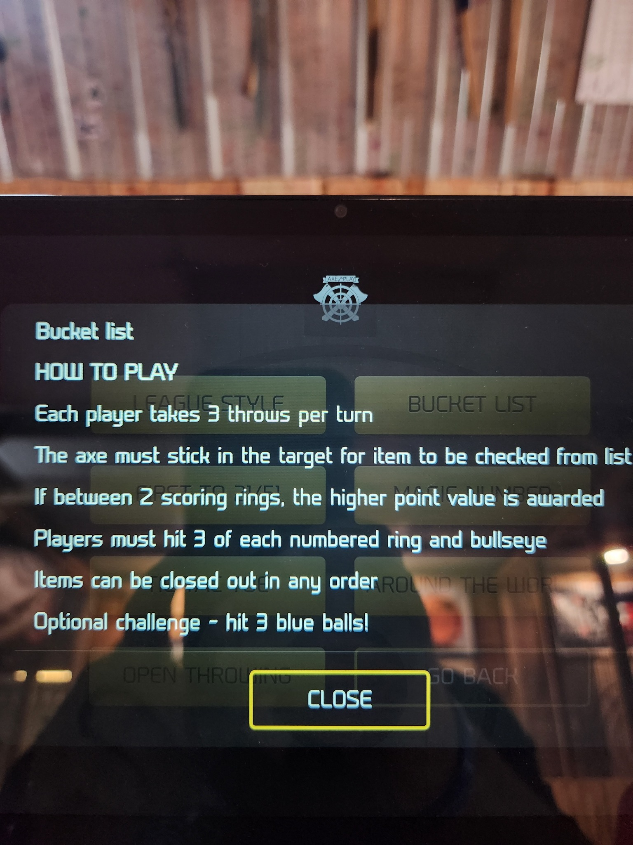
Bucket List instructions
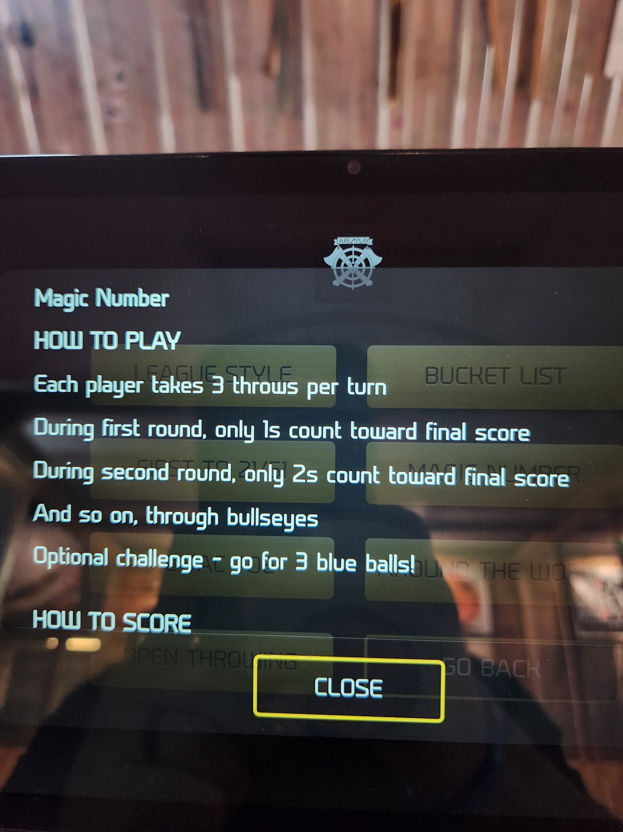
Magic Number instructions
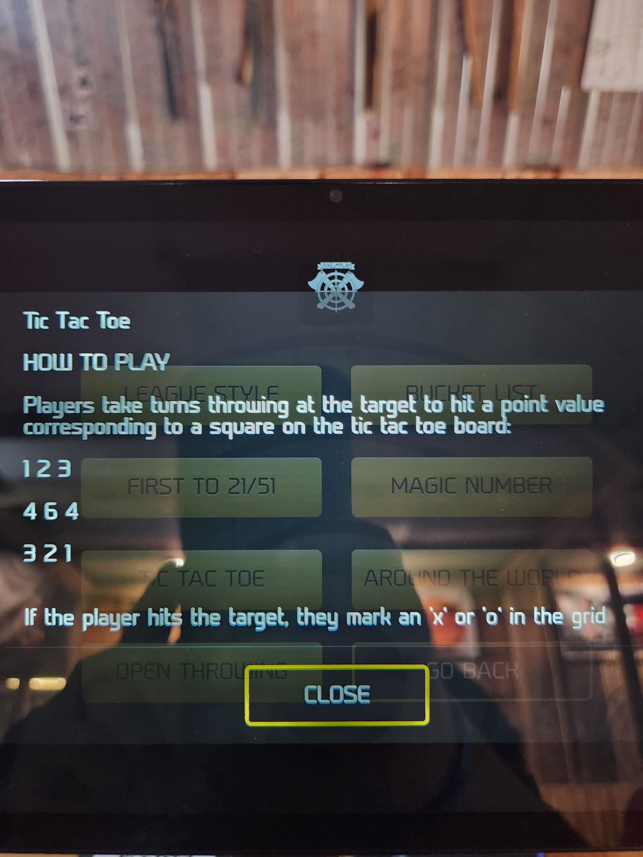
Tic Tac Toe instructions
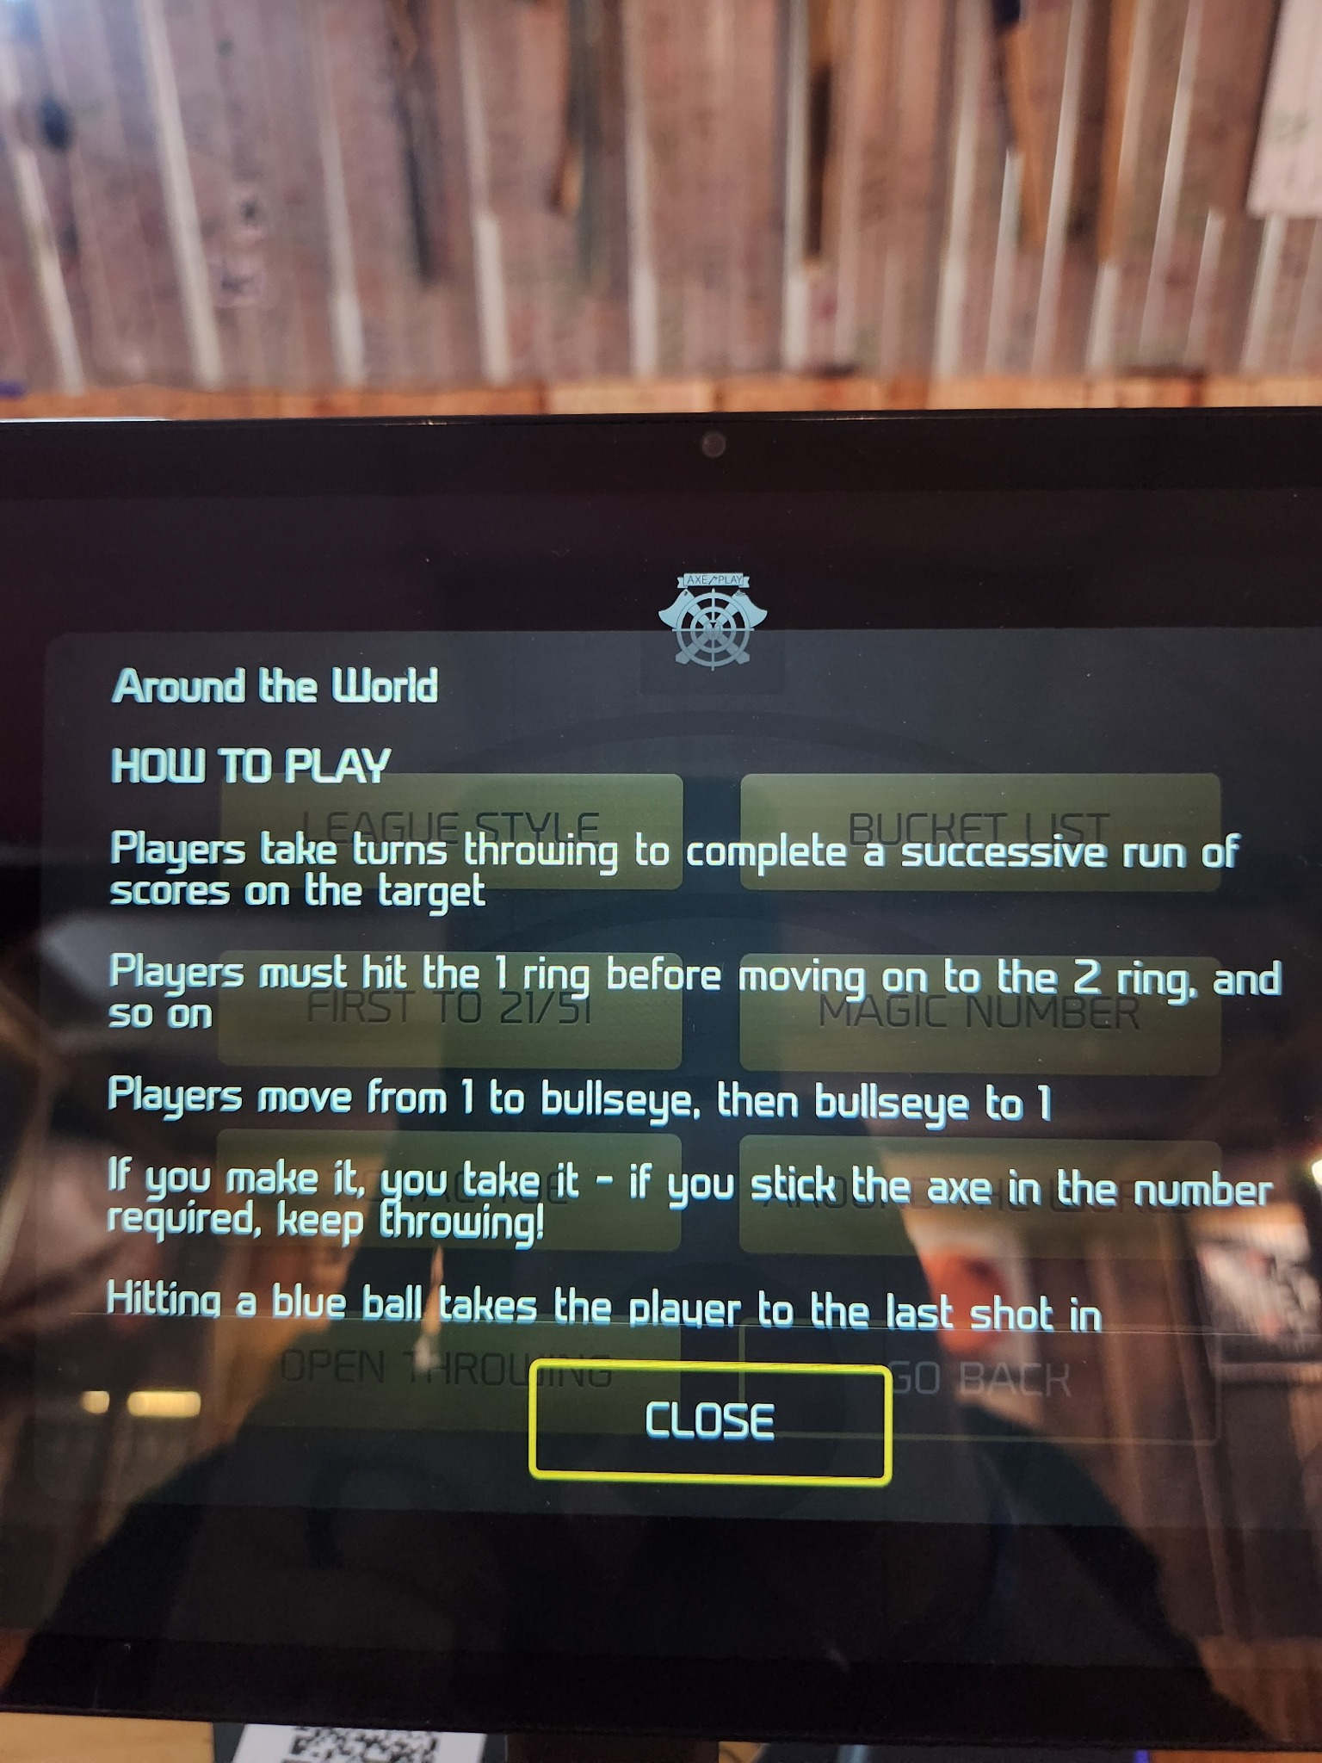
Around the World instructions

