Altium has a very nice way of managing Gerber’s.

1. Create/add an Job Output file
2. Under fabrication.
   1. Add NC Drill File – Select PCB
   2. Add Gerber’s – Select PCB
      1. Under Gerber’s check all the items. See Image:
      2. 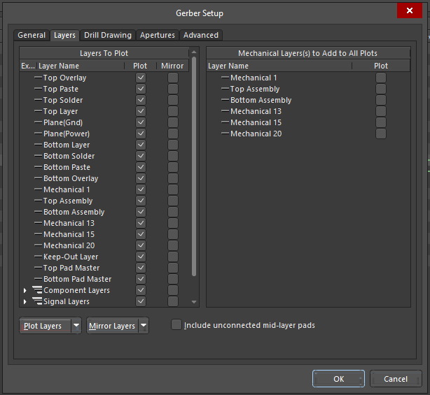
3. Need to place a board outline on Mechaical #1.
4. Press Generate.
5. Create a master Directory and copy both the NC Drill and Gerber Folders into the newly created directory.
6. Zip Directory and the you can up load to JLPCB.com