A Reproduction Study
Reproducing a Kinematic-Wave-Based Adaptive Transit Signal Priority Controller Optimised by a Genetic Algorithm
Original article: Behbahani, H., & Poorjafari, V. (2022). Proposing a kinematic wave-based adaptive transit signal priority control using genetic algorithm. IET Intelligent Transport Systems, 17(5), 912–928. https://doi.org/10.1049/itr2.12316
Scope: classical Information-Systems methods (optimal-control delay modelling and genetic-algorithm search); no deep learning or reinforcement learning.

1. Introduction and Article Summary
Adaptive Transit Signal Priority (TSP) seeks to reduce delay for public-transport (PT) vehicles at signalised intersections without unduly penalising general traffic. The reproduced article proposes KATC (a kinematic-wave-based adaptive transit-signal controller) that departs from conventional vehicle-based signal optimisation by minimising average passenger delay across both modes. By weighting each vehicle by its passenger occupancy, a fully loaded bus receives priority proportional to the number of people it carries rather than being treated as a single vehicle.
KATC operates as a closed control loop with four elements: a data layer that reads general-traffic demand and the position and occupancy of approaching PT vehicles; a kinematic-wave delay model that predicts, for any candidate signal plan, the delay of both modes using shockwave analysis; a genetic algorithm (GA) that searches green-time splits and phase sequence to minimise average passenger delay; and an actuation layer that deploys the optimised plan. The signal is re-optimising every cycle over a three-cycle rolling horizon. In its full form (KATC-2), which optimises both green times and phase sequence, the authors report reductions in average passenger delay relative to a vehicle-based SYNCHRO baseline and to a green-time-only variant (KATC-1), with the largest gains at low saturation and high PT occupancy.
This project reimplements the KATC method from scratch and evaluates whether its behaviour and reported improvements can be recreated. Consistent with reproduction studies generally, the objective is faithful reimplementation and an honest account of what reproduces and what does not, rather than an exact match of the original figures. The method is entirely classical: optimal-control delay estimation combined with metaheuristic search.

2. The Original Method
The delay model rests on a triangular fundamental diagram, from which queue-formation and queue-dissipation shockwave speeds are derived. For general traffic, queue length during red and the minimum green required to clear it determine whether a cycle is under- or over-saturated; undersaturated cycles incur a triangular queue-profile delay, while oversaturated cycles form a residual queue that carries into the next cycle. For PT vehicles, delay is computed by trajectory analysis across two cycles, giving four saturation cases each subdivided by the vehicle's arrival position. The two modal delays are combined into average passenger delay, which serves as the optimisation objective.
The optimiser is a genetic algorithm operating on a binary chromosome that encodes, per cycle, a two-bit phase-sequence variable and three six-bit coefficient factors distributing green time between major and minor movements. Over a three-cycle horizon the chromosome is sixty bits. The GA is configured with a population of 150, 150 generations, elitism, mask-based crossover, and adaptive mutation rising from 0.01 to 0.02, with fitness defined as the inverse of average passenger delay. Signal plans are constrained so that phase lengths respect the cycle length, a minimum-green floor, and the NEMA dual-ring barrier.

3. Reproduction Methodology
The method was rebuilt as six phases. Phases 1 and 2 form a simulator-independent analytical core, validated by 37 automated unit tests; Phases 3 to 6 provide the simulation environment and evaluation.

3.1 Kinematic-wave delay model
The delay model was implemented directly from the article's equations, which were verified against a clean source (a LaTeX transcription of the published equations cross-checked against a rendered comparison, and the publisher HTML for the constraint equations). Because the article provides no worked numerical example, the model was validated by physical-consistency testing (non-negative delays; monotonic behaviour in green time, red time, and demand; correct residual-queue formation and propagation) and by an internal identity: the oversaturated queue-length equation reduces exactly to the undersaturated one when the residual vanishes. This identity independently evidences that both equations were transcribed faithfully.

3.2 Genetic-algorithm optimiser
The GA was reproduced with the article's verified configuration and encoding. A separate suite of unit tests confirmed lossless chromosome encoding and decoding, guaranteed constraint satisfaction under extreme parameter values, and correct optimisation behaviour (monotone improvement under elitism and deterministic results under a fixed seed). Wiring the optimiser to the delay model reproduced the article's preliminary analytical test: on a representative scenario the GA reduced average passenger delay by approximately 46% relative to random signal plans, converging within roughly 25 generations in under three seconds (Figure 1). This is consistent with the article's reported convergence behaviour and, being independent of the simulator, provides an early validation of the full analytical stack.
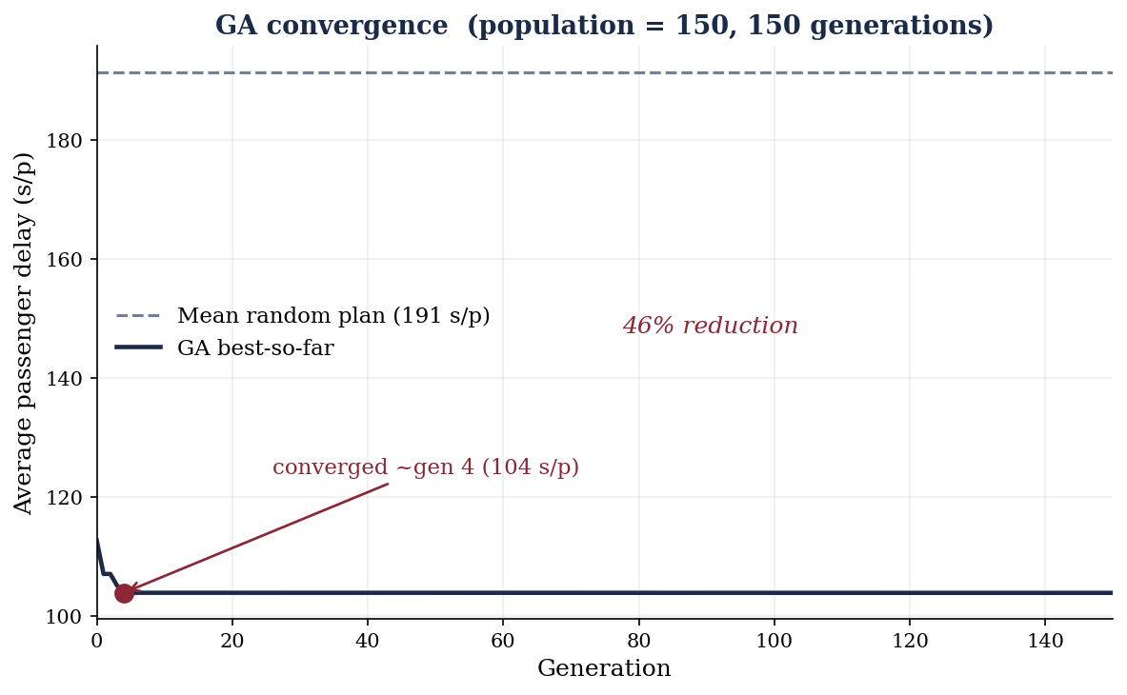
Figure 1. Convergence of the reproduced genetic algorithm on the analytical delay model.

3.3 Simulation environment
The controller was evaluated in SUMO, an open-source microscopic traffic simulator, coupled to the KATC controller through the TraCI interface. A four-legged intersection was constructed with two-lane major and one-lane minor approaches, each with an exclusive left-turn lane, controlled by a full NEMA dual-ring eight-phase signal. Demand was generated with the article's turning proportions and eight PT routes with their specified headways, scalable by degree of saturation (DOS). Each cycle, the control loop reads traffic state and bus information, runs the KATC optimiser, writes the optimised NEMA plan back to the signal, and advances one cycle — reproducing the read–optimise–actuate architecture of the original.

3.4 Controllers and experimental design
Three controllers were implemented: KATC-2 (green times and phase sequence), KATC-1 (green times only), and a fixed-time baseline. Because the analytical delay model is invariant to phase sequence, the phase-sequence decision in KATC-2 was resolved from simulation-measured bus delay using an epsilon-greedy strategy, so that KATC-2 differs from KATC-1 through genuinely observed effects rather than a nominal parameter. The full experimental grid follows the original: seven DOS levels (0.4 to 1.0) crossed with five PT-occupancy levels (20 to 60), across three controllers, giving 105 one-hour scenarios with a two-cycle warm-up.

4. Deviations from the Original
Several deviations were made and are documented here, as they bound the comparability of results:
- Simulator. The original evaluates KATC in VISSIM via a COM interface; this reproduction substitutes SUMO with TraCI, since the available VISSIM trial disables the control interface the method requires. Results should therefore be read as reproducing the method's behaviour and relative trends rather than the exact reported figures.
- Baseline. SYNCHRO, a commercial package, was unavailable; a fixed-time Webster-style plan was used as the vehicle-based baseline in its place.
- Coefficient-factor mapping. The article does not publish the exact mapping from the three coefficient factors to the eight NEMA movements; a dual-ring-consistent interpretation was adopted and documented.
- Phase sequence. As noted above, phase sequence was resolved from simulation measurements because the analytical model does not depend on it.

5. Results
Table 1 reports mean average passenger delay by DOS for each controller, averaged over PT occupancy. Two features are immediately apparent. First, the absolute delay magnitudes (roughly 140 to 235 seconds per passenger) are substantially higher than the article's reported range of approximately 35 to 47 seconds per passenger. This gap is expected: SUMO's delay measure and driver model differ from VISSIM's, and the simulator substitution precludes exact-magnitude reproduction. Second, the ranking of controllers is not uniform across saturation levels.
Table 1. Mean average passenger delay (s/passenger) by DOS and controller.
DOS | Fixed-time | KATC-1 | KATC-2
0.4 | 162.7 | 184.4 | 146.7
0.5 | 160.2 | 185.5 | 193.4
0.6 | 165.6 | 220.6 | 157.4
0.7 | 154.7 | 200.5 | 144.7
0.8 | 147.5 | 140.3 | 145.0
0.9 | 154.8 | 231.9 | 222.5
1.0 | 161.3 | 211.7 | 166.5

Against KATC-1, the reproduction is clear and positive: KATC-2 achieved lower average passenger delay in 25 of 35 scenarios, a mean improvement of approximately 13.5%. This confirms the article's central claim that adding phase-sequence optimisation to green-time optimisation yields a measurable benefit — the distinguishing contribution of KATC-2.
Against the fixed-time baseline, the picture is mixed. KATC-2 outperformed fixed-time in 20 of 35 scenarios, but the mean improvement across the grid was slightly negative (approximately −6.4%), driven by two anomalous saturation levels (DOS 0.5 and DOS 0.9) at which KATC-2 performed markedly worse than the baseline. At the remaining five DOS levels, KATC-2 was competitive with or better than fixed-time, with improvements of roughly 5 to 10% at low-to-moderate saturation. Figure 2 shows the improvement of KATC-2 over both comparators as a function of DOS; Figure 3 shows mean delay by controller.
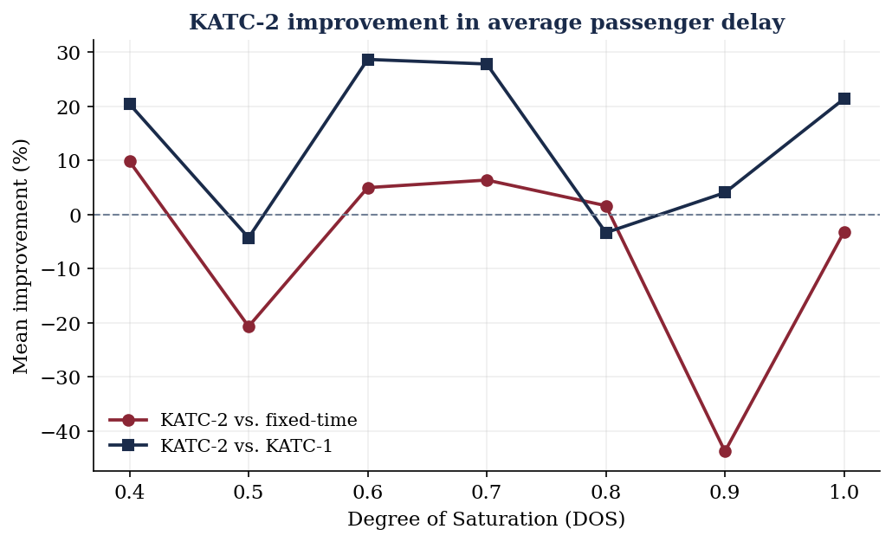
Figure 2. KATC-2 improvement in average passenger delay over fixed-time and over KATC-1, by DOS.
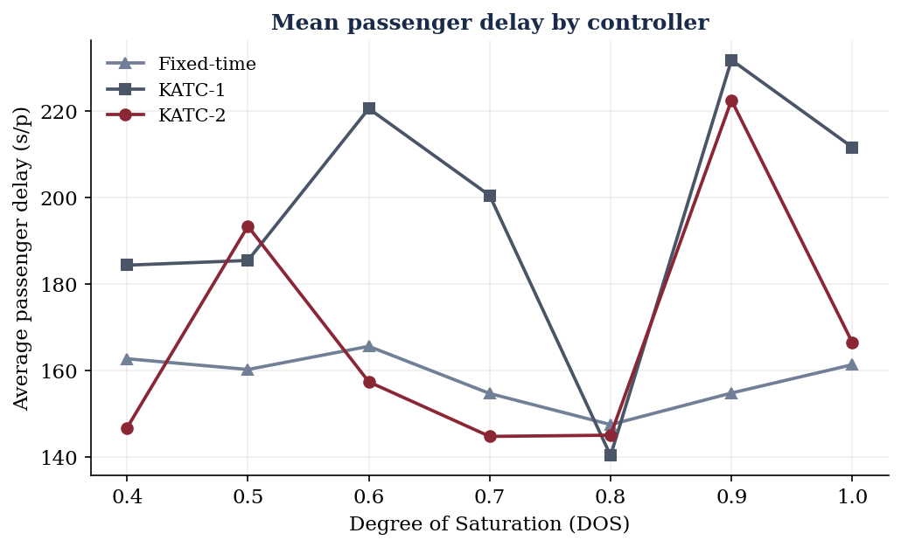
Figure 3. Mean average passenger delay by controller across saturation levels.

6. Discussion and Conclusion
The reproduction succeeded at the level of method and mechanism. The kinematic-wave delay model was rebuilt and validated against its own internal identity; the genetic algorithm was reproduced faithfully and converged as the article describes; and the full read–optimise–actuate loop runs end-to-end in simulation. The article's core methodological claim — that phase-sequence optimisation gives KATC-2 an edge over KATC-1 — reproduced clearly, with KATC-2 improving on KATC-1 in the large majority of scenarios.
The reproduction diverged, however, in two respects. Absolute delay magnitudes were far higher than the original, an expected consequence of the VISSIM-to-SUMO substitution and the different delay measures involved. More substantively, KATC-2 did not uniformly beat the fixed-time baseline: it won in a majority of scenarios but exhibited high variance and two anomalous high-loss points. Several factors plausibly contribute. The controller re-optimises from scratch each cycle, which can destabilise green-time allocation, particularly where a stable fixed plan is already near-optimal; the analytical fitness function, computed with uncalibrated fundamental-diagram parameters, is only a proxy for the delay SUMO actually measures, so the optimiser may favour plans that are not optimal in simulation; and the two outlier saturation levels suggest scenario-specific interactions worth isolating in future work.
Taken together, the study reproduces the KATC method and its principal internal comparison while showing that its advantage over a conventional baseline is, under an independent simulator and uncalibrated parameters, less robust than the original reports. The value of the exercise lies precisely here: a reproduction demonstrates understanding not by matching every number but by identifying where a method holds, where it breaks, and why. The original article's reliance on commercial tools, an unpublished coefficient mapping, and an unavailable code artifact all raised the cost of reproduction — and documenting those gaps is itself a contribution.

References
Behbahani, H., & Poorjafari, V. (2022). Proposing a kinematic wave-based adaptive transit signal priority control using genetic algorithm. IET Intelligent Transport Systems, 17(5), 912–928. https://doi.org/10.1049/itr2.12316
Goldberg, D. E. (1989). Genetic algorithms in search, optimization, and machine learning. Addison-Wesley.
Koonce, P., Rodegerdts, L., Lee, K., Quayle, S., Beaird, S., Braud, C., Bonneson, J., Tarnoff, P., & Urbanik, T. (2008). Traffic signal timing manual (Report No. FHWA-HOP-08-024). Federal Highway Administration.
Lighthill, M. J., & Whitham, G. B. (1955). On kinematic waves II: A theory of traffic flow on long crowded roads. Proceedings of the Royal Society of London A, 229(1178), 317–345. https://doi.org/10.1098/rspa.1955.0089
Lopez, P. A., Behrisch, M., Bieker-Walz, L., Erdmann, J., Flötteröd, Y.-P., Hilbrich, R., Lücken, L., Rummel, J., Wagner, P., & Wießner, E. (2018). Microscopic traffic simulation using SUMO. In Proceedings of the 21st IEEE International Conference on Intelligent Transportation Systems (pp. 2575–2582). https://doi.org/10.1109/ITSC.2018.8569938
Richards, P. I. (1956). Shock waves on the highway. Operations Research, 4(1), 42–51. https://doi.org/10.1287/opre.4.1.42
Webster, F. V. (1958). Traffic signal settings (Road Research Technical Paper No. 39). Her Majesty's Stationery Office.

