Segmentation of CT Lung Scans Using Image Processing Techniques
Class Project COMP 5230 – Computer Vision
Terry Griffin

Introduction
This project will investigate the current state of the art methods for automatic segmentation of computed tomography (CT) lung scans. The focus will be on approaches which make use of image processing techniques rather than deep learning approaches. A system will be implemented which takes a CT lung scan as input and produces labels identifying the lobes of the lungs. The goal of the project is to gain a full understanding of the current best practices through study, and implement of a system which demonstrates performance comparable with contemporary approaches.

Motivations
Lung cancer continues to be one of the leading causes of death in the U.S. and world wide. Early detection through the use of CT scans is an important step in increasing the chance of patient survival. Computer-aided diagnosis (CAD) systems can greatly improve the efficiency and effectiveness of physicians in evaluating these scans, a process which tends to be a time intensive and laborious.

The first step in automatic analysis of a CT scan is separating the lung tissue from the blood and air vessels and the surrounding bone and musculature. Once the lung tissue has been isolated, the next step is to identify the lobes which make up the two lungs. The result of these two steps is a labeled map of the CT scan which can be used by additional systems to identify and categorize potentially cancerous tumors.

The problem can be viewed as taking a 3-D image such as Figure 1 and labeling it according to the lung lobe segments shown in Figure 2.

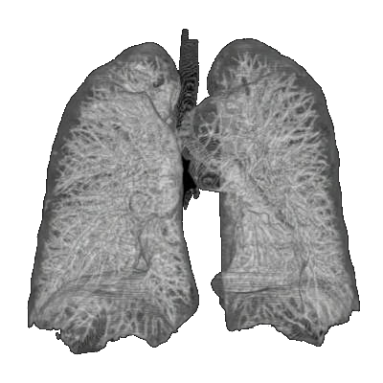
Figure 1: 3-D Lung Scan

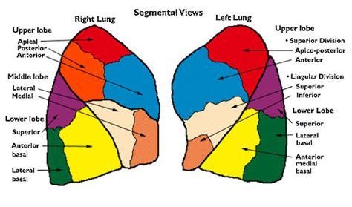
Figure 2: Segments of the Lungs
Related Work
Automatic segmentation of images in general, and medical images in particular has a long history. A variety of approaches have been applied to this problem, including the use of templates or atlases, thresholding, connected component analysis, watershed algorithms, as well as statistical approaches such as the use of Markov random fields. Typically some preprocessing steps are also involved which use techniques such as normalization, blurring, dilation, and erosion for noise reduction and to provide a constrained input space.

Although there are many useful approaches to this problem which have shown increasing degrees of success, there has yet not emerged a fully satisfying solution which works consistently in the most general case. The various implemented systems tend to work well for certain datasets but not others, and/or contain “magic numbers” for thresholds and other parameters which must be empirically derived.
Proposed Approach
There are two phases to this project. The first is to complete a thorough literature search of the current best approaches to the lung segmentation problem. After analyzing the existing approaches and their respective strengths and weaknesses a system will be designed and implemented which takes advantage of the known best practices.

I plan to implement the system using C++ and the OpenCV library. OpenCV provides high quality implementations of the basic image processing operations that I am most likely to require. Using C++ will allow building a system which is efficient in terms of runtime speed.

Evaluation
During development I plan on using the LObe and Lung Analysis 2011 (LOLA11) and the LUNA16 datasets. Once the system is working reliably I will test with other available datasets to ensure the general applicability of the selected approach.

Manual evaluation of the segmentation result is possible and will be the initial approach taken. However, a more automated method for analyzing the results is necessary to process the number of scans required to be confident in the systems true capabilities.

The challenge in evaluating these types of systems is in obtaining labeled data with which to compare the generated results. One method for independent evaluation is submitting results to the LOLA11 competition. However, as the competition has not had many recent submission, the result can only be considered as a baseline and not a true comparison with the performance of current systems.

Better methods of evaluation and comparison with other systems will need to be developed as part of the analysis phase of this project.
Timeline
With the expectation that the project will be due roughly at the beginning of May, this leaves roughly ten weeks for the project. I plan on spending the first four weeks, until March 17, doing the literature search. This will be followed by four weeks to design and develop the segmentation system. This step should be complete by April 14. The remaining time will be spent evaluating the system and producing the final report.

References
ACS, 2018. American Cancer Society, Cancer Facts and Figures.
<http://www.cancer.org/research/cancerfactsstatistics/index>.
Bragman, F., McClelland, J., Jacob, J., Hurst, J., Hawkes, D., Pulmonary Lobe Segmentation With Probabilistic Segmentation of the Fissures and a Groupwise Fissure Prior, IEEE Transactions on Medical Imaging, Volume 36, Number 8, August 2017
Firdouse, M., Balasubramanian, M, A Survey on Lung Segmentation Methods, Advances in Computational Sciences and Technology, Volume 10, Number 9 (2017) pp. 2875-2885.
Hu, S., Hoffman, E., Reinhardt, J., Automatic Lung Segmentation for Accurate Quantization of Volumetric X-Ray CT Images, IEEE Transactions on Medical Imaging, Volume 20, Number 6, June 2001
Lassen, Bianca & van Rikxoort, Eva & Schmidt, Michael & Kerkstra, Sjoerd & van Ginneken, Bram & Kuhnigk, Jan-Martin. (2012). Automatic Segmentation of the Pulmonary Lobes From Chest CT Scans Based on Fissures, Vessels, and Bronchi. IEEE transactions on medical imaging. 32. . 10.1109/TMI.2012.2219881.
Lo, Pechin & Goldin, Jonathan & Oria, D & Banola, A & Brown, M. (2011). Historic automated lung segmentation method: performance on LOLA11 data set. The fourth international workshop on pulmonary image analysis. 257-260.
Pinho, Rômulo & Delmon, Vivien & Vandemeulebroucke, Jef & Rit, Simon & Sarrut, David. (2011). Keuhkot: A Method for Lung Segmentation <http://www.lungworkshop.org/2011/resources/Keuhkot_-A-Method-for-Lung-Segmentation.pdf>.

