Diet Schema in ORM and ORM 2

To give a feeling for the difference made by the ORM 2 notation, a 3 page Diet schema (minus subtype definitions, textual constraints, and some derivation rules) is shown in both the Visio ORM source model notation and the ORM 2 notation. With either notation, the mandatory role dots may be placed at either the object type end or the role end. The color fill for derived fact types is an optional choice.
The ORM2 schemas were drawn with the ORM 2 Visio stencil, which may currently be used only for drawing. In contrast, the ORM2 modeling tool under development will generate code to implement ORM models. A screen shot of an early version of the ORM2 modeling tool is appended.

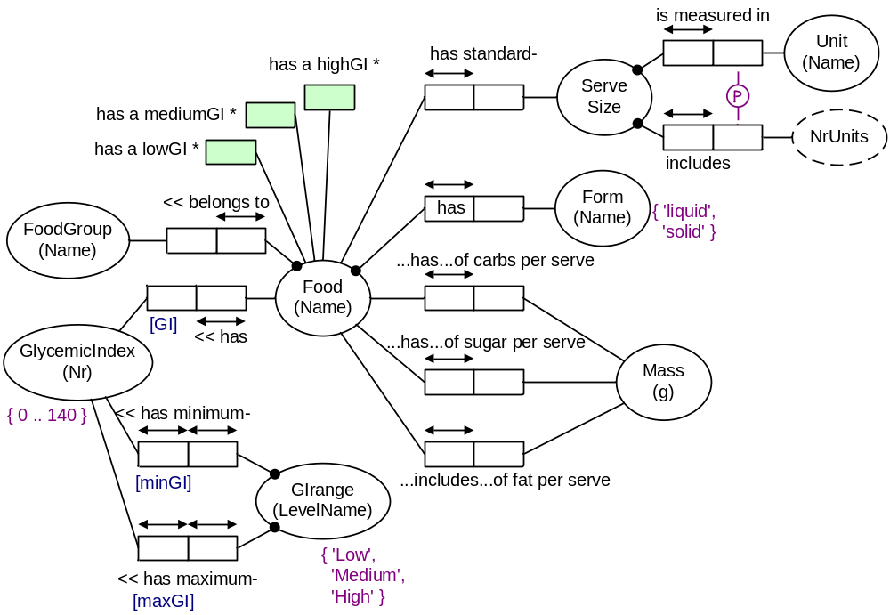
Page 1:

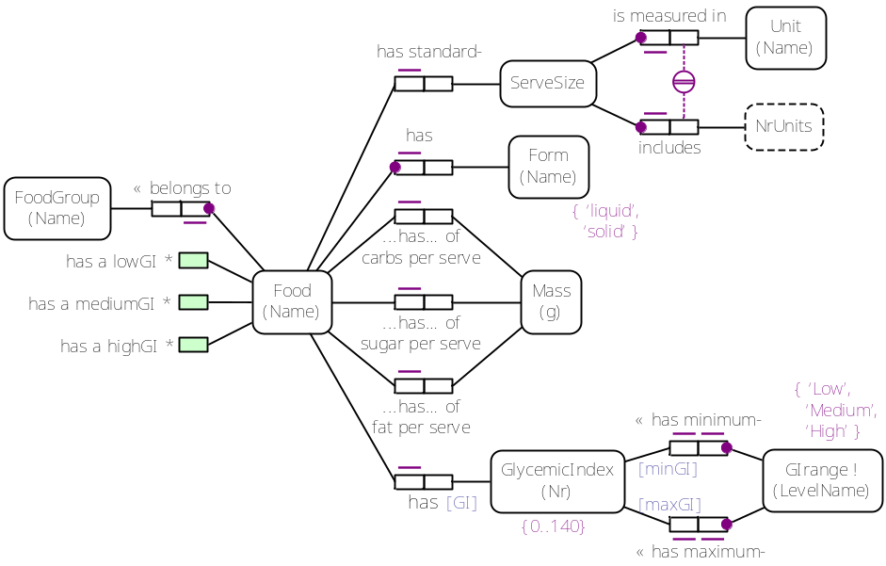

Page 2:
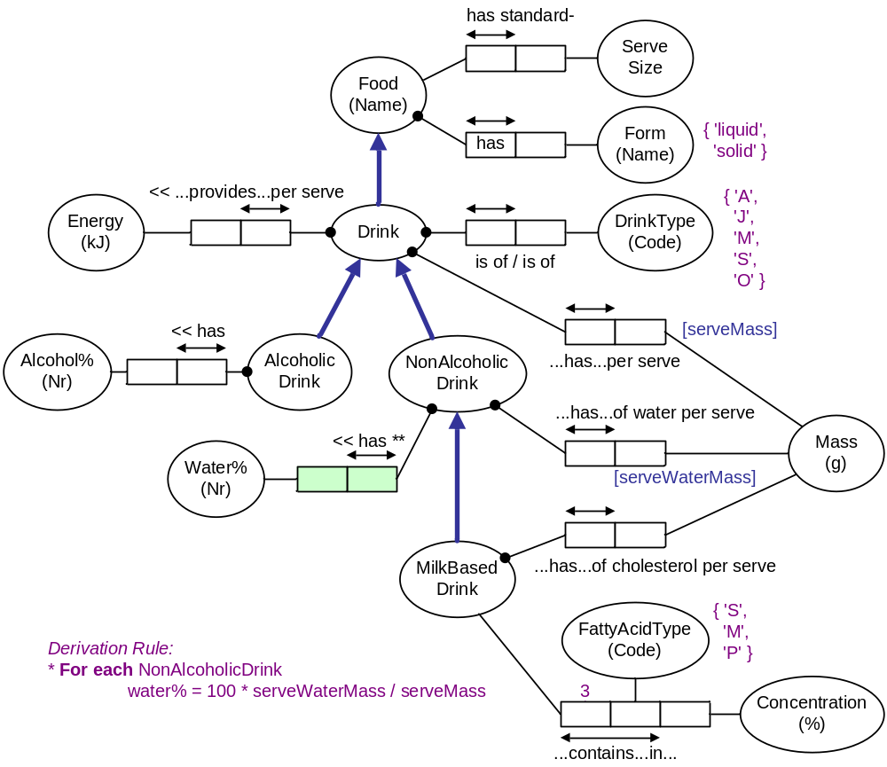

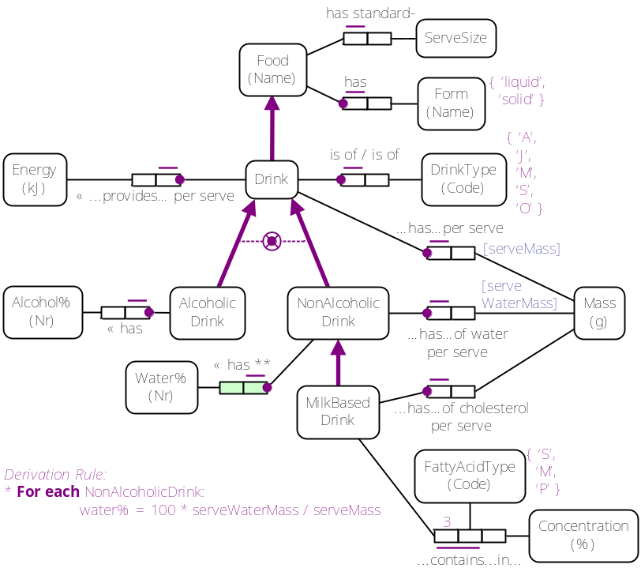

Page 3:
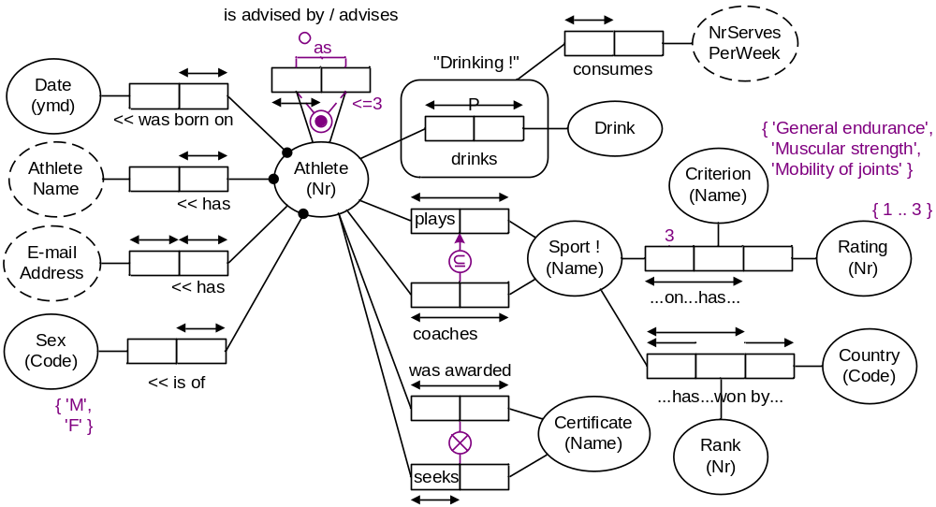

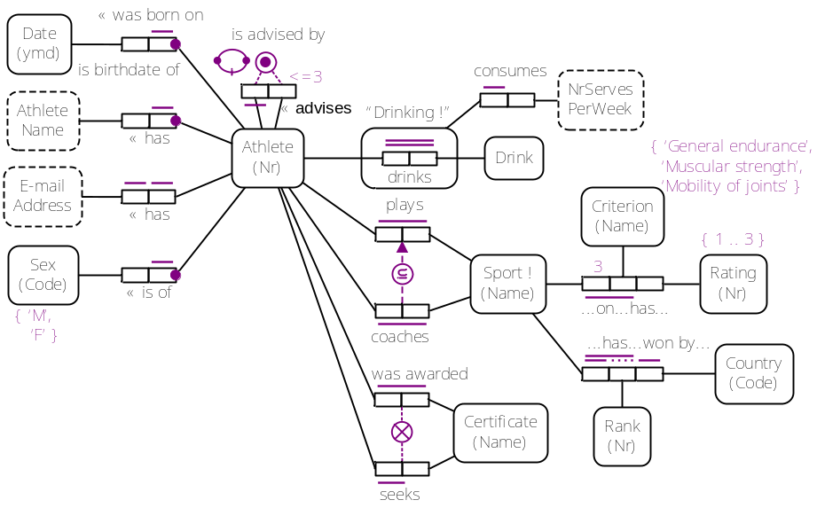

Screenshot of the ORM 2 modeling tool prototype

The following screen shot illustrates a student’s use of the ORM 2 modeling tool’s fact editor, as of early 2005 (the user interface is likely to change over time). Although the student has incorrectly modeled Address and Year as value types, and has repeated the reference scheme for Person, you can still get an idea of the interface from the screen shot. The student is in the process of entering a fourth fact type into the schema. As soon as he/she types “P”, the tool uses Intellisense to select possible completions of the type name from a drop-down list of object types. Once a fact type is entered, it may be drawn automatically.

