User Guide
Feature reference for API capture, observed call sequences, and relationship analysis.
USER GUIDE | Version 2.11.13 | Updated October 2026

Contents
- Purpose and operating model
- Live Capture and request inspection
- Troubleshooting and performance
- Visual API Flow
- API Relationships
- Settings, masking, and exports
- How capture works
- Clear results behavior
- Exporting and interpreting evidence
- Privacy, limitations, and recommended workflow
- What changed since v2.10.1
- Quick reference

1. Purpose and operating model
RUCKUS One API Inspector v2.11.13 observes the API calls your browser makes while you use the RUCKUS One web application, and helps you understand the order, shape, and timing of those calls. It is intentionally limited to capture and analysis.
- Observed call: a request/response exchange recorded during browser activity.
- Observed order: the order in which calls appear in the capture timeline.
- Workflow group: a heuristic grouping of calls that likely belong to one activity window.
- Potential relationship: a candidate link based on identifiers or other observed evidence.
- Inference: a suggested interpretation that should be validated rather than treated as fact.

2. Live Capture and request inspection

Capture traffic
- Open the RUCKUS One page and the API Inspector side panel (click the extension’s toolbar icon).
- Click Start Live Capture before reproducing the task. The button becomes Stop Live Capture and the header badge changes from CAPTURE OFF to CAPTURING.
- Use RUCKUS One normally. Requests appear in the timeline as they are observed, newest first.
- Narrow the timeline with the search box and the filters described below.
- Select a request card to expand its details: method, full URL, status, timing, source, and request/response headers and bodies where available.
- Click Stop Live Capture when you have enough evidence, or Clear results before the next test.
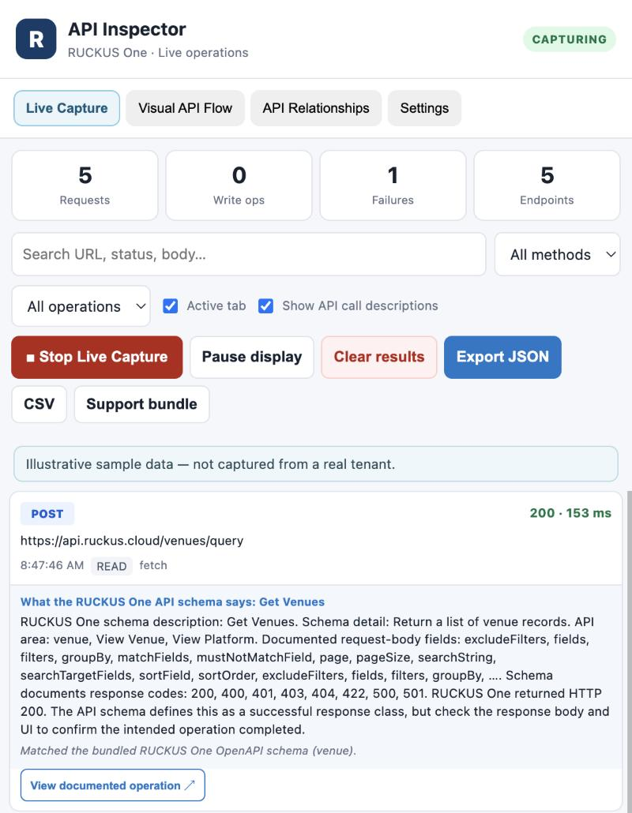
Figure 1. Live Capture: summary counters, filters, capture controls, and request cards with schema-based descriptions. Illustrative sample data.

Summary counters
Counter | Meaning
Requests | Number of captured requests currently held.
Write ops | Calls classified as likely writes (see below). POST read queries are not counted.
Failures | Responses with an error status (400 and above) or no response.
Endpoints | Distinct method + path combinations seen.

Controls and filters
Control | What it does
Search | Matches text in the URL, status, and request/response bodies.
All methods | Show only GET, POST, PUT, PATCH, DELETE, or OPTIONS requests.
All operations | Show all, Writes only, Failures only, or Likely polling requests.
Active tab | When ticked, shows only requests from the browser tab you are currently viewing.
Show API call descriptions | Adds a plain-language description of each endpoint to its card, matched against the bundled RUCKUS One API schema, with a View documented operation link.
Start / Stop Live Capture | Turns capture on or off. The setting is remembered.
Pause display | Stops the timeline from updating so you can read it while capture continues in the background. The button changes to Resume display; click it to catch up.
Clear results | Clears the captured list and the flow map after you confirm. See section 8.
Export JSON / CSV / Support bundle | Export the currently filtered requests. See section 6.

Request cards
- Each card shows the HTTP method, the status and duration, the URL, the time, a tag (READ, WRITE OP, or LIKELY POLLING), and the capture source (fetch or XHR).
- With descriptions on, the card also shows what the endpoint does according to the schema, including documented parameters and response codes. A match is labeled as exact or as a possible schema match; when the inspector cannot tell what an endpoint does, it says so rather than guessing.
- A write is PUT, PATCH, or DELETE, or a POST that is not a known read query. RUCKUS One uses POST for many reads (for example paths ending in /query, /search, /list, or /count), and those count as reads. A GraphQL POST counts as a write only if its body contains a mutation.
- Likely polling marks GET calls whose URL suggests polling (status, health, metrics, events, notifications, and similar) or that repeat five or more times.

Smart API Explorer
The explorer is a read-only reference for a captured request. Choose a request from the list to see its observed request and response structure and the JSON fields found in it. Use Copy method + endpoint, Copy sanitized cURL, or Copy Python template to take the call into your own tooling. Sanitized snippets use placeholders for credentials and redact sensitive values.

Interpreting request details
- HTTP method indicates the kind of operation; it does not prove whether server state changed.
- HTTP status is what the browser observed. Interpret it alongside the endpoint, the request, and surrounding calls.
- Duration helps find slow calls within the current capture. Browser timing is not server processing time.
- Details show only the evidence available to the extension; some headers, fields, or exchanges may not be visible, and large bodies may be truncated.

3. Troubleshooting and performance
The Troubleshooting & performance panel on the Live Capture tab summarizes the currently filtered traffic and helps narrow an investigation.
- Metrics: request count, failure count, average latency, and 95th-percentile latency.
- Findings: short notes such as failed calls, with guidance on what to inspect first. A missing response is not proof of a server failure.
- Incident Correlation: click Analyze incident to look across the filtered capture for related failures, response patterns, slow calls, empty results, and nearby requests. Findings are hypotheses supported by captured metadata, not root causes. Export incident report JSON saves them.
- Workflow Regression & Performance Baselines: enter a baseline name and click Save current baseline to keep a sanitized snapshot (endpoint metrics, status counts, and sequence metadata, without bodies). Later, capture the same workflow again, choose the baseline, and click Compare current traffic to see endpoint, status, sequence, and latency changes. Delete baseline removes it and Export regression report JSON saves the comparison. Comparison uses observations only; nothing is replayed.
- Workflow analysis: a heuristic note on write-like calls and failures in the current view.
Evidence-based diagnosis The tool highlights patterns; it is not an automatic root-cause detector. A failed request may be a symptom rather than the cause, and a slow request may reflect network conditions, browser behavior, or server processing.

4. Visual API Flow
The Visual API Flow tab turns captured traffic into a connected-node view so you can follow the observed order of calls without reading the timeline row by row. It contains the flow map and the Workflow Discovery panel.

Discover a workflow
- Capture a focused, repeatable RUCKUS One task.
- Open the Visual API Flow tab and click Discover workflows. Discovery uses all captured requests, regardless of the Live Capture filters.
- Review the discovered workflow: its time window, its steps in order, and how many steps are write-like.
- Follow the connected nodes in the map. Click a node to inspect its captured request, provided the record is still in the current capture.
- Use Copy step list to copy the sequence as text, or Export flow JSON to save the discovered flow.
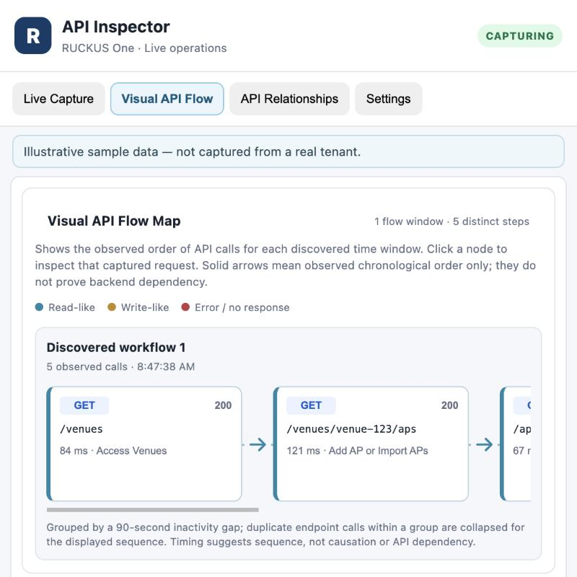
Figure 2. Visual API Flow map: a discovered workflow shown as connected nodes in observed order.
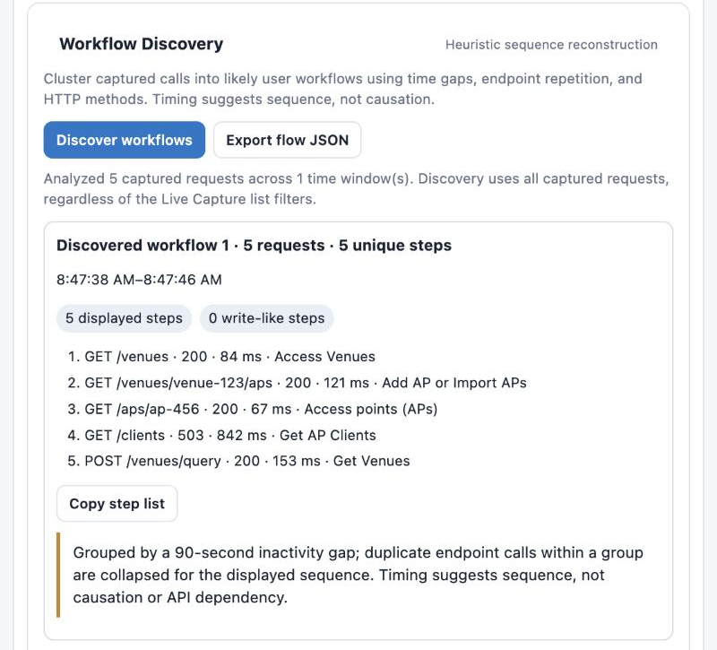
Figure 3. Workflow Discovery: the Discover workflows and Export flow JSON buttons, and the step list for a discovered workflow.

What each node shows
- HTTP method and endpoint path.
- Observed status and duration.
- A plain-language description of the endpoint when one is available.
- Color cues: read-like calls, write-like calls, and errors or no response.

Workflow grouping
Discovery groups requests into likely activity windows using an inactivity gap of about 90 seconds, and collapses repeated calls to the same endpoint within a group in the displayed sequence. This is a practical heuristic: a long-running task may be split, and unrelated activity inside one window may be grouped together.
Sequence versus dependency Connectors show observed order or a candidate relationship; they do not prove that one request is a prerequisite for another. A browser may issue independent requests in sequence or in parallel, and a UI action may trigger calls that are not causally related.

5. API Relationships
The API Relationships tab (Interactive API Dependency Mapper) analyzes captured requests and responses for potential links between calls. Click Analyze captured traffic to build it; results reflect the requests captured at that moment.
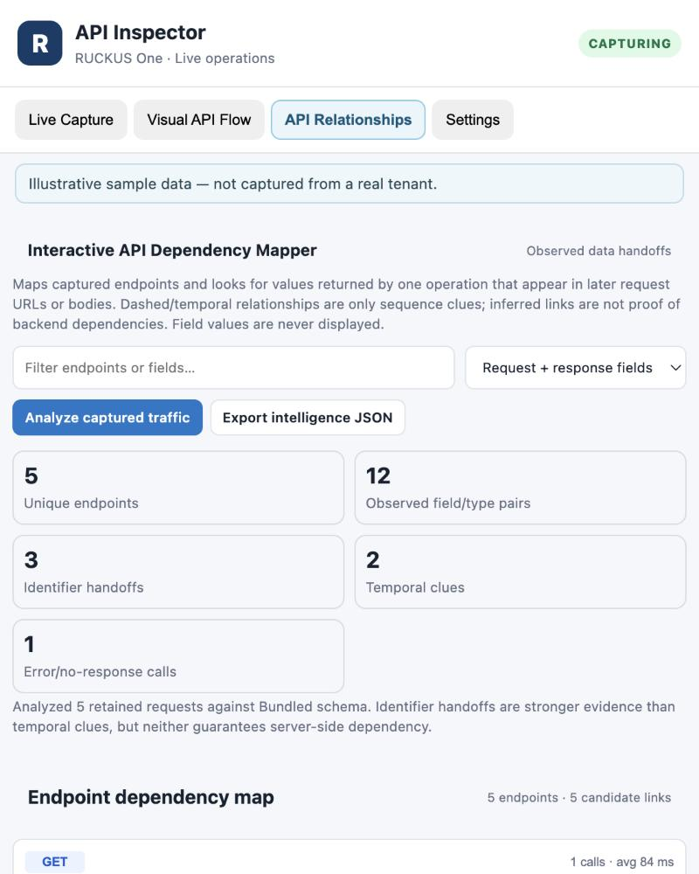
Figure 4. API Relationships: analysis counters and the endpoint dependency map. Illustrative sample data.
Result | Meaning
Unique endpoints | Distinct method + path combinations analyzed.
Observed field/type pairs | JSON field paths and value types seen across the captured calls.
Identifier handoffs | A value returned by one response that appears later in another request URL or body. Stronger evidence of a relationship.
Temporal clues | Calls that follow each other closely in time. Weaker evidence than a handoff.
Error / no-response calls | Calls in the analysis that failed.

- Endpoint dependency map: every captured endpoint with its call count, average duration, and status, followed by Candidate relationships showing the source call, the target call, and the field that links them.
- Filter the view by endpoint or field text, and choose request fields, response fields, or both with the Field scope list.
- Field Intelligence: an inventory of observed JSON fields and types. Values are never displayed, only structure. “Name indexed” means a similarly named field exists in the active bundled schema; it does not guarantee complete schema coverage.
- Export intelligence JSON saves the analysis.
- A matching identifier does not prove a server-side dependency; identifiers can be reused, coincidental, or belong to separate resources.

6. Settings, masking, and exports
The Settings tab holds three optional protections and limits. They change what is exported, or how much of each response is kept; they do not change the requests themselves. All three start at their original behavior.
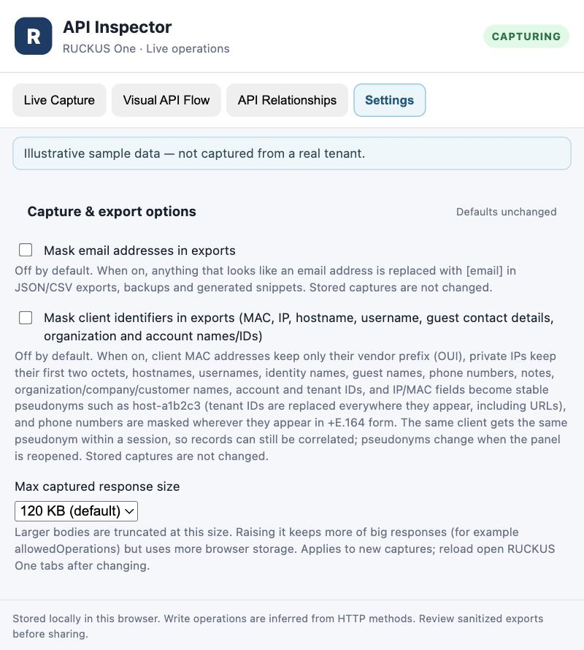
Figure 5. Settings tab: capture and export options.

Mask email addresses in exports
Off by default. When on, anything that looks like an email address is replaced with [email] in exports, backups, and generated snippets.

Mask client identifiers in exports
Off by default. When on, exports replace identifying values with stable pseudonyms so records stay correlatable without revealing the original:
Data | Result in the export
Client MAC addresses | Vendor prefix (OUI) kept; the last three octets become a pseudonym.
Private IPv4 addresses (10.x, 172.16–31.x, 192.168.x) | First two octets kept; the rest becomes a pseudonym. Public IPs and version numbers are left alone.
Hostnames, usernames, identity and group names, device and client names | Pseudonyms such as host-a1b2c3 or user-9z8y7x.
Guest contact details: names, phone numbers, notes, host-approval emails | Pseudonyms; +E.164 phone numbers are masked wherever they appear. A generic name field is masked only inside guest-style records, so venue, WLAN, and SSID names stay readable.
Organization, customer, and account data: company and tenant names, account, entitlement, user, and tenant IDs, tenant contact emails | Pseudonyms. Tenant IDs are replaced everywhere they appear, including in URLs.

The same value gets the same pseudonym within one panel session, so you can still see that two records involve the same client. Pseudonyms change when you reopen the panel.

Max captured response size
Response bodies larger than the limit are truncated when captured: 120 KB (default), 500 KB, 1 MB, or 2 MB. Raise it if an important response is cut off, remembering that larger limits use more browser storage. The setting applies to new captures; reload any open RUCKUS One tabs after changing it.
Masking is not a guarantee Masking covers the named fields and patterns only. Other names, free-text fields, venue and SSID names, and resource IDs remain readable. Always read an export before sharing it.

What each export contains
Export | Contents
Export JSON | The currently filtered requests plus a summary, sanitized.
CSV | Timestamp, method, URL, status, status text, duration, source, page URL, headers, and bodies for the filtered requests.
Support bundle | Summary, per-endpoint statistics, discovered workflows, baselines, and the filtered request records, for sharing with support.
Export flow JSON | The discovered workflow groups and steps.
Export intelligence JSON | Endpoint, field, and relationship analysis.
Incident / regression report JSON | Correlation findings or baseline comparison results.

7. How capture works
- Where: only pages on ruckus.cloud, and only their page fetch and XHR traffic. Requests from iframes, and requests made before capture was turned on, are not recorded.
- What is skipped: static files (such as locale bundles and config JSON) and feature-flag service calls, so the timeline stays focused on API calls.
- What is redacted: authorization headers, cookies, and common token, password, and secret fields (including values in URLs) are replaced with [REDACTED] at capture time and again at export.
- Storage: captures are stored locally in the browser and limited to the most recent 5,000 requests. Nothing is sent anywhere by the extension.
- Impact on the page: capture reads responses from a copy, so it does not hold up the page’s own requests, including streaming responses.

8. Clear results behavior
Clear results resets the current investigation so the next capture starts cleanly. It asks for confirmation first.
When you click Clear results | Behavior
Captured request list | Cleared.
Visual API Flow map | Cleared.
Discovered workflow details | Cleared.
Live capture ON/OFF state | Preserved; clearing does not toggle capture.
Saved performance baselines | Preserved.
Settings (masking options, size limit) | Preserved.

After clearing, the map stays empty until you capture new requests and discover workflows again. If capture was ON, new requests begin filling the timeline immediately.

9. Exporting and interpreting evidence
- Export only the minimum evidence needed to answer the question.
- Turn on the masking options in Settings before you export for anyone outside your team, then read the file.
- Exports follow the current filters, so check them before exporting.
- Keep the distinction between observed facts and inferred relationships in any report you write.
- A JSON flow export is data for analysis, not an API playback file.

10. Privacy, limitations, and recommended workflow

Privacy and safe handling
- Captured traffic can contain tenant, customer, and client information. Treat browser profiles, exports, and screenshots as sensitive operational data.
- Do not share credentials, access tokens, or customer-specific details without authorization.
- Use a test tenant for workflows that may involve configuration changes.

Technical and interpretation limits
- The extension sees page fetch/XHR traffic only; iframes and traffic before capture started are not observed.
- Some request/response details may be unavailable, redacted, or truncated at the size limit.
- Workflow grouping and relationship detection are heuristic; observed call order is not proof of backend causality.
- Write classification is inferred from the method and path, not confirmed from the response.
- A tenant ID is replaced in an export only once the extension has seen it; customer tenant IDs come from the delegation response, so an earlier record could keep one if that response was not captured.
- The extension does not replay or execute API sequences.

Recommended investigation pattern
- Define one question and one RUCKUS One workflow to investigate.
- Start capture, reproduce the task, and avoid unrelated navigation.
- Inspect key requests and note status, timing, and field structure.
- Discover workflows and review the Visual API Flow map.
- Use API Relationships to look for identifier handoffs.
- Repeat the capture if you need to confirm a suspected pattern.
- Choose your masking options, export the evidence, and review it.
- Click Clear results before the next test; saved baselines remain.

Quick reference
Area | Use it for
Live Capture | Observe and inspect calls; explain endpoints; check failures and latency; save and compare baselines.
Visual API Flow | Discover call sequences and view the flow map; export the discovered flow.
API Relationships | Investigate identifier handoffs and observed JSON field structures.
Settings | Mask emails and client/organization identifiers in exports; set the captured response size limit.
Clear results | Reset the current requests and flow without changing capture ON/OFF state.

