RUCKUS ONE

Getting Started
Install the extension and capture your first RUCKUS One API workflow.
QUICK START | Version 2.10.1 | Updated October 2026

1. What this tool is for
RUCKUS One API Inspector is a browser extension for observing API traffic generated while you use RUCKUS One. Its focus is to show which calls are in use, their observed order, their request/response characteristics, and likely relationships between calls.
Scope This is a capture and analysis tool. It does not build recipes, replay API sequences, or automate API changes.

2. Install in Chrome or Edge
- Download and extract the RUCKUS One API Inspector v2.10.1 ZIP.
- Open chrome://extensions in Chrome or edge://extensions in Edge.
- Enable Developer mode.
- Choose Load unpacked and select the extracted ruckus_one_api_inspector folder—the folder that contains manifest.json.
- Open or reload your RUCKUS One tab, then open the extension side panel from the browser’s extension controls.
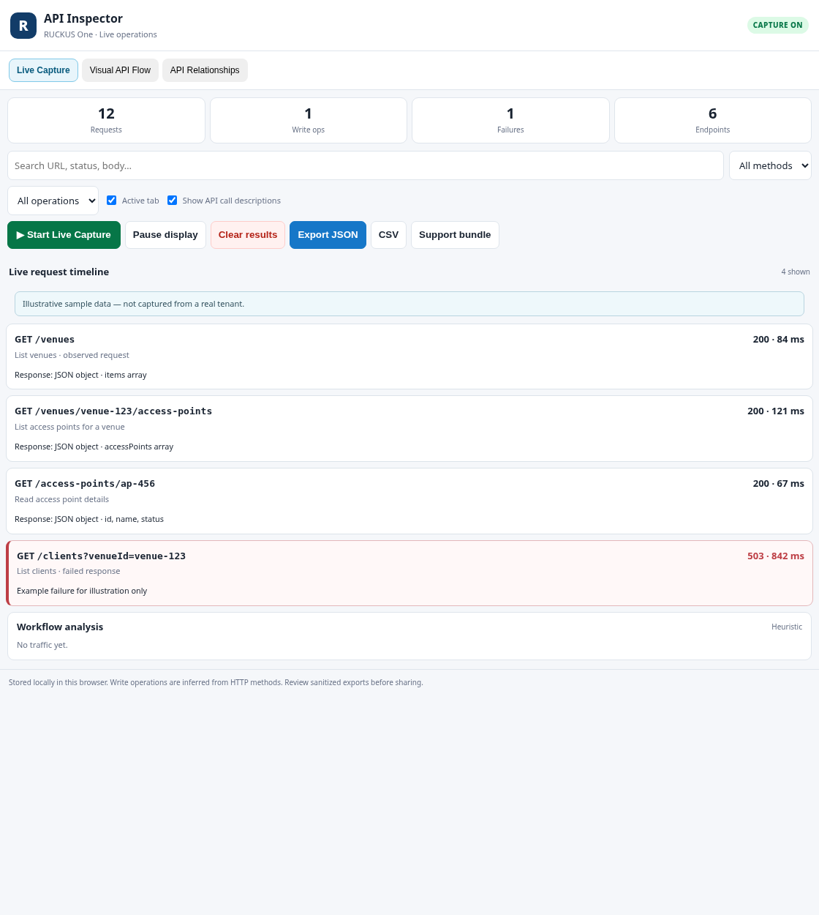
Figure 1. Example extension side panel and main navigation. The screenshot uses illustrative sample data; it is not the browser extensions installation page.
Updating Keep the new release in its own folder until it loads successfully. Reload the extension and the RUCKUS One tab after installing. Keep any exports you need before replacing an older build.

3. Capture your first workflow
- Sign in to your intended RUCKUS One tenant normally. A test tenant is best for repeatable investigations.
- Open API Inspector and select Start Live Capture.
Figure 2. Live Capture with example requests, response status, and duration. Sample values are illustrative.
- Perform one focused task, such as opening a venue and viewing its AP list. Keep the first capture small and repeatable.
- Review the Live Capture timeline. Filter or search the captured requests to narrow the list.
- Select an API call to inspect its method, endpoint, status, timing, and available request/response details.
- Open Workflow Flow and select Discover workflows to group calls into likely activity windows.
- Review the Visual API Flow map. Select a node to jump to the corresponding captured request for inspection.
- When finished, stop live capture if desired or use Clear Capture before starting a new investigation.

4. Understand the Visual API Flow map
The map presents captured API calls as nodes connected in observed chronological order. Each node can show the HTTP method, endpoint path, HTTP status, duration, and an endpoint interpretation where available. Color cues help distinguish read-like calls, write-like calls, and failures.
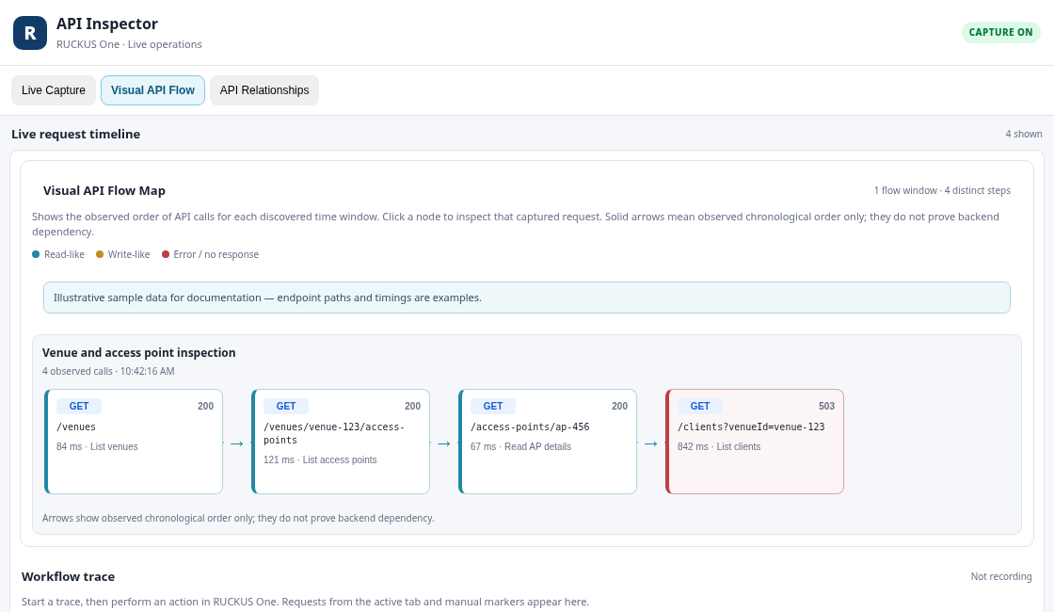
Figure 3. Visual API Flow map showing a sample sequence of observed calls.
- Select a node to inspect its captured request when that record is still available.
- Use the map to follow the call order associated with a UI task and identify where a failure or slow call occurred.
- Workflow grouping uses an inactivity gap of about 90 seconds to separate activity windows.
- Use the map as evidence of observed order, not proof that one API call depends on another.
Clear Capture in v2.10.1 Clear Capture clears the captured request list, the Visual API Flow map, and discovered workflow details. It preserves whether live capture is currently ON or OFF. Saved workflow traces and performance baselines are preserved.

5. The three main areas
Area | Purpose
Live Capture | Capture and filter API requests; inspect status, timing, endpoint, and request/response details.
Workflow Flow | Discover likely call sequences, use manual action markers, and view the connected-node API flow map.
API Relationships | Explore potential identifier handoffs and observed JSON field structures across captured calls.

6. A repeatable investigation
- ☐ Write down the exact UI task you are testing.
- ☐ Start capture before performing the task.
- ☐ Perform the task once, without unrelated navigation.
- ☐ Identify the key calls and their observed order.
- ☐ Inspect failures, slow calls, and request/response field shapes.
- ☐ Discover workflows and review the Visual API Flow map.
- ☐ Export only the evidence you need and review it before sharing.
- ☐ Clear Capture before the next test if you want a clean flow.

7. Troubleshooting

The extension does not appear
- Confirm you selected the folder that directly contains manifest.json.
- Check the browser extension page for load errors.
- Reload the extension, then reload the RUCKUS One tab.

No calls appear
- Confirm Start Live Capture is active.
- Navigate or refresh the RUCKUS One page after capture starts.
- The tool focuses on page fetch/XHR traffic and may not see every network exchange.
- Try a single known UI action and check whether the timeline updates.

The flow map is empty
- Capture requests first; the map is based on observed calls, not a generated sample workflow.
- Open Workflow Flow and run Discover workflows.
- If you just used Clear Capture, the empty map is expected until new requests are captured and workflows are rediscovered.

The flow arrows seem to imply a dependency
Arrows indicate observed sequence or a candidate relationship. They do not establish backend causality. Validate a suspected dependency with repeated captures and appropriate testing.

8. Privacy and safe handling
- Captured traffic and exports may reveal tenant names, resource identifiers, configuration details, or operational patterns.
- Review JSON, CSV, and support exports before sharing them.
- Do not share access tokens, credentials, or sensitive tenant information.
- Use an approved test tenant when investigating workflows that may alter configuration.

