RUCKUS ONE

User Guide
Feature reference for API capture, observed call sequences, and relationship analysis.
USER GUIDE | Version 2.10.1 | Updated October 2026

Contents
- Purpose and operating model
- Live Capture and request inspection
- Visual API Flow map
- Workflow Flow and manual trace markers
- API Relationships
- Troubleshooting and performance analysis
- Clear Capture behavior
- Exporting and interpreting evidence
- Privacy, limitations, and recommended workflow

1. Purpose and operating model
RUCKUS One API Inspector v2.10.1 is designed to observe API calls generated by the RUCKUS One web application and help engineers understand the order and shape of those calls. The product is intentionally limited to capture and analysis.
- Observed call: a request/response exchange recorded during browser activity.
- Observed order: the order in which calls appear in the capture timeline.
- Workflow group: a heuristic grouping of calls that likely belong to one activity window.
- Potential relationship: a candidate link based on identifiers or other observed evidence.
- Inference: a suggested interpretation that should be validated rather than treated as a fact.
Not included API recipes, API sequence playback, controlled sequence execution, execution history, rollback planning, documentation/playbook generation, Partner Lab Mode, projects/backups, and recipe authoring are outside the scope of this capture-focused release.

2. Live Capture and request inspection

Capture traffic
- Open the RUCKUS One page and the API Inspector side panel.
- Select Start Live Capture before reproducing the task.
- Use the application normally. Captured requests should appear in the timeline as they are observed.
- Use available search and filters to narrow the timeline by endpoint, method, or outcome.
- Select a request to inspect its details, including method, endpoint path, status, timing, and available request/response structure.
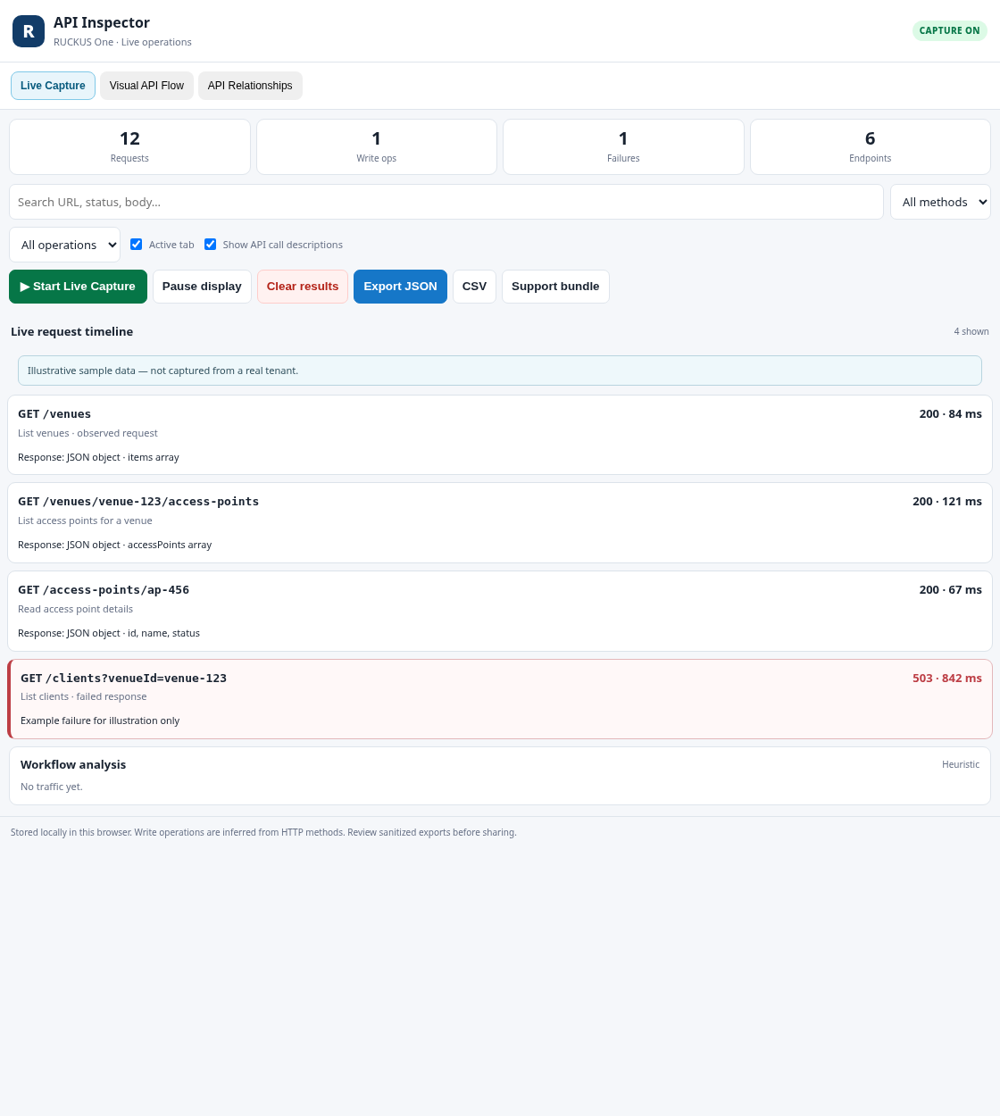
Figure 1. Live Capture timeline with illustrative sample requests. Values are examples, not tenant data.
- Stop capture when you have enough evidence, or clear the current capture before the next test.

Interpreting request details
- HTTP method gives a broad indication of operation type; it does not alone prove whether the action changed server state.
- HTTP status describes the response observed by the browser. Interpret it alongside the endpoint, request, and surrounding calls.
- Duration helps identify relatively slow calls in the current capture. Browser timing may not equal server processing time.
- Request/response details show the evidence available to the extension. Some headers, fields, or exchanges may not be visible.

3. Visual API Flow map
The Visual API Flow map turns a captured workflow into a connected-node view so engineers can follow the observed order of API calls without reading the entire timeline row by row.
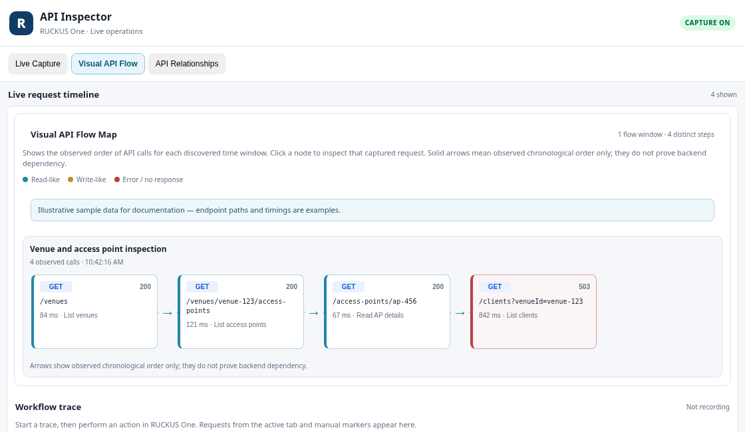
Figure 2. Visual API Flow map showing observed call order. Sample paths and timings are illustrative.

What each node shows
- HTTP method and endpoint path.
- Observed HTTP status and request duration when available.
- A plain-language endpoint interpretation when one is available.
- Visual cues that help distinguish read-like calls, write-like calls, and failures.

Using the map
- Capture a focused RUCKUS One task.
- Open Workflow Flow and choose Discover workflows.
- Review the connected nodes in the Visual API Flow map.
- Follow the connectors to understand the observed chronological sequence.
- Select a node to inspect its corresponding captured request, provided the record remains in the current capture.
- Use the map to locate the calls around an error, a slow response, or a notable change in response structure.
Sequence versus dependency Connectors show observed order or a candidate relationship; they do not prove that one request is a prerequisite for another. A browser may issue independent requests in sequence or in parallel, and a UI action may trigger calls that are not causally related.

Workflow grouping
Workflow discovery groups requests into likely activity windows. The current grouping behavior uses an inactivity gap of approximately 90 seconds. This is a practical heuristic: a long-running task may be split, and unrelated activity within the same window may be grouped together.

4. Workflow Flow and manual trace markers
Workflow Flow is where you discover likely call sequences and use manual markers to connect your own actions with the captured timeline.

Discover a workflow
- Start capture and perform one repeatable UI task.
- Choose Discover workflows.
- Review the proposed groups and their request order.
- Compare the proposed flow with the actual UI actions you performed.
- Use the Visual API Flow map to inspect the sequence and select individual calls for details.

Use manual trace markers
When manual workflow tracing is available in the current panel, start a trace, add a marker at meaningful user actions, and stop the trace after reproducing the task. Markers help correlate actions with nearby requests; they do not prove causality.

5. API Relationships
API Relationships analyzes captured requests and responses for potential links between calls, including identifier values in responses that appear in later request paths or bodies, and repeated JSON field paths.
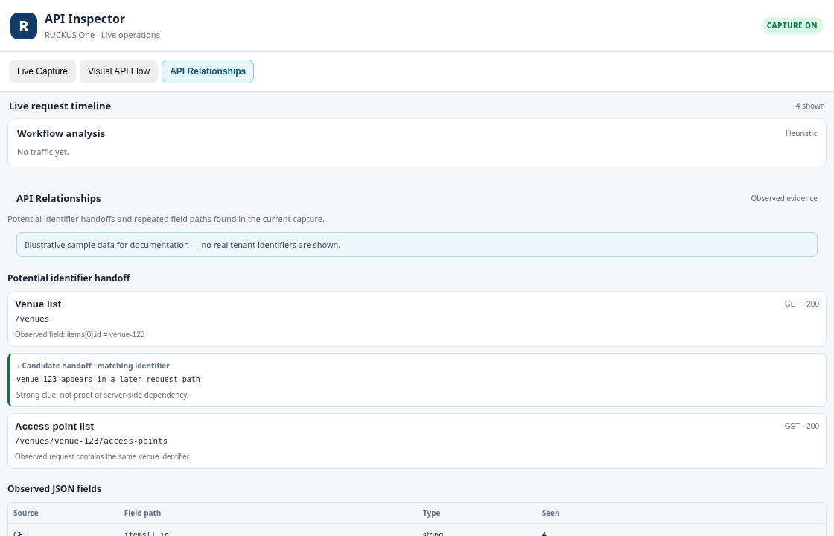
Figure 3. API Relationships view showing a candidate identifier handoff and observed JSON fields.
- Identifier matches can suggest that one response provides an identifier used by a later request.
- Temporal proximity can help find candidate relationships but is weaker evidence than an exact identifier match.
- Field analysis can show observed JSON paths and types across captured calls.
- A matching identifier does not prove a server-side dependency; identifiers can be reused, coincidental, or associated with separate resources.

6. Troubleshooting and performance analysis
Use captured status codes, timing, and call order to narrow a troubleshooting investigation.
- Find failed requests and inspect nearby calls for context.
- Compare durations to identify calls that are unusually slow within the same capture.
- Look for repeated requests or empty results that may help explain the observed UI behavior.
- Use the flow map to see where a failure occurred in the observed sequence.
- Repeat the same UI action in a clean capture to determine whether the pattern is reproducible.
Evidence-based diagnosis The tool highlights patterns; it is not an automatic root-cause detector. A failed request may be a symptom rather than the cause, and a slow request may be affected by network conditions, browser behavior, or server processing.

7. Clear Capture behavior in v2.10.1
Clear Capture is intended to reset the current investigation so the next capture starts cleanly.
When you select Clear Capture | Behavior
Captured request list | Cleared.
Visual API Flow map | Cleared.
Discovered workflow details | Cleared.
Live capture ON/OFF state | Preserved; clearing does not toggle capture.
Saved workflow traces | Preserved.
Performance baselines | Preserved.
After clearing, the map remains empty until you capture new requests and discover workflows again. If live capture was ON, new requests can begin filling the timeline immediately.

8. Exporting and interpreting evidence
Where export controls are available, use JSON or CSV to preserve captured evidence for analysis. Workflow discovery may provide a flow JSON export. Export options depend on the current view.
- Export only the minimum evidence needed to answer the question.
- Review files before sharing them; endpoint paths, identifiers, tenant names, and configuration details may be sensitive.
- Keep the distinction between observed facts and inferred relationships in any report you prepare.
- A JSON flow export is data for inspection and analysis, not an API playback file.

9. Privacy, limitations, and recommended workflow

Privacy and safe handling
- Captured traffic may contain sensitive tenant and resource information.
- Treat browser profiles, exports, and screenshots as potentially sensitive operational data.
- Do not share credentials, access tokens, or customer-specific details without authorization.
- Use a test tenant for workflows that may involve configuration changes.

Technical and interpretation limits
- The extension focuses on browser page fetch/XHR traffic and may not observe every network exchange.
- Some request/response details may be unavailable or sanitized.
- Workflow grouping and relationship detection are heuristic.
- Observed call order is not proof of backend causality or API dependency.
- The extension does not replay or execute API sequences.

Recommended investigation pattern
- Define one question and one UI workflow to investigate.
- Start capture, reproduce the task, and avoid unrelated navigation.
- Inspect key requests and note status, timing, and field structure.
- Discover workflows and review the Visual API Flow map.
- Use API Relationships to investigate possible identifier handoffs.
- Repeat the capture if you need to confirm a suspected pattern.
- Clear Capture before the next test, remembering that saved traces and baselines remain.

Quick reference
Area | Use it for
Live Capture | Observe and inspect API calls made by RUCKUS One.
Workflow Flow | Discover call sequences, add manual markers, and view the Visual API Flow map.
API Relationships | Investigate candidate identifier handoffs and JSON field structures.
Clear Capture | Reset current requests and flow details without changing capture ON/OFF state.

