RUCKUS ONE

Getting Started
Install the extension and capture your first RUCKUS One API workflow.
QUICK START | Version 2.11.12 | Updated October 2026

1. What this tool is for
RUCKUS One API Inspector is a browser extension for observing the API traffic your browser generates while you use RUCKUS One. It shows which calls are made, the order they were observed in, their request and response characteristics, and likely relationships between calls.
Scope This is a capture and analysis tool. It does not build recipes, replay API sequences, or change your tenant. It records page traffic passively, only on RUCKUS One pages (ruckus.cloud and ruckusone.com), and keeps everything locally in your browser. The side panel itself makes no outbound network calls.

2. Install in Chrome or Edge
- Download the latest package, ruckus_one_api_inspector_chrome_v2.11.12.zip, from the GitHub repository (TerryHenry/ruckus-one-api-inspector) and extract it.
- Open chrome://extensions in Chrome or edge://extensions in Edge.
- Turn on Developer mode.
- Choose Load unpacked and select the extracted ruckus_one_api_inspector folder — the folder that directly contains manifest.json.
- Open or reload your RUCKUS One tab, then click the extension’s toolbar icon. The API Inspector side panel opens.
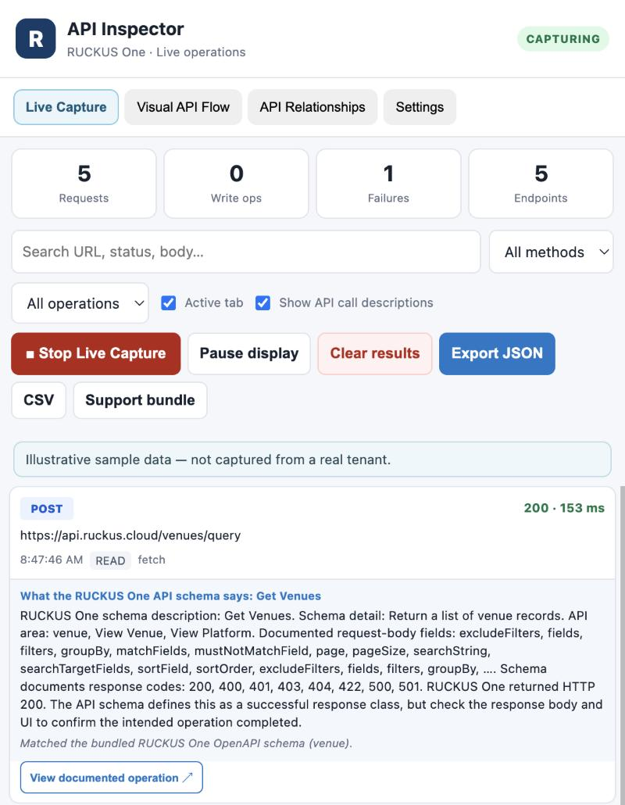
Figure 1. The side panel after install: the four tabs (Live Capture, Visual API Flow, API Relationships, Settings), summary counters, filters, and capture controls. Screenshots use illustrative sample data, not tenant data.
Updating Keep a new release in its own folder until it loads successfully, then reload the extension at chrome://extensions and reload your RUCKUS One tab. Export anything you need first: your captured requests live in the browser’s extension storage, and removing the old build can discard them.

3. Capture your first workflow
- Sign in to your intended RUCKUS One tenant as usual. A test tenant is best for repeatable investigations.
- Open the API Inspector side panel and click Start Live Capture. The button changes to Stop Live Capture and the badge in the header reads CAPTURING.
- Perform one focused task in RUCKUS One, such as opening a venue and viewing its AP list. Keep the first capture small and repeatable.
- Watch the Live Capture timeline fill in. Use the search box, the method and operation filters, and the Active tab checkbox to narrow it down.
- Select a request card to inspect its method, endpoint, status, timing, and request/response details. With Show API call descriptions on, each card also explains what the endpoint does, using the bundled RUCKUS One API schema.
- Open the Visual API Flow tab and click Discover workflows to group the calls into likely activity windows.
- Review the flow map. Click a node to jump to the captured request behind it.
- When you are done, click Stop Live Capture, or Clear results before starting a new investigation.
Tip Capture only records traffic while it is ON. Start capture first, then navigate. Requests the page made before you started are not recorded.

4. Read the Visual API Flow map
The map shows captured calls as nodes joined in observed chronological order. Each node can show the HTTP method, endpoint path, status, duration, and a plain-language description of the endpoint. Color cues separate read-like calls, write-like calls, and errors.
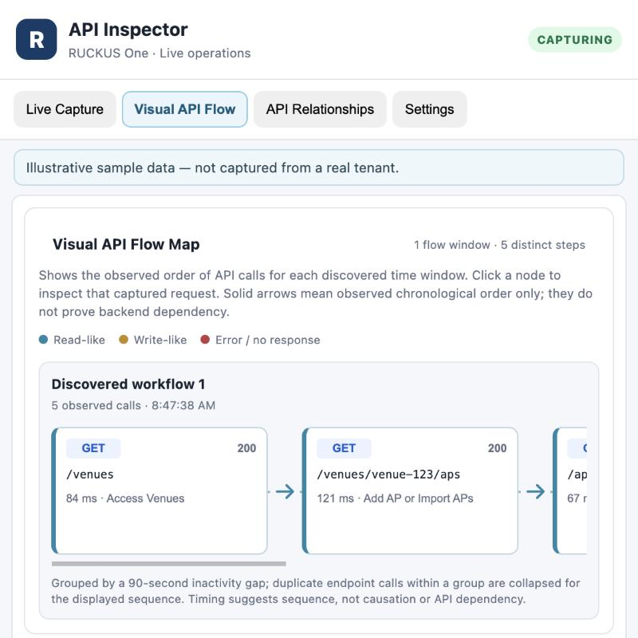
Figure 2. Visual API Flow map: a discovered workflow shown as connected nodes in observed order.
- Select a node to inspect its captured request while that record is still in the current capture.
- Use the map to follow the call order behind a UI task and to spot where a failure or slow call happened.
- Calls are grouped into a workflow when they occur within about 90 seconds of each other; repeated calls to the same endpoint in a group are collapsed in the displayed sequence.
- Treat the map as evidence of observed order, not proof that one call depends on another.
Clear results Clear results asks you to confirm, then clears the captured request list, the flow map, and the discovered workflow details. It does not change whether live capture is ON or OFF, and saved performance baselines are kept.

5. The four main areas
Tab | Purpose
Live Capture | Capture and filter requests; inspect status, timing, and details; explain endpoints; check failures and latency; compare against saved baselines.
Visual API Flow | Discover likely call sequences and view them as a connected-node map. Export the discovered flow as JSON.
API Relationships | Find candidate identifier handoffs between calls and see the JSON field structures observed across captured traffic.
Settings | Optional export protections (mask emails, mask client and organization identifiers) and the maximum captured response size.

6. Share captures safely (Settings tab)
Captured traffic can contain tenant, customer, and client information. Before you share an export, open the Settings tab. All three options are off by default and change what you export, not what is stored.
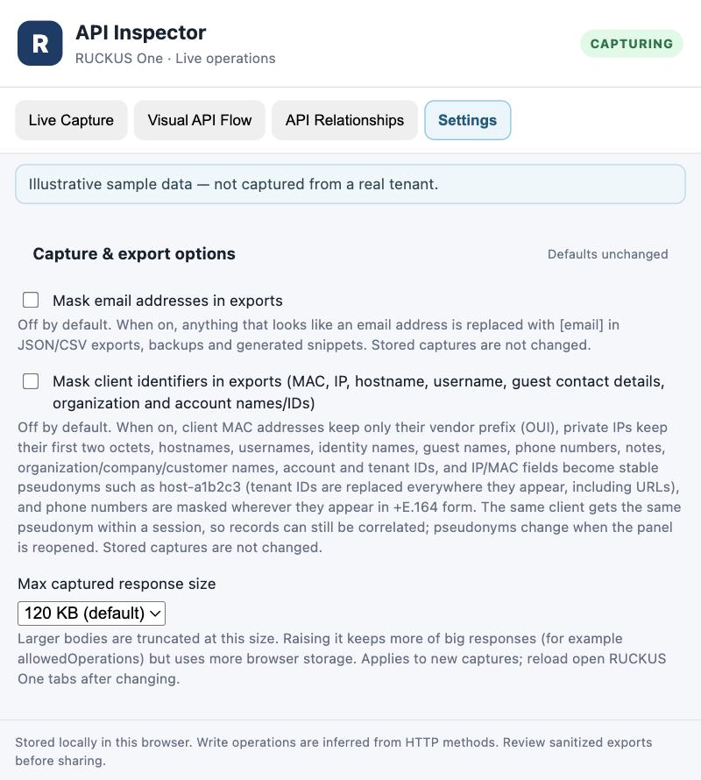
Figure 3. Settings tab: capture and export options.
Option | What it does
Mask email addresses in exports | Replaces anything that looks like an email address with [email].
Mask client identifiers in exports | Replaces client MAC addresses (vendor prefix kept), private IPs (first two octets kept), hostnames, usernames, guest names, phone numbers, notes, organization and customer names, and account and tenant IDs with stable pseudonyms such as host-a1b2c3. Tenant IDs are replaced everywhere, including URLs.
Max captured response size | Response bodies larger than this are truncated: 120 KB (default), 500 KB, 1 MB, or 2 MB. Applies to new captures; reload open RUCKUS One tabs after changing it. Larger limits use more browser storage.

Still review every export Masking covers the named fields only. Venue, WLAN, and SSID names, resource IDs, and free-text fields stay readable, so read an export before it leaves your hands.

7. A repeatable investigation
- ☐ Write down the exact UI task you are testing.
- ☐ Click Start Live Capture before performing the task.
- ☐ Perform the task once, without unrelated navigation.
- ☐ Identify the key calls and their observed order.
- ☐ Inspect failures, slow calls, and request/response field shapes.
- ☐ Discover workflows and review the Visual API Flow map.
- ☐ Turn on the masking options you need, then export only the evidence required.
- ☐ Click Clear results before the next test if you want a clean flow.

8. Troubleshooting

The extension does not appear
- Confirm you selected the folder that directly contains manifest.json.
- Check chrome://extensions for load errors on the extension’s card.
- Reload the extension, then reload the RUCKUS One tab.

No calls appear
- Confirm capture is ON: the button should read Stop Live Capture and the header badge should read CAPTURING.
- Navigate or refresh the RUCKUS One page after capture starts; earlier traffic is not recorded.
- Only pages on ruckus.cloud and ruckusone.com are captured, and only their page fetch/XHR traffic. Requests from iframes and requests the page made before capture began are not seen.
- Static files (such as locale or config JSON) and feature-flag service calls are filtered out on purpose.
- Check the Active tab checkbox: when it is ticked, the timeline shows only the tab you are looking at.
- Check the filters: a search term, method, or operation filter can hide requests.

The flow map is empty
- Capture requests first; the map is built from observed calls.
- Open the Visual API Flow tab and click Discover workflows.
- After Clear results the map stays empty until new requests are captured and workflows are discovered again.

A response body looks cut off
- Bodies are truncated at the maximum captured response size (120 KB by default). Raise it in Settings, then reload the RUCKUS One tab and capture again.

The flow arrows seem to imply a dependency
Arrows show observed sequence or a candidate relationship. They do not establish backend causality. Validate a suspected dependency with repeated captures and appropriate testing.

9. Privacy and safe handling
- Authorization headers, cookies, and common token, password, and secret fields are redacted when traffic is captured and again when you export.
- Captures and exports can still reveal tenant and customer names, IDs, client MAC and IP addresses, and configuration details. Use the Settings masking options and review exports before sharing.
- Do not share access tokens, credentials, or customer-specific information without authorization.
- Use an approved test tenant when investigating workflows that might change configuration.
- Captures are stored locally in this browser and are limited to the most recent 5,000 requests.

