

DeskLogs User Guide

Version 1.0

Created August 8, 2016

# General Overview

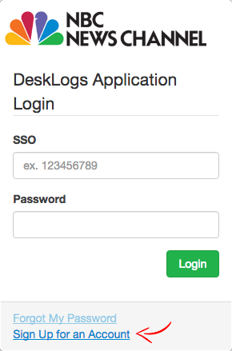This guide is designed as a starting point for using the NBC News Channel DeskLogs Application. The following guidelines will help you to sign up, log in, and get started using this application as a part of your daily workflow.

## Signing Up

When you first access this site, you will need to sign up in order to use the application. To access the Sign Up page, click on the “Sign Up for an Account” link found on the **Login** page.

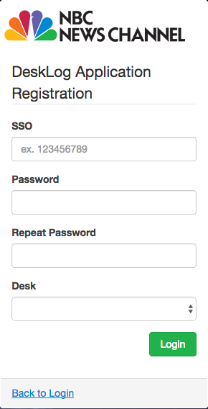Once you are on the Sign Up page, fill out the required information and click on **Login** to create your account and log in.

SSO**:**  Your NBC SSO.

Password: Unique password, must be at least 8 characters long.

Desk**:** Your desk assignment. This is used for delivering desk specific notifications to you directly.

*Please note, this application connects to our VOD Manage page to look up your name, email address and phone number. You must have a Manage page login to use this app.

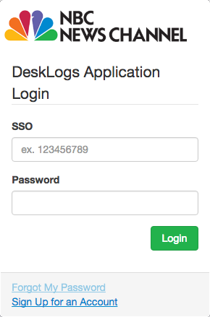

## Logging In

From the **Login** page, enter your SSO and DeskLogs password to log into the application.

After logging into the application, you will be redirected to the Incoming Tab in the DeskLogs panel.

If are unable to login or have forgotten your password, click on the “Forgot My Password” link. You will be redirected to a page with

## Application Structure and Intended Workflow

### Desks

### Lists

### Logs

## Changing the Current Working Date

## Changing Account Settings

# Troubleshooting

# Frequently Asked Questions