EEE 4482 Server Installation and Programming
Worksheet 7a – Writing REST API in PHP for Database Application
Objective: To familiarize the steps in writing API in PHP to access Maria database

Tools: Windows PC

Software: Oracle VM Virtual Box version 6.1.12
CentOS 7
Filezilla
Notepad++
Anaconda

Topics covered:
- Writing HTML pages
- Writing REST API in PHP
- Accessing Maria database using PHP

Component list:
mCentos7min-trial01_PHP7_AfterWS7.zip - A virtual machine zip file with Apache, MariaDB and PHP installed

Testing the installation of PHP server
- Download and unzip the provided virtual machine zip file.
- Open Oracle VM Virtual Box. Open the unzipped virtual machine.
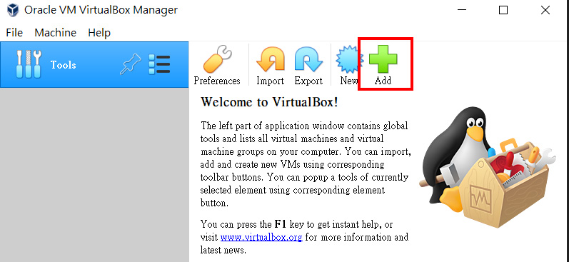

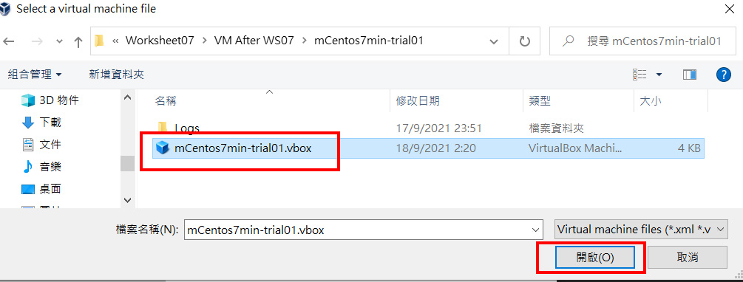
- We need to change the MAC address of the network card inside the virtual machine. Highlight the added virtual machine and press the “Settings” button.
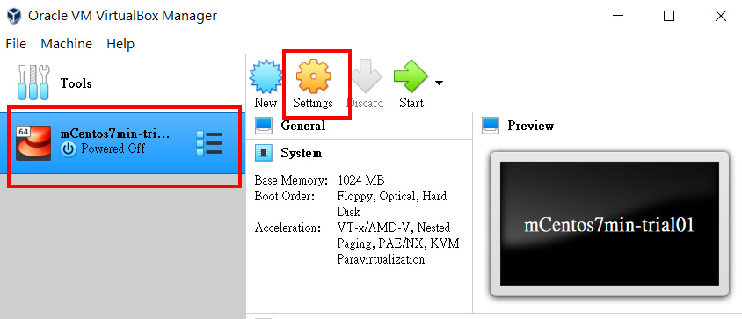
Select the “Network”. Click the “Advanced” word. In the line “MAC Address”, press the “Generates a new random MAC address” button as shown below. Finally, press “OK” button.
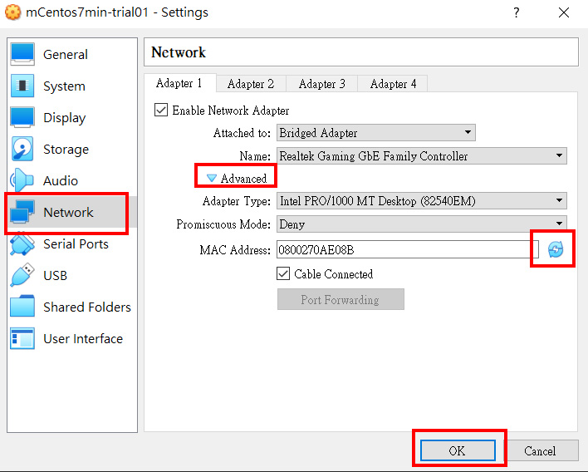
In case there is not enough IP to allocate, we use the following settings.
In the “Attached to:” dropdown list, select “Host-only Adapter”. In the “Name” dropdown list, select “VirtualBox Host-Only Ethernet Adapter”. Finally, click “OK” button at the bottom right corner.
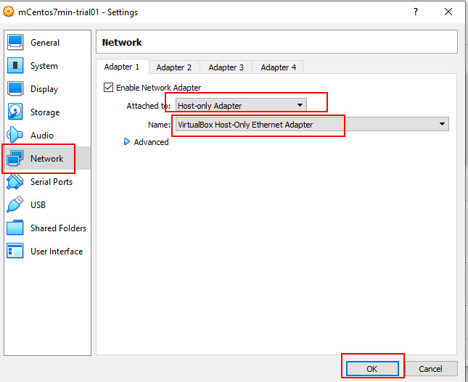

- Press the green arrow button to start the virtual machine.
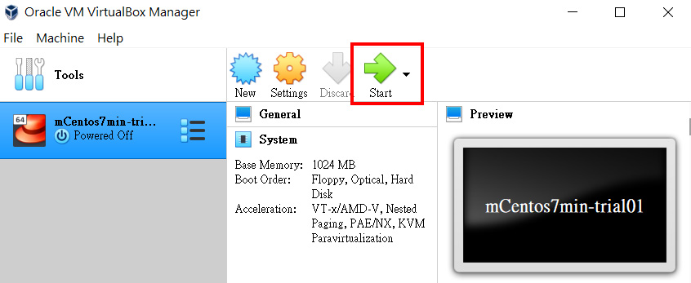
- After booting the Linux, login the system using “root” and password “netlab123”.
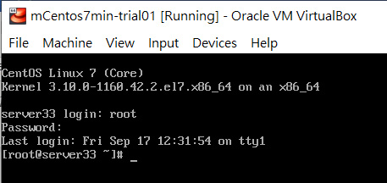
- We need to get the IP address of the Virtual Machine. We enter the following command to get the allocated IP address.
ip a | grep inet

You should get similar response as shown below.
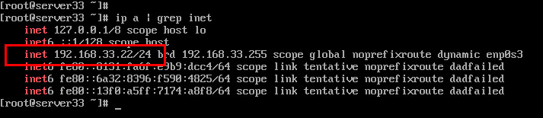
In this example, the IP is 192.168.33.22. Please check your IP address and write it down.
IP address of the virtual machine is _____________________________

- Now, we can test if the installation of PHP is ok or not. Open a browser and enter the following link.

http:// [ your IP address ]/info.php

For example, in my case, I type http://192.168.33.22/info.php. I get the following page. That means the PHP server installation is properly installed.
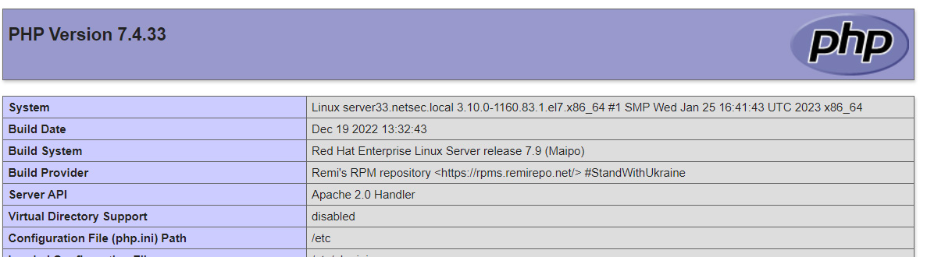

Write a simple HTML page
In this part, we are going to learn to write a simple HTML page.
What is HTML?
HTML stands for Hyper Text Markup Language
HTML is the standard markup language for creating Web pages
HTML describes the structure of a Web page
HTML consists of a series of elements
HTML elements tell the browser how to display the content

- Create a text file with filename “SimpleTest.html”. Type the following html code into the file. Save the file to a new folder “C:\WS7a\”. You may use any text editor to edit the file. Notepad++ is one of the free nice editors.
<!DOCTYPE html>
<html>
<head>
<title>Page Title here</title>
</head>
<body>
<h1>My First Heading</h1>
<h2>My Second Heading</h2>
<h3>My Third Heading</h3>
<h4>My Fourth Heading</h4>
<h5>My Fifth Heading</h5>
<h6>My Sixth Heading</h6>
<!-- Write your comments here -->
<p>My first paragraph.</p>
<a href="http://st-eng.vtc.edu.hk/">Engineering department website</a>
</body>
</html>

- Download and install Filezilla or other similar application. E.g. type “Filezilla download” from a search engine. Click to open a webpage and download the installation file. Install the application.
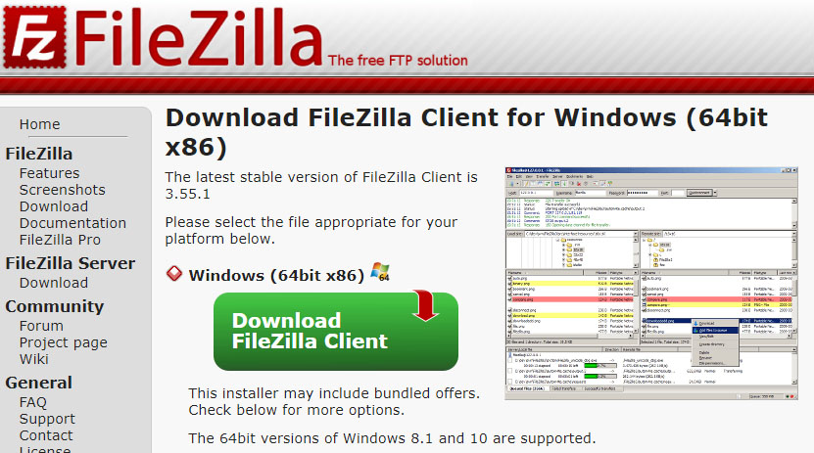
- Run the Filezilla. Connect to your virtual machine using your IP address. Logon with “root” and password “netlab123”. Use port number 22. Press “Quickconnect” button to connect to the virtual machine.
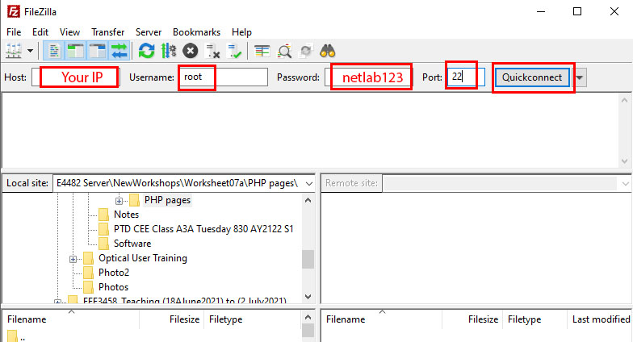
- Set the path in the “Local site”. I.e. “C:\WS7a\” (where you save the file “SimpleTest.html”). Set the path “/var/www/html” in the “Remote site”. Double click the “SimpleTest.html” under “Local site” to transfer the file from local site to remote site.
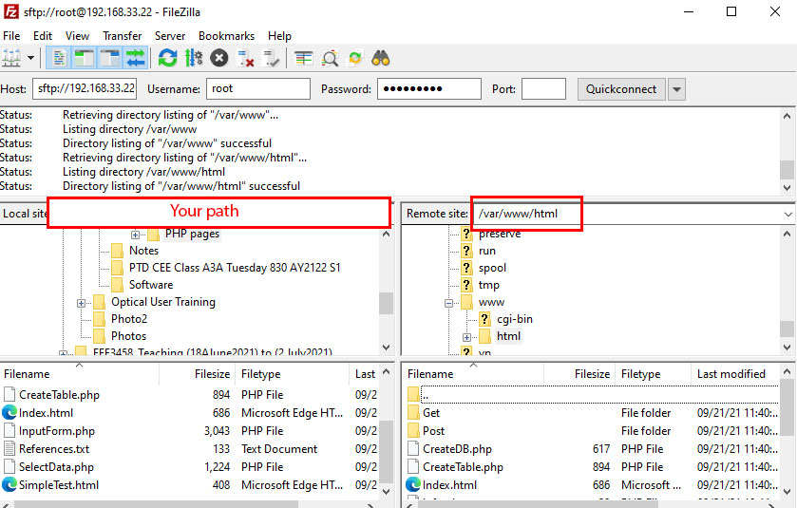
- Use a browser and enter the following link to see the page. This is your first HTML page posted up on your web server.

http://[ your IP ]/SimpleTest.html
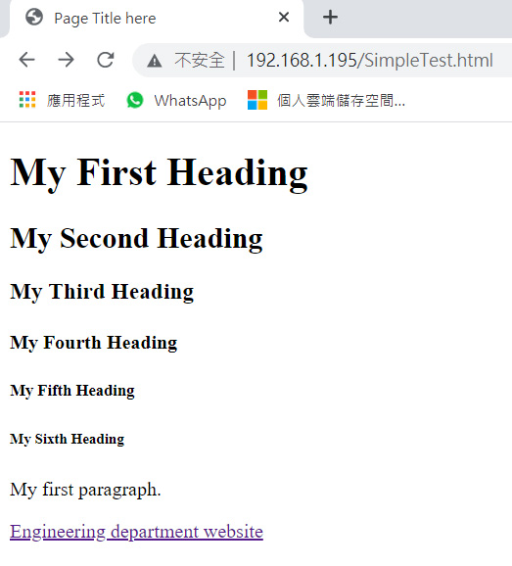
Try out the link to see if it is working.

Exercise
- Write a HTML page with filename “[Your name].html”. E.g. “ChanTaiMan.html” with the following appearance.
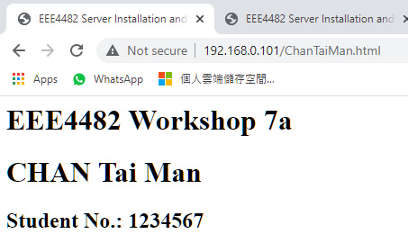
Write your code here.
<!DOCTYPE html>
<html>
<head>
<title>EEE4482 Server Installation and Programming</title>
</head>
<body>
<h1>EEE4482 Workshop 7a</h1>
<h1>CHAN Tai Man</h1>
<h2>Student No.: 1234567</h2>
</body>
</html>

Writing a form
In our application, we need to have a client to retrieve/send data from/to our online database. In our case, the client is the browser of the user. User may need to provide some information to be saved into the database. Usually, we use a HTML page with form to collect user input. The user input is most often sent to a server for processing.

- Create a text file with filename “BasicInputForm_GET.html” and write the following code into the file. (You may use Notepad++ or any other editor you like.)
<html>
<head> <title>Registration Form</title> </head>
<body>
<h2> Send data to server script using GET method</h2>
<form action="DisplayData_GET.php" method="get">
Firstname: <input type="text" name="firstname"><br><br>
Lastname: <input type="text" name="lastname"><br><br>
E-mail: <input type="text" name="email"><br><br>
<input type="submit" value="Send to server script DisplayData_GET.php">
</form>
</body>
</html>

This HTML code makes use of a form to collect 3 data from user: firstname, lastname and email address. It uses “GET” method to send the data to the receiving server script “DisplayData_GET.php”. We shall write this script later.
- Next, we need to write the server script to receive data from the client (“BasicInputForm_GET.html”). Create a text file with filename “DisplayData_GET.php”. Type the following code into the PHP file.
<html><body>
<?php
if ($_SERVER["REQUEST_METHOD"] == "GET") {
$firstname = $_GET["firstname"];
$lastname = $_GET["lastname"];
$email = $_GET["email"];
}
echo "Data is received using \"GET\"<br>";
echo "Firstname = $firstname<br>";
echo "Lastname = $lastname<br>";
echo "Email = $email<br>";
?>
</body></html>

This is the script to receive data sent from BasicInputForm_GET.html using “GET” method. Then, the PHP script sends some HTML code back to the user as a response. The response includes the firstname, lastname and email address received.

- Upload the two files “BasicInputForm_GET.html” and “DisplayData_GET.php” to the folder “/var/www/html/” in the virtual machine. Open a browser and input the link as follows.

http:// [ your IP ]/BasicInputForm_GET.html
E.g. http://192.168.0.101/ BasicInputForm_GET.html

You should see the screen similar to the following figure.
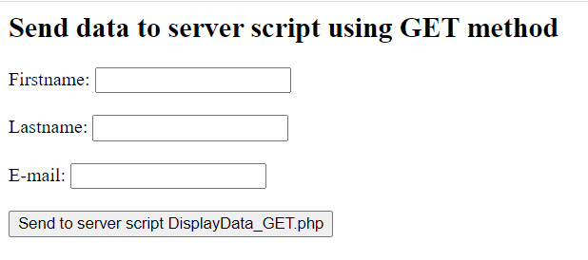

- Type something into the form and click the button at the bottom. You should see the following response from the server. For example, you type “Tai Man”, “CHAN” and “abc@email.com” into the form and click the bottom button.
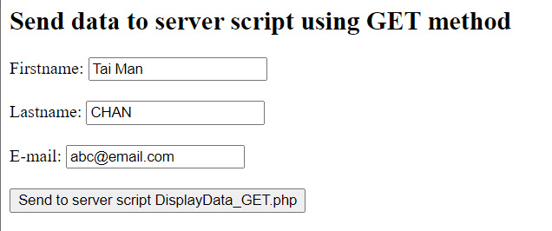
You should be the following response from the server.
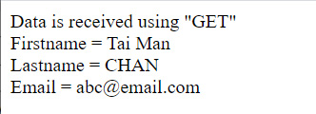
- The following is some explanation to what is happening.
- The client (user) uses a browser to open the “BasicInputForm_GET.html” page.
- The client fills in some information and sends the data to the server script “DisplayData_GET.php” using GET method.
- The server script “DisplayData_GET.php” processes the received data and returns a response to the client. It tells user the data received by the server.

Exercise
- You can do similar job using “POST” method. Search on the web and create the following files and test it.
BasicInputForm_POST.html
DisplayData_POST.php
Capture the screens and show it in the box below.
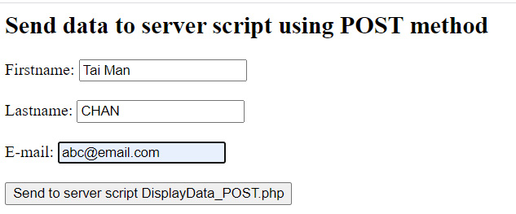
*********************
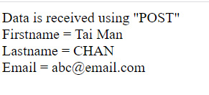

Write down the code for “BasicInputForm_POST.html”.
<html>
<head> <title>Registration Form</title> </head>
<body>
<h2> Send data to server script using POST method</h2>
<form action="DisplayData_POST.php" method="post">
Firstname: <input type="text" name="firstname"><br><br>
Lastname: <input type="text" name="lastname"><br><br>
E-mail: <input type="text" name="email"><br><br>
<input type="submit" value="Send to server script DisplayData_POST.php">
</form>
</body></html>

Write down the code for “DisplayData_POST.php”.
<html><body>
<?php
if ($_SERVER["REQUEST_METHOD"] == "POST") {
$firstname = $_POST["firstname"];
$lastname = $_POST["lastname"];
$email = $_POST["email"];
}
echo "Data is received using \"POST\"<br>";
echo "Firstname = $firstname<br>";
echo "Lastname = $lastname<br>";
echo "Email = $email<br>";
?>
</body></html>

Write a PHP page to create a database
- Create a text file with filename “CreateDB.php” and write the following code into the file.
<?php
$servername = "localhost";
$username = "root";
$password = "netlab123";
$dbname = "mySQLDB";

try {
$conn = new PDO("mysql:host=$servername", $username, $password);
// set the PDO error mode to exception
$conn->setAttribute(PDO::ATTR_ERRMODE, PDO::ERRMODE_EXCEPTION);
$sql = "CREATE DATABASE $dbname";
// use exec() because no results are returned
$conn->exec($sql);
echo "Database mySQLDB created successfully<br>";
// Close connection
$conn = null;
} catch(PDOException $e) {
echo $sql . "<br>" . $e->getMessage();
// Close connection
$conn = null;
}

$conn = null;
?>

- Upload the file “CreateDB.php” to the folder “/var/www/html/” in the virtual machine. Open a browser and input the link as follows.

http:// [ your IP ]/CreateDB.php
E.g. http://192.168.0.101/CreateDB.php

You should get the following response from the server.
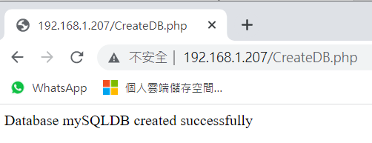
- The following is some explanation to what is happening. The client (user) runs the server script “CreateDB.php”. The server script:
- Connects to the database server using the logon “root” and password “netlab123”
- Instructs the database server to create a new database called “mySQLDB”
- Send a response to client with the sentence “Database mySQLDB created successfully”
- Disconnect from the database server

- When you run the server script “CreateDB.php” again, you would get the following response.
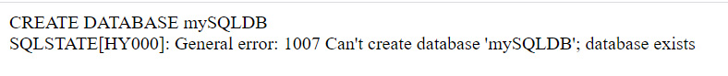
It tells the user an error message that the database server cannot create a database with name “mySQLDB”. It is because a database with the same name exists.

Create a table inside the database “mySQLDB”
- Create a text file with filename “CreateTable.php” and write the following code into the file.
<?php
$servername = "localhost";
$username = "root";
$password = "netlab123";
$dbname = "mySQLDB";

try {
$conn = new PDO("mysql:host=$servername;dbname=$dbname", $username, $password);
// set the PDO error mode to exception
$conn->setAttribute(PDO::ATTR_ERRMODE, PDO::ERRMODE_EXCEPTION);

// sql to create table
$sql = "CREATE TABLE MyGuests (
id INT(6) UNSIGNED AUTO_INCREMENT PRIMARY KEY,
firstname VARCHAR(30) NOT NULL,
lastname VARCHAR(30) NOT NULL,
email VARCHAR(50),
reg_date TIMESTAMP DEFAULT CURRENT_TIMESTAMP ON UPDATE CURRENT_TIMESTAMP
)";

// use exec() because no results are returned
$conn->exec($sql);
echo "Table MyGuests created successfully";

// Close connection
$conn = null;
} catch(PDOException $e) {
echo $sql . "<br>" . $e->getMessage();

// Close connection
$conn = null;
}

$conn = null;
?>

We create a table with name “MyGuests”. The table has 5 columns: "id", "firstname", "lastname", "email" and "reg_date".

- Upload the file “CreateTable.php” to the folder “/var/www/html/” in the virtual machine. Open a browser and input the link as follows.

http:// [ your IP ] / CreateTable.php
E.g. http://192.168.0.101/ CreateTable.php

You should get the following response from the server.
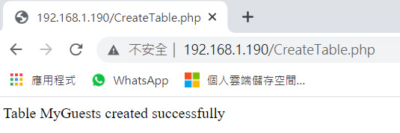
- The following is some explanation to what is happening. The client runs the server script “CreateTable.php”. The script:
- Connects to the database server using the logon “root” and password “netlab123”.
- Instructs the database server to create a new table called “MyGuests” inside the database “mySQLDB”.
- Send a response to client with the sentence “Table MyGuests created successfully”
- Disconnect from the database server

- If you run the server script “CreateTable.php” again, you should see the following response from the server.
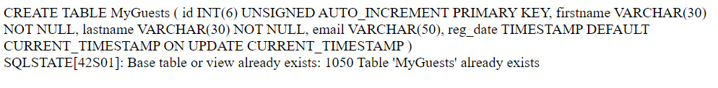
It is because there exists a table named “MyGuests” inside the database “mySQLDB”. Therefore, the server cannot create a table with the same name.

- Now, we add several lines (highlighted in yellow color) in the file “[Your name].html” (e.g. “ChanTaiMan.html”) so that we can run the two server scripts “CreateDB.php” and “CreateTable.php” easily.
<!DOCTYPE html>
<html>
<head>
<title>EEE4482 Server Installation and Programming</title>
</head>
<body>
<h1>EEE4482 Workshop 7a</h1>
<h1>CHAN Tai Man </h1>
<h2>Student No.: 1234567</h2>
<h2>Create database</h2><br>
<a href=CreateDB.php>Create a database mySQLDB</a> <br><br>
<h2>Create table in database</h2><br>
<a href=CreateTable.php>Create a table MyGuests in database mySQLDB</a> <br><br>
</body>
</html>

- Upload the file “ChanTaiMan.html” to the folder “/var/www/html/” in the virtual machine. Open a browser and input the link as follows.

http:// [ your IP ]/ChanTaiMan.html
E.g. http://192.168.0.101/ChanTaiMan.html

You should get the webpage similar to the following figure.
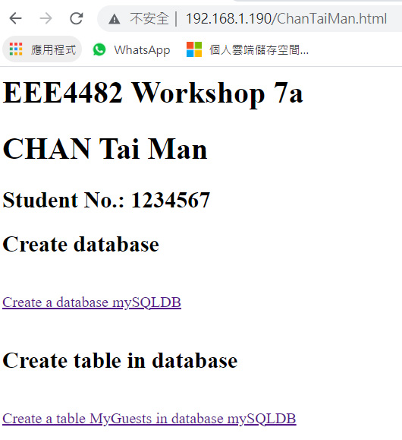

Write a server script in PHP to insert data into database
- Create a text file with filename “InsertData_GET.php” and write the following code to the file.
<html><body>
<?php
$servername = "localhost";
$username = "root";
$password = "netlab123";
$dbname = "mySQLDB";

if ($_SERVER["REQUEST_METHOD"] == "GET") {
$firstname = test_input( $_GET["firstname"] );
$lastname = test_input( $_GET["lastname"] );
$email = test_input( $_GET["email"] );
}

function test_input($data) {
$data = trim($data);
$data = stripslashes($data);
$data = htmlspecialchars($data);
return $data;
}

try {
$conn = new PDO("mysql:host=$servername;dbname=$dbname", $username, $password);
// set the PDO error mode to exception
$conn->setAttribute(PDO::ATTR_ERRMODE, PDO::ERRMODE_EXCEPTION);

// begin the transaction
$conn->beginTransaction();

// our SQL statements
$conn->exec("INSERT INTO MyGuests (firstname, lastname, email)
VALUES ('$firstname', '$lastname', '$email')");

// commit the transaction
$conn->commit();
echo "New records created successfully<br>";
echo "Firstname = $firstname<br>";
echo "Lastname = $lastname<br>";
echo "Email = $email<br>";
// Close connection
$conn = null;
} catch(PDOException $e) {
echo $sql . "<br>" . $e->getMessage();

// Close connection
$conn = null;
}
$conn = null;
?>
</body></html>

- Open the file “BasicInputForm_GET.html” and change the code highlighted in yellow color as shown below.
<html>
<head><title>Registration Form</title></head>
<body>
<h2> Send data to server script using GET method</h2>

<form action="InsertData_GET.php" method="get">
Firstname: <input type="text" name="firstname"><br><br>
Lastname: <input type="text" name="lastname"><br><br>
E-mail: <input type="text" name="email"><br><br>
<input type="submit" value="Send to server script InsertData_GET.php">
</form>
</body>
</html>

- Upload the file “InsertData_GET.php” and “BasicInputForm_GET.html” to the folder “/var/www/html/” in the virtual machine. Open a browser and input the link as follows.

http:// [ your IP ] / BasicInputForm_GET.html
E.g. http://192.168.0.101/ BasicInputForm_GET.html

Type something into the form and click the button at the bottom. You should see the following response from the server. For example, you type “Tai Man”, “CHAN” and “abc@email.com” into the form and click the bottom button.
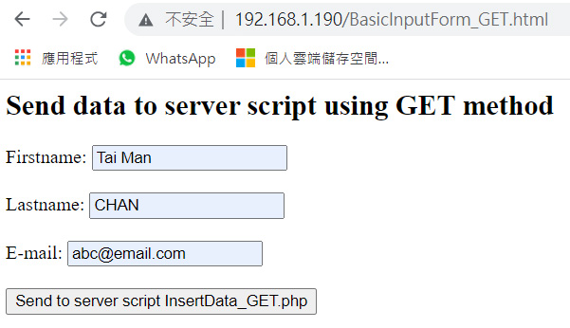

You should get the following response from the server.
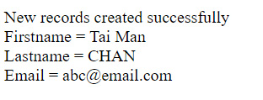
- The following is some explanation to what is happening.
- The client (user) uses a browser to visit the “BasicInputForm_GET.html” page.
- The client fills in some information and sends the data to the server script “InsertData_GET.php” using GET method.
- The server script “InsertData_GET.php” processes the received data (insert data into database) and return a response to the client. It tells the client the data received by the server.
Exercise
- Note that we include a function called “test_input()” in the “InsertData_GET.php” to process user input data.
function test_input($data) {
$data = trim($data);
$data = stripslashes($data);
$data = htmlspecialchars($data);
return $data;
}

Search on the internet and explain the function of the three functions.
https://www.w3schools.com/php/php_form_validation.asp
Trim() - The trim() function removes whitespace and other predefined characters from both sides of a string. List of predefine dcharacters:
"\0" - NULL
"\t" - tab
"\n" - new line
"\x0B" - vertical tab
"\r" - carriage return
" " - ordinary white space
Stripslashes() - The stripslashes() function removes backslashes.
Htmlspecialchars() - The htmlspecialchars() function converts some predefined characters to HTML entities.

The predefined characters are:
& (ampersand) becomes &amp;
" (double quote) becomes &quot;
' (single quote) becomes &#039;
< (less than) becomes &lt;
> (greater than) becomes &gt;
This prevents attackers from exploiting the code by injecting HTML or Javascript code (Cross-site Scripting attacks) in forms.

https://www.w3schools.com/php/php_form_validation.asp

Write a server script in PHP to retrieve all the data from the database
- Create a text file with filename “RetrieveData.php”. Type the following code into the file.
<html><body>
<?php
echo "<table style='border: solid 1px black;'>";
echo "<tr><th>Id</th><th>Firstname</th><th>Lastname</th><th>Email</th><th>Registration date</th></tr>";
class TableRows extends RecursiveIteratorIterator {
function __construct($it) {
parent::__construct($it, self::LEAVES_ONLY);
}
function current() {
return "<td style='width:150px;border:1px solid black;'>" . parent::current(). "</td>";
}
function beginChildren() {
echo "<tr>";
}
function endChildren() {
echo "</tr>" . "\n";
}
}

$servername = "localhost";
$username = "root";
$password = "netlab123";
$dbname = "mySQLDB";
try {
$conn = new PDO("mysql:host=$servername;dbname=$dbname", $username, $password);
$conn->setAttribute(PDO::ATTR_ERRMODE, PDO::ERRMODE_EXCEPTION);
$stmt = $conn->prepare("SELECT id, firstname, lastname, email, reg_date FROM MyGuests");
$stmt->execute();

// set the resulting array to associative
$result = $stmt->setFetchMode(PDO::FETCH_ASSOC);
foreach(new TableRows(new RecursiveArrayIterator($stmt->fetchAll())) as $k=>$v) {
echo $v;
}
} catch(PDOException $e) {
echo "Error: " . $e->getMessage();
}
$conn = null;
echo "</table>";
?>
</body></html>

- Upload the file “RetrieveData.php” to the folder “/var/www/html/” in the virtual machine. Open a browser and input the link as follows.

http:// [ your IP ]/RetrieveData.php
E.g. http://192.168.0.101/RetrieveData.php

You should see the screen similar to the following figure.
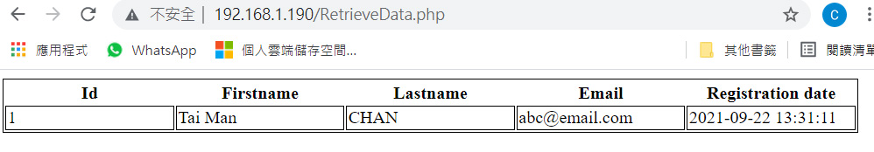
- The following is some explanation to what is happening. The client (user) runs the server script “RetrieveData.php”. The server script:
- Connects to the database server using the user “root” and password “netlab123”
- Instructs the database server to retrieve all the data from the database “mySQLDB”
- Send a response to client with a table showing all the data in the database.
- Disconnect from the database server

- Now, we add several lines (highlighted in yellow color) in the file “[Your name].html” (e.g. “ChanTaiMan.html”) so that we can run the two pages “BasicInputForm_GET.html” and “RetrieveData.php” easily.
<html><head>
<title>EEE4482 Server Installation and Programming</title>
</head>
<body>
<h1>EEE4482 Workshop 7a</h1>
<h1>CHAN Tai Man </h1>
<h2>Student No.: 1234567</h2>

<h2>Create database</h2><br>
<a href=CreateDB.php>Create a database mySQLDB</a> <br><br>

<h2>Create table in database</h2><br>
<a href=CreateTable.php>Create a table MyGuests in database mySQLDB</a> <br><br>

<h2>Insert data into database using GET method</h2><br>
<a href=BasicInputForm_GET.html>Input form using GET method</a> <br><br>

<h2>Retrieve data from database</h2><br>
<a href=RetrieveData.php>Get all data from database</a> <br><br>

</body></html>

- Upload the file “[Your name].html” (e.g. “ChanTaiMan.html”) to the folder “/var/www/html/” in the virtual machine. Open a browser and input the link as follows.

http:// [ your IP ] / [Your name].html
E.g. http://192.168.0.101/ ChanTaiMan.html

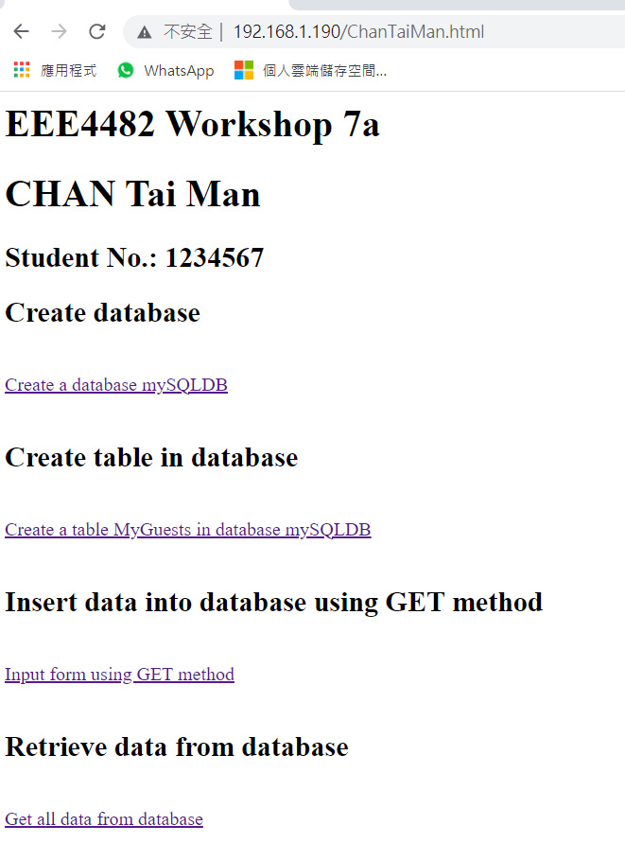
Try out the two newly added links.

Method to delete an existing database
We can delete an existing database using the following procedure.
- On the command prompt (getty) of the virtual machine, logon to mysql-console by using the following command. We use login name “root”.
mysql -u root -p
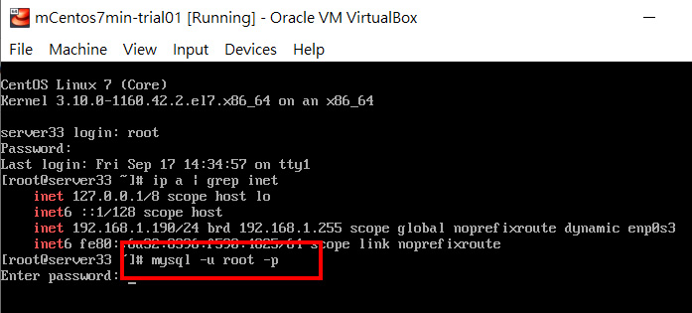
- Type the password “netlab123”. This is the password we set for the login name “root” when we install MariaDB.
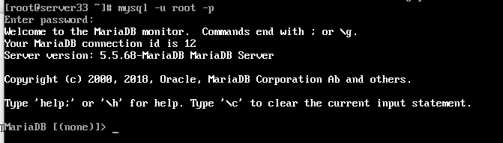
- To show all the database inside the database server, we use the following command:
show databases;
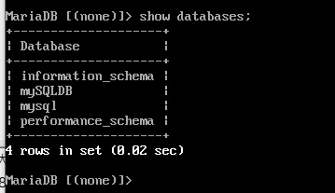
- To delete the database “mySQLDB”, we use the following command:
drop database mySQLDB;
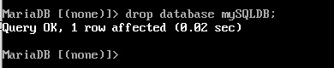
- Check if the database “mySQLDB” is deleted or not using the following command:
show databases;
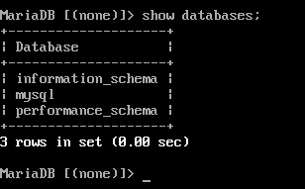
Note that the database “mySQLDB” no longer exists.
Now, you can use the page “[Your name].html” (e.g. “ChanTaiMan.html”) to test the all scripts again.

Exercise
- Create and write a server script “InsertData_POST.php” which uses POST method to receive data. Modify the file “BasicInputForm_POST.html” so that the form will send data to the file “InsertData_POST.php”.
The code for “BasicInputForm_POST.html”
<html>
<head>
<title>Registration Form</title>
</head>
<body>
<h2> Send data to server script using POST method</h2>

<form action="InsertData_POST.php" method="post">
Firstname: <input type="text" name="firstname"><br><br>
Lastname: <input type="text" name="lastname"><br><br>
E-mail: <input type="text" name="email"><br><br>
<input type="submit" value="Send to server script InsertData_POST.php">
</form>
</body>
</html>
The code for “InsertData_POST.php”
<html><body>
<?php
$servername = "localhost";
$username = "root";
$password = "netlab123";
$dbname = "mySQLDB";

if ($_SERVER["REQUEST_METHOD"] == "POST") {
$firstname = test_input( $_POST["firstname"] );
$lastname = test_input( $_POST["lastname"] );
$email = test_input( $_POST["email"] );
}

function test_input($data) {
$data = trim($data);
$data = stripslashes($data);
$data = htmlspecialchars($data);
return $data;
}

try {
$conn = new PDO("mysql:host=$servername;dbname=$dbname", $username, $password);
// set the PDO error mode to exception
$conn->setAttribute(PDO::ATTR_ERRMODE, PDO::ERRMODE_EXCEPTION);

// begin the transaction
$conn->beginTransaction();

// our SQL statements
$conn->exec("INSERT INTO MyGuests (firstname, lastname, email)
VALUES ('$firstname', '$lastname', '$email')");

// commit the transaction
$conn->commit();
echo "New records created successfully<br>";
echo "Firstname = $firstname<br>";
echo "Lastname = $lastname<br>";
echo "Email = $email<br>";
// Close connection
$conn = null;
} catch(PDOException $e) {
echo $sql . "<br>" . $e->getMessage();

// Close connection
$conn = null;
}
$conn = null;
?>
</body></html>

Create a REST API (Optional)
Currently, the API script “RetrieveData.php” returns us data in HTML format. However, this is not convenient if we have an application who wants to retrieve data from the database. A more common way is that the script returns us data in JSON format. JSON (JavaScript Object Notation) is a lightweight data-interchange format. It is easy for humans to read and write and for machines to parse and generate.

- Create a text file with filename “API_RetrieveData.php”. Type the following code into the file.
<?php
header("Content-Type:application/json");
$servername = "localhost";
$username = "root";
$password = "netlab123";
$dbname = "mySQLDB";
try {
$conn = new PDO("mysql:host=$servername;dbname=$dbname", $username, $password);
$conn->setAttribute(PDO::ATTR_ERRMODE, PDO::ERRMODE_EXCEPTION);
$conn->setAttribute(PDO::ATTR_EMULATE_PREPARES,false);
$stmt = $conn->prepare("SELECT id, firstname, lastname, email, reg_date FROM MyGuests");
$stmt->execute();

$data = [];
while ($row = $stmt->fetch(PDO::FETCH_ASSOC)) {
$data[] = $row;
}
$response = [];
$response['data'] = $data;
echo json_encode($response, JSON_PRETTY_PRINT);
} catch(PDOException $e) {
echo "Error: " . $e->getMessage();
}
$conn = null;
?>

- Upload the file “API_RetrieveData.php” to the folder “/var/www/html/” in the virtual machine. Open a browser and input the link as follows.

http:// [ your IP ]/API_RetrieveData.php
E.g. http://192.168.0.101/API_RetrieveData.php

You should see the screen similar to the following figure. The data is returned to us in JSON format.
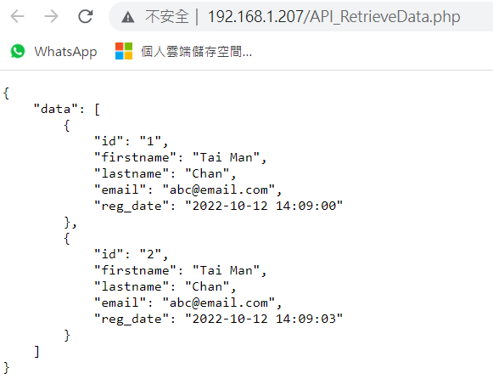

- Create a text file with filename “API_RetrieveData.html”. Type the following code into the file. [Remember to replace the [Your IP] with your IP highlighted in yellow.]
<!DOCTYPE html>
<html><head>
<title>JavaScript - read JSON from API</title>
<script src="https://code.jquery.com/jquery-3.2.1.min.js"></script>
</head>
<body>
<script>
$.getJSON('http://[Your IP]/API_RetrieveData.php', function(data) {
document.write("<table style='border: solid 1px black;'>");
var arr = data.data;
//console.log(data.data); //for debugging
document.write("<tr>");
for (var key in arr[0]){
document.write("<th>"+key+"</th>");
}
document.write("</tr>");

for (var i = 0; i < arr.length; i++){
document.write("<tr>");
var obj = arr[i];
for (var key in obj){
var value = obj[key];
document.write("<td style='width:150px;border:1px solid black;'>"+value+ "</td>");
}
document.write("</tr>");
}
document.write("</table>");
});
</script>
</body></html>

- Upload the file “API_RetrieveData.html” to the folder “/var/www/html/” in the virtual machine. Open a browser and input the link as follows.

http:// [ your IP ]/API_RetrieveData.html
E.g. http://192.168.0.101/API_RetrieveData.html

You should see the screen similar to the following figure. This HTML file makes a request to the API “API_RetrieveData.php” and use a HTML table to display the received data which is in JSON format.
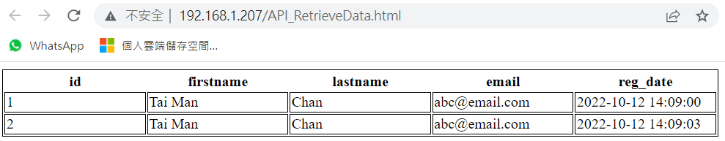
- We can create a Python program to retrieve data through the REST API “API_RetrieveData.php”. Create a text file with filename “ClientRetrieveData.py”. Type the following code into the file. [Remember to replace the [Your IP] with your IP highlighted in yellow.]
import requests
api_url = "http://[Your IP]/API_RetrieveData.php"
#Can use GET or POST methods
response = requests.get(api_url)
#response = requests.post(api_url)
print( f"API returns {response.status_code}" )
if response.status_code == 200:
received_json = response.json()
print( f"Print the returned data in JSON format" )
print( received_json )
else:
print( f"Problem !" )

- Open the “Anaconda” and use the “Spyder” app to open the file “ClientRequestData.py”. Execute the program. You should see the result similar to the following.
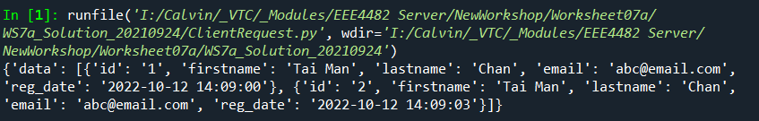
This Python program makes a request to the REST API “API_RetrieveData.php” using GET method. Then, we convert the returned string which is in JSON format into a data structure similar to dictionary in Python. Finally, we print the data. We can get the first record using the code “received_json[“data”][0]”. You should get a result similar to the following.
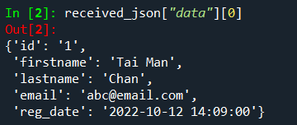
It is indeed a dictionary. You can retrieve ‘email’ using the code “received_json[“data”][0][“email”]”

- We can also send a request to API “InsertData_GET.php” using the following Python program. Create a text file with filename “ClientInsertData_GET.py”. Type the following code into the file. [Remember to replace the [Your IP] with your IP highlighted in yellow.]
import requests
api_url = "http://[Your IP]/InsertData_GET.php?firstname=Tai Man&lastname=CHAN&email=a@vtc.edu.hk"
response = requests.get(api_url)
print( f"API returns {response.status_code}" )
Execute the program, you should get result similar to the following.
Here, we insert a new record to the database with
Firstname = Tai Man
Lastname = CHAN
Email = a@vtc.edu.hk
If the API returns 200, it means the operation is successful.

- Similarly, we can send a request to API “InsertData_POST.php” using the following Python program. Create a text file with filename “ClientInsertData_POST.py”. Type the following code into the file. [Remember to replace the [Your IP] with your IP highlighted in yellow.]
import requests
api_url = 'http:// [Your IP] /InsertData_POST.php'
myobj = {"firstname":"Peter",'lastname':'LAM', 'email':'peter@abc.com'}

response = requests.post( api_url, myobj )
print( f"API returns {response.status_code}" )
# print returned string from PHP
print( f"Response text = \n{response.text}")
Execute the program, you should get result similar to the following.
Here, we insert a new record to the database with
Firstname = Tai Man
Lastname = CHAN
Email = a@vtc.edu.hk
If the API returns 200, it means the operation is successful.

- Instead of using Python to access the database, we can also do similar things using microcontrollers. Here, we use ESP32 as an example to illustrate it. Type the following code into a file named “HTTP_request_InsertData.ino”. [Remember to replace the [Your IP] with your IP highlighted in yellow. Also to replace [Your Wifi SSID] [Wifi pwd] with WiFi network name and password. Note that we assume the ESP32 and the server is under the same LAN. You may need to download and install the “HTTPClient.zip” library.

#include <HTTPClient.h> //Download: https://electronoobs.com/eng_arduino_httpclient.php
#include <WiFi.h> //Download: https://electronoobs.com/eng_arduino_wifi.php
//Add WIFI data
const char* ssid = "[Your Wifi SSID]"; //Add your WIFI network name
const char* password = "[Wifi pwd]"; //Add WIFI password

String data_to_send = ""; //Text data to send to the server
unsigned int Actual_Millis, Previous_Millis;
int refresh_time = 3000; //Refresh rate of connection to website (recommended more than 1s)

void setup() {
delay(10);
Serial.begin(115200); //Start monitor
WiFi.begin(ssid, password); //Start wifi connection
Serial.print("Connecting...");
while (WiFi.status() != WL_CONNECTED) { //Check for the connection
delay(500);
Serial.print(".");
}

Serial.print("Connected, my IP: ");
Serial.println(WiFi.localIP());
Actual_Millis = millis(); //Save time for refresh loop
Previous_Millis = Actual_Millis;
}

void loop() {
//We make the refresh loop using millis() so we don't have to sue delay();
Actual_Millis = millis();
if(Actual_Millis - Previous_Millis > refresh_time){
Previous_Millis = Actual_Millis;
if(WiFi.status()== WL_CONNECTED){ //Check WiFi connection status
HTTPClient http; //Create new client
int response_code;
// Can use POST method or GET method
bool POST = true;
if (POST){ // POST method
data_to_send = "firstname=A&lastname=B&email=C"; //Data to be sent
//Begin new connection to website
http.begin("http://[Your IP]//InsertData_POST.php" );
//Prepare the header
http.addHeader("Content-Type", "application/x-www-form-urlencoded");
//Send the POST. This will give us a response code
response_code = http.POST(data_to_send);
}
else{ // GET method
//Begin new connection to website
http.begin("http://[Your IP]//InsertData_GET.php?firstname=D&lastname=E&email=F");
http.addHeader("Content-Type", "application/x-www-form-urlencoded"); //Prepare the header
response_code = http.GET();
}

//If the code is higher than 0, it means we received a response
if(response_code > 0){
Serial.println("HTTP code " + String(response_code)); //Print return code
if(response_code == 200){ //If code is 200, we received a good response
String response_body = http.getString(); //Save the data coming from the website
Serial.print("Server reply: "); //Print data to the monitor for debug
Serial.println(response_body);
}//End of response_code = 200
}//END of response_code > 0
else{
Serial.print("Error sending POST/GET, code: ");
Serial.println(response_code);
}
http.end(); //End the connection
}//END of WIFI connected
else{
Serial.println("WIFI connection error");
}
}
}

Upload the code to your ESP32 board using Arduino IDE. You should see something similar to the following in the serial monitor.
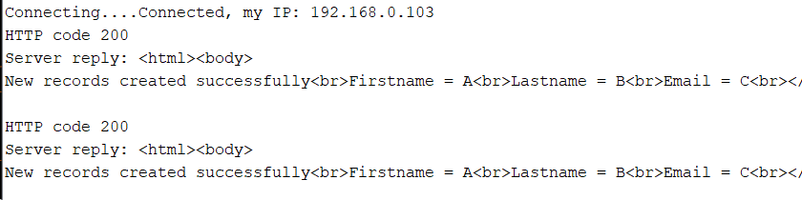

- Similarly, to retrieve data from database using microcontroller like ESP32, Type the following code into a file named “HTTP_request_RetrieveData.ino”. [Remember to replace the [Your IP] with your IP highlighted in yellow. Also to replace [Your Wifi SSID] [Wifi pwd] with WiFi network name and password. Note that we assume the ESP32 and the server is under the same LAN.

#include <HTTPClient.h> //Download: https://electronoobs.com/eng_arduino_httpclient.php
#include <WiFi.h> //Download: https://electronoobs.com/eng_arduino_wifi.php

//Add WIFI data
const char* ssid = "[Your Wifi SSID]"; //Add your WIFI network name
const char* password = "[Wifi pwd]"; //Add WIFI password

String data_to_send = ""; //Text data to send to the server
unsigned int Actual_Millis, Previous_Millis;
int refresh_time = 3000; //Refresh rate of connection to website (recommended more than 1s)

void setup() {
delay(10);
Serial.begin(115200); //Start monitor
WiFi.begin(ssid, password); //Start wifi connection
Serial.print("Connecting...");
while (WiFi.status() != WL_CONNECTED) { //Check for the connection
delay(500);
Serial.print(".");
}

Serial.print("Connected, my IP: ");
Serial.println(WiFi.localIP());
Actual_Millis = millis(); //Save time for refresh loop
Previous_Millis = Actual_Millis;
}

void loop() {
//We make the refresh loop using millis() so we don't have to sue delay();
Actual_Millis = millis();
if(Actual_Millis - Previous_Millis > refresh_time){
Previous_Millis = Actual_Millis;
if(WiFi.status()== WL_CONNECTED){ //Check WiFi connection status
HTTPClient http; //Create new client
//Begin new connection to website
http.begin("http://[Your IP]/API_RetrieveData.php");
//Prepare the header
http.addHeader("Content-Type", "application/x-www-form-urlencoded");

// Can use POST method or GET method
//int response_code = http.GET();
int response_code = http.POST("");

//If the code is higher than 0, it means we received a response
if(response_code > 0){
Serial.println("HTTP code " + String(response_code));
if(response_code == 200){
//Save the data comming from the website
String response_body = http.getString();
Serial.print("Server reply: ");
Serial.println(response_body);
}//End of response_code = 200
}//END of response_code > 0
else{
Serial.print("Error sending POST/GET, code: ");
Serial.println(response_code);
}
http.end(); //End the connection
}//END of WIFI connected
else{
Serial.println("WIFI connection error");
}
}
}

Upload the code to your ESP32 board using Arduino IDE. You should see something similar to the following in the serial Monitor.
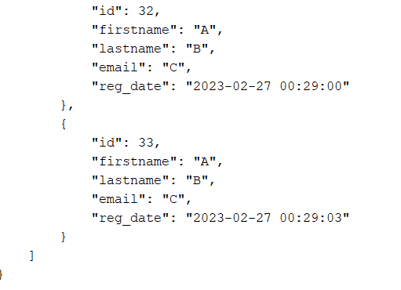

To capture the screen
Press the keyboard shortcut Windows Key + Shift + S. Your screen will dim and a mini menu will appear at the top of your screen. Drag the rectangular area that you want to capture with the mouse. Finally, paste the captured image to your word document.

References
https://www.w3schools.com/html/default.asp
https://www.w3schools.com/php/php_forms.asp
https://zetcode.com/javascript/jsonurl/
Appendix:
Steps in setting up Arduino IDE for ESP32-WROOM board
It is assume that we are using the board ESP32-WROOM-32
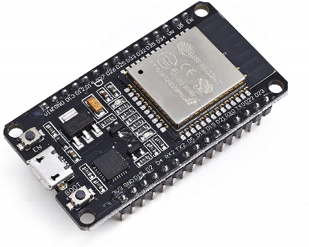
1. Download Arduino IDE from website.
Search “Arduino IDE download” from the web and search for IDE version 1.8.X. Or go to page https://www.arduino.cc/en/software. Select Legacy IDE (1.8.X). We download the ZIP version of the IDE.
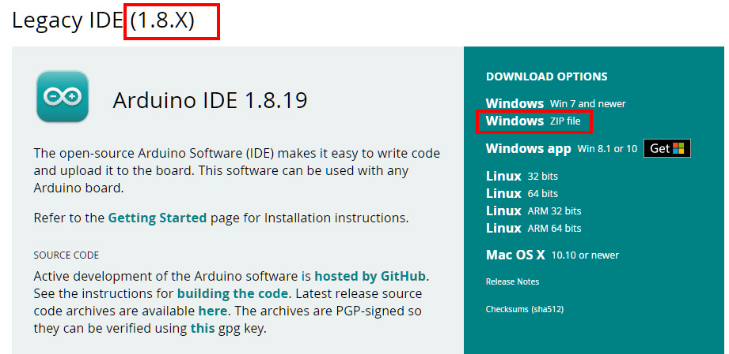

2. To make the IDE portable, follow this extra steps.
Unzip the folder. Inside the folder, create a new folder named “portable”. The installed library will be stored in this folder. Note that the folder must be named “portable”.
3. In the web, search “ESP32 JSON link espressif” or go to page “https://espressif-docs.readthedocs-hosted.com/projects/arduino-esp32/en/latest/installing.html “.
Copy the following link.
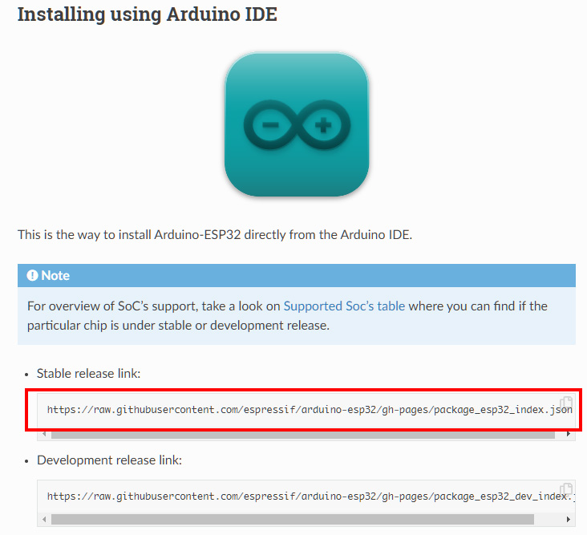
Open the Arduino IDE. Paste the link to “File>Preferences” under “Additional boards manager URL”.
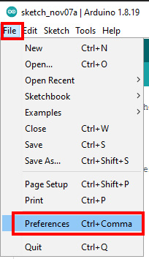
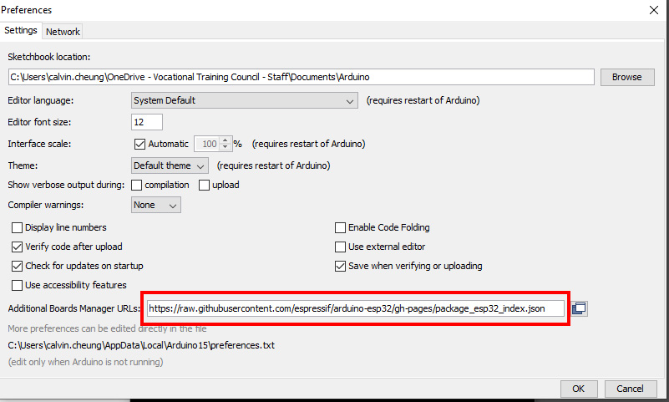

4. Download and install packages
Go to “Tools > Board: XXXX > Boards Manager…”
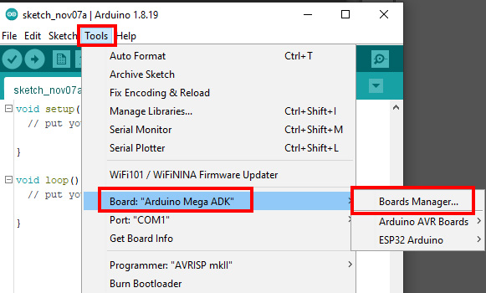
Search “ESP32” and install it.
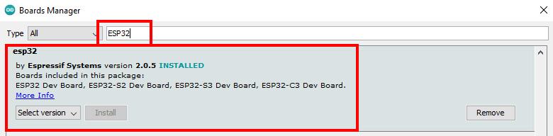
This operation installs something into the folder “portable”.
5. To setup the IDE for project, we need to select the appropriate board. Click “Tools > Board: XXX > ESP32 Arduino > ESP32 Wrover Module”
We can select “ESP32 Wrover Module” or “ESP32 Dev Module”. Other boards are also ok except “ESP32CXX”. Then, we can create our project and program it.
