**Design document**

s3582779 Yipeng Zhang

s3528894 Yanjie Zhang

**First page is explanation of the design, second page is our class diagram.**

1. **Explain how your design will be able to store the information of games, athletes and user predictions.**

We create two texts called “Athlete list” and “Official list” in the Data folder so that we can store default athletes and official data.

We use construction to give game, athletes and officials detailed information and store each information in the arraylist including specific detailed data such as game id, athletes points and final points of every athletes. New an object of the athlete class and use mutator to get name, age, state and type of the athlete.

Prediction works as that input a number meaning as an athlete, and make it as a parameter and compare it with the real winner. In a method called showPredict, judge the predicted player is 1st or not.

1. **Explain how your class hierarchy will forbid a user from creating a “generic” type of participant (i.e. not a athlete nor an official)**

Athlete and official are two different class but both inheriting the user class. While

user class is an abstract class, nothing can be created by the user class. Athlete and official class have different construction, so, if an user want to create a new role, it must be an athlete or an official, but never be a “generic” type.

1. **Explain the process by which your program will maintain a game and give correct score to athletes according to their performance.**

Firstly, we use selectGame method to chose the specific game, and then create a new game( getAthlete method will chose 8 random athlete who meet the requirement of choosing athlete for a game) . After starting the game( call starGame method) it will [automatically](https://www.baidu.com/link?url=BsFHjY8TPyilC9UZ_CsPff485y82LzRBjWV9zV54g76Pr3e07fWTqEpj6N2a9q_Xvq7yQuKM_WPaMy3W8udW0k48BCY3xB8lJTpKBo4GTUq&wd=&eqid=f64f3fad0003ee540000000458df81ee) distribute results among every athletes(setResult method) and use rank method to give every athletes a rank in this game. Finally, we use refreshpoint method to add correct points for first three place athletes.

1. **Explain how a user prediction can be checked with the actual game results.**

We make the prediction number(represent an athlete) as a parameter and compare it with the real winner. In a method called showPredict, judge the predicted player is 1st or not. If the predicted athlete get the 1st, system will output a congratulation message on the screen.

Class diagram.

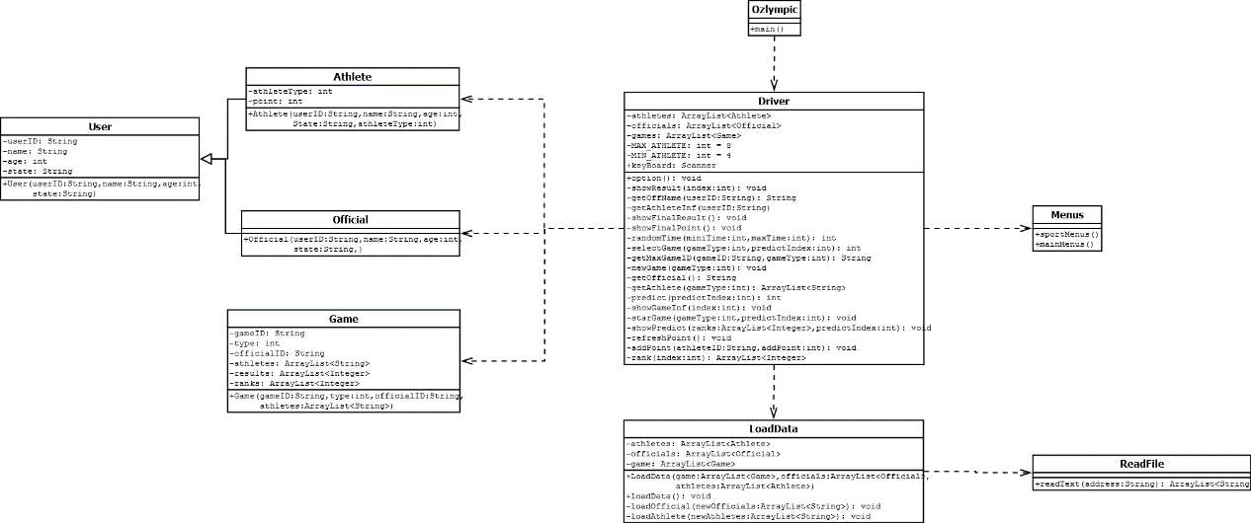

Contribution:

Yipeng: abstract class, read data from file

Yanjie Zhang: Driver class. Program construction design.

Through this assignment, I happily cooperated with Yipeng Zhang. We divided the task into two parts. I’m responsible for the driver class which is important to implement the major function in this program. I’ve got lots of experience on coding and program construction. About coding skills, I exercised to implement the requirement and whole logic in the program. About program construction, I’ve tried to make the program like ‘low coupling and high cohesion’.

About teamwork, I think it was a very fantastic experience because we made a perfect cooperation with almost no problem. By using github and email, we kept communication and progress on the coding part. It is really a useful experience for me to study Java.