

**UNIVERSITI TUNKU ABDUL RAHMAN**

**Faculty of Information and Communication Technology (FICT)**

**UCCD2044 Object-Oriented Programming Practices**

**Group Assignment**

**Session 202201**

**January 2022 Trimester**

OOP Programming Assignment

Store Management System (SMS)

1.Tang Sutian (20ACB00149)

2.Tan Kean Yew (20ACB00148)

|  |  |  |
| --- | --- | --- |
| Student1 | Student2 | Total |
| 50% | 50% | 100% |

**Description of the system**

1) User are request to key in their first name and last name(optional) at the first page.

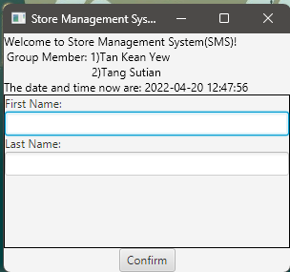

2)User are request to key in the quantity of the product.

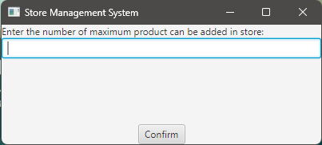

3)User can choose their option in the menu.

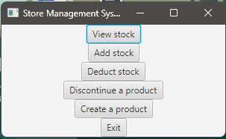

4)When user choose for View Stock, it will prompt user to choose the type of product.

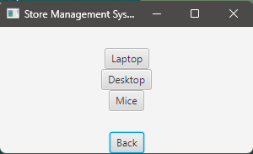

If user choose Laptop, it will show the all the product which type is laptop same as other product.

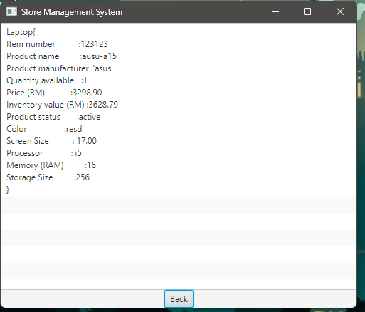

5) If user choose Add Stock, it will request user to choose the product type

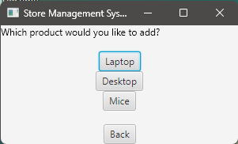

If user click on the laptop, it will show the product.

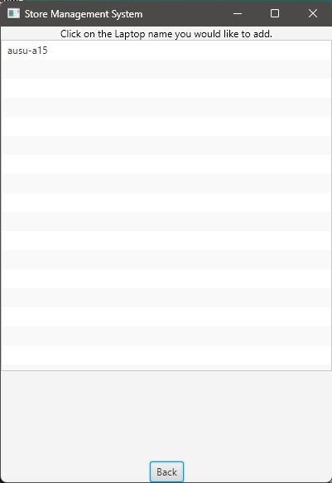

After user click on the product, it will prompt user to enter the quantity to add in. After clicked to confirm, user will be bring back to the menu.

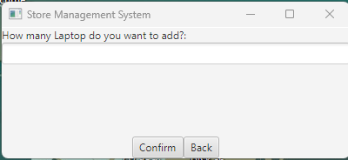

6)If user click on the Deduct Stock, it will request user to choose the product type to deduct.

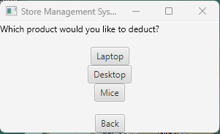

Same as the Add Stock, user can choose for the product that want to deduct the stock.

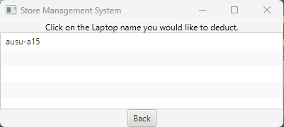

After that, user need to key in the amount of the stock that want to deduct. After click to confirm user will be bring back to menu page.

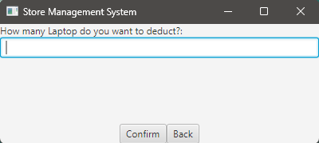

7) If user choose to the Discontinue a Product, it will request user to choose the product type.

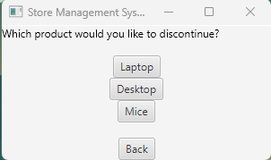

IF user choose laptop type, it will show the product, user can click on the product and it will discontinue it. After discontinue, user will be bring back to menu page automatically.

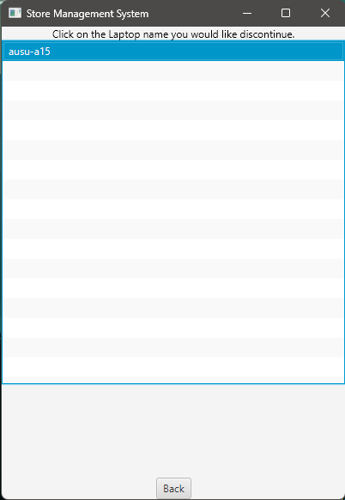

8) If user choose Create a Product, it will request user to enter the stock quantity of the product, and the type of the product.

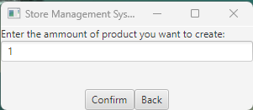 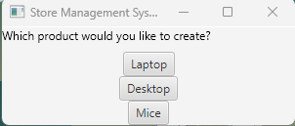

After that, user need to enter the detail of the product. Figure below showing the detail of Laptop, it is similar for other product such as Desktop and Mice.

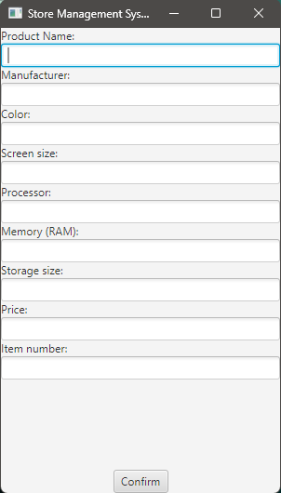

9) when user choose Exit, it will bring user to GOODBYE page which will show the user ID.

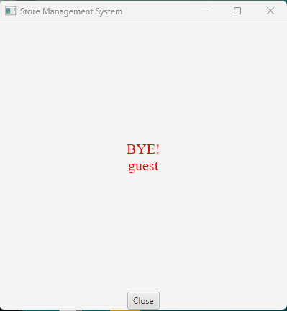

**Handling Error**

1) When user is not entering the first name or entering number in the name column, it will show error page and request user to enter again.

2) When user entering not digit value in the max product to added, it will show error page and request user to enter again.

3) When user entering not digit value in the product detail (for certain column), it will show error page and request user to enter again.

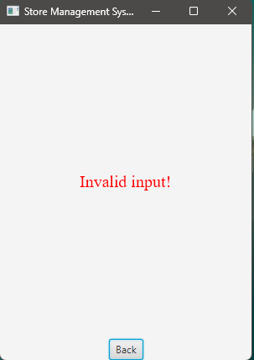

4) When no product is added, viewing stock, adding stock, deducting stock, discontinue stock will display error.

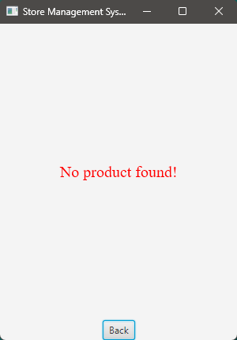

**UML DIAGRAM**

1) Product

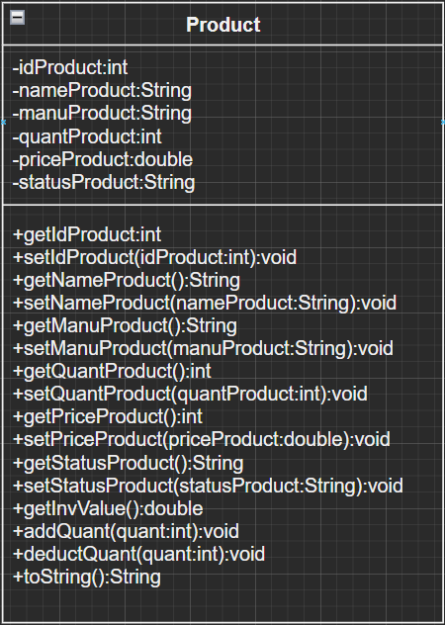

2)Desktop

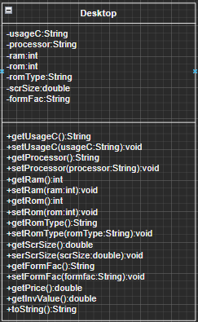

3)Laptop

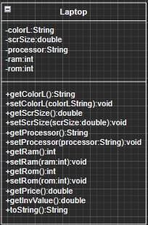

4)Mice

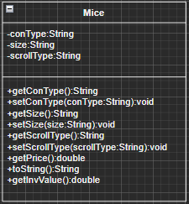

5)Admin Info

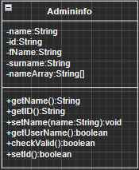

6)Store Management



7)GUI



8)Welcome

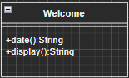

**REMINDER**

The commented part of our code in store management class is the main code and method is created as stated in guideline. After we created the javaFX GUI part, we just realized that the method following the guideline cannot be directly call as we need to do step by step by prompting the user clicking the button. Thus, we break the method we created in commented part below into different part so that the GUI can function properly. The reason we keep and commented source code below is because we hope to let miss know we does follow the guideline and put a lot of extra effort on the GUI part since we need to rewrite all the code. If miss want to check the main code part without GUI, can check code below. We hope miss can see our effort. Thank you.